Exhibit No.:
Issues: Pre-Approval
Witness: Mark L. Oligschlaeger
Sponsoring Party: MoPSC Staff
Type of Exhibit: Cross-Surrebuttal Testimony
Case No.: EO-2003-0271
Date Testimony Prepared: June 3, 2003

MISSOURI PUBLIC SERVICE COMMISSION

UTILITY SERVICES DIVISION

CROSS-SURREBUTTAL TESTIMONY

OF

MARK L. OLIGSCHLAEGER

UNION ELECTRIC COMPANY
D/B/A AMEREN UE

CASE NO. EO-2003-0271

Jefferson City, Missouri

June 2003

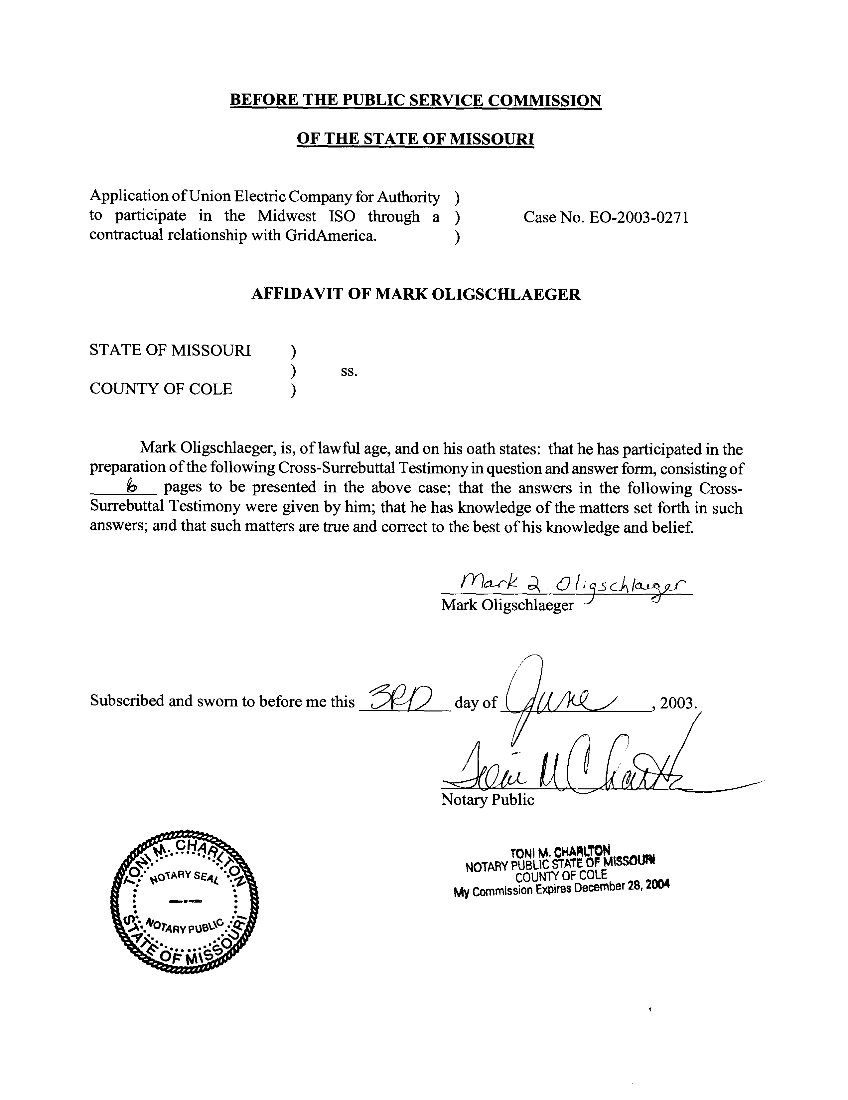

CROSS-SURREBUTTAL TESTIMONY

OF

MARK L. OLIGSCHLAEGER

UNION ELECTRIC COMPANY
d/b/a AmerenUE

CASE NO. EO-2003-0271

Q. Please state your name and business address.
A. Mark L. Oligschlaeger, P.O. Box 360, Jefferson City, MO 65102.
Q. Are you the same Mark L. Oligschlaeger that has previously submitted rebuttal testimony in this proceeding on May 2, 2003?
A. Yes, I am.
Q. What is the purpose of this cross-surrebuttal testimony?
A. The purpose of this testimony is to respond to the rebuttal testimony of Aquila, Inc. (AQN) witness John W. McKinney concerning cost recovery of regional transmission organization (RTO) costs, in the context of the Application of Union Electric Company d/b/a AmerenUE (UE) to participate in the Midwest Independent Transmission System Operator, Inc. (MISO) through a contractual arrangement with GridAmerica LLC (GridAmerica). GridAmerica will operate as an “independent transmission company” (ITC).
Q. What is Mr. McKinney’s specific concern in this proceeding regarding recoverability of RTO costs?
A. Mr. McKinney’s concern appears to be that AQN (or perhaps any electric utility) should not be expected to transfer operational control of its transmission assets to an RTO without first receiving assurances from the Commission that its RTO costs will be allowed recovery in AQN’s future rate proceedings.
Q. Based upon this concern, what does AQN recommend that the Commission do in this proceeding?
A. Mr. McKinney’s rebuttal testimony states at p. 5, “As an alternative to AmerenUE’s direct case, AQN proposes that the Commission make an express finding as to the reasonableness and recoverability of RTO costs as a part of this application case.”
Q. What does the Staff interpret Mr. McKinney’s “alternative” proposal to mean?
A. The Staff interprets Mr. McKinney’s testimony as advocating the Commission pre-approve RTO costs for rate purposes at the time utilities seek Commission approval for RTO membership.
Q. What is the Staff’s position on Mr. McKinney’s “alternative” proposal in this proceeding?
A. Consistent with its position expressed many times in past proceedings, the Staff recommends that the Commission defer all ratemaking findings associated with UE’s Application to subsequent rate proceedings. It should continue to be UE’s burden to justify the prudence and reasonableness of all of the costs for which it seeks recovery in rate proceedings, including costs associated with RTO membership, at the time a change in general rate levels is sought.
Q. From a policy perspective, why should rate determinations by the Commission be reserved for rate proceedings?
A. First, it is my understanding that the Commission is required to consider “all relevant factors” when setting a utility’s general rate levels. Making rate determinations on a piecemeal and isolated basis in application cases, such as Mr. McKinney proposes, does not appropriately take “all relevant factors” into account, in the Staff’s opinion.
Second, Mr. McKinney’s position in essence seems to be that the Commission should decide in this proceeding that RTO costs be granted rate recovery in a general, abstract sense (i.e., if the Commission authorizes UE to participate in MISO through GridAmerica, then logically costs associated with that participation should be given rate recovery by the Commission). However, the Commission’s rate decisions should only be made after it has the ability to analyze and review the facts and circumstances under which actual costs are incurred. Without such an analysis and review, the Commission cannot determine if the actual costs in question are prudent and reasonable. Such a review and analysis is best done in general rate proceedings.
Third, given the historical practice of reserving rate determinations to rate proceedings, the Staff has historically reserved detailed analysis of a utility’s revenue, expense and rate base levels to general rate proceedings. This approach allows the Staff to process non-rate application cases, including UE’s instant Application, on a timelier basis than would otherwise be possible. If the Staff believed that approval of this Application by the Commission would result in rate decisions by the Commission that could not be revisited in subsequent general rate proceedings, it should be obvious that much additional work by the Staff and other parties to this proceeding would be necessary to protect the public interest.
Q. Would the Staff have approached this application by UE in a different manner, if it believed rate determinations by the Commission would be pending?
A. Yes. For example, UE did not submit a detailed cost/benefit analysis to support its decision to participate in MISO through GridAmerica in this proceeding. The Staff, in reviewing all of the evidence that was provided by UE, believes that UE’s Application is adequate for purposes of recommending whether the Commission should grant approval of participation in MISO through GridAmerica or not. On the other hand, if rate decisions are to be made in this proceeding regarding future rate recovery of RTO costs, the Staff believes that a more detailed cost/benefit analysis must be required of UE to support such rate determinations.
Q. Are there additional reasons why pre-approval of RTO cost recovery in UE’s instant Application would be unwise?
A. Yes. First, UE has attached as schedules to Mr. Daniel Godar’s direct testimony in this proceeding several contracts that set out the relationships among MISO, GridAmerica and the GridAmerica participants (including UE). Among other things, these contracts allow UE a right to withdraw from participation in GridAmerica 36 months after its participation in GridAmerica begins (Godar Schedule 3, pp. 33-34), as well as a broad right to withdraw from GridAmerica at the conclusion of five years of membership (Godar Schedule 4, p. 10 and pp. 40-41). Any pre-approval of rate recovery by UE for GridAmerica costs may serve to “bias” UE’s decision as to whether to exercise its rights to withdraw from GridAmerica in the future, if alternative courses of action would require UE to go through another Commission rate recovery proceeding.
Second, as previously discussed, UE’s Application in this case specifically seeks permission to participate in MISO through GridAmerica. Other Missouri electric companies will presumably have alternative choices of RTOs to join besides MISO, and will also have a choice as to whether to participate in an RTO through an ITC or not. If the Commission were to grant pre-approved rate treatment to UE for its participation in MISO through GridAmerica in this proceeding, this may provide an inappropriate incentive for other Missouri electric utilities to choose a similar course of action to UE’s regarding RTO membership, rather than seek authorization for alternative approaches that have yet to receive pre-approved ratemaking.
Q. To your knowledge, is UE seeking any pre-approval of rate treatment of RTO costs in this proceeding?
A. No.
Q. In any future application by AQN to join an RTO, is it free to seek ratemaking determinations from the Commission concerning RTO costs at that time?
A. Yes. The Staff is not aware of any reason why the Commission’s decisions in this Application regarding UE’s participation in an RTO would prejudice any request by AQN for ratemaking determinations in a subsequent AQN RTO application. For this reason, the Staff is confused why AQN is raising this issue at this time in this proceeding. Again, the Staff notes that any request by AQN for pre-approval of ratemaking treatment of RTO costs should be supported with a greater level of cost/benefit justification than that provided by UE for its Application in this case. In addition, it should again be emphasized that the Staff has consistently opposed such pre-approval requests in the past.
Q. Are other Staff witnesses addressing the issue raised in Mr. McKinney’s rebuttal testimony in this proceeding?
A. Yes. Staff witness Michael S. Proctor of the Energy Department will also be addressing Mr. McKinney’s rebuttal testimony in his cross-surrebuttal testimony in this case. In addition, Mr. McKinney’s rebuttal testimony raises certain legal questions to which the Staff’s attorneys will be responding at an appropriate time.
Q. Please summarize your cross-surrebuttal testimony.
A. AQN witness McKinney appears to recommend that the Commission pre-approve rate recovery of RTO costs by UE in this Application, a position that UE itself has not supported to-date in this proceeding. The Staff is opposed to pre-approval of rate recovery in non-rate case proceedings, both in general and specifically in the context of RTO applications. This position is consistent with both the Staff’s and the Commission’s past practices in rate and non-rate applications. Nonetheless, AQN is free to include such a request for pre-approved rate treatment in any subsequent application it may file to join the MISO or another RTO.
Q. Does this conclude your cross-surrebuttal testimony?
A. Yes, it does.

