BEFORE THE PUBLIC SERVICE COMMISSION
OF THE STATE OF MISSOURI

In the Matter of the Application of Union Electric )
Company, d/b/a AmereUE, for a Metering Variance ) Case No. EE-2004-0267
To Service Brentmoor at Oaktree. )
)
In the Matter of the Application of Union Electric ) Case No. EE-2004-0268
Company, d/b/a AmerenUE, for a Metering Variance )
To Service River’s Edge Properties, L.L.C. )

REQUEST OF RIVER’S EDGE FOR EXTENSION OF FILING DATE

Comes now River’s Edge Properties, L.L.C. (“River’s Edge”) and requests a one-week extension of the May 26th deadline for filing a proposed procedural schedule. In support of its request, River’s Edge states as follows:
- On May 12, the Commission issued its Notice of Case Reassignment, Order Consolidating Cases and Order Directing Filing. In that Order, the Commission directed the parties to file a proposed procedural schedule by May 26.
- The parties have had several discussions in an effort jointly to propose a schedule to the Commission. However, they have had some difficulty due to uncertainty over the scheduling of a major rate case and the need of River’s Edge to retain its experts for this case.
- It is anticipated that these scheduling uncertainties will be resolved within the next week. Accordingly, River’s Edge requests a one-week extension of the deadline to file a procedural schedule, until June 2, 2004.
- Counsel for River’s Edge has consulted the counsel for Brentmoor at Oaktree, Union Electric Company the Commission Staff, and has been informed that no party objects to this request.
WHEREFORE, River’s Edge requests a one-week extension until June 2, 2004 for the parties to file a proposed procedural schedule herein.
Respectfully submitted,

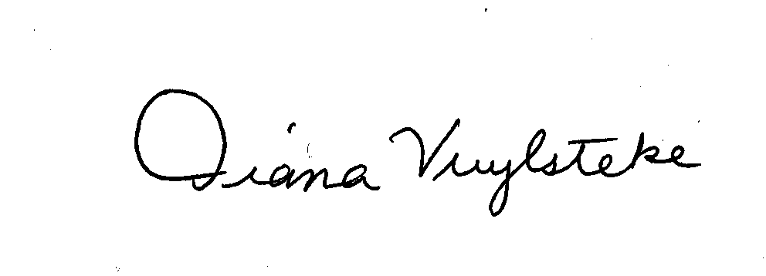
BRYAN CAVE, LLP

By:______________________
Diana M. Vuylsteke, # 42419
211 N. Broadway, Suite 3600
St. Louis, Missouri 63102
Telephone: (314) 259-2543
Facsimile: (314) 259-2020
E-mail: dmvuylsteke@bryancave.com

Attorney for River’s Edge Properties

CERTIFICATE OF SERVICE

I hereby certify that copies of the foregoing have been sent to the parties on the Commission’s service list this 25th day of May, 2004.

________________________

