BEFORE THE PUBLIC SERVICE COMMISSION
OF THE STATE OF MISSOURI

In the Matter of the Application of KCP&L )
Greater Missouri Operations Company ) Case No. EO-2009-0341
Containing its Annual Fuel Adjustment Clause )
True-Up )

OBJECTION TO TRUE-UP

COME NOW, Ag Processing Inc., a cooperative, and Sedalia Industrial Energy Users’ Association (“Industrial Intervenors”) and for their Objection to the proposed True-Up state as follows:
1. On May 29, 2009, KCPL – GMO filed an application related to its true-up of revenues and expenses under its fuel adjustment clause. GMO seeks a total of approximately $1.3 of additional revenues associated with a claimed under-recovery of fuel and purchased power costs.
2. In State ex rel. Utility Consumers Council of Missouri v. Public Service Commission, the Missouri Supreme Court addressed the legality and constitutionality of fuel adjustment clauses. There, the Supreme Court discussed retroactive ratemaking.
The utilities take the risk that rates filed by them will be inadequate, or excessive, each time they seek rate approval. To permit them to collect additional amounts simply because they had additional past expenses not covered by either clause is retroactive rate making, i.e., the setting of rates which permit a utility to recover past losses or which require it to refund past excess profits collected under a rate that did not perfectly match expenses plus rate-of-return with the rate actually established. Past expenses are used as a basis for determining what rate is reasonable to be charged in the future in order to avoid further excess profits or future losses, but under the prospective language of the statutes, §§ 393.270(3) and 393.140(5) they cannot be used to set future rates to recover for past losses due to imperfect matching of rates with expenses.

The Supreme Court concluded that retroactive ratemaking was not only a bad regulatory methodology, it was also unconstitutional.
The commission has the authority to determine the rate to be charged, §393.270. In so determining it may consider past excess recovery insofar as this is relevant to its determination of what rate is necessary to provide a just and reasonable return in the future, and so avoid further excess recovery. It may not, however, redetermine rates already established and paid without depriving the utility (or the consumer if the rates were originally too low) of his property without due process.

3. In 2005, the General Assembly enacted Section 386.266. While that section provides statutory authority for fuel adjustment clauses, it does not alter the constitutional doctrine prohibiting retroactive ratemaking. As set forth in its application, then, GMO’s request amounts to unconstitutional retroactive ratemaking. Such action is constitutionally prohibited and should be rejected.
WHEREFORE, AGP / SIEUA respectfully request that the Commission reject GMO’s request for a true-up and collection of alleged under-recovery of fuel and purchased power costs.

Respectfully submitted,
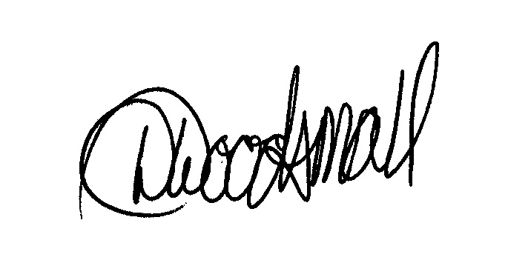
Stuart W. Conrad, MBE #23966
David L. Woodsmall, MBE #40747
3100 Broadway, Suite 1209
Kansas City, Missouri 64111
(816) 753-1122 Ext. 211
Facsimile: (816) 756-0373
Internet: stucon@fcplaw.com

ATTORNEYS FOR AG PROCESSING, INC. AND SEDALIA INDUSTRIAL ENERGY USERS’ ASSOCIATION

CERTIFICATE OF SERVICE

I HEREBY CERTIFY that I have this day served the foregoing pleading by email, facsimile or First Class United States Mail to all parties by their attorneys of record as provided by the Secretary of the Commission.

David L. Woodsmall

Dated: July 22, 2009

585 S.W.2d 41 (Mo. banc 1979).
Id. at page 59 (emphasis added, footnotes omitted).
Id. at page 58 (emphasis added, footnotes omitted).

