#### BEFORE THE PUBLIC SERVICE COMMISSION

#### OF THE STATE OF MISSOURI

|  |  |  |
| --- | --- | --- |
| In the Matter of Confluence Rivers Utility Operating Company, Inc.’s Request for Authority to Implement a General Rate Increase for Water Service and Sewer Service Provided in Missouri Service Areas | )  )  )  )  )  ) | **File No. WR-2023-0006**  **File No. SR-2023-0007** |

NOTICE OF EXTRA-RECORD COMMUNICATION

Issue Date: July 26, 2023

On July 26, 2023, a letter was received by the Public Service Commission from Jeffrey Hughes. The letter was viewed by Chairman Scott Rupp, Commissioner Jason Holsman, Commissioner Maida Coleman, Commissioner Glen Kolkmeyer, and Commissioner Kayla Hahn, as well as policy advisor Mark Johnson. Cherlyn Voss, manager of the regulatory analysis department also viewed the letter.

The Commission has promulgated rules denoted as the “Standards of Conduct” at 20 CSR 4240-4 and Section 20 CSR 4240-4.030 specifically deals with extra record communication. Since the letter could be considered an extra-record communication under Commission Rule 20 CSR 4240-4.030, this notice of communication is filed in conformance with that rule. A copy of the letters are also attached to this notice.

­­­­­­­­­­­­­­­­­­­­­­­­­­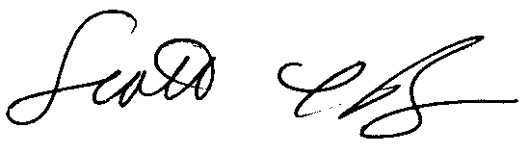

______________________________________

Chairman Scott Rupp,

Missouri Public Service Commission

Dated at Jefferson City, Missouri,

this 26th day of July, 2023.



______________________________________

Commissioner Maida Coleman,

Missouri Public Service Commission

Dated at Jefferson City, Missouri,

this 26th day of July, 2023.

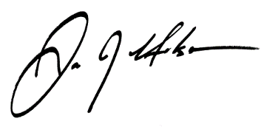

______________________________________

Commissioner Jason Holsman,

Missouri Public Service Commission

Dated at Jefferson City, Missouri,

this 26th day of July, 2023.

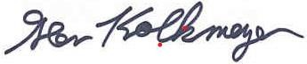

______________________________________

Commissioner Glen Kolkmeyer,

Missouri Public Service Commission

Dated at Jefferson City, Missouri,

this 26th day of July, 2023.

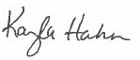

______________________________________

Commissioner Kayla Hahn,

Missouri Public Service Commission

Dated at Jefferson City, Missouri,

this 26th day of July, 2023.

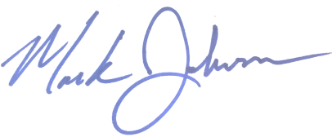

______________________________________

Mark Johnson,

Regulatory Analysis Manager, Regulatory Analysis

Dated at Jefferson City, Missouri,

this 26th day of July, 2023.

/S/ Cherlyn Voss

______________________________________

Cherlyn Voss,

Regulatory Analysis Manager, Regulatory Analysis

Dated at Jefferson City, Missouri,

this 26th day of July, 2023.