BEFORE THE PUBLIC SERVICE COMMISSION
STATE OF MISSOURI

In the Matter of the Joint Application of )
Acceris Management and Acquisition LLC )
LLC and Acceris Communications Corp. )
for Approval of the Acquisition of Certain ) Case No. TO-2005-0508
Assets of Acceris Communications Corp. )
by Acceris Management and Acquisition LLC )

JOINT APPLICATION FOR APPROVAL OF TRANSFER OF ASSETS

COME NOW Acceris Management and Acquisition LLC (“ACCERIS” or “Buyer”) and Acceris Communications Corp. (“ACC” or “Seller”), (referred to collectively hereinafter as “Joint Applicants” or “the Parties”), by and through counsel, pursuant to Sections 392.290 and 392.300 RSMo., and 4 CSR 240-2.060 and 4 CSR 240-3.520, and hereby jointly request Commission approval of a transaction whereby ACCERIS will acquire certain Missouri assets of ACC, including, but not limited to, the subscriber base of ACC. Joint Applicants further request cancellation of ACC’s Missouri certificate of service authority and tariffs after consummation of the transfer of assets.
In support of their request, Joint Applicants state the following:
- The Parties
A. Acceris Management and Acquisition LLC
1. ACCERIS is a limited liability company organized under the laws of the State of Minnesota and is a wholly owned subsidiary of NCE. NCE is a privately owned holding company with experience in the telecommunications industry. ACCERIS is not currently authorized to provide telecommunications services in any jurisdiction, but is in the process of obtaining authority to provide interexchange and/or local exchange telecommunications services throughout the United States. An Application for Certificate of Service Authority and for Competitive Classification seeking authority for ACCERIS to provide intrastate, interexchange and non-switched local exchange telecommunications services in the State of Missouri is being filed contemporaneously with this Application. The nature of ACCERIS’ business is telecommunications.
2. A copy of ACCERIS’ Certificate of Authority from the Missouri Secretary of State, as required by 4 CSR 240-2.060(1)(C), will be late-filed as Appendix A.
3. The principal office of ACCERIS is located at:
60 South Sixth Street, Suite 2535
Minneapolis, Minnesota (MN) 55402
Telephone: (612) 465-0260
Facsimile: (612) 455-1022

4. ACCERIS states that it does not have any outstanding Annual Reports or assessment fees owed to the Missouri Public Service Commission and it does not have any pending action or final unsatisfied judgments or decisions against it from any state or federal agency or court which involve customer service or customer rates, which action, judgment, or decision has occurred within three years of the date of this application.
- Acceris Communications Corp.
5. Acceris Communications Corp. (ACC) is a corporation organized under the laws of the State of Delaware. ACC is authorized under Section 214 of the Communications Act of 1934, as amended, to provide, and is currently providing domestic interstate and international telecommunications service throughout the United States. ACC also has authority to provide, and is currently providing, intrastate, interexchange telecommunications services in the contiguous 48 states, Hawaii and the District of Columbia.
6. ACC was granted certificate of service authority to provide interexchange telecommunications services in the State of Missouri by an Order issued by the Commission on July 31, 2000, in Case No. TA-2000-847.
7. A copy of CAA’s Certificate of Authority from the Missouri Secretary of State, as required by 4 CSR 240-2.060(1)(C), is attached to this Application as Appendix B.
8. ACC is also authorized to provide competitive local exchange services in Alabama, Arkansas, Colorado, Connecticut, Delaware, Florida, Georgia, Idaho, Indiana, Iowa, Kentucky, Louisiana, Maryland, Massachusetts, Michigan, Montana, Nebraska, Nevada, New Jersey, New Mexico, New York, North Carolina, North Dakota, Ohio, Oklahoma, Oregon, Pennsylvania, Rhode Island, South Carolina, South Dakota, Washington, and West Virginia. ACC is currently providing such service in Florida, Massachusetts, New Jersey, New York, and Pennsylvania.
9. The principal office of ACC is located at:
1001 Brinton Road
Pittsburgh, PA 15221
Telephone: 412-244-2100

10. ACC states that it does not have any outstanding Annual Reports or assessment fees owed to the Missouri Public Service Commission and it does not have any pending action or final unsatisfied judgments or decisions against it from any state or federal agency or court which involve customer service or customer rates, which action, judgment, or decision has occurred within three years of the date of this application.
II. DESIGNATED CONTACTS
11. All communications, notices, orders and decisions respecting this
Application and proceeding should be addressed to:
William D. Steinmeier
Mary Ann (Garr) Young Patrick D. Crocker
William D. Steinmeier, P.C. Early, Lennon, Crocker & Bartosiewicz, P.L.C.
2031 Tower Drive 900 Comerica Building
Jefferson City, Missouri 65109 Kalamazoo, Michigan 49007-4752
Tel: (573) 659-8672 Tel: (269) 381-8844
Fax: (573) 636-2305 Fax: (269) 381-8822
Email: wds@wdspc.com Email: pcrocker@earlylennon.com
myoung0654@aol.com

12. Please direct any questions concerning ACCERIS to Mr. Crocker at the addresses and numbers above.
13. Please direct any questions concerning ACC to:

Lance J.M. Steinhart, Esq.
Lance J.M. Steinhart, P.C.
1720 Windward Concourse
Suite 250
Alpharetta, GA 30005
Telephone: (770) 232-9200
Facsimile: (678) 775-1194
E-mail: lsteinhart@telecomcounsel.com
III. The Transaction
14. Pursuant to an Asset Purchase Agreement executed May 19, 2005, ACC has agreed to sell to ACCERIS, and ACCERIS has agreed to purchase all telecommunications assets and operations of ACC, including but not limited to: (1) all PUC/PSC/FCC licenses, CPCNs and tariffs authorizing Seller to provide telecommunications services in all relevant states to the extent assignable or transferable; and (2) the customer base as of the Closing Date. Pursuant to 4 CSR 240-3.520(2)(B), a copy of the Asset Purchase Agreement will be provided to the Commission as Appendix C upon issuance of a Protective Order by the Commission in this case. A Motion for Protective Order is being filed separately in this matter for that purpose.
IV. Public Interest Considerations
15. The transaction contemplated by the Asset Purchase Agreement will serve the public interest by enabling ACCERIS to achieve increased economies of scale and compete more effectively in the telecommunications marketplace. More effective competition will ultimately lead to lower prices and the availability of more products and services to the public. The acquisition of the ACC customer base by ACCERIS will enable these subscribers to continue to receive high-quality telecommunications service at affordable rates without interruption.
16. Upon approval of this transaction, ACCERIS will provide notice to the ACC Customers, and assure them of the Buyer’s commitment to continue the provision of high quality, affordable services pursuant to the company’s filed tariff. Specifically, customers will continue to receive the high quality, affordable telecommunications services that they presently receive, and the proposed acquisition will be virtually transparent to ACC’s customers. As such, the transaction will not cause inconvenience or confusion to ACC customers. In addition, Joint Applicants submit that the notice to be provided to customers, pursuant to 4 CSR 240-33.150 (4), will be given in each subscriber’s bill at least thirty (30) days prior to the effective date of the change, and will reasonably and adequately advise them of both the change in their telecommunications services provider and their opportunity to choose another provider. A copy of the sample notice of the transfer appears as Appendix D attached hereto.
17. ACCERIS certifies that it has the necessary managerial, technical and financial resources to provide the public with quality telecommunications service throughout the State. After the consummation of the transaction, ACCERIS will be led by a team of well-qualified managers comprised of its existing personnel. ACCERIS expects that the ample managerial, technical and financial expertise of this managerial team will enable it to provide high quality service to ACC customers as well as to expand its customer base. The proposed acquisition will therefore promote competition in the Missouri telecommunications services market and serve the public interest.
18. The transfer will have no impact on the tax revenues of any political subdivision in the state of Missouri.
V. CANCELLATION OF CERTIFICATE AND TARIFF
19. Because ACCERIS will acquire substantially all of the assets of ACC and ACC will thereafter cease operations in this state, ACC will no longer require authority to provide service in this state. Joint Applicants therefore respectfully request that through this proceeding the Commission grant any authority necessary to permit ACC to discontinue service upon consummation of the Transaction and permit ACC to relinquish its certificate of service authority in this state, simultaneously with the effective date of the Acquisition.
20. Thus, ACC requests that its Missouri Certificates of Service Authority and tariffs be cancelled, upon completion of the instant transaction.
VI. CONCLUSION
WHEREFORE, Acceris Management and Acquisition LLC and Acceris Communications Corp. respectfully and jointly request that the Commission authorize the sale of assets from Acceris Communications Corp. to Acceris Management and Acquisition LLC.
Respectfully submitted,
/s/ William D. Steinmeier
William D. Steinmeier, Mo. Bar #25689
Mary Ann (Garr) Young, Mo. Bar #27951
WILLIAM D. STEINMEIER, P.C.
2031 Tower Drive
P.O. Box 104595
Jefferson City, MO 65110-4595
Tel.: (573) 659-8672
Fax: (573) 636-2305
Email: wds@wdspc.com
Myoung0654@aol.com

ATTORNEYS FOR THE PARTIES:
Acceris Management and Acquisition LLC
And Acceris Communications Corp.

June 30, 2005

Certificate of Service
I hereby certify that a copy of the foregoing document has been served electronically on the Office of the General Counsel of the Missouri Public Service Commission and the Office of Public Counsel, on this 30th day of June 2005.

/s/ William D. Steinmeier

Appendix A

Acceris Management and Acquisition, LLC:

Missouri Secretary of State Certificate

(To be late-filed)

Appendix B

Acceris Communications Corp:

Missouri Secretary of State Certificate
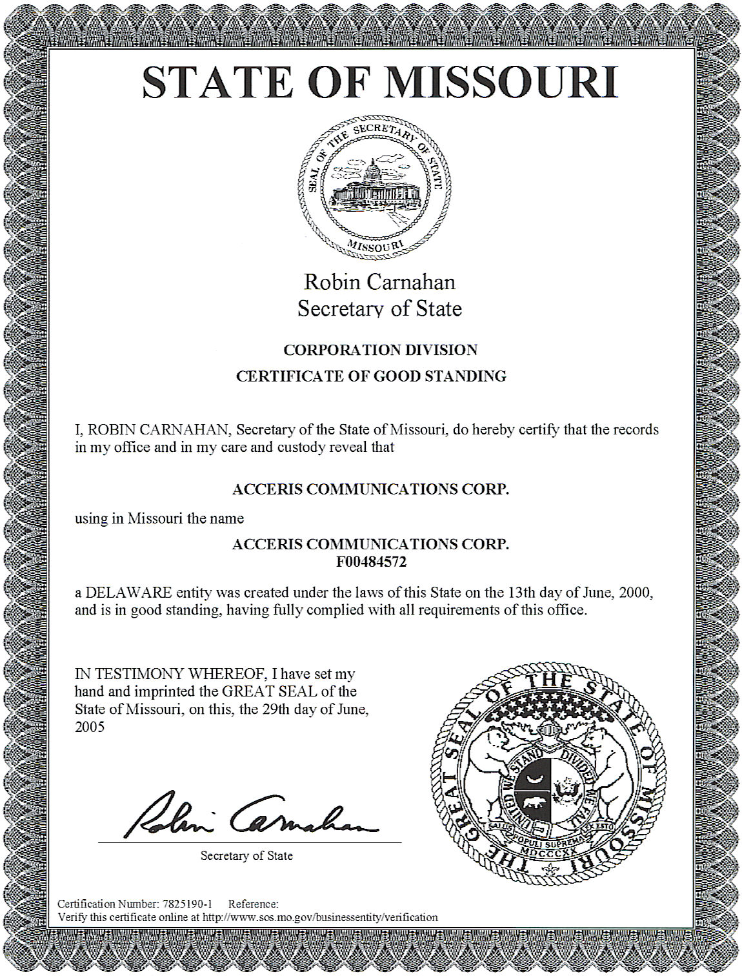

Appendix C

Asset Purchase Agreement

(To be late-filed)

Appendix D

Sample Notice to Customers

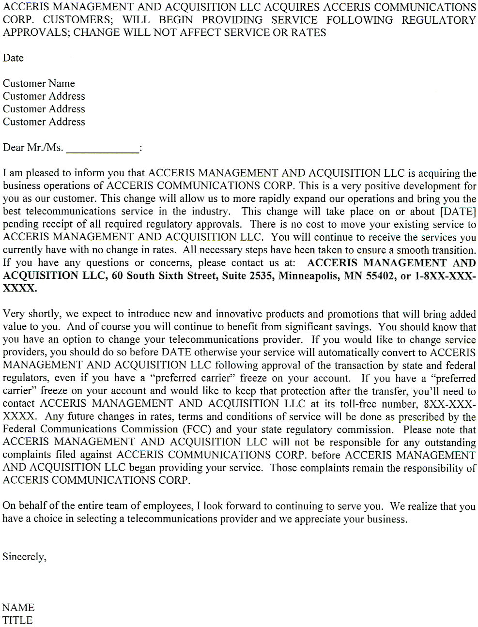

Verifications

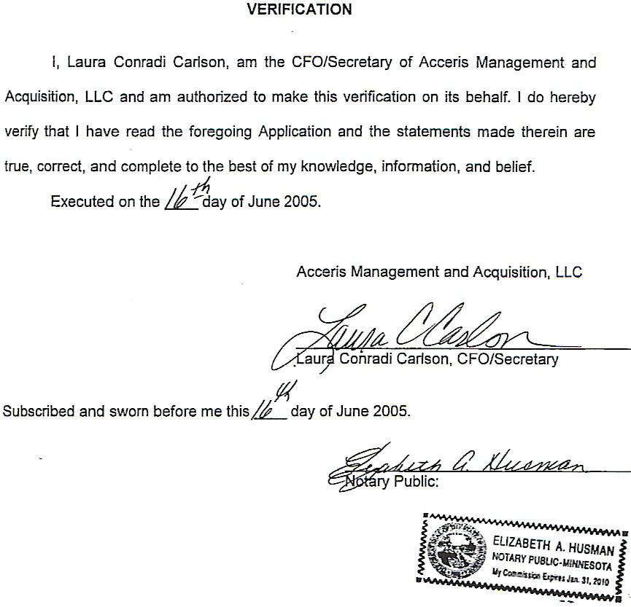
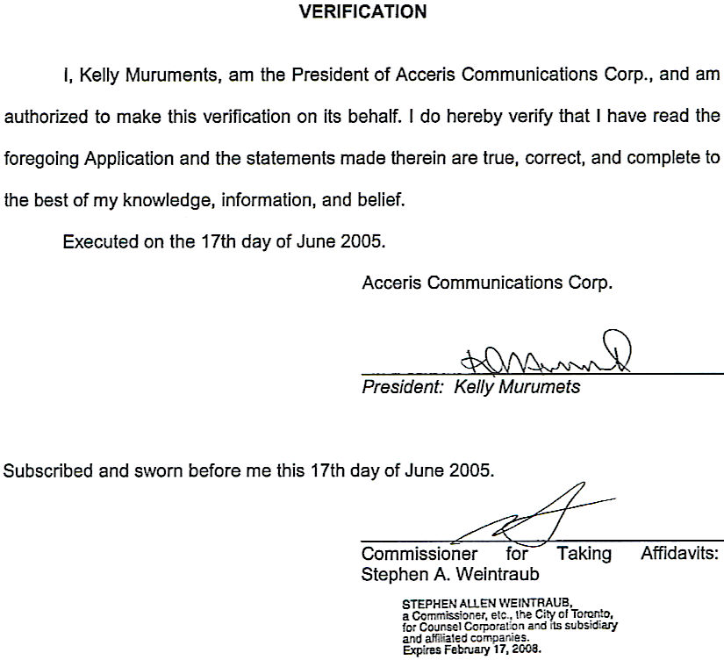

ACC initially received its certificate of service authority to provide intrastate interexchange telecommunications services within the State of Missouri under the name PT-1 Counsel, Inc. (Case No. TA-2000-847). By Order of September 24, 2002, in Case No. XT-2003-0098, the Commission recognized the change of PT-1 Counsel’s corporate name to WorldxChange Corporation. By Order issued May 16, 2003, the Commission recognized the change of WorldxChange Corp.’s name to WorldxChange Corp d/b/a Acceris Communications, in Case No. XN-2003-0461. In its Order Approving Tariff in Case No. XN-2005-0057, issued September 28, 2004, the Commission acknowledged the change of the corporate name from Worldxchange Corp. to Acceris Communications Corp.

