Exhibit No.:
Issue: Depreciation
Witness: Paul W. Adam

Sponsoring Party: MoPSC Staff
Type of Exhibit: Direct Testimony
Case No.: TC-2002-1076
Date Testimony Prepared: August 5, 2002

MISSOURI PUBLIC SERVICE COMMISSION

UTILITY SERVICES DIVISION

DIRECT TESTIMONY

OF

PAUL W. ADAM

BPS TELEPHONE COMPANY

CASE NO. TC-2002-1076

Jefferson City, Missouri

August 2002
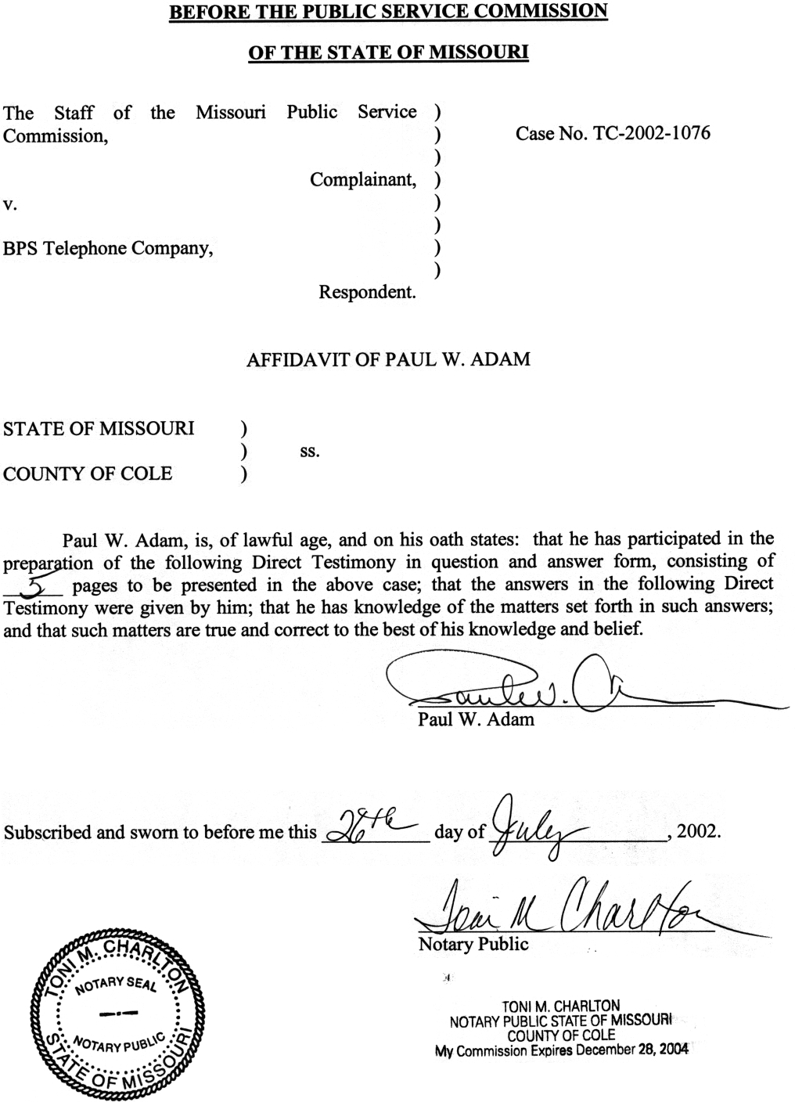
DIRECT TESTIMONY
OF
PAUL W. ADAM
BPS TELEPHONE COMPANY
CASE NO. TC-2002-1076

Introduction
Q. Please state your name and business address.
A. Paul W. Adam, P.O. Box 360, Jefferson City, MO 65102.
Q. By whom are you employed and in what capacity?
A. I am employed by the Missouri Public Service Commission (PSC or Commission) as an Engineer in the Engineering and Management Services Department.
Q. What are your duties as an engineer in the Engineering and Management Services Department?
A. I am responsible for depreciation calculations and studies of companies regulated by the Commission.
Q. Would you please state briefly your qualifications, educational background and experience?
A. I am a Registered Professional Engineer in Missouri and Colorado. In 1967, I earned a Bachelor of Science degree in Chemical Engineering from the University of Missouri-Columbia. I served in the U.S. Army after graduating and subsequently was employed in the oil industry from 1969 until 1991 as an engineer in various capacities, with the exception of a brief period from 1971 to 1974 when I completed a Masters Degree in Business Administration at the University of Missouri and also built single-family homes.
From 1991 to 1993 I managed a concrete products plant in Northwest Missouri. In 1994, I accepted my current position.
Q. Have you ever testified before the Commission?
A. Yes.

Purpose Of This Testimony
Q. What is the purpose of your direct testimony in this case?
A. The purpose of my direct testimony is to present Staff’s proposed depreciation rates and to support these rates.

Proposed Depreciation Rates
Q. What are the depreciation rates that you are proposing in this case?
A. My proposed depreciation rates are presented in Schedule 1, attached to this testimony.
Q. Why should these depreciation rates be used by BPS Telephone Company (Company or BPS)?
A. The majority of the depreciation rates given in Schedule 1 are Staff’s standardized telephone depreciation rates that have been developed by Staff. These standardized rates were developed from observations of the lives of telephone plant belonging to several larger Missouri companies that had historical mortality data that could be analyzed for plant life. The majority of BPS’s plant is similar to the plant of those large companies and can be expected to experience lives that closely match the standardized depreciation rates.
Q. Are there some BPS accounts that should not use the standardized rates?
A. Yes. There are four BPS accounts that have specific circumstances which indicate that depreciation rates other than the standardized depreciation rates should be used by BPS.
Q. Which four accounts are you referring to?
A. The four accounts are: 1) Aerial Wire, account number 2431.0; 2) Circuit Equipment-Analog, account number 2232.2; 3) Poles, account number 2411; and 4) Aerial Cable-Metallic, account number 2421.2.
Q. What are the specifics of these four accounts that indicate that depreciation rates other than the standardized depreciation rates should be used and what rates do Staff consider appropriate for these four accounts?
A. For the Aerial Wire and Circuit Equipment Analog, the Company should be ordered to use a zero (0%) percent depreciation rate because both accounts are fully accrued and no new plant is expected to be added to either account in the future. Therefore, when the current plant-in-service is retired from service the plant balance and accrual balance will be zeroed.
The Poles account has a plant-in-service balance of $269,479 per BPS’s December 31, 2001 annual report. The accrued reserve in the same annual report is $222,669. There is $46,810 to be accrued over the life of the poles-in-service to reach full accrual ($269,479 - $222,669 = $46,810). BPS is only installing buried cable and the Poles account is not expected to have future additions other than replacement poles. BPS has no long-term plans for replacement of the poles currently in service with buried cable. For depreciation purposes, the poles that are currently in-service can be expected to remain in-service for an average of 10 years based on information obtained from the Company. Therefore, an accrual of $4,681 per year for the next 10 years will allow the Poles account to become fully accrued. A depreciation rate of 1.74% ($269,470 * 1.74% = $4,681) will achieve this goal.
Q. What is the situation with the fourth account, Aerial cable-metallic?
A. The situation is similar to the Poles account. BPS’s December 31, 2001 annual report shows a plant-in-service balance of $847,595 for Aerial cable-metallic. The same annual report shows the accrual balance of $627,677 for this account. The Company needs to accrue $219,918 to be fully accrued in the Aerial cable-metallic account. This account is not expected to have plant added to it in the future other than maintenance. For depreciation purposes, the current plant-in-service can be expected to remain in service for an average of 10 years based on information obtained from the Company. The Company needs an annual accrual of $21,992 each of the next 10 years to be fully accrued. A depreciation rate of 2.59% (847,595 * 2.59% = $21,992) will achieve this goal.
Q. What are your depreciation rate proposals for each of the four accounts?
A. I propose that the depreciation rate for Aerial wire be 0%, for Circuit Equipment-analog be 0%, for Poles be 1.74% and for Aerial cable-metallic be 2.59% as shown in Schedule 1 attached to this testimony.
Q. Is net salvage included in the depreciation rates you are proposing?
A. No. These depreciation rates are designed to recover the original capital cost of plant over the used and useful life of the plant.
Q. How is net salvage handled in this case?
A. Net salvage is determined by Staff auditors and included as an annual expense with other expense determinations.
Q. What is Staff’s depreciation proposal in this case?
A. Staff’s proposal is that the depreciation rates presented in Schedule 1 attached to this testimony be ordered as the appropriate depreciation rates for BPS Telephone Company.
Q. Does this conclude your direct testimony?
A. Yes, it does.

BPS TELEPHONE COMPANY
DEPRECIATION RATES
CASE NO. TC-2002-1076
ACCOUNT | ACCOUNT NUMBERS | DEPRECIATION RATES | AVERAGE SERVICE LIFE (YEARS)
MOTOR VEHICLES | 2112 | 11.63% | 8.6
GARAGE WORK EQUIPMENT
OTHER WORK EQUIPMENT | 2116 | 7.14% | 14.0
BUILDINGS | 2121 | 2.86% | 35.0
FURNITURE | 2122 | 7.14% | 14.0
OFFICE EQUIPMENT-OFFICE SUPPORT | 2123.1 | 10.00% | 10.0
OFFICE EQUIPMENT-COMPANY COMMUNICATIONS | 2123.2 | 11.90% | 8.4
GENERAL PURPOSE COMPUTERS | 2124 | 15.63% | 6.4
DIGITAL SWITCHING | 2212 | 6.67% * | 15.0
CIRCUIT EQUIPMENT-DIGITAL | 2232.1 | 10.00% | 10.0
CIRCUIT EQUIPMENT-ANALOG | 2232.2 | 0.00%
POLES | 2411 | 1.74% | 21.0
AERIAL CABLE-METALLIC | 2421.2 | 2.59% | 21.0
BURIED CABLE-METALLIC | 2423.00 | 4.17% | 24.0
BURIED CABLE-NONMETALLIC | 2423.10 | 3.57% | 28.0
BLOCK & DROP BURIED | 2423.20 | 4.17% | 24.0
BURIED FIBER SUBSCRIBER CABLE | 2423.30 | 3.57% | 28.0
AERIAL WIRE | 2431.0 | 0.00%

* TAO 1009 allows the Company to book the accrual using a depreciation rate of 10.00%. This booked accrual is not to be used for rate purposes.

