BEFORE THE PUBLIC SERVICE COMMISSION
OF THE STATE OF MISSOURI

In the Matter of the Application of )

Neutral Tandem-Missouri, LLC )
For a Certificate of Service Authority to ) Case No. CA-2006-0035
Provide Basic Local Telecommunications )
Services in Portions of the State of Missouri )
and for Competitive Classification )

APPLICATION FOR CERTIFICATE OF SERVICE AUTHORITY
AND FOR COMPETITIVE CLASSIFICATION

COMES NOW Neutral Tandem-Missouri, LLC (“Applicant"), by and through its undersigned counsel, and pursuant to sections 392.361, 392.410, 392.420, 392.430 and 392.450, RSMo, the Federal Telecommunications Act of 1996, and 4 CSR 240-2.060 and 4 CSR 240-3.510, files this verified Application requesting that the Missouri Public Service Commission (hereinafter, “the Commission”) issue an order that:
- grants Applicant certificate of service authority to provide basic local exchange telecommunications services, pursuant to Chapter 392 RSMo;

- grants competitive status to Applicant and Applicant's requested services; and

- waives certain Commission rules and statutory provisions pursuant to Sections 392.420 and 392.361 RSMo, consistent with the Commission's customary treatment of certificated providers of competitive local exchange telecommunications services.

In support of its Application, Applicant states as follows:

1. Applicant Neutral Tandem-Missouri, LLC is a corporation duly organized and existing under and by virtue of the laws of the State of Delaware and is duly authorized to transact business in the State of Missouri. The character of business performed by Applicant is telecommunications services. A copy of Applicant’s Certificate of Authority from the Missouri Secretary of State, as required by 4 CSR 240-2.060(1)(C), is attached to this Application as Appendix A. Applicant's principal place of business is:
One South Wacker Drive, Suite 200
Chicago, Illinois (IL) 60606
Telephone: (312)-384-8000

2. An officer’s verification is attached hereto.
3. All communications, notices, orders and decisions respecting this Application and proceeding should be addressed to:
William D. Steinmeier
Mary Ann (Garr) Young Patrick D. Crocker
William D. Steinmeier, P.C. Early, Lennon, Crocker & Bartosiewicz, P.L.C.
2031 Tower Drive 900 Comerica Building
Jefferson City, Missouri 65109 Kalamazoo, Michigan 49007-4752
Tel: (573) 659-8672 Tel: (269) 381-8844
Fax: (573) 636-2305 Fax: (269) 381-8822
Email: wds@wdspc.com Email: pcrocker@earlylennon.com
myoung0654@aol.com

4. Questions regarding Applicant’s proposed tariff should be directed to Ms. Young. All inquires concerning Applicant's ongoing operations should be directed to:
Ron Gavillet
Neutral Tandem-Missouri, LLC
One South Wacker Drive, Suite 200
Chicago, Illinois (IL) 60606
Telephone: (312) 384-8000
Fax: (312) 346-3276

5. By this Application, Applicant seeks authority to offer and provide basic local telecommunications service on a facilities-based and resold basis to customers throughout all the exchanges currently served by: (a) Southwestern Bell Telephone, L.P., d/b/a SBC Missouri (SBC), formerly known as Southwestern Bell Telephone Company (SWBT); (b) Sprint Missouri, Inc., (Sprint); (c) CenturyTel of Missouri, LLC (CenturyTel); and (d) Spectra Communications Group, LLC d/b/a CenturyTel (Spectra). The specific SWBT, Sprint, CenturyTel and Spectra exchanges within which Applicant proposes to offer service are listed in the local exchange tariffs of the respective incumbent local exchange providers, and will be listed in Applicant’s initial proposed tariff. Applicant’s proposed service areas will follow the respective exchange boundaries of the stated incumbent LECs and shall be no smaller than an exchange as required by Section 392.455(3) RSMo. Applicant may seek authorization to provide service in exchanges served by other incumbent LECs in a subsequent proceeding.
6. Applicant proposes to offer and provide all forms of basic local telecommunications service, including (but not limited to): (a) Basic Exchange Services, including local exchange flat rate, measured rate service, pre-paid local exchange, operator services, etc.; (b) Custom and Class Features, including call waiting, caller ID, call forwarding, etc.; and (c) Ancillary Services such as 911, directory listing, and directory assistance. Applicant’s initial service offering will consist of transport and access services for competitive carriers. Applicant initially intends to provide facilities-based and resold services to primarily other carriers, and will not be marketing to residential customers or small businesses at this time.
7. Applicant possesses the technical and managerial resources and abilities necessary to provide the services it proposes as required by Section 392.455(1) RSMo. The background and experience of Applicant's management is described in Appendix B attached to this Application.
8. Applicant also possesses the necessary financial qualifications to provide the services it proposes as required by Section 392.455(1) RSMo Supp. 1997 and has the necessary capital to conduct its proposed operations in Missouri. Applicant will late-file its recent financial statements as Appendix C. Applicant is seeking a Protective Order from the Commission to enable it to file such statements under seal.
9. Pursuant to this Application, Applicant also seeks classification of itself and its new basic local telecommunications service offerings as competitive, with accompanying reduced regulation pursuant to Sections 392.361 RSMo and 4 CSR 240-3.510(1)(A). Applicant believes that its proposed services will be subject to sufficient competition to justify a lesser degree of regulation and that granting this request will allow greater price and service options for telephone users.
10. Applicant will offer basic local telecommunications service as a separate and distinct service in accordance with Section 392.455 RSMo. Applicant will give consideration to equitable access for all customers in Missouri, without regard to their income or where they might reside, to affordable telecommunications services in Applicant's proposed service areas in accordance with Section 392.455(5) RSMo.
11. Applicant is willing to comply with all applicable Commission rules and is willing to meet all relevant service standards including, but not limited to, quality of service, billing, and tariff filing and maintenance. Consistent with the Commission's treatment of other certificated competitive local exchange telecommunications companies, Applicant requests that, at minimum, the following statutes and regulations for Applicant and its proposed basic local exchange service offerings be waived at this time:

STATUTES
392.210.2 Uniform System of Accounts
392.240.1 Just & Reasonable Rates
392.270 Ascertain Property Values
392.280 Depreciation Accounts
392.290 Issuance of Securities
392.300.2 Acquisition of Stock
392.310 Issuance of stock and debt
392.320 Stock dividend payment
392.330 Issuance of securities, debts & notes
392.340 Reorganizations
REGULATIONS
4 CSR 240-3.550(5)(C) File exchange boundary maps with PSC
4 CSR 240-10.020 Depreciation fund income
4 CSR 240-30.040 Uniform system of accounts

12. Applicant acknowledges 4 CSR 2403.510(1)(C), which requires that a tariff and any applicable interconnection agreements must be filed with the commission and approved before service can be provided. Applicant will promptly file a tariff with a 45-day effective date as soon as possible.
13. Applicant herein states that there are no pending actions or final unsatisfied judgments or decisions against it in any state, federal agency, or court which involve customer service or rates for which action, judgment, or decision has occurred within three (3) years of the date of this Application.
14. Applicant hereby affirms that the Company does not have any overdue annual reports or fees owed to the Missouri Public Service Commission.
15. Applicant submits that the public interest will be served by Commission approval of this Application because Applicant's proposed services will create and enhance competition and expand customer service options, consistent with the legislative goals set forth in the Telecommunications Act of 1996 and Chapter 392 RSMo. Prompt approval of this Application also will expand the availability of innovative, high-quality and reliable telecommunications services within the State of Missouri.
WHEREFORE, Neutral Tandem-Missouri, LLC respectfully requests that the Commission grant it a certificate of service authority to provide basic local telecommunications service as herein requested, classify Applicant and its proposed services as competitive, and grant waivers of the aforesaid statutes and regulations.
Respectfully submitted,

/s/ William D. Steinmeier

William D. Steinmeier, MoBar #25689
Mary Ann (Garr) Young, MoBar #27951
WILLIAM D. STEINMEIER, P.C.
2031 Tower Drive
P.O. Box 104595 Jefferson City, MO 65110-4595
(573) 659-8672 (phone)
(573) 636-2305 (fax)
wds@wdspc.com
myoung0654@aol.com

ATTORNEYS FOR NEUTRAL TANDEM- MISSOURI, LLC

July 22, 2005

CERTIFICATE OF SERVICE

I hereby certify that a copy of the foregoing Verified Application has been served electronically on the General Counsel’s Office and the Office of the Public Counsel this 22nd day of July 2005.

/s/ William D. Steinmeier

William D. Steinmeier

APPENDIX A

Secretary of State Certificate

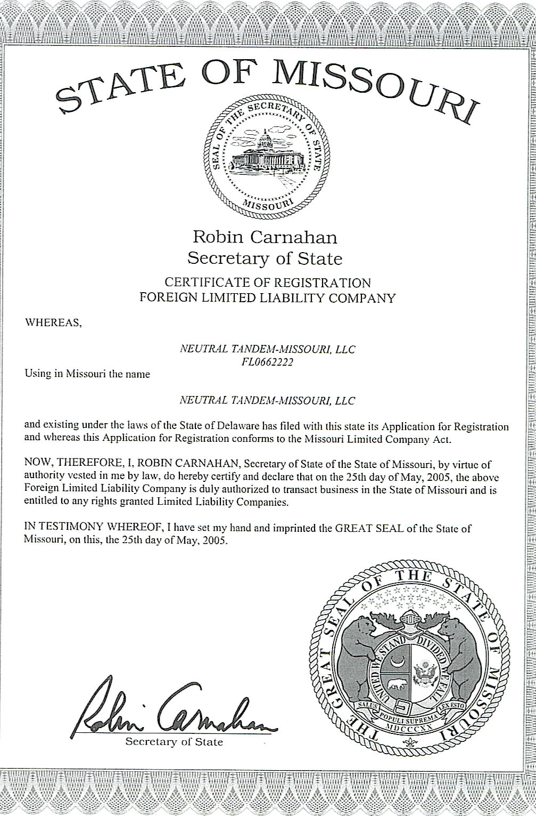

APPENDIX B

Background and Experience of Key Management

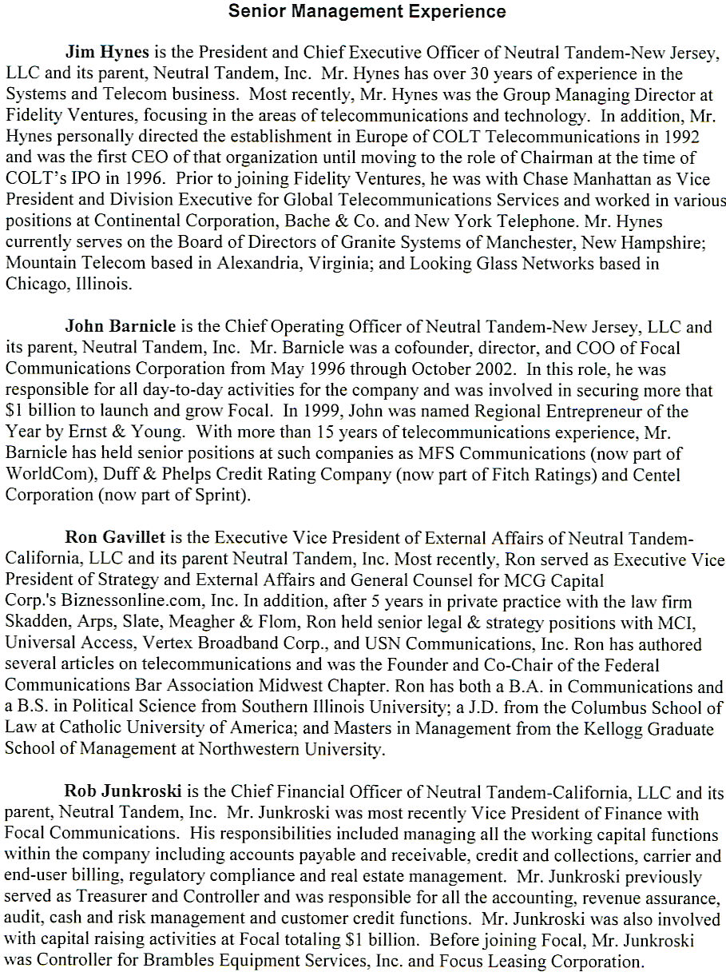

APPENDIX C

Pro Forma Financial Statements

To be late-filed under seal

Verification

