BEFORE THE PUBLIC SERVICE COMMISSION
STATE OF MISSOURI

In the Matter of the Joint Application of )
NOSVA Limited Partnership and )
Red River Networks, LLC )
for Approval of the Acquisition of Certain ) Case No. XM-2006-0185
Assets of Red River Networks, LLC )
by NOSVA Limited Partnership )

JOINT APPLICATION FOR APPROVAL OF TRANSFER OF ASSETS

COME NOW NOSVA Limited Partnership (ANOSVA@ or “Buyer”) and Red River Networks, LLC (ARRN@ or “Seller”), (referred to collectively hereinafter as “Joint Applicants” or “the Parties”), by and through counsel, pursuant to Sections 392.290 and 392.300 RSMo., and 4 CSR 240-2.060 and 4 CSR 240-3.520, and hereby jointly request Commission approval of a transaction (“the Acquisition”) whereby NOSVA will acquire certain Missouri assets of RRN, including, but not limited to, the customer accounts of RRN. Joint Applicants further request cancellation of RRN’s Missouri certificate of service authority and tariffs after consummation of the transfer of assets.
In support of their request, Joint Applicants state the following:
- The Parties
A. NOSVA Limited Partnership
1. NOSVA is a Maryland limited partnership with principal offices located at 4380 Boulder Highway, Las Vegas, Nevada, 89121. NOSVA is authorized to provide interexchange services throughout the United States.
2. NOSVA is authorized to, and does, provide interexchange telecommunications services in the State of Missouri pursuant to certificate of service authority granted by the Commission on August 2, 1994 in Case No. TA-94-153.
3. A copy of NOSVA’s Certificate of Authority from the Missouri Secretary of State, as required by 4 CSR 240-2.060(1)(C), was filed with the Commission in Case No. TA-94-153, is still in good standing, and is hereby incorporated by reference herein. NOSVA’s current status with the Secretary of State may be confirmed on-line at www.sos.mo.gov/business/business_svcs.asp.
4. NOSVA states that it does not have any outstanding Annual Reports or assessment fees owed to the Missouri Public Service Commission and it does not have any pending action or final unsatisfied judgments or decisions against it from any state or federal agency or court which involve customer service or customer rates, which action, judgment, or decision has occurred within three years of the date of this application.
- Red River Networks, LLC
5. RRN is an Oklahoma limited liability company with principal offices located at 201 Robert S. Kerr, Suite 500, Oklahoma City, Oklahoma 73102. RRN is authorized to provide interexchange services throughout the United States.
6. RRN is authorized to, and does, provide interexchange telecommunications services in the State of Missouri pursuant to certificate of service authority granted by the Commission on August 11, 2003 in Case No. XA-2003-0576.
7. A copy of RRN’s Certificate of Authority from the Missouri Secretary of State, as required by 4 CSR 240-2.060(1)(C), was filed with the Commission in Case No. XA-2003-0576, is still in good standing, and is hereby incorporated by reference herein. RRN’s current status with the Secretary of State may be confirmed on-line at www.sos.mo.gov/business/business_svcs.asp.
8. RRN states that it does not have any outstanding Annual Reports or assessment fees owed to the Missouri Public Service Commission and it does not have any pending action or final unsatisfied judgments or decisions against it from any state or federal agency or court which involve customer service or customer rates, which action, judgment, or decision has occurred within three years of the date of this application.
II. DESIGNATED CONTACTS
9. All communications, notices, orders and decisions respecting this
Application and proceeding should be addressed to:

Ben Bronston
Nowalsky, Bronston & Gothard
A Professional Limited Liability Company
3500 North Causeway Boulevard, Suite 1442
Metairie, Louisiana 70002
Telephone: (504) 832-1984
Telefax: (504) 293-8204
Email: bbronston@nbglaw.com

William D. Steinmeier
Mary Ann (Garr) Young
William D. Steinmeier, P.C.
2031 Tower Drive
Jefferson City, Missouri 65109
Telephone: (573) 659-8672
Telefax: (573) 636-2305
Email: wds@wdspc.com
myoung0654@aol.com

with a copy to:
Justin T. King
Counsel for Red River Networks LLC
King Law Firm
15 N. Robinson, Suite 1150
Oklahoma City, OK 73102

III. The Transaction
10. Applicants submit that the Acquisition will accomplish the following:
a. RRN will sell, transfer and assign to NOSVA all of RRN's right, title and interest in and to RRN's assets, as defined in the Asset Purchase Agreement.

b. In consideration for the above transfer and sale of assets, NOSVA will pay to RRN the purchase price set forth in the Asset Purchase Agreement Agreement.

c. The Asset Purchase Agreement, marked Exhibit A to this Joint Application, is being filed as a separate pdf document.

11. The customers of RRN will be given prior written notice of the Acquisition. Unless they choose to switch their service to a different carrier the customers of RRN will continue to receive service pursuant to authority previously granted to RRN by this State until such time as this Commission grants the instant application at which time the customers will be serviced under NOSVA=s authority. A sample of the customer notice is attached to this Application as Exhibit B.
12. NOSVA is well-qualified to consummate the transactions which are the subject of this Application. The technical, managerial and financial personnel of RRN will assist with the transition and integration of the acquired Assets after the transaction. Thereafter, the technical, managerial and financial personnel of NOSVA will continue to serve the transferred RRN customers with the same high level of expertise. Managerial profiles of NOSVA=s management team are attached to this Joint Application as Exhibit C.
IV. Public Interest Considerations
13. The transaction contemplated by the Asset Purchase Agreement will serve the public interest by creating operating efficiencies which will serve to enhance the overall capacity of enabling NOSVA to compete more effectively in the telecommunications marketplace and to provide telecommunications services for a greater number of consumers in the State of Missouri at competitive rates. The acquisition of the RRN customer base by NOSVA will enable these subscribers to continue to receive high-quality telecommunications service at affordable rates without interruption.
14. Upon approval of this transaction, NOSVA will provide notice to the RRN customers, and assure them of the Buyer’s commitment to continue the provision of high quality, affordable services pursuant to the company’s filed tariff. Specifically, customers will continue to receive the high quality, affordable telecommunications services that they presently receive, and the proposed acquisition will be virtually transparent to RRN’s customers. As such, the transaction will not cause inconvenience or confusion to RNN customers. In addition, Joint Applicants submit that the notice to be provided to customers, pursuant to 4 CSR 240-33.150 (4), will be given in each subscriber’s bill at least thirty (30) days prior to the effective date of the change, and will reasonably and adequately advise them of both the change in their telecommunications services provider and their opportunity to choose another provider. A copy of the sample notice of the transfer appears as Exhibit B attached hereto.
15. NOSVA certifies that it has the necessary managerial, technical and financial resources to provide the public with quality telecommunications service throughout the State. After the consummation of the transaction, NOSVA will be led by a team of well-qualified managers comprised of its existing personnel. NOSVA expects that the ample managerial, technical and financial expertise of this managerial team will enable it to provide high quality service to RRN customers as well as to expand its customer base. The proposed acquisition will therefore promote competition in the Missouri telecommunications services market and serve the public interest.
16. The transfer will have no impact on the tax revenues of any political subdivision in the state of Missouri.
V. CANCELLATION OF CERTIFICATE AND TARIFF
17. Because NOSVA will acquire substantially all of the assets of RRN and RRN will thereafter cease operations in this state, RRN will no longer require authority to provide service in this state. Joint Applicants therefore respectfully request that through this proceeding the Commission grant any authority necessary to permit RRN to discontinue service upon consummation of the Transaction and permit RRN to relinquish its certificate of service authority in this state, simultaneously with the effective date of the Acquisition.
18. Thus, RRN requests that its Missouri Certificates of Service Authority and tariffs be cancelled, upon completion of the instant transaction.
VI. CONCLUSION AND PRAYER
WHEREFORE, NOSVA Limited Partnership and Red River Networks, LLC respectfully and jointly request that the Commission issue an Order in this case: (1) authorizing the sale of assets from Red River Networks, LLC to NOSVA Limited Partnership including, but not limited to, the customer accounts of RRN; and (2) canceling the certificate of service authority and tariffs of Red River Networks, LLC in Missouri upon consummation of the transaction.
Respectfully submitted,
/s/ William D. Steinmeier
William D. Steinmeier, Mo. Bar #25689
Mary Ann (Garr) Young, Mo. Bar #27951
WILLIAM D. STEINMEIER, P.C.
2031 Tower Drive
P.O. Box 104595
Jefferson City, MO 65110-4595
Tel.: (573) 659-8672
Fax: (573) 636-2305
Email: wds@wdspc.com
Myoung0654@aol.com

ATTORNEYS FOR THE PARTIES:
NOSVA Limited Partnership
And Red River Networks, LLC

October 31, 2005

Certificate of Service
I hereby certify that a copy of the foregoing document has been served electronically on the Office of the General Counsel of the Missouri Public Service Commission and the Office of Public Counsel, on this 31st day of October 2005.

/s/ William D. Steinmeier

Exhibit A

Asset Purchase Agreement

(Filed as separate pdf. file)

Exhibit B

Sample Notice to Customers
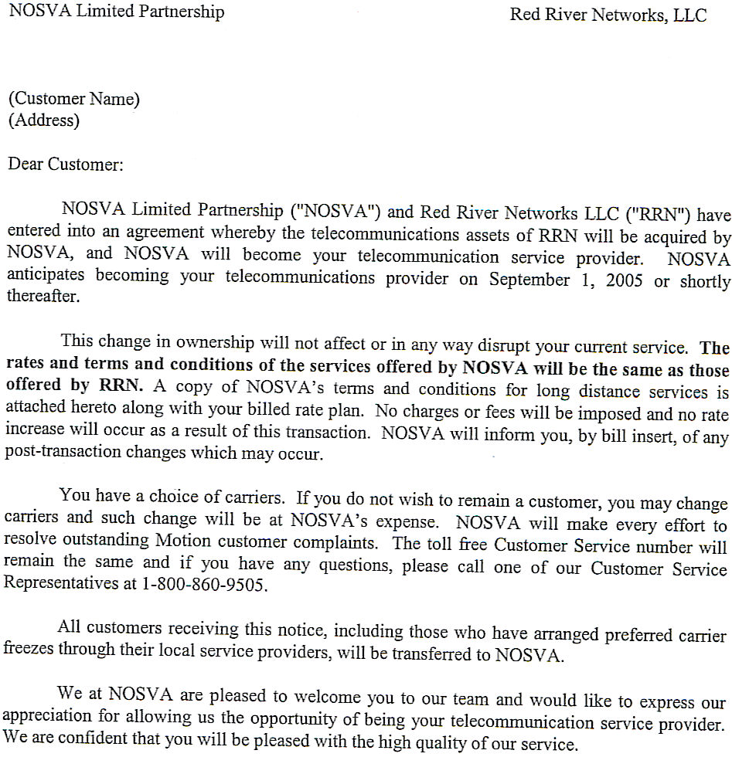

Exhibit C

NOSVA Management Profiles

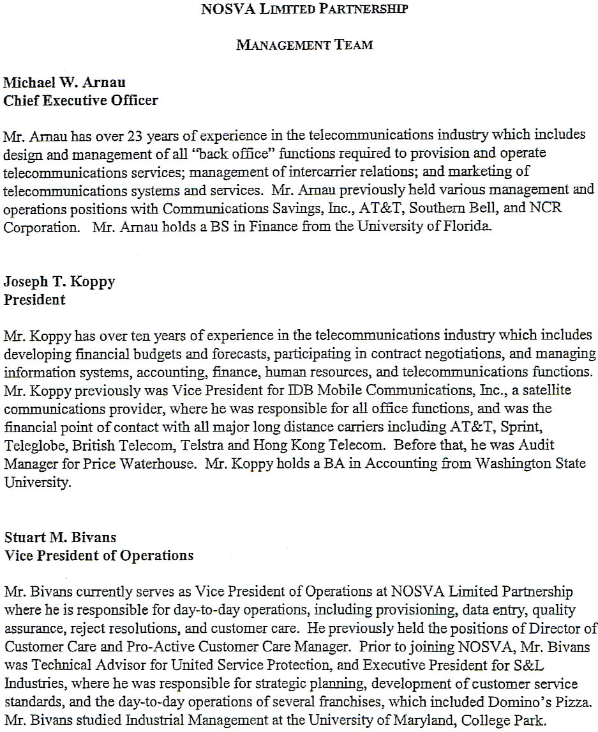

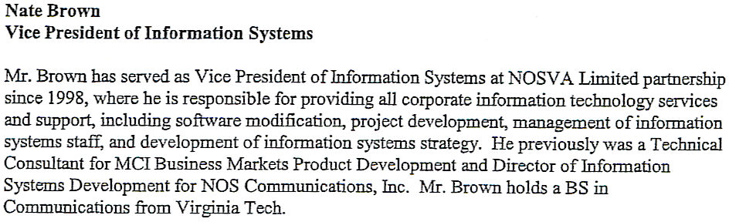

Verifications

