BEFORE THE PUBLIC SERVICE COMMISSION
OF THE STATE OF MISSOURI
In the Matter of the Application of )
)

CommPartners, LLC )
)
For a Certificate of Service Authority to ) Case No. ____LA-2006-0174___
Provide Basic Local Exchange )
Telecommunications Services in Portions of )
the State of Missouri )
and for Competitive Classification )

APPLICATION FOR BASIC LOCAL EXCHANGE CERTIFICATE OF SERVICE AUTHORITY AND FOR COMPETITIVE CLASSIFICATION

COMES NOW CommPartners, LLC (“CommPartners” or “Applicant"), by and through its undersigned counsel, and pursuant to sections 392.361, 392.410, 392.420, 392.430 and 392.450, RSMo, the Federal Telecommunications Act of 1996, and 4 CSR 240-2.060 and 4 CSR 240-3.510, files this verified Application requesting that the Missouri Public Service Commission (hereinafter, “the Commission”) issue an order that:
- grants Applicant certificate of service authority to provide basic local exchange telecommunications services, pursuant to Chapter 392 RSMo;

- grants competitive status to Applicant and Applicant's requested services; and

- waives certain Commission rules and statutory provisions pursuant to Sections 392.420 and 392.361 RSMo, consistent with the Commission's past treatment of other certificated providers of competitive interexchange telecommunications services.

In support of its Application, Applicant states as follows:

1. Applicant, CommPartners, LLC, is a limited liability company, duly organized and existing under and by virtue of the laws of the State of Nevada and is duly authorized to transact business in the State of Missouri. The character of business performed by Applicant is telecommunications services. A copy of Applicant’s Certificate of Registration from the Missouri Secretary of State, as required by 4 CSR 240-2.060(1)(C), is attached to this Application as Exhibit A. Applicant's principal place of business and toll-free customer service phone numbers are:
CommPartners LLC
3291 North Buffalo Drive, Suite 8
Las Vegas, Nevada 89129.
Toll-Free Customer Service Phone Number: (877) 297-0926

2. An officer’s verification is attached hereto.
3. All communications, notices, orders and decisions respecting this Application and proceeding should be addressed to:
Mary Ann (Garr) Young Kristopher E. Twomey
William D. Steinmeier Andrew M. Ganz
William D. Steinmeier, P.C. Law Office of Kristopher E. Twomey
2031 Tower Drive 1519 E. 14th Street, Suite A
Jefferson City, Missouri 65109 San Leandro CA 94577
Tel: (573) 659-8672 Tel: (510) 903-1304
Fax: (573) 636-2305 Fax: (510) 868-8418
Email: wds@wdspc.com Email: kris@lokt.net
myoung0654@aol.com

4. Questions concerning Applicant's ongoing operations should be directed to:

David S. Clark, President
3291 North Buffalo Drive, Suite 8
Las Vegas, Nevada 89129.
Toll-Free Customer Service Phone Number: (877) 297-0926

5. By this Application, Applicant seeks authority to offer and provide basic local telecommunications service on a facilities-based and resold basis to customers throughout all the exchanges currently served by: (a) Southwestern Bell Telephone, L.P., d/b/a SBC Missouri (SBC), formerly known as Southwestern Bell Telephone Company (SWBT); (b) Sprint Missouri, Inc., (Sprint); (c) CenturyTel of Missouri, LLC (CenturyTel); and (d) Spectra Communications Group, LLC d/b/a CenturyTel (Spectra). The specific SBC, Sprint, CenturyTel and Spectra exchanges within which Applicant proposes to offer service are listed in the local exchange tariffs of the respective incumbent local exchange providers, and will be listed in Applicant’s initial proposed tariff. Applicant’s proposed service areas will follow the respective exchange boundaries of the stated incumbent LECs and shall be no smaller than an exchange as required by Section 392.455(3) RSMo. Applicant may seek authorization to provide service in exchanges served by other incumbent LECs in a subsequent proceeding.
6. CommPartners proposes to provide facilities-based basic local and interexchange services, which will give residential and business end users the opportunity to originate and terminate local and long distance telephone calls to other end users through access to the local exchange network. These calls are placed and received on a Voice Over Internet Protocol (“VoIP”) platform that originates with non-dedicated broadband access. The local exchange services CommPartners proposes to provide will enable end users to select the long distance carrier of their choice. A more detailed explanation of CommPartners’ proposed services and maps of CommPartners’ network are included in Exhibit B.
CommPartners proposes to offer local exchange services by installing and collocating its switching and ancillary equipment in the central offices of incumbent local exchange carriers. CommPartners may also purchase unbundled network elements and may resell the services of other certificated carriers. It proposes to offer a variety of services, including but not limited to, residential basic line service, business basic line service, PBX trunks, DID service and PRI service. CommPartners also intends to offer long distance services—both intra and inter-LATA—to business and residential customers through the use of its own switching facilities and the resale of services of other certificated carriers, and is seeking interexchange certificate of service authority in a separate application. CommPartners requests that all services be classified as competitive by the Commission.
7. Applicant possesses the technical and managerial resources and abilities necessary to provide the services it proposes as required by Section 392.455(1) RSMo. A description of the technical and managerial resources and abilities of CommPartners and its officers is attached as Exhibit C.
8. Applicant possesses the necessary financial resources and abilities to provide the services it proposes as required by Section 392.455(1) RSMo. and has the necessary capital to conduct its proposed operations in Missouri. Applicant’s pro forma financial statements are attached as Exhibit D.
9. Pursuant to this Application, Applicant also seeks classification of itself and its basic local telecommunications service offerings as competitive, with accompanying reduced regulation pursuant to Sections 392.361 RSMo and 4 CSR 240-3.510(1)(A). Applicant believes that its proposed services will be subject to sufficient competition to justify a lesser degree of regulation and that granting this request will allow greater price and service options for telephone users.
10. Applicant will offer basic local telecommunications service as a separate and distinct service in accordance with Section 392.455 RSMo. Applicant will give consideration to equitable access for all customers in Missouri, without regard to their income or where they might reside, to affordable telecommunications services in Applicant's proposed service areas in accordance with Section 392.455(5) RSMo.
11. Applicant is willing to comply with all applicable Commission rules and is willing to meet all relevant service standards including, but not limited to, quality of service, billing, and tariff filing and maintenance. Consistent with the Commission's treatment of other certificated competitive local exchange telecommunications companies, Applicant requests that, at minimum, the following statutes and regulations for Applicant and its proposed basic local exchange service offerings be waived at this time:

STATUTES
392.210.2 Uniform System of Accounts
392.240.1 Just & Reasonable Rates
392.270 Ascertain Property Values
392.280 Depreciation Accounts
392.290 Issuance of Securities
392.300.2 Acquisition of Stock
392.310 Issuance of stock and debt
392.320 Stock dividend payment
392.330 Issuance of securities, debts & notes
392.340 Reorganizations

REGULATIONS
4 CSR 240-3.550(5)(C) File exchange boundary maps with PSC
4 CSR 240-10.020 Depreciation fund income
4 CSR 240-30.040 Uniform system of accounts

12. Applicant acknowledges 4 CSR 240-3.510(1)(C), which requires that a tariff and any applicable interconnection agreements must be filed with the Commission and approved before service can be provided. Applicant will promptly file a proposed basic local exchange services tariff with a forty-five (45) day effective date as soon as possible.
13. Applicant herein states that there are no pending actions or final unsatisfied judgments or decisions against it in any state, federal agency, or court that involve customer service or rates for which action, judgment, or decision has occurred within three (3) years of the date of this Application.
14. Applicant hereby affirms that the Company does not have any overdue annual reports or fees owed to the Missouri Public Service Commission.
15. Applicant submits that the public interest will be served by Commission approval of this Application because Applicant's proposed services will create and enhance competition and expand customer service options, consistent with the legislative goals set forth in the Telecommunications Act of 1996 and Chapter 392 RSMo. Prompt approval of this Application also will expand the availability of innovative, high-quality and reliable telecommunications services within the State of Missouri.
16. Applicant agrees that, unless otherwise ordered by the Commission, Applicant’s originating and terminating switched exchange access rates will be no greater than the lowest Commission-approved corresponding access rates in effect for each ILEC within whose service area(s) Applicant seeks authority to provide service. Additionally, pursuant to the Commission’s Report and Order in Case No. TO-99-596, Applicant agrees that if the ILEC in whose service area Applicant is operating decreases its originating and/or terminating access service rates, Applicant shall file an appropriate tariff amendment to reduce its originating and/or terminating access rates within thirty (30) days of the ILEC’s reduction of its originating and/or terminating access rates in order to maintain the cap on switched exchange access rates.
WHEREFORE, Applicant CommPartners Communications, LLC, respectfully requests that the Commission grant it a certificate of service authority to provide basic local telecommunications service as herein requested, classify Applicant and its proposed services as competitive, and grant waivers of the aforesaid statutes and regulations.
Respectfully submitted,

/s/Mary Ann Young

Mary Ann (Garr) Young, MoBar #27951
William D. Steinmeier, MoBar #25689
WILLIAM D. STEINMEIER, P.C.
2031 Tower Drive
P.O. Box 104595 Jefferson City, MO 65110-4595
Phone: (573) 634-8109
Fax: (573) 634-8224
Email: myoung0654@aol.com
wds@wdspc.com

Attorneys for CommPartners, LLC

CERTIFICATE OF SERVICE

I hereby certify that a copy of the foregoing Verified Application has been served electronically on the General Counsel’s Office and the Office of the Public Counsel this 17th day of October 2005.

/s Mary Ann Young

OFFICER’S VERIFICATION

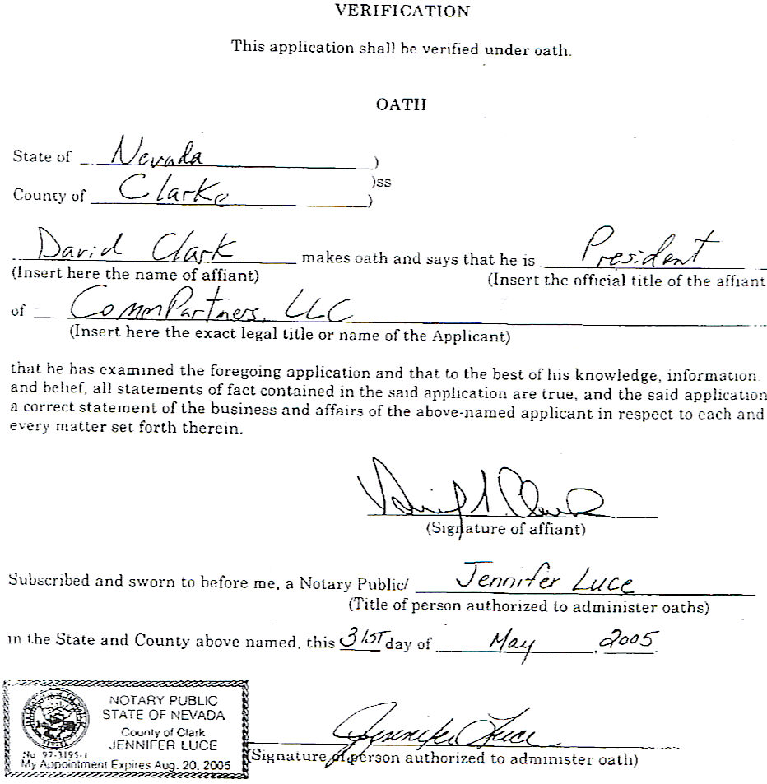

EXHIBIT A

Secretary of State Certificate

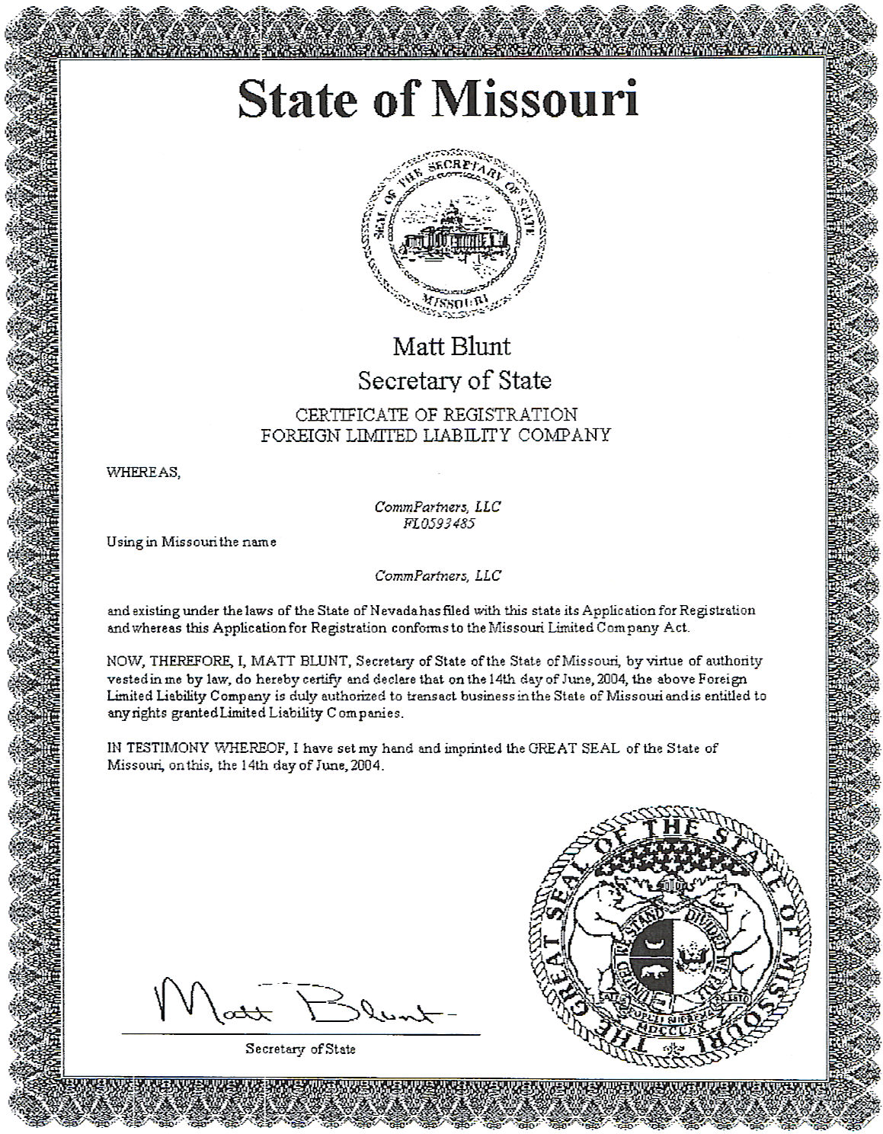

EXHIBIT B

Detailed description of CommPartners, LLC’s
Network Structure
CommPartners, LLC’s Network Structure

All of CommPartners’ services are facilities-based. These facilities consist strictly of existing structures and as such will not result in any environmental damage. To begin operations, Applicant initially installed] one softswitch device at each of its switch centers located in Las Vegas, Chicago, New York and Atlanta. These switch centers are connected to Applicant’s network operations center in Las Vegas. The total cost of these softswitches was approximately $2.5 million. This will be sufficient to establish the national reach of Applicant’s network. CommPartners expects to deploy additional softswitches as traffic volume increases in specific geographic areas. These additional investments are expected to incrementally reduce transport costs as the switches are placed closer to end-users’ traffic.

CommPartners’ network is a “hub-centric” topology consisting of CommPartners’ switching centers located in Las Vegas, Chicago, Atlanta and New York. These switch centers are collocation points situated in highly sophisticated environments where large numbers of network providers meet for interconnection among their networks. At these locations, CommPartners has placed softswitch equipment, routers and border control devices. All calls originating from or terminating to Missouri residences and businesses will utilize the Chicago switching center.

CommPartners has entered into a one-year, renewable contract with Internap, a managed Internet aggregation company, to manage CommPartners’ VoIP traffic that originates with non-dedicated broadband access. With the use of Internap’s infrastructure connected independently at each of CommPartners’ switching centers, CommPartners’ data traffic is one step away from the strong majority of major Internet backbone carrier in the country. VoIP traffic initiated from end-users on CommPartners’ network is carried from the Internet to CommPartners’ nearest switch center in a prioritized fashion by Internap. Internap provides 100% up-time service level agreements and routes packets across the Internet in the least congested configuration available. With Internap’s management of CommPartners’ non-dedicated broadband access VoIP traffic, we seek to minimize time delays and quality erosion associated with moving IP traffic across the public Internet.

CommPartners’ system is designed to route calls originating on CommPartners’ network to the nearest switch site and transport them to the receiving party in the most efficient manner possible. Each of CommPartners’ switching centers is connected to the PSTN by traditional voice transport circuits which we lease from telecommunications carriers. CommPartners’ switch sites are interconnected by high capacity fiber links leased from telecommunications carriers, creating a controlled, high quality VoIP backbone providing favorable economics for the movement of VoIP calls across the US.

As CommPartners becomes approved as a competitive carrier in each state, CommPartners will lease traditional voice transport from each of CommPartners’ switch sites to access tandem switch centers owned and operated by the incumbent local exchange carrier in each state. After CommPartners has access to these tandems, VoIP traffic can be terminated through the tandem to the local rate center (a local calling office owned and operated by the incumbent carrier), to other CLECs and to wireless carriers for delivery to the receiving party.

CommPartners believes that security and quality of service are critical factors to CommPartners’ success. Thus, CommPartners has integrated border control devices into each of CommPartners’ switch sites. These devices function as VoIP firewalls to protect the integrity of CommPartners’ network from hackers. The combination of border control devices with managed Internet routing is designed to yield maximum protection from unlawful intruders while providing a quality of service for VoIP traffic comparable to traditional telephone calls.

The actual call flow within CommPartners’ network is summarized as follows: an end-user initiates the call as a data transmission. The call flows from the end-user’s broadband provider to CommPartners’ nearest switch and is then routed to CommPartners’ switch that is closest to the called party. At the switch site nearest the called party, CommPartners determines whether the called party is also a VoIP user or a user of traditional voice services. If the called party is a VoIP user, CommPartners terminates the call as a data transmission over their broadband connection and never accesses the PSTN. However, if the called party is a traditional voice user, CommPartners converts the call into a traditional voice protocol and sends the call to the nearest RBOC/ILEC/CLEC or wireless carrier’s local telephone switch that serves the called party.

CommPartners’ network approach and design delivers superior capabilities, achieves the same geographic coverage and leverages the burgeoning market opportunity for a fraction of the infrastructure capital investment required of traditional voice networks. The structure of CommPartners’ network also allows solutions for two pressing issues for the offering of VoIP – CALEA and emergency 911 services. CommPartners has contracted with a noted telecommunications solutions provider to develop a 911 application for VoIP. This partner currently provides 911 functionality to many carriers. This solution should be available in mid- 2005. In the meantime, CommPartners will utilize standard E911systems to provide emergency services to its wholesale customers.


Local PSTN Gateway
Border Control
Edge Router
Core Router
Provisioning Proxy
Public
Internet
SIP ATA
POTS Phone
SIP Phone
SIP Phone
Softswitch
Unified Messaging
SS7 Gateway
Long Distance Gateway
RKS – Billing Server
Provisioning Servers
Core Router
Application Core
Least Cost
Long Distance
SS7
Aggregator
Regional POP
Regional
POP
Back Office &
Billing Platform
WISP Router
Wireless
Modem
Wireless Data
Network
SIP Phone
POTS Phone
SIP ATA
Customer LAN
Router
DSLAM/CMTS
POTS Phone
MTA
DSL or HFC
Network
SIP ATA
SIP Phone
Local PSTN
Connection
POTS Phone
Private, Meshed
IP Network

EXHIBIT C

Background and Experience of Key Management
CommPartners—Background and Experience
Of Key Management
David S. Clark – President and Director. Since participating in Applicant’s founding in June 2003, Mr. Clark has served as Applicant’s President and a member of Applicant’s board of directors. Mr. Clark has overall responsibility for strategic guidance, personnel, financing, sales and corporate development/administration. From May 1997 to January 2001, Mr. Clark was Senior Vice President, Sales & Marketing and Senior Vice President, Investor Relations for MGC/Mpower Communications. Mr. Clark’s responsibilities included corporate sales and marketing development and implementation and a leading role in securing nearly $1 billion in private equity, IPO, secondary equity and high yield debt financing. Mr. Clark was also the primary contact for investors and Wall Street funds and analysts at Mpower. From February 2001 to June 2001, Mr. Clark was the Chief Operating Officer for Wedding Referral Services (an Internet services company) and from August of 2001 to July 2002, he was the President and Chief Executive Officer for Pinnacle Armor (a manufacturer of patented, advanced ballistic armor). Mr. Clark has been in the telecommunications industry since 1989 with companies spanning private pay telephone, inmate phone system and specialty satellite services. Mr. Clark was a civilian contractor to the British military in Bosnia and was responsible for the Welfare Phone Service (via satellite) provided to British troops serving under the United Nations peacekeeping mandate. Mr. Clark serves as a director of Antenna Technology Communications, Inc. in Chandler, Arizona, and holds a degree in Mass Communications from Texas Tech University. Mr. Clark resides in Las Vegas, Nevada.
Patrick Chicas – Vice President & Chief Technology Officer and Director. Since co-founding CommPartners in June 2003, Mr. Chicas has served as Applicant’s Vice President and Chief Technology Officer and as a member of Applicant’s board of directors. Mr. Chicas is responsible for the network architecture and topology, vendor selection, POP construction and all engineering aspects of the Company. From August 2000 to November 2003, Mr. Chicas was the president, co-Chairman and a member of the board at Rubicon Media Group, an Internet publishing concern. From March 1999 to August 2000, Mr. Chicas was the Vice President for Data Services at Mpower Communications. While at Mpower, Mr. Chicas designed the company’s VoIP network for small business services. From January 1997 to September 1998, Mr. Chicas was the first executive hire and Vice President of Operations at Digital Island, Inc. Mr. Chicas has prior telecommunications experience with PacTel Cellular (now Verizon) and GTE Mobilnet (now Verizon), As an early participant in Internet-related businesses, Mr. Chicas was a co-founder of Hawaii Online’s Internet Access Service. Hawaii Online was the first statewide ISP in Hawaii and was ultimately sold to GST Communications. Mr. Chicas also co-founded LJ.net, an ISP founded to serve rural communities in the western United States. Mr. Chicas resides in Las Vegas, Nevada.
James H. Thompson – Vice President & Chief Integration Officer. Mr. Thompson co-founded Applicant and has served as Applicant’s Vice President and Chief Integration Officer since June 2003. From 1997 to May 2003, Mr. Thompson was an independent consultant for numerous ISPs and is a long time business associate of Mr. Chicas. Prior to 1997, Mr. Thompson was a co-founder of Hawaii Online and LJ.net Internet service providers with Mr. Chicas. Mr. Thompson also spent nine years at VeriFone where he was responsible for the design of the communications infrastructure that has allowed VeriFone to become a leader in point-of-sale transactions. Mr. Thompson’s earlier career experience included a posting as vice president of technology for Knight-Ridder’s Viewtron service and various joint projects with AT&T Bell labs. Mr. Thompson currently serves as a board member of Royal Hawaiian Entertainment. Mr. Thompson holds a Bachelor of Science in Electrical Engineering from the University of Hawaii and lives in Honolulu, Hawaii.
Mitchell H. Allee – Vice President & Chief Systems Officer. Mr. Allee co-founded Applicant and has served as Vice President and Chief Systems Officer since June 2003. Mr. Allee is responsible for the integration of all network operating components with Applicant’s back-office platform. Since 1985, Mr. Allee has served as the Chairman, CEO and COO of CMS Solutions Inc. CMS Solutions is a computer software consulting company specializing in custom design of on-time, real time, integrated operational business management control systems. At CMS Solutions, Mr. Allee is responsible for strategic planning, sales, support, technical direction and financial management and control. From 1997 to the present, Mr. Allee has also served as the co-Chairman and CEO of Allegiant Airlines, a charter and scheduled service carrier Mr. Allee founded. Mr. Allee authored the operating system for ValuJet, which pioneered the use of “ticketless” travel in the airline industry. Mr. Allee also developed the integrated back-office system used by Mpower Communications. Mr. Allee has a thorough and in-depth knowledge of telephone operating and billing back-office systems. Mr. Allee is a graduate of Louisiana State University and lives in Fresno, California.
Mark Peterson – Vice President, Sales and Marketing. Mr. Peterson joined Applicant as Vice President of Sales & Marketing in August 2004. From February 2002 to July 2004, Mr. Peterson was Vice President of Sale & Marketing for Allegiant Airlines, where he was responsible for marketing, sales, corporate communications and reservations functions. From January 2001 to January 2002, Mr. Peterson served as a consultant with Gallagher Equity Management, providing management services to invested companies. From February 1996 to October 2000, Mr. Peterson was the President for the Western Region of Mpower Communications. In this role, Mr. Peterson was responsible for the company’s profit and loss, sales, marketing and operations in California and Nevada. Mr. Peterson holds a Bachelor of Arts in Political Science from California State University, Chico. Mr. Peterson also attended the California Northern School of Law. Mr. Peterson lives in Fresno, California.
Mike Burke – Vice President, Operations. Mr. Burke has served as Vice President, Operations for Applicant since June 2004. Mr. Burke is responsible for the construction, deployment and operation of Applicant’s network throughout the United States. From September 2003 to April 2004, Mr. Burke served as Regional Director at Amerisco E3 Energy Services. From January 2003 to August 2003, he served as the General Manager for E3 Energy Services (subsequently purchased by Amerisco). From December 2000 to January 2003, Mr. Burke was the Executive Director for Sierra Pacific Communications. In this role, Mr. Burke was responsible for the development and deployment of a state-wide fiber optic network in Nevada. From November 1996 to November 2000, Mr. Burke was a Vice President at MGC/Mpower Communications. At Mpower, Mr. Burke was in charge of network strategic planning and operations. Mr. Burke resides in Henderson, Nevada.
Maurice J. Gallagher, Jr. – Director. Mr. Gallagher is an initial investor and member of Applicant’s board of directors. From September 2001 to the present, Mr. Gallagher has served as co-Chairman of Allegiant Airlines. In early 1996, Mr. Gallagher co-founded MGC Communications, Inc. (now Mpower Communications) one of the first competitive local exchange carriers after the advent of the Telecommunications Act of 1996. Mr. Gallagher has a long entrepreneurial history including co-founding ValuJet Airlines, BankServ and investing and providing senior management direction to companies that include telecommunications and Internet applications service provider companies. Mr. Gallagher is the principal of Gallagher Equity Management, a private equity firm located in Las Vegas, Nevada. Mr. Gallagher is a graduate of the University of California at Davis with a Bachelor of Arts in History and holds an MBA from the University of California at Berkeley. Mr. Gallagher resides in Las Vegas, Nevada.
Daniel A. Cartwright – Director. Since Applicant’s inception in June 2003, Mr. Cartwright has served as a member of Applicant’s board of directors. Mr. Cartwright also currently serves as Executive Vice President of Circle F Ventures, LLC, a venture capital firm, and has served in this capacity since 1996. Since February 1996, Mr. Cartwright has also been the Treasurer and Chief Financial Officer of Fleming Securities. Mr. Cartwright serves on four boards of directors: Copper Star Bank, WEB Corp., Antenna Technology Communications, Inc. and Primetrica, Inc. Mr. Cartwright has extensive experience in the healthcare, cable, telecommunications and satellite industries. Mr. Cartwright has a Bachelor of Science degree in Accounting from Arizona State University and received his CPA license from the state of Texas. Mr. Cartwright lives in Tempe, Arizona.
Jeffrey Hardesty – Director. Since Applicant’s inception, Mr. Hardesty has served as a member of Applicant’s board of directors. From 1996 to the present, Mr. Hardesty has been the primary technology consultant for Circle F Ventures. In this role, Mr. Hardesty evaluates investment opportunities from an information system and core technology perspective. Since 1993, Mr. Hardesty has also served as the Chief Financial Officer and Chief Technology Officer for a crystal and oscillator business. From 1986 to the present, Mr. Hardesty has consulted for a wide range of business in the information systems industry. Mr. Hardesty holds a bachelors degree in accounting from Mesa State College and lives in Scottsdale, Arizona.

EXHIBIT D

Pro Forma Financial Statements

(NOTE: Exhibit D is contained in a separate file)

