Exhibit No.:
Issues: Modification of LNP
Requirements

Witness: Natelle Dietrich
Sponsoring Party: MO PSC Staff
Type of Exhibit: Rebuttal Testimony
Case No.: TO-2004-0504 &
TO-2004-0505
Date Testimony Prepared: July 2, 2004

MISSOURI PUBLIC SERVICE COMMISSION

UTILITY OPERATIONS DIVISION

REBUTTAL TESTIMONY

OF

NATELLE DIETRICH

CASS COUNTY TELEPHONE COMPANY
AND CRAW-KAN TELEPHONE COOPERATIVE, INC.

CASE NOS. TO-2004-0504 & TO-2004-0505

Jefferson City, Missouri
July 2004
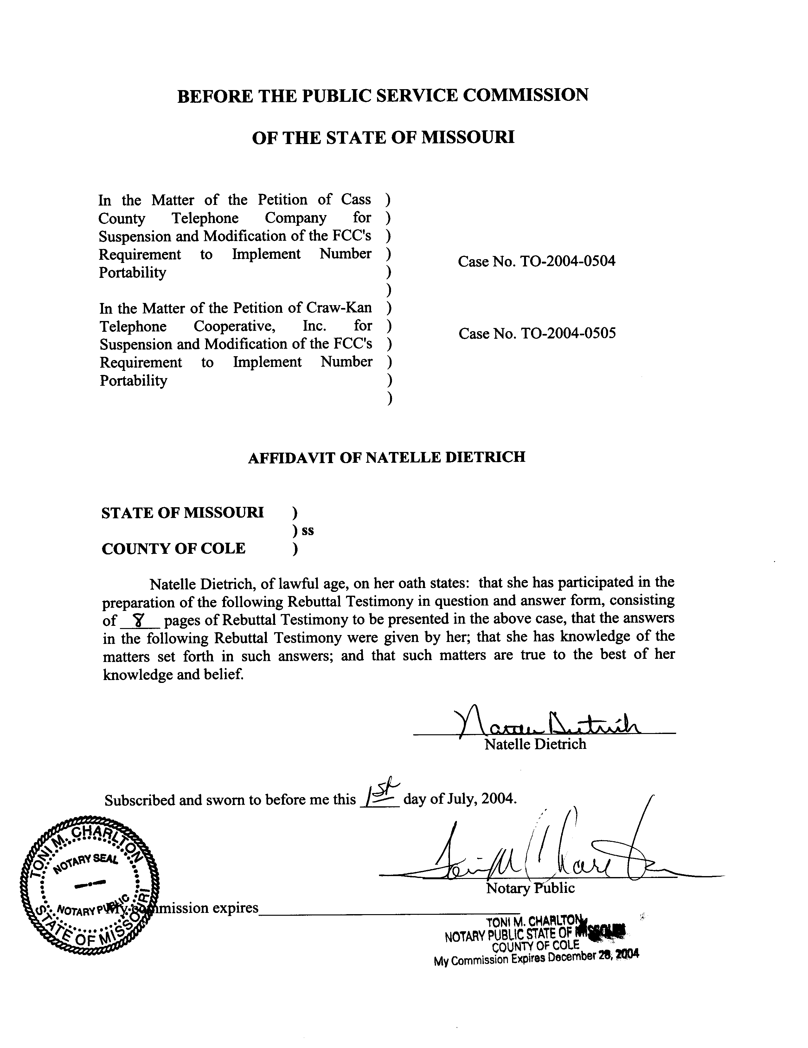

REBUTTAL TESTIMONY

OF

NATELLE DIETRICH

CASS COUNTY TELEPHONE COMPANY AND

CRAW-KAN TELEPHONE COOPERATIVE, INC.

CASE NOS. TO-2004-0504 AND TO-2004-0505

Q. Please state your name and business address.
A. My name is Natelle Dietrich. I am employed by the Missouri Public Service Commission (Commission), 200 Madison Street, Jefferson City, Missouri, 65101.
Q. Please describe your work experience.
A. I am employed as a supervisor and regulatory economist for the Telecommunications Department Staff (Staff) of the Commission. My duties include the review and analysis of cost studies and the application of general costing theory as it relates to the regulation of telecommunications services with supervisory responsibility to ensure thorough and complete economic analysis of telecommunications issues by the economic/competitive analysis Staff. I have previously testified or filed affidavits in Case Nos. TA-99-405, an analysis of the appropriateness of a “payday loan” company providing prepaid telecommunications service; TO-2001-455, the AT&T/Southwestern Bell Telephone Company (SWBT) arbitration, which included issues associated with unbundled network elements; TO-2001-222, the MCI/SWBT arbitration, which also included issues related to unbundled network elements; TR-2002-251, Sprint’s price cap
adjustments; and TO-2004-0370, IO-2004-0467, TO-2004-0505 et al., the present LNP suspension/modification cases. I have also prepared comments and testified in several proposed rulemakings before the Commission.
As supervisor of the Telecommunications Department economic/competitive analysis group, I have reviewed many cost studies and have had testimony prepared at my direction and under my supervision on many cost related dockets including, but not limited to TO-2001-437, TO-2001-438 and TO-2001-440 (the SWBT 271 “spin-off cases); TR-2001-65, an investigation into the cost of providing switched access service in Missouri; TO-2001-455, the AT&T/SWBT arbitration; TO-2001-222, the MCI/SWBT arbitration; and, TO-2004-0207, the Triennial Review Order proceeding.
Through an appointment to the National Association of Regulatory Utility Commissioners Staff Subcommittee on Telecommunications and as Assistant Chair to the Federal Regulatory Policy Sub-Group, I am responsible for monitoring federal telecommunications activity and informing the Commission of relevant federal activity. I have prepared comments on behalf of the Commission to be filed at the Federal Communications Commission (FCC) on several occasions. These comments included such issues as the Coalition for Affordable Local and Long Distance Service’s (CALLS) modified access charge reform proposal; the Multi-Association Group’s (“MAG”) interstate access reform and universal service support proposal for incumbent local exchange carriers subject to rate-of-return regulation; and, the feasibility of a bill-and-keep approach as means of attaining a unified regime for the flows of payments between carriers. I have also prepared congressional testimony on behalf of the Commission on number conservation efforts in Missouri.
I also worked for over 13 years in lending, analyzing customer credit, financial histories and payment capabilities of individuals and businesses. The last five plus years were spent working in the risk asset unit where I was responsible for and successful in reducing the bank’s risk exposure by several million dollars per year through restructuring high-risk customer debt using means that continue to meet the customer’s financial needs and payment abilities.
Q. Please describe your educational background.
A. I hold a Bachelor of Arts Degree in English from the University of Missouri-St. Louis and a Master’s Degree in Business Administration from William Woods University.
Q. Are you the same Natelle Dietrich that provided testimony during the May 5, 2004, local number portability on-the-record-presentation in Case Nos. TO-2004-0370, IO-2004-0467, TO-2004-0505, et al.?
A. Yes I am.
Q. What is the purpose of your pre-filed testimony?
A. The purpose of my testimony is to respond to the testimony of Robert C. Schoonmaker on behalf of Cass County Telephone Co. (Cass) and Craw-Kan (Craw-Kan) Telephone Cooperative, Inc (collectively, companies) and to support the companies’ Petitions for suspension and modification of the Federal Communications Commission’s (FCC) requirements that local exchange carriers implement local number portability (LNP).
Q. What is the issue in these cases?
A. The issue in these cases is whether the Commission should grant Cass and Craw-Kan a modification of the FCC’s intermodal porting requirements.
Q. Do you agree with the various statements and assertions in Mr. Schoonmaker’s Testimony as to the potential harm of implementing the intermodal porting requirements absent a modification of the FCC’s rules?
A. Yes I do. As Mr. Schoonmaker points out in his Testimony on page 15, beginning at line 20, the FCC noted that rating and routing issues were being addressed in other proceedings and would not be addressed in its November 10, 2003, Memorandum Opinion and Order and Further Notice of Proposed Rulemaking (Order).
Q. What are the possible implications of the FCC directing intermodal porting prior to addressing the rating and routing issues?
A. Cass and Craw-Kan have intrastate tariffs on file with the Missouri Public Service Commission. These tariffs outline the companies’ local service area. Transporting calls to numbers that have been ported to a wireless carrier with no point of presence in the Cass or Craw-Kan local service area could result in the carriers inappropriately operating much like an interexchange carrier instead of a local exchange carrier. Further, as Mr. Schoonmaker states on page 16, lines 18 and 19 of his Testimony, the company and/or its customers’ may suffer economic harm as a result of the intermodal porting requirements absent a modification.
Q. Are you suggesting it should be the responsibility of the wireless carrier, in this case, Western Wireless, to bear the transport costs associated with intermodal porting?
A. No, I am not. In its Order, the FCC clearly mandated that intermodal porting should have been implemented by May 24, 2004. Further, in its Third Report and Order, issued May 1998, the FCC established local number portability (LNP) cost recovery mechanisms allowing incumbent local exchange carrier to recover the costs associated with implementing LNP from its end users. In their petitions, the companies indicated they would be LNP capable by the May 24, 2004, deadline, and by design these companies can recover the implementation costs from their customers if they so choose. However, as previously indicated, the FCC left unresolved issues associated with rating and routing calls once a number has ported, creating additional economic issues associated with intermodal porting. In order to complete calls to ported numbers, a company must either build facilities or establish business arrangements with other carriers such as Southwestern Bell Telephone, L.P., d/b/a SBC Missouri or Sprint Missouri, Inc. Mr. Schoonmaker, on Page 19 of his Testimony, estimates negotiations could cost Cass or Craw-Kan between $20,000 and $100,000 or more depending on whether issues were resolved or required arbitrations. While I have no personal knowledge as to the validity of the cost estimates or costs associated with deploying additional facilities to accommodate transporting ported calls, I agree the costs could be substantial.
Q. Are you recommending the Commission order wireless carriers, including Western Wireless, to establish a point of presence in the Cass and Craw-Kan service territories?
A. No, I am not. My recommendation is that the Commission find that the companies and/or their end user subscribers are not responsible for establishing facilities or business relationships to transport ported calls. This recommendation would allow the wireless carriers to determine the appropriate method for transporting calls.
Q. Would any arrangements as a result of modifications ordered by the Commission be permanent arrangements?
A. No. As previously noted, the FCC stated that it would address the rating and routing issues in other pending dockets. In its Recommendations filed April 12, 2004, Staff recommended the Commission grant a modification and authorize the carriers to establish an intercept message only until such time as the FCC addresses the rating and routing issues. The Staff Recommendations are incorporated and attached as Exhibit A.
Q. Does Staff have any changes to its Recommendations?
A. Yes it does. On page 26, lines 21 to 22 of his Testimony, Mr. Schoonmaker recommends the modification remain in place for a period of six months after a final FCC determination of the party responsible for such transport service. In its June 24, 2004 Order, the Commission, in Case No. TO-2004-0455, granted Mid-Missouri Telephone Company a modification of the FCC’s local number portability requirements for small rural local exchange carriers until the FCC further addresses the rating and routing issues associated with porting number and ordered the parties to notify the Commission 10 days from the date the FCC issues any further decisions addressing the rating and routing issues associated with porting numbers. The Commission has issued similar orders in other cases. Staff suggests this notification would be appropriate for Cass and Craw-Kan also.
Q. Do you have reason to believe that Western Wireless would support a temporary modification as discussed in your testimony and Staff’s Recommendation?
A. Yes. In the on-the-record presentation, Mr. William Steinmeyer, counsel for Western Wireless said, “I would just point out -- and I don't know if this is the -- if this is the proper forum for doing it, but as we sit here and listen to the discussion on Western Wireless's point of view, we would be willing to pay for land-to-mobile transport on an interim basis if it helped move LNP [a]long at SBC transit rates assuming the telecos could make the necessary arrangements.” (Pages 115-116 of the transcript.)
Q. Beginning on page 25 of his Testimony, Mr. Schoonmaker discusses Cass exchanges within the Metropolitan Calling Area (MCA) and the potential for the Commission to order bill and keep as the means for establishing the necessary business arrangements for transporting ported numbers in the MCA. Should the Commission address this issue in these proceedings?
A. No. The Commission established the MCA Task Force for the purpose of examining whether, and if so, what type of changes should be made to the MCA Plans and to calling scopes in general. In its Order Appointing Task Force Members and Scheduling Meeting, the Commission asked the Task Force to evaluate the impact of local number portability and the MCA. Since the Task Force is to review this issue, that is the appropriate forum for addressing issues related to local number portability and the MCA.
Q. Please summarize your recommendation?
A. I am recommending the Commission grant the Cass and Craw-Kan requests for modification to address call rating and routing issues pursuant to Section 251 (f)(2)(A)(i) and (B) of the Telecommunications Act of 1996. I recommend the Commission effectuate that approval by affirmatively stating in its order that neither the companies, nor their customers, will be responsible for any transport or long distance charges associated with porting numbers and any associated calls outside companies’ local service area. Staff recommends this modification be a conditional modification until such time as the FCC further addresses the rating and routing issues associated with porting numbers and that the companies’ notify the Commission 10 days from the date the FCC further addresses the rating and routing issues. Staff also recommends the Commission authorize companies to block seven-digit dialed calls to ported numbers where the facilities and/or appropriate third party arrangements have not been established (i.e., block calls that would appear to be local, but in fact are long distance calls). Finally, Staff recommends the Commission direct companies to establish an intercept message once the first number is ported so that remaining subscribers are informed of any call rating and routing issues associated with completing a call to a ported number. Such message could be similar to the following text: “The number you are calling has been ported to another carrier. That carrier has not made arrangements to complete the call as dialed.”
Q. Does this end your testimony?
A. Yes it does.

