Exhibit No.:
Issues: Suspension &
Modification of LNP
Requirements

Witness: Natelle Dietrich
Sponsoring Party: MO PSC Staff
Type of Exhibit: Testimony
Case No.: TO-2004-0526
Date Testimony Prepared: June 18, 2004

MISSOURI PUBLIC SERVICE COMMISSION

UTILITY OPERATIONS DIVISION

TESTIMONY

OF

NATELLE DIETRICH

OREGON FARMERS MUTUAL TELEPHONE COMPANY

CASE NO. TO-2004-0526

Jefferson City, Missouri
June 2004
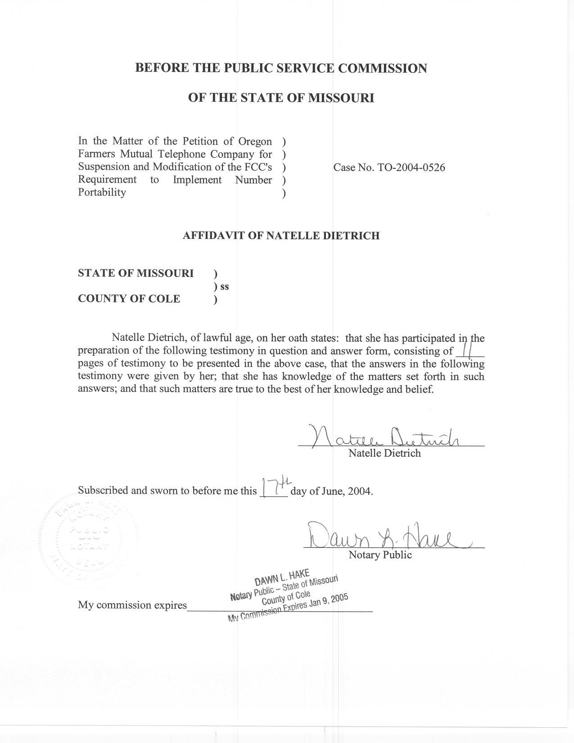

TESTIMONY

OF

NATELLE DIETRICH

OREGON FARMERS MUTUAL TELEPHONE COMPANY

CASE NO. TO-2004-0526

Q. Please state your name and business address.
A. My name is Natelle Dietrich. I am employed by the Missouri Public Service Commission (Commission), 200 Madison Street, Jefferson City, Missouri, 65101.
Q. Please describe your work experience.
A. I am employed as a supervisor and regulatory economist for the Telecommunications Department Staff (Staff) of the Commission. My duties include the review and analysis of cost studies and the application of general costing theory as it relates to the regulation of telecommunications services with supervisory responsibility to ensure thorough and complete economic analysis of telecommunications issues by the economic/competitive analysis Staff. I have previously testified or filed affidavits in Case Nos. TA-99-405, an analysis of the appropriateness of a “payday loan” company providing prepaid telecommunications service; TO-2001-455, the AT&T/Southwestern Bell Telephone Company (SWBT) arbitration, which included issues associated with unbundled network elements; TO-2001-222, the MCI/SWBT arbitration, which also included issues related to unbundled network elements; TR-2002-251, Sprint’s price cap adjustments; and TO-2004-0370, IO-2004-0467, TO-2004-0505 et al, the present LNP
suspension/modification cases. I have also prepared comments and testified in several proposed rulemakings before the Commission.
As supervisor of the Telecommunications Department economic/competitive analysis group, I have reviewed many cost studies and have had testimony prepared at my direction and under my supervision on many cost related dockets including, but not limited to TO-2001-437, TO-2001-438 and TO-2001-440 (the SWBT 271 “spin-off cases); TR-2001-65, an investigation into the cost of providing switched access service in Missouri; TO-2001-455, the AT&T/SWBT arbitration; TO-2001-222, the MCI/SWBT arbitration; and, TO-2004-0207, the Triennial Review Order proceeding.
Through an appointment to the National Association of Regulatory Utility Commissioners Staff Subcommittee on Telecommunications and as Assistant Chair to the Federal Regulatory Policy Sub-Group, I am responsible for monitoring federal telecommunications activity and informing the Commission of relevant federal activity. I have prepared comments on behalf of the Commission to be filed at the Federal Communications Commission (FCC) on several occasions. These comments included such issues as the Coalition for Affordable Local and Long Distance Service’s (CALLS) modified access charge reform proposal; the Multi-Association Group’s (“MAG”) interstate access reform and universal service support proposal for incumbent local exchange carriers subject to rate-of-return regulation; and, the feasibility of a bill-and-keep approach as means of attaining a unified regime for the flows of payments between carriers. I have also prepared congressional testimony on behalf of the Commission on number conservation efforts in Missouri.
I also worked for over 13 years in lending, analyzing customer credit, financial histories and payment capabilities of individuals and businesses. The last five plus years were spent working in the risk asset unit where I was responsible for and successful in reducing the bank’s risk exposure by several million dollars per year through the restructuring high-risk customer debt using means that continue to meet the customer’s financial needs and payment abilities.
Q. Please describe your educational background.
A. I hold a Bachelor of Arts Degree in English from the University of Missouri-St. Louis and a Master’s Degree in Business Administration from William Woods University.
Q. Are you the same Natelle Dietrich that provided expert testimony during the May 5, 2004, local number portability on-the-record-presentation in Case Nos. TO-0370, IO-2004-0467, TO-2004-0505, et al?
A. Yes I am.
Q. What is the purpose of your pre-filed testimony?
A. Several incumbent local exchange telecommunications carriers (ILECs) requested a two-year suspension of the Federal Communications Commission’s (FCC) intermodal porting requirements. I compiled a spreadsheet of the cost information provided with the ILEC petitions and completed an analysis of that information in order to make a recommendation as to the economic feasibility of small ILEC subscribers bearing the costs associated with local number portability. Through that analysis and the corresponding recommendations, $1.68 appears to be the point at which any greater amount could result in a significant economic impact if subscribers bear the costs associated with local number portability. The purpose of my testimony is to explain my analysis and rationale for recommending what appears to be a cut-off point of $1.68.
Q. Did you determine that $1.68 is the uppermost point at which it is economically feasible for subscribers to bear the costs associated with local number portability?

A. Not specifically. Although it appears that $1.68 is the cut-off point for Staff, it is not that simple. I considered multiple factors in making my recommendations. It just happens that after reviewing several factors and based on the numbers presented for each ILEC, the “line” is drawn at a total monthly recurring charge increase of $1.68 per company subscriber.
Q. You state that you considered multiple factors in making your recommendations. What factors were considered?
A. Following is an outline of the factors or steps I completed in making my recommendations.
Reviewed FCC orders to seek guidance on the FCC’s expectations for local number portability cost recovery;
- Reviewed cost projections of each company;
- Considered the type of switch currently employed versus switch upgrade expense projections;
- Compared the rates for all companies to determine any large gap that might be considered a reasonable cut-off point;
- Reviewed the increase in the monthly recurring rate compared to the current rate;
- Reviewed the increase for implementation only versus the additional increase for database queries once a number is ported;
- Reviewed the rates for other LECs in Missouri.
Q. Please explain what you reviewed in FCC orders to seek guidance on the FCC’s expectations for local number portability cost recovery.
A. On May 5, 1998, the FCC adopted its Third Report and Order, implementing cost recovery mechanisms for local number portability. In the Report and Order, the FCC noted, “[it] will allow but not require incumbent [I]LECs subject to rate-of-return or price-cap regulation to recover their carrier-specific costs directly related to providing number portability through a federal charge assessed on end-users.” The FCC allowed the costs related to number portability to be required for a maximum of 5 years “to help produce reasonable charges for customers and avoid imposing those charges for an unduly long period.” In other words, to determine a monthly recurring charge, the ILEC obtains the current cost for implementation, divides that number by its access lines, and further divides that number by 60 months. Following is a hypothetical, mathematical example:
$150,000 implementation costs/1000 access lines/60 months = a recurring charge of $2.50 per subscriber per month for 60 months.

Once the ILEC recovers its initial implementation costs, the FCC considers number portability a normal network feature. Therefore, any remaining costs are to be recovered through existing mechanisms available for recovery of the general costs of providing service.

The FCC determined that “recovery from end users should be designed so that end users generally receive the charges only when and where they are reasonably able to begin receiving the direct benefits of long-term number portability”. Once local number portability is implemented, the ILEC’s subscribers should immediately be able to receive the benefits of porting, if they so choose.
Q. Are there other means in which a small ILEC can recover the costs associated with LNP?
A. The FCC also found that small ILECs can benefit from economies of scale by arranging for another carrier or third-party provider to provide number portability. This assertion was supported in the FCC’s Memorandum Opinion and Order on Reconsideration of the Third Report and Order. The FCC further stated, “such [small ILECs] could arrange for another carrier to perform queries for them, enter into cooperative agreements with other small carriers, or install number portability in their own networks and use excess number portability capacity to provide query service to other carriers.”
Q. Did the FCC address the recovery of costs associated with database queries?
A. The FCC requires ILECs to treat the query service charge as a new service within the meaning of Section 61.49(g). However, querying calls, and assessing the associated charges, prior to the date the first number is ported from that ILEC’s switch was found to be inconsistent with the FCC’s Third Report and Order and Cost Classification Order. In other words, end users would not be charged the monthly recurring cost associated with database queries or dips until such time as the first number is actually ported.
Q. Please explain your review of the cost projections of each company.
A. The ILECs filed company-specific cost and implementation information. I reviewed this information and compared it to the cost information submitted by other ILECs to determine that costs were similar, included the same components and were calculated in a similar manner.
Q. Please explain your review of the type of switch currently employed versus switch upgrade expense projections.
A. Some ILECs indicated switches would need to be replaced within a couple years. Other ILECs had newer switches, but indicated vastly different implementation costs for the same type of switch. This information was reviewed with technical Staff. As part of this review, technical Staff agreed that certain switches would need to be replaced, largely due to the technical limitations of the switch, the lack of on-going vendor technical investment in research and development of customer features, and the lack of on-going vendor support. Technical Staff also verified that the projections for implementation could vary depending on the version of the switch and excess capacity projections and needs.
Q. Please explain what you mean when you say you compared the rates for all companies to determine any large gap that might be considered a reasonable cut-off point.
A. The various LNP suspension petitions were filed over a two-month period. As petitions and associated cost and implementation support were filed, I compiled a spreadsheet of this information. I then reviewed the spreadsheet to determine any large gaps, or clear cut-off points, in the monthly recurring charges for implementation and database dips. Originally, there was a fairly significant gap with the monthly recurring charges falling below $1.00 or above $2.50. As more cost information was received from various companies over the two-month period, the lower end of the gap was raised to what appears as a cut-off of the $1.68 as discussed in my testimony.
Q. Please discuss your review of the increase in the monthly recurring rate compared to the current rate.
A. Staff researched tariffs to determine the current residential basic local rate for each company. I then compared the future rate (the basic local rate plus the addition of the LNP surcharge) to the current basic local rate. Based on this review, it was discovered that some ILEC customers could see an increase in rates of approximately five percent, while other ILEC customers could see an increase in rates in excess of 75 percent. Staff recommended suspension for those Petitioners’ with rate increases of approximately 40 percent or greater.
Q. Please discuss your review of the increase for implementation only versus the additional increase for database queries once a number is ported.
A. As previously stated, the FCC found that charging for database queries prior to the porting of the first number was inconsistent with the FCC’s Third Report and Order and Cost Classification Order. Therefore, I reviewed the monthly recurring charge for implementation versus the additional increase a company can charge once a number is ported. For implementation, charges were less than $1.00 per month for all carriers but one. In contrast, for database queries alone, five carriers will have monthly recurring surcharges in excess of $2.50. Therefore, for most carriers, the majority of the charge will only be incurred after the first number is ported. (The spreadsheet I prepared outlining costs for all companies was entered as proprietary exhibit number 10 at the May 5, 2004, on-the-record presentation.)
Q. Please discuss your review of the rates of other ILECs in Missouri.
A. The FCC’s LNP cost recovery requirements were to begin when local number portability was implemented by a carrier. For SBC, Sprint Missouri, Inc. and CenturyTel of Missouri, Inc., LNP was implemented around 1999. The three companies have charged their subscribers LNP surcharges around $.50 to $.80 for the past five years. These charges, since averaged over the entire customer base, were not only assessed in areas of effective competition, but in areas where consumers had no competitive choice since wireline-to-wireline porting was the only requirement. In response to questions from the bench during the on-the-record presentation, I also compared the basic local rates of these carriers, with LNP surcharges included, to the basic local rate with LNP charges estimated by the Petitioners. Following is a summary of that analysis, only including rate bands or zones with access lines comparable to Petitioners’ access lines.

Company | Residential Rates for Comparable Rate Bands
SBC | 7.49 to 9.03
Sprint | 13.02 to 13.57
CenturyTel | 9.38 to 9.87

Q. Please summarize your testimony.
A. Given the FCC’s mandate that “porting from a wireline carrier to a wireless carrier is required where the requesting wireless carrier’s ‘coverage area’ overlaps the geographic location in which the customer’s wireline number is provisioned” and its previous determination that “recovery from end users should be designed so that end users generally receive the charges only when and where they are reasonably able to begin receiving the direct benefits of long-term number portability”, I reviewed several factors, as discussed herein, in making my recommendations as to the point at which it is economically feasible for subscribers to bear the costs associated with local number portability. Through analysis and the corresponding recommendations, $1.68, with a 40 percent or greater monthly rate increase appears to be the point at which any greater increase could result in a significant economic impact if subscribers are required to bear the costs associated with local number portability. However, it should be noted this number is not supported on its own, but must be considered in context of all the factors discussed in my testimony.
Q. Does this conclude your testimony?
A. Yes it does.

In the Matter of Telephone Number Portability, Third Report and Order, CC Docket No. 95-116 (1998) at para. 135.
Id. at para. 144.
Id. at paras. 143-144.
Id. at para. 142.
In the Matter of Telephone Number Portability, CC Docket No. 95-116, Memorandum Opinion and Order on Reconsideration and Order on Application for Review, February 15, 2002, at para. 64.
Id. at para. 100.
In the Matter of Telephone Number Portability CTIA Petitions for Declaratory Ruling on Wireline-Wireless Porting Issues, Memorandum Opinion and Order and Further Notice of Proposed Rulemaking, November 10, 2003, at para. 1.
In the Matter of Telephone Number Portability, Third Report and Order, CC Docket No. 95-116 (1998) at para. 142.

