Exhibit No.:
Issues: Rate Design

Witness: Bill Peters
Sponsoring Party: MO PSC Staff
Type of Exhibit: Direct Testimony
Case No.: TC-2002-1076
Date Testimony Prepared: August 5, 2002

MISSOURI PUBLIC SERVICE COMMISSION

Utility Operations DIVISION

Direct Testimony

OF

Bill Peters

Missouri Public Service Commission

CASE NO. TC-2002-1076

Jefferson City, Missouri
August, 2002

**Denotes Highly Confidential Information**

NP
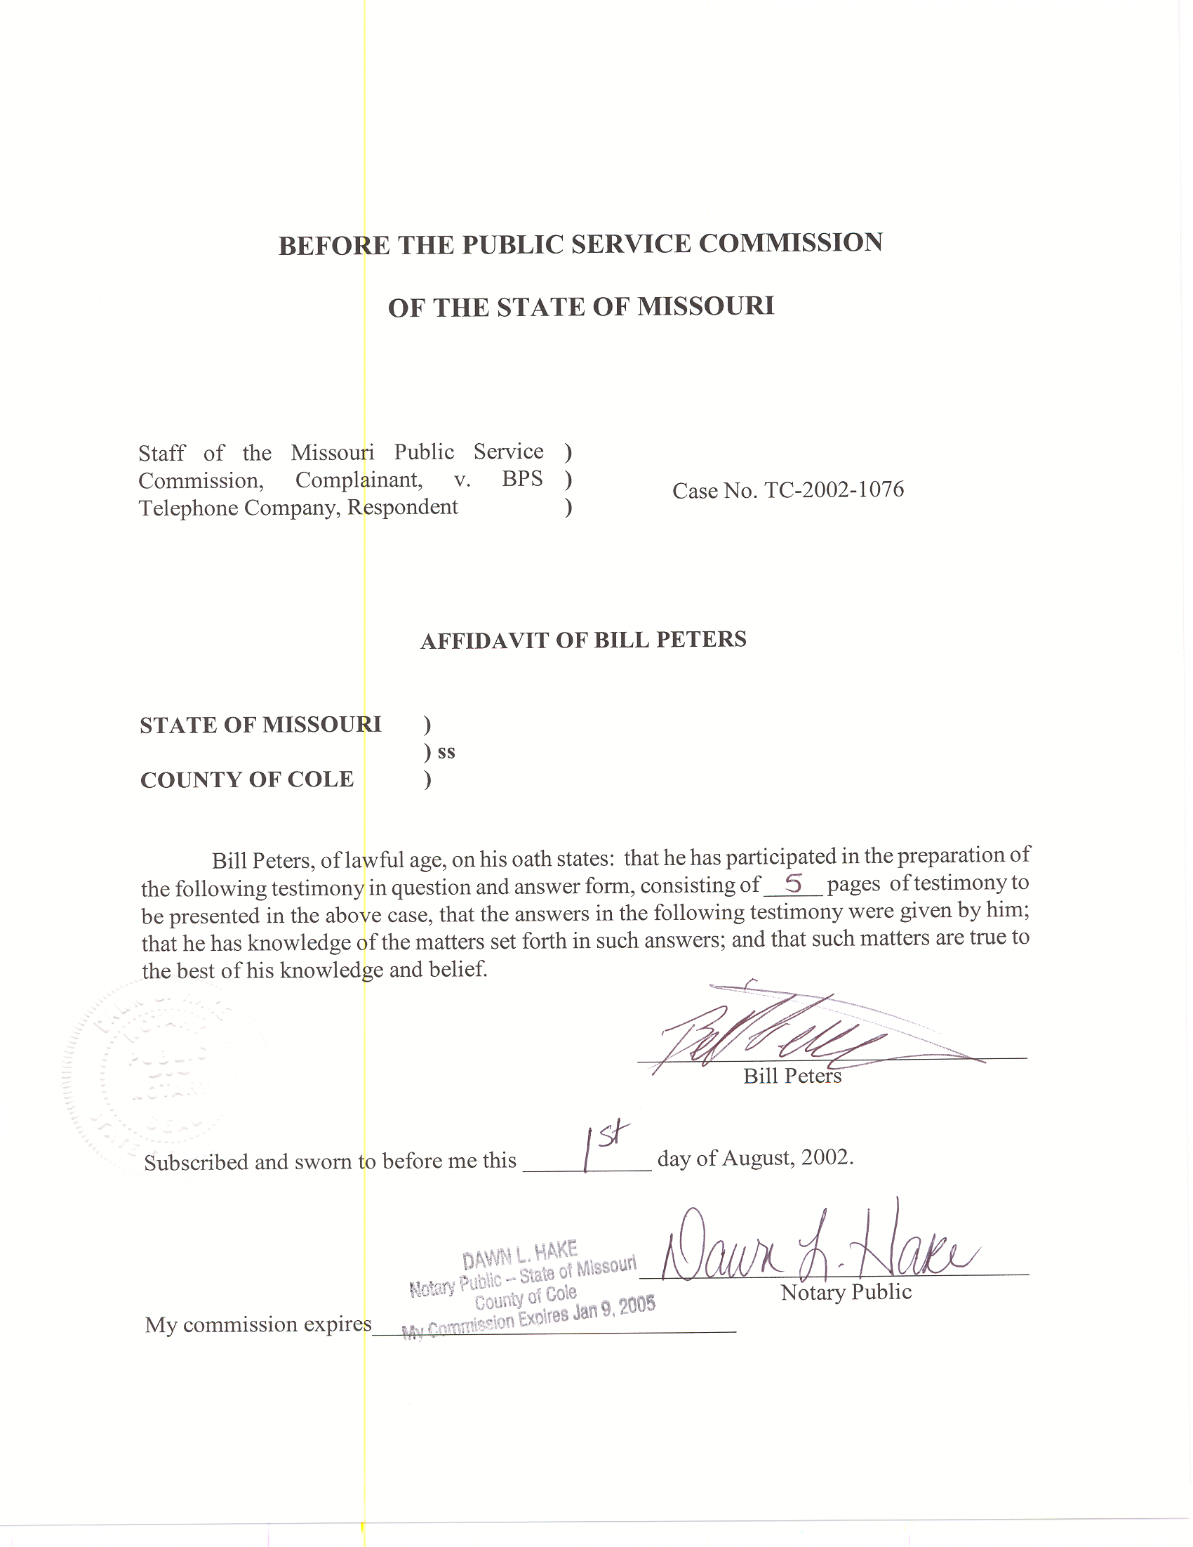
DIRECT TESTIMONY
OF BILL PETERS
MISSOURI PUBLIC SERVICE COMMISSION
Case No. TC-2002-1076

Q. Please state your name and give your business address.
A. My name is Bill Peters and my business address is Post Office Box 360, Governor Office Building, Suite 500, 200 Madison Street, Jefferson City, Missouri 65102-0360.
Q. By whom are you employed?
A. I am employed by the Missouri Public Service Commission (PSC or Commission).
Q. How long and in what capacity have you been employed at the Commission?
A. I was hired as a Regulatory Economist for the Telecommunications Department Staff (Staff) in September 2001.
- Describe your educational background and employment history.
A. I received a B.S. in Economics from Illinois State University in August of 1998 and an M.S. in Applied Economics from the same institution in May of 2001. My Master’s sequence was “Regulation of Public Utilities: Telecommunications, Electricity and Natural Gas.” In between my degrees, I volunteered with Peace Corps – Armenia as an instructor of Economics and English at Shirak University in Gumri, Armenia. After
returning from the Peace Corps, I completed a four-month internship at the Citizens Utility Board, a consumer advocacy organization, in Chicago, IL.
Q. What are your duties at the Commission?
A. Since beginning employment with the Commission, I have reviewed, analyzed and written recommendations for various case filings, tariff filings and interconnection agreements. Filings are reviewed and recommendations are written to ensure consistency with the public interest, Missouri and Federal rules and regulations. I have also reviewed various cost studies and conducted general research related to telecommunications and economics.
Q. Have you previously testified before the Commission?
A. Yes, I testified in Case No. TO-2002-222, In the Matter of the Petition of MCImetro Access Transmission Services LLC, Brooks Fiber Communications of Missouri, Inc., and MCI WorldCom Communications, Inc., for Arbitration of an Interconnection Agreement With Southwestern Bell Telephone Company Under the Telecommunications Act of 1996.
Introduction
Q. What is the purpose of your testimony?
A. My testimony proposes new intrastate access rates for BPS Telephone Company. Staff’s proposed rate reductions fully transfer BPS’s overearnings into lower intrastate access rates. Staff witness William Voight explains, in his Direct Testimony, why Staff supports applying the entire overearnings towards access. Staff specifically proposes eliminating the Intralata Equal Access Recovery Charge and reducing the following rates: Originating Carrier Common Line (CCL), Terminating CCL, and Local switching (LS).
Issues Discussion
Q. What are the current and Staff’s proposed new intrastate intralata and interlata access rates?
A. Current
CCL Originating $0.02990131
CCL Terminating $0.07141421
LS $0.02815218
Line Termination $0.00491350
EARC $0.00136000
Proposed
CCL Originating $0.01286024
CCL Terminating $0.03071449
LS $0.01422120 (includes line termination)
EARC $0.00000000
- What was Staff’s goal regarding redesigning BPS rates?
A. Staff purposefully set out to propose intrastate access rates that result in yearly revenue reductions equal to the amount of BPS’s overearnings in 2001. Staff witness William Voight’s Direct Testimony in this case explains why Staff chose to apply the entirety of overearnings to intrastate access rates.
Q. What is the Intralata Equal Access Recovery Charge?
A. The Intralata Equal Access Recovery Charge (EARC) is an interim charge that allowed companies to recover the cost of implementing itralata interexchange carrier choice.
Q. Please explain why the Staff proposes to eliminate the Intralata Equal Access Recovery Charge?
A. It is Staff’s position that this charge is no longer appropriate given the company’s substantial overearnings. Since the company has been overearning, the cost of implementing intralata equal access should have been recovered. Allowing the company to continue recovering this charge would be in conflict with the intended purpose of the charge.
Q. How did Staff calculate these rates?
A. The method utilized is actually a quite simple calculation. Using originating and terminating usage data provided by BPS (Originating and Terminating usage data is 2001 data) and current intrastate access rates, it is simple to calculate the proposed rates which result in a revenue reduction equal to the amount of BPS’s overearnings. The following expression provides the proposed revenue as a percentage of current revenue.
Z= proposed revenue as a percentage of current revenue
R=current revenue
X= adjusted overearnings

X=adjusted overearnings
Z= (R-X)/R

R=originating minutes*originating price + terminating minutes*terminating price
(Calculated in HC Schedule A)

X= overearnings amount – EARC*(total minutes)

Before overearnings is entered into the equation (Z= (R-X)/R), an amount equal to the current EARC price multiplied by total minutes is subtracted from Staff’s overearnings figure. This allows the EARC to be eliminated before any other charges are reduced. (Calculated in HC Attachment A)

Z= 0.43008936
Z is multiplied by current rates resulting in Staff’s proposed rates. In the final step, Line Termination was added to Local Switching. That aggregate charge retains the Local Switching moniker.
Under Staff’s proposed rates, BPS will be earning the correct amount of money (R-X) on a going-forward basis, assuming the same amount of originating and terminating minutes.
Q. Why was 2001 data used?
A. Usage data from 2001 is the most recent data available and is a good, simple approximation of the future.
Q. Does this conclude your Direct Testimony?
A. Yes.

SCHEDULE A IS DEEMED
HIGHLY CONFIDENTIAL IN ITS ENTIRETY

