Exhibit No.:
Issues: Tariff Issues
Witness: Craig M. Branum
Sponsoring Party: MoPSC Staff
Type of Exhibit: Rebuttal Testimony
Case No.: GT-2004-0049
Date Testimony Prepared: October 8, 2003

MISSOURI PUBLIC SERVICE COMMISSION

Utility Operations DIVISION

REBUTTAL TESTIMONY

OF

CRAIG M. BRANUM

MISSOURI GAS ENERGY

CASE NO. GT-2004-0049

Jefferson City, Missouri

October, 2003

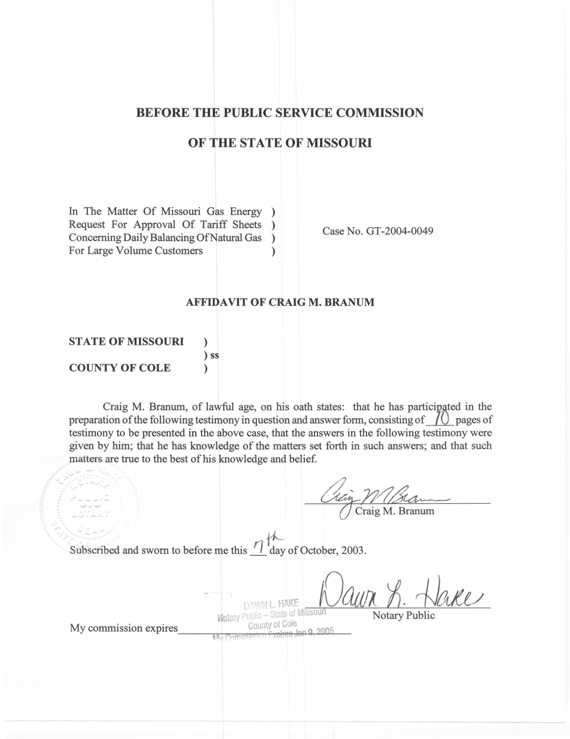
TABLE OF CONTENTS

TERMS AND DEFINITIONS 2
Southern Star Tariff Changes 9

REBUTTAL TESTIMONY
OF
CRAIG M. BRANUM
MISSOURI GAS ENERGY
CASE NO. GT-2004-0049

Please state your name and business address.
Craig M. Branum, 200 Madison Street, Suite 500, Jefferson City, Missouri 65101.
By whom are you employed and in what capacity?
I am employed by the Missouri Public Service Commission (Commission or MoPSC) as a Utility Policy Analyst I.
Please describe your educational background.
I graduated from Lincoln University in December 1996, with a Bachelor of Science degree in Business Administration.
Please review your work experience.
In April 1997, I was employed with the Missouri Department of Insurance as an Insurance Product Analyst. In this position I was responsible for reviewing and, if necessary, requiring modifications to new and revised property and casualty insurance policies to ensure compliance with the laws of the State of Missouri. The purpose of this review process was to protect the insurance consumers of Missouri.
I assumed my current position with the Commission in September 1999. My responsibilities with the Commission involve monitoring and analyzing proceedings at the Federal Energy Regulatory Commission (FERC) to keep the Commission apprised of matters that might ultimately affect Missouri natural gas consumers. I also assist in the formulation and preparation of the MoPSC’s positions to be presented at FERC.
Have you previously filed testimony before the Commission?
No, I have not. However, I have previously filed testimony on behalf of the Commission before the FERC in a Kansas Pipeline Company rate case, FERC Docket No. RP99-485-000.
With reference to Case No. GT-2004-0049, what issues are you responsible for in this case?
The purpose of my testimony is to provide the Commission information regarding the terms and definitions used by Southern Star Central Gas Pipeline, Inc. (Southern Star) in its tariff. I will compare Missouri Gas Energy’s (MGE) tariff language to Southern Star’s tariff language as it relates to these various terms and definitions. I will also discuss some of the changes made to Southern Star’s tariff in FERC Docket No. RP03-356-000 and the possible effects of those changes on MGE.

TERMS AND DEFINITIONS
Since several pipelines serve MGE, why have you chosen to compare MGE’s tariff with Southern Star’s tariff?
Because Southern Star delivers the majority (about 66%) of MGE’s gas supplies.
Regarding the terms and definitions found in Southern Star’s currently effective tariff, please explain what an “Operational Flow Order” or “OFO” is.
Southern Star’s tariff, Original page 203 (Schedule 1), states, “[an] Operational Flow Order (”OFO”) is an order issued to alleviate conditions, inter alia, which threaten or could threaten the safe operations or system integrity, of Southern Star's system, or to maintain operations required to provide efficient and reliable firm service.”
Are there different types of OFOs that can occur on Southern Star’s pipeline system?
Yes. Southern Star has two types of OFOs, a Standard OFO and an Emergency Response OFO.
Please explain the difference between the two OFOs.
Southern Star’s tariff states, “a Standard Operational Flow Order shall consist of pre-emptive or preventive actions or measures that neutralize or reduce threats to, or otherwise preserve, as reasonably deemed necessary by Southern Star, the integrity of all or a portion of its system. An Emergency Response Operational Flow Order shall consist of actions or measures required by Southern Star that neutralize or reduce threats to, or otherwise preserve, the integrity of all or a portion of its system which requires an immediate response as reasonably deemed necessary by Southern Star.” (See Schedule 1.)
In what types of situations can Southern Star issue an OFO?
Southern Star has the right to issue an OFO to protect the integrity of its system, but pursuant to FERC Regulation 18 CFR 284.12(b)(2)(iv), “a pipeline must take all reasonable actions to minimize the issuance and adverse impacts of operational flow orders (OFOs) or other measures taken to respond to adverse operational events on its system. A pipeline must set forth in its tariff clear standards for when such measures will begin and end and must provide timely information that will enable shippers to minimize the adverse impacts of these measures.” Southern Star can issue OFO directives related to its storage and/or transportation services so as to reduce or increase the flow of gas to the affected area of the pipeline system.
When Southern Star issues an OFO, is the OFO normally issued for the entire system or for certain segments of the pipeline?
It depends on the situation and condition the pipeline is attempting to address. OFOs can be system-wide directives, directives related to only certain segments of its system, or they can be customer-specific. Schedule 2 includes two examples of OFOs that occurred on Southern Star’s system earlier this year.
Are the penalties for OFOs in MGE’s tariff similar to the penalties in Southern Star’s tariff?
Yes, MGE’s OFO penalties generally follow Southern Star’s OFO penalties.
Please explain what the term “balancing” on a pipeline means.
Balancing means to make the amount of gas put into the pipeline equal to the amount of gas taken out of the pipeline in any given time period. This can also be expressed as making deliveries of gas into and withdrawals from a pipeline equal, or balanced. Balancing may be accomplished daily, monthly or seasonally, with penalties generally assessed on customers for excessive imbalance.
What is a “Period of Daily Balancing” or “PODB?”
As defined on Southern Star’s currently effective tariff, Original page 236 (See Schedule 3), “A period of daily balancing occurs when confirmed nominations and anticipated no-notice service deliveries are expected to exceed anticipated receipts plus storage withdrawal capability on Southern Star's pipeline system. During such periods of daily balancing, actual receipts and deliveries of gas are allocated to no-notice transportation and storage agreements on a daily basis rather than on a monthly basis.” However, I should note that in FERC Docket No. RP03-356, Southern Star is seeking to remove this language from its tariff.
Why has Southern Star proposed to remove the PODB language from its tariff?
In Docket No. RP03-356, Southern Star is proposing to become “a daily allocating pipeline,” i.e. Southern Star will be allocating transportation and storage volumes to individual shippers’ accounts on a daily basis; thus making the existing PODB language redundant and unnecessary.
Please define “imbalance.”
An imbalance is when a Shipper delivers or causes delivery to the pipeline, at the receipt point(s), a quantity of gas which, after appropriate reduction for fuel and loss, is less than or greater than the quantity of gas taken from the pipeline at the delivery point(s). In other words, a transportation customer either puts more or less gas than it is using into the pipeline system.
What is “Burner-tip Balancing?”
“Burner-tip Balancing” is a predetermined allocation methodology that is effectuated by an agreement between the pipeline and a delivery point operator, such as MGE. Under such an agreement, the volumes delivered during a given month to end-use customers located behind the point operator (as measured by electronic metering equipment purchased by each end-use transportation customer and adjusted for lost and unaccounted for gas and thermal content) are reported to the pipeline and considered to be the actual deliveries for those end use customers. The remaining pipeline deliveries to that delivery point are considered to be the transportation volumes of the delivery point operator. Therefore, any balancing between end-use shippers’ receipts and deliveries was done on the pipeline system, not by MGE.
How long have MGE and its end-use transportation customers had
burner-tip balancing?
In MGE’s case, its “Burner-tip Balancing” agreement is from a September 28, 1993, Stipulation and Agreement (“agreement”) before the Commission in Case No. GR-93-240 (Schedule 4). This agreement was made between Western Resources (now MGE), Commission Staff, ARMCO, Midwest Gas Users Association, Office of Public Counsel, U.S. Department of Energy, Williams Natural Gas Company (now Southern Star), and Mountain Iron & Supply Company. The agreement allowed for tariff language to be placed in MGE’s tariff, requiring customers who qualified for and took transportation service to install and pay for electronic gas metering (“EGM”) equipment and associated expenses. In exchange for the commitment to install EGM equipment, Southern Star agreed to provide burner-tip balancing, for a one-year period, commencing October 1, 1993, to all MGE customers transporting gas on its system. Under burner-tip balancing, the actual volumes delivered to each affected transportation customer by MGE, as adjusted for lost and unaccounted for gas and thermal content, are considered the transportation volumes delivered by Southern Star to MGE on behalf of each end-use customer for all purposes. Southern Star agreed to continue providing burner-tip balancing after this initial one-year period on behalf of any customer who has installed EGM equipment for at least 90 percent of the customer’s annual delivered volumes. However, on April 29, 2003, in FERC Docket No. RP03-356, Southern Star stated it was discontinuing burner-tip balancing. MGE was able to negotiate a six-month extension (until November 1, 2003) of its burner-tip balancing agreement with Southern Star.
What will the effect be on MGE when this service is cancelled?
The most significant effect of Southern Star canceling this agreement will be that any balancing between end-use transportation customers’ pipeline receipts and their deliveries will now be considered to be on MGE’s system. Previously, with
burner-tip balancing, the customers were regularly in balance on MGE’s system and Southern Star was responsible for collecting any over/under usage from its customers behind MGE’s city gate. Now, without burner-tip balancing, MGE will have the burden of keeping its system in balance. Thus, MGE is requesting to put into place tariff language designed to help reduce the risk of its customers gaming its system.
What do you mean by “gaming its system”?
The term “gaming the system” in this context refers to the ability of a customer to build up a surplus or deficit of delivered gas on the delivery system versus what they are using in a particular time period for purposes of saving on delivered gas cost. An example of this could be a customer having more gas delivered at the beginning of a month when gas prices are low, when the customer expects gas prices to increase through the month, and not delivering gas into the system toward the end of the month to remove their imbalance and at the same time avoid buying more expensive gas. This behavior can impact system integrity through its impacts on distribution system pressures, especially during critically cold periods.
What are Monthly Cash Outs?
A “Monthly Cash Out” is a procedure that pipelines and local distribution companies (LDC) perform in an attempt to keep their systems in balance. The pipeline or LDC will compare a shipper’s receipts, less applicable fuel charges, to the actual amount of gas delivered for each shipper or customer. On Southern Star’s system, a customer actually has up to two months to get its account in balance before having to cash out its imbalance completely. On MGE’s system, customers are required to cash out within a month.
Are there any penalties related to Monthly Cash Outs?
Yes. Both Southern Star and MGE have penalty provisions related to these cash outs. Southern Star’s cash out penalty provisions are on its First Revised Sheet No. 244 and 245 (See Schedule 5) and MGE’s proposed cash out penalty provisions are on its First Revised Sheet No. 61.2.
Are MGE’s penalties the same as the Monthly Cash Out penalties found in Southern Star’s tariff language for Monthly Cash Outs?
Not completely. Schedule 6 presents the differences between the Monthly Cash Out penalties for Southern Star and MGE.
Are MGE’s Monthly Cash Out percentages reasonable and appropriate?
Yes. MGE needs to have tariff provisions, in place, which help deter its customers and end users from creating an imbalance on its system, especially since Southern Star has cancelled burner-tip balancing making MGE responsible for all imbalances at MGE’s delivery points on Southern Star’s system.

Southern Star Tariff Changes
In FERC Docket No. RP03-356-000, Southern Star states that it intends to change from a “monthly allocating” pipeline to a “daily allocating” pipeline. Please explain the difference between a “monthly allocating” pipeline and a “daily allocating” pipeline.
As stated in Southern Star’s cover letter to its initial filing in RP03-356-000 (See Schedule 7), “[c]urrently, on Southern Star’s system, shippers schedule gas on a daily basis and Southern Star measures gas received and delivered on its system on a daily basis. However, rather than allocating the actual daily receipts and deliveries based on daily scheduled quantities and system use, which reflects the way the commodity and capacity were transacted that day, the actual daily receipts and deliveries and the daily scheduled quantities for the month are summed and an allocation of monthly totals is performed.” Accordingly, Southern Star’s proposed tariff sheets will change the allocation of actual volumes from monthly to daily in order to accurately reflect the daily commodity and capacity transactions that occurred each day, rather than as a sum of those days for an entire month.
In RP03-356-000, Southern Star changed its transportation rates from monthly to daily rates to coincide with its request to change to a daily allocating pipeline. Please explain the difference between monthly rates and daily rates.
Basically, the rate level is the same. Southern Star calculated its daily rates by taking its current monthly rates multiplied by 12 (for months) and then dividing it by 365 (for days) to come up with the daily rate.
What other changes can MGE expect on its system with regard to Southern Star’s proposed tariff changes?
MGE will most likely incur additional charges brought about by Southern Star charging for daily authorized overruns for deliverability and capacity if they choose to request additional deliveries over maximum daily deliveries allowed by MGE’s contract (its daily contract demand). In the past, Southern Star only charged MGE for the net amount of overrun volumes used in a month, not on a daily basis. During the month, if MGE requested authorized overruns, it had until the end of the month to correct the imbalance, allowing it to net the volumes to a zero balance. If Southern Star’s proposed language goes into effect, and Staff expects that it will, MGE will no longer have an entire month to balance out its authorized overruns. Rather it will have to pay a charge for authorized overruns for each day it request authorization to deliver volumes beyond its daily contract demand.
Does this conclude your rebuttal testimony?
A. Yes, it does.

