Exhibit No.:
Issues: Suspension &
Modification of LNP
Requirements

Witness: Natelle Dietrich
Sponsoring Party: MO PSC Staff
Type of Exhibit: Surrebuttal Testimony
Case No.: TO-2004-0401
Date Testimony Prepared: July 16, 2004

MISSOURI PUBLIC SERVICE COMMISSION

UTILITY OPERATIONS DIVISION

SURREBUTTAL TESTIMONY

OF

NATELLE DIETRICH

KLM TELEPHONE COMPANY

CASE NO. TO-2004-0401

Jefferson City, Missouri
July 2004
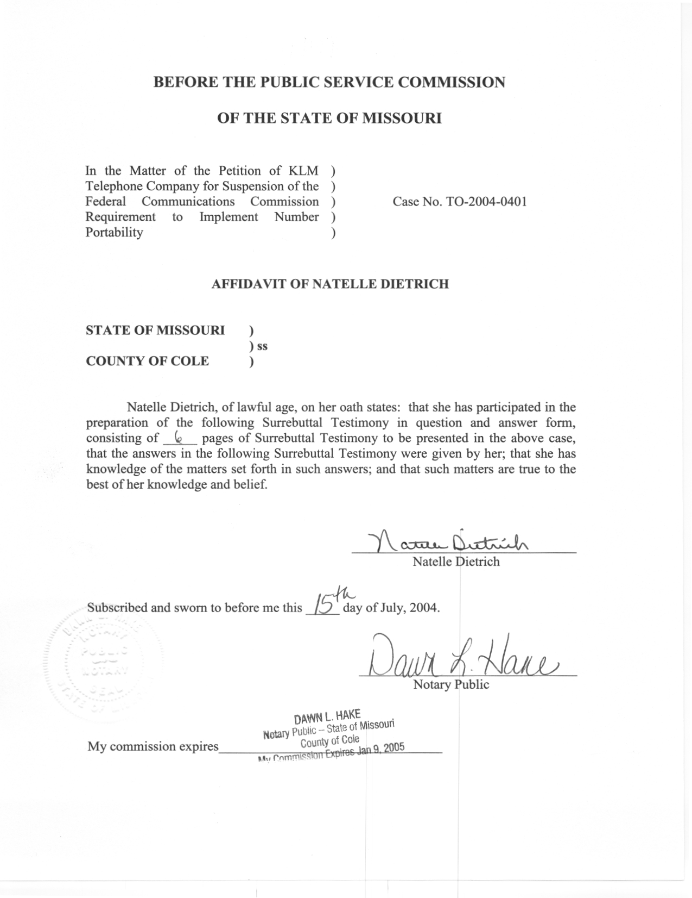

SURREBUTTAL TESTIMONY

OF

NATELLE DIETRICH

KLM TELEPHONE COMPANY

CASE NO. TO-2004-0401

- Please state your name.
- My name is Natelle Dietrich.
Q. Are you the same Natelle Dietrich that filed Rebuttal Testimony in this case?
A. I am.
- What is the purpose of your testimony?
- The purpose of my testimony is to respond to the Rebuttal Testimony of Mr. Ron Williams on behalf of WWC Holding Company, Inc. (Western Wireless d/b/a CellularOne) (Western).
- What is KLM Telephone Company’s (KLM) obligation for implementing local number portability (LNP)?
- KLM is a “two percent” carrier with at least part of its service area within the top 100 MSAs. As Mr. Williams has noted, the Federal Communications Commission (FCC) released an Order on January 16, 2004, granting a waiver to local exchange carriers with less than two percent of the nation’s subscriber lines in the aggregate that operate in the top 100 MSAs, such as KLM. This waiver was a limited waiver of the intermodal porting requirements allowing the “two percent” carriers until May 24, 2004, or six months from receiving a bona fide request (BFR) to implement LNP.
- Has KLM received a bona fide request from a wireless provider?
A. According to the Direct Testimony of Mr. Copsey, KLM had not yet received a bona fide request. In his Rebuttal Testimony, Mr. Williams indicates Western has now issued a BFR to KLM. Receipt of a BFR would imply that KLM now has six months to implement LNP. Therefore, KLM would not have been required to implement LNP, or perform the necessary switch modifications, upgrades or replacements until receipt of that BFR.
- Mr. Williams, on page 6 of his Rebuttal Testimony, discusses the intent of Congress and the FCC with respect to intermodal porting requirements. Do you agree with his assessment that Congress did not intend to insulate rural telephone competition?
- Yes I do. As Mr. Williams notes, the FCC stated, “Congress intended exemption, suspension, or modification of the section 251 requirements to be the exception rather than the rule…We believe that Congress did not intend to insulate smaller or rural LECs from competition.” It is because of this assertion that the Telecommunications Department, as discussed in my Staff Recommendations and testimony in the various LNP cases, has only supported two-year suspensions in limited circumstances when the suspension standards were justified.
- You mention suspension standards. Is there a standard for a waiver or suspension of intermodal porting requirements?
- Yes. A “two percent” carrier can petition a state commission for a suspension by providing substantial, credible evidence that there are special circumstances to justify the suspension. Section 251(f)(2) of the Telecommunications Act of 1996 states: The State commission shall grant such petition to the extent that, and for such duration as, the State commission determines that suspension -
“(A) is necessary –
  - to avoid a significant adverse economic impact on users of telecommunications services generally;
  - to avoid imposing a requirement that is unduly economically burdensome; or
  - to avoid imposing a requirement that is technically infeasible; and
(B) is consistent with the public interest, convenience, and necessity.” (47 U.S.C. § 251 (f) (2)).

- In your opinion, is the public interest served by the requested suspension?
- Yes it is. In my opinion, on behalf of the Telecommunications Department, it is in the public interest to allow KLM the opportunity to replace its switch as opposed to creating a situation where KLM subscribers incur LNP implementation costs and then, within the next two years, incur duplicative costs when KLM replaces its switch. By granting KLM a suspension to allow for switch replacement, all of KLM’s subscribers will receive the benefit associated with the costs incurred for that switch replacement, as opposed to receiving little benefit from costs incurred for LNP implementation.
- Mr. Williams discusses KLM’s cost projections and provides an alternative LNP cost estimate for KLM. Do you have any concerns regarding his cost discussion?
- Yes I do. Mr. Williams, on page 15, lines 7-9, of his Rebuttal Testimony estimates 60 intermodal ports per year, or 5 ports per month, for KLM. Mr. Williams does not provide justification for this estimate. Also, Mr. Williams, on page 15 beginning at line 10, questions the “Verisign Porting Charges” and states that Verisign functionality is, in part, redundant to Neustar costs. Once again, Mr. Williams does not explain this statement. Finally, Mr. Williams continues by explaining that other Verisign features are not necessary if KLM’s port volume is in the range forecasted by Western. Again, however, Mr. Williams does not explain the assertion. On page 15, beginning at line 15, Mr. Williams presents a modified recurring rate that KLM could assess its subscribers. Do Mr. Williams’ estimates or concerns change your recommendation for KLM?
- No. As previously stated, Mr. Williams presents a modified recurring rate without providing support for his estimates or concerns. However, a discussion as to whether Mr. Williams’ recurring cost estimates or KLM’s recurring cost estimates are accurate is not pertinent to my recommendation in this case since I did not use the recurring costs as a basis for my recommendation. As previously stated, my recommendation, on behalf of the Telecommunications Department, was based on the implementation costs, and whether those costs should be duplicative by first implementing LNP to meet the FCC’s LNP intermodal porting requirements, and then in the near future, replacing the switch due to lack of future technical support.
- You stated that you used the implementation costs as the basis for your recommendation. Did Mr. Williams have any comments on the implementation costs?
- Yes he did. On page 16 of his Rebuttal Testimony, lines 4-6, Mr. Williams states, “The KLM cost exhibit identifies non-recurring switch upgrade costs for LNP that appear consistent with cost estimates made by other carriers implementing similar upgrades to their Mitel switches.” Therefore, the costs I used in making the Telecommunications Department’s recommendation, appear to be supported, or at least not challenged, by Western.
- Have you changed your recommendation to approve KLM’s petition for a two-year suspension of the FCC’s intermodal porting requirements based on the Rebuttal Testimony of Mr. Williams?
- No. My recommendation, on behalf of the Telecommunications Department, continues to support a two-year suspension of the FCC’s intermodal porting requirements for KLM to allow KLM time to replace existing switches, consistent with the FCC’s waiver standards and Section 251(f)(2)(A)i and (B) of the Telecommunications Act of 1996.
Q. After reviewing Mr. Williams’ Rebuttal Testimony, have you changed your recommendation on KLM’s request for modification until the FCC addresses the issue of carrier responsibility for the transport of local calls to wireless providers with rate centers outside the local exchange areas of KLM (rating and routing issues)?
A. As indicated in my Rebuttal Testimony, upon further review I also support modification until such time as the FCC addresses the outstanding rating and routing issues. Regardless of when the FCC resolves the routing and rating issues, it is, and was, the Telecommunications Department Staff’s position that neither the Petitioner, nor its wireline customers, should be responsible for any transport or long distance charges associated with porting numbers and any associated calls outside Petitioner’s local service area.
- Does this end your Surrebuttal Testimony?
A. Yes it does.

In the Matter of Telephone Number Portability, CC Docket No. 95-116, FCC 04-12, 19 FCC Rcd 875 (2004).
Memorandum Opinion and Order and Further Notice of Proposed Rulemaking. In the Matter of Telephone Number Portability and CTIA Petitions for Declaratory Ruling on Wireline-Wireless Porting Issues. CC Docket No. 95-116. par. 30.

