Exhibit No.:
Issues: Weather Normalization

Witness: Dennis Patterson
Sponsoring Party: MO PSC Staff
Type of Exhibit: Surrebuttal Testimony
Case No.: GR-2004-0209
Date Testimony Prepared: June 14, 2004

MISSOURI PUBLIC SERVICE COMMISSION

UTILITY OPERATIONS DIVISION

SURREBUTTAL TESTIMONY

OF

DENNIS PATTERSON

MISSOURI GAS ENERGY

CASE NO. GR-2004-0209

Jefferson City, Missouri
June 2004
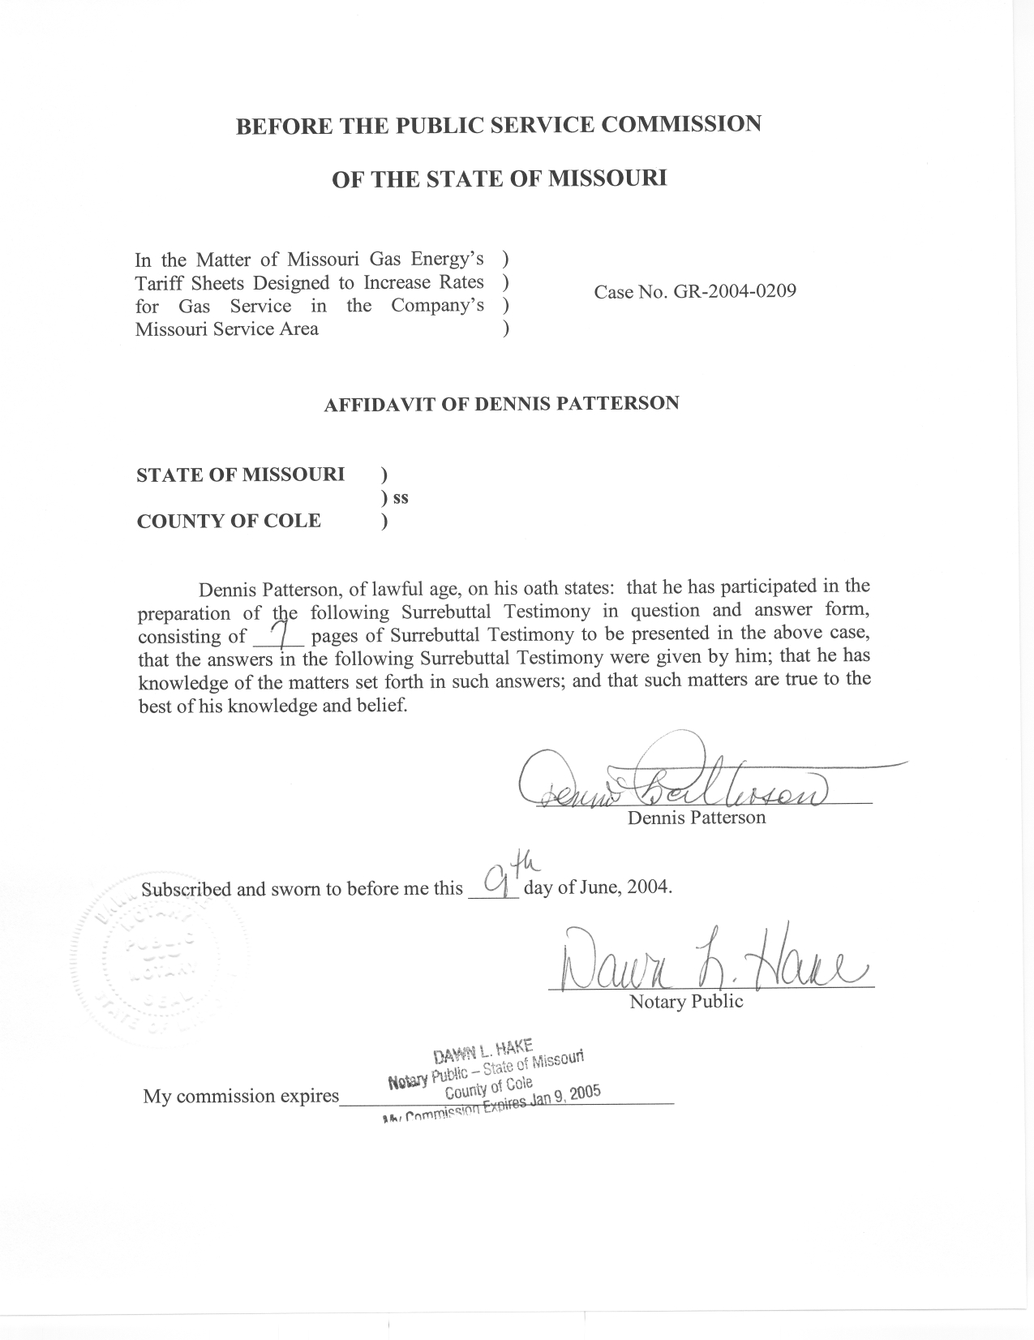

TABLE OF CONTENTS

SUMMARY 1
STAFF RECOMMENDATIONS 2
DETAILS OF DR CUMMINGS’ REBUTTAL TESTIMONY 4
CONCLUSIONS 7

SURREBUTTAL TESTIMONY

OF

DENNIS PATTERSON

MISSOURI GAS ENERGY

CASE NO. GR-2004-0209

Q. Please state your name and business address.
A. My name is Dennis Patterson and my business address is Missouri Public Service Commission, P. O. Box 360, Jefferson City, Missouri, 65102.
Q. What is your present position with the Missouri Public Service Commission (Commission)?
A. I am a Regulatory Economist in the Energy Department of the Utility Operations Division.
Q. Are you the same Dennis Patterson who has submitted Direct and Rebuttal Testimony in this case?
A. Yes, I am.

SUMMARY
Q. What is the purpose of your Rebuttal Testimony?
A. I will address the written Rebuttal Testimony of Company witness F. Jay Cummings, PhD on the issue of weather normalization of test year revenues.
Q. What issues in Dr. Cummings’ Rebuttal Testimony will you address?
A. I will first address Dr. Cummings’ concerns regarding the recommendations of the Staff and the decisions of the Missouri Public Service Commission (Cummings Rebuttal, Page 6, lines 11-16; Page 6, line 23 through Page 7, line 2). I will then address certain other details of Dr. Cummings’ Rebuttal Testimony where he proposes to remove or discard certain years and days of HDD data from the calculation of average annual HDD. As before, I will defer to other Staff witnesses for the calculation of weather adjustments.

STAFF RECOMMENDATIONS
Q. What are the Staff’s recommendations for calculating normal weather?
A. The Staff continues to recommend the use of the National Oceanic and Atmospheric Administration (NOAA) normals based on a three-decade time period in rate cases before the Commission. This period is currently the years 1971 through 2000.
Q. Why does the Staff continue to recommend this standard?
A. The three-decade normals period is the international standard that is long enough and recalculated often enough for statistical and practical reasons, and is accepted by national weather agencies whose responsibility is to provide the standards. “A climate normal is defined, by convention, as the arithmetic mean of a climatological element computed over three consecutive decades…” (Climatology of the United States No. 81, Monthly Normals of Temperature, Precipitation and Heating and Cooling Degree Days, 1971-2000, Missouri, in the section entitled “Computational Procedures.)” (Please see Schedule 1-3.) The Staff has also verified that NOAA normals based on the current three-decade time period to be statistically superior to averages based on the shorter time periods, for summer and winter temperatures at the many Missouri weather stations in the regulated utility service areas.
Q. How does the Staff believe that its recommendation should be applied?
A. The Staff believes that the recommendation should apply for regulated electric, gas and water utilities in Missouri, and that the consequences of departing from this reliable standard would be far-reaching.
Q. Have longer time periods been considered?
A. Yes, because there is evidence that a longer time period would be superior statistically to the three-decade period normally used in Missouri. However, it is difficult and costly to maintain consistent historical data for weather stations for long time periods.
Q. Why is this true?
A. The difficulty arises because changes can occur at the stations that are not in control of the Commission, and that NOAA does not address if the changes occur before the standard three-decade normals period: “Ideally, the data record for such a 30-year period should be free of any inconsistencies in observational practices (e.g., changes in station location, instrumentation, time of observation, etc.) and be serially complete (i.e. no missing values). When present, inconsistencies can lead to a non-climatic bias in one period of a station’s record relative to another, yielding an “inhomogeneous” data record.” (Please see “Computational Procedures” at Schedule 1-3.)
Q. Is the standard for the calculation of normals restricted to the choice of time period?
A. No. The standard includes numerous crosschecks and addresses unavoidable inconsistencies in temperature data. (Please see “Computational Procedures” at Schedule 1-3.)
Q. In your Rebuttal Testimony, did you conclude that the NOAA methodology using the three-decade time period was superior for the calculation of the HDD normals?
A. Yes, I did, using Kansas City as an example. I showed in my Rebuttal Testimony that normals calculated from shorter time periods were not superior because they are not as accurate and because they changed more from one year to the next. This result is general for Missouri weather stations whose annual HDD values vary around a constant or slowly changing average over many years. That is, normals calculated from three decades of data on a 10-year update schedule are more accurate and vary less than the alternatives presented by Dr. Cummings.
Q. If it could be shown conclusively that a different time period were superior to the Staff’s proposed three-decade period, would the Staff change its recommendation?
A. Yes, if the costs were not prohibitive and consistent data were available.
Q. Would such a time period be shorter than 30 years?
A. Not under current climatic conditions, where annual HDD values appear to vary about a constant average for Missouri stations. The shorter time period could be superior only if the weather patterns in Missouri began to change quite drastically, beyond the limits illustrated in my Rebuttal Testimony for Kansas City.

DETAILS OF DR CUMMINGS’ REBUTTAL TESTIMONY
Q. In his Rebuttal Testimony, did Dr. Cummings show that his 20-year time period was superior to the three-decade time period that NOAA uses to calculate weather normals?
A. No. Under the objective statistical criteria of accuracy and stability, I don’t believe that he has.
Q. What did Dr. Cummings establish in his Rebuttal Testimony?
A. He appeared to try to establish that HDD normals from shorter time periods ending in 2003 resulted in a smaller number of HDD than the HDD normal from the 30-year time period ending in 2000 (Cummings Rebuttal Testimony, page 9, lines 3-19). Dr. Cummings then appeared to suggest that the Company might therefore merit the concession of a higher revenue requirement based on the suggestion that the distribution of warm and cold years in the normals period was not balanced between early and later years (Cummings Rebuttal, page 10, lines 1-8). He also appeared to establish that a select group of jurisdictions had approved the use of shorter time periods in the past as another basis for the desired concession (Cummings Rebuttal, all of pages 7 and 8). Finally, he appeared to favor calculations where extreme high and low annual or daily HDD values were discarded before normals would be calculated (Cummings Rebuttal, page 8, lines 7-9 and page 12, lines 4-14). The universal effect of these alternatives would be to reduce the influence of annual HDD values from certain years in the 1970s and 1980s by excluding one or more of them from the calculations of average annual HDD.
Q. Has Dr. Cummings presented any statistical evidence that would justify a departure from NOAA’s established standard of three-decade normals calculated from data that had been made consistent, in favor of alternatives that discard selected annual HDD values or daily HDD values?
A. No. The Staff sees no statistical reason to adopt any of these alternatives, because the universal effect would be to discard valuable information that should be included in the calculation of average annual HDD.
Q. What would persuade the Staff to discard certain annual HDD or daily HDD observations?
A. Staff members are not climatologists, and are therefore not necessarily qualified to discard HDD observations. However, the Staff recognizes that HDD observations that were several standard deviations away from the average value for the year, month or day (as appropriate) should be considered for elimination or estimation. Similarly, HDD observations that were greatly different from those at neighboring stations would be suspect.
Q. Has anyone reviewed the temperature and HDD data in this case for such departures?
A. Yes. NOAA climatologists have already performed the necessary quality control to insure that the data are statistically acceptable.
Q. When do NOAA climatologists perform the quality control procedures?
A. NOAA performs such procedures twice: first, at the time the daily temperature and HDD data are archived and published, and again when the HDD normals are calculated from the archived data.
With regard to daily HDD, the underlying daily temperature data are extensively reviewed: “Historical cooperative station index. Cooperative stations are U.S. stations operated by local observers, which generally report max/min temperatures and precipitation. National Weather Service (NWS) data are also included in this dataset. The data receive extensive automated +(sic.) manual quality control.” (National Climatic Data Center (NCDC) Inventories website, page 1.) (Please see Schedule 2, attached to my Surrebuttal Testimony) I have provided a text version of the electronic document as working papers for my Surrebuttal Testimony.
With regard to NOAA normals products: “Each monthly observation is evaluated using a modified quality control procedure … where station observation departures are computed, compared with neighboring stations, and then flagged and estimated where large differences with neighboring values exist.” (Schedule 1-3.)

CONCLUSIONS
Q. Please summarize your Surrebuttal Testimony.
A. First, in response to the legitimate concerns voiced in Dr. Cummings’ Rebuttal Testimony, I have attempted to illustrate that the three-decade time period used by NOAA is part of a carefully crafted set of climatology standards that should not be abandoned arbitrarily. Second, in response to the several alternative calculations that were supported in Dr. Cummings’ Rebuttal Testimony, I have attempted to show that there is no valid statistical reason for removing selected years or days from the temperature and HDD data that are used to calculate average annual HDD for the Kansas City and Joplin service areas of the Company. For these reasons, the Staff continues to recommend that the current 1971-2000 edition of NOAA’s Monthly Station Normals be used as the basis for weather normalization in the present MGE rate case.
Q. Does this conclude your Surrebuttal Testimony?
A. Yes, it does.

