Exhibit No.:
Issues: Weather Normalization

Witness: Dennis L. Patterson
Sponsoring Party: Mo PSC Staff
Type of Exhibit: Direct Testimony
Case No.: WR-2003-0500 &
WC2004-0168
Date Testimony Prepared: October 3, 2003

MISSOURI PUBLIC SERVICE COMMISSION

Utility Operations DIVISION

DIRECT TESTIMONY

OF

DENNIS L. PATTERSON

Missouri-American Water Company

CASE NO. WR-2003-0500 & WC-2004-0168

Jefferson City, Missouri
October 2003

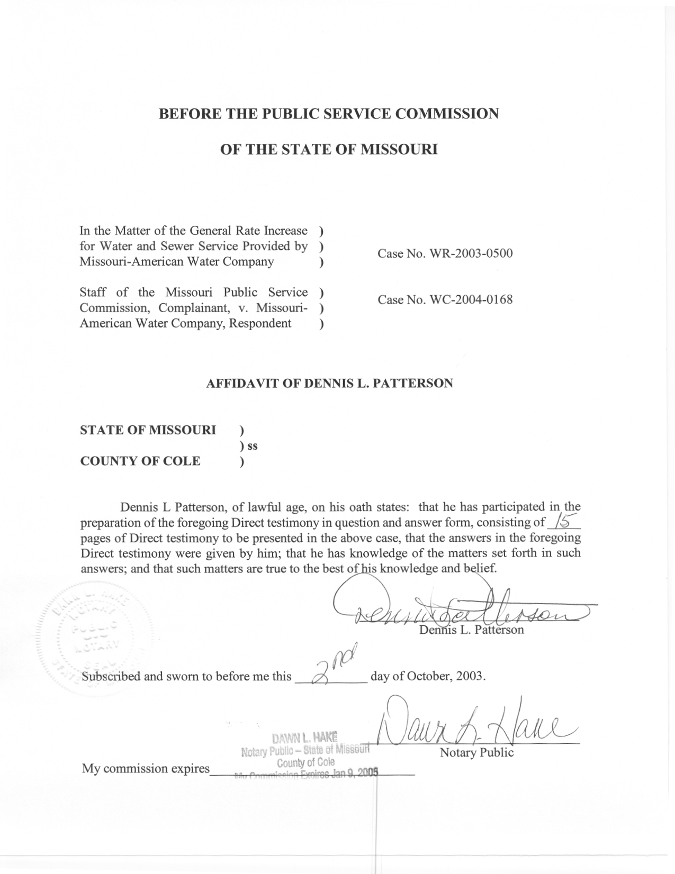

TABLE OF CONTENTS

PURPOSE 2
OVERVIEW 2
BILLING DATA 5
BILLING ADJUSTMENTS 7
TREND ADJUSTMENTS AND SHIFTS 10
WEATHER ADJUSTMENTS 11
SUMMARY 14

DIRECT TESTIMONY
OF

DENNIS L. PATTERSON

MISSOURI-AMERICAN WATER COMPANY

CASE NOS. WR-2003-0500 AND WC-2004-0168

Q. Please state your name and business address.
A. My name is Dennis Patterson and my business address is Missouri Public Service Commission, P. O. Box 360, Jefferson City, MO 65102.
Q. What is your present position with the Missouri Public Service Commission (Commission)?
A. I am a Regulatory Economist in the Energy Department of the Utility Operations Division.
Q. Please review your educational background and work experience.
A. I was trained as an officer and aviator in the U.S. Army. I studied economics, math, sciences and languages, receiving a B.A. in Latin American Studies (University of Missouri, 1983) and an M.S. in Agricultural Economics (University of Missouri, 1989). I joined the Staff of the Commission in April, 1986. I established the Staff's centralized weather data base, and have continued to maintain and improve it by employing data and methods from reliable sources. I have been employed by the Commission, the Missouri Army National Guard, the University of Missouri, the U.S. Army Reserves, and the U.S. Army.

PURPOSE

Q. What is the purpose of your direct testimony?
A. The purpose of my direct testimony is to support my estimates of weather normalized water consumption, expressed as gallons per meter per day (GMD).
Q. How were your estimates used in this case?
A. I furnished these estimates to Staff witness Edward F. Began, for use in his calculations of weather normalized water sales volumes.
Q. What were the service areas for which you calculated weather normalized GMD?
A. The service areas were Brunswick, Jefferson City, Joplin, Mexico, Parkville, St. Charles, St. Joseph, St. Louis County, and Warrensburg.
Q. What were the customer classifications for which you calculated weather normalized GMD?
A. Each of the service areas had Residential and Commercial rate classes. The St. Louis County Residential and Commercial classes were further subdivided by their respective Monthly and Quarterly reading schedules. St. Louis County had Monthly and Quarterly Other Public Authority rate class sub classifications as well. Since the classifications were modeled separately, and they are called rate classes in my direct testimony.

OVERVIEW
Q. What were your estimates of weather adjusted GMD by service area and rate class for the 12 billing months ending December, 2000
A. These estimates are presented in Schedule 1 attached to my direct testimony.
Q. What was the overall company-wide effect of your weather normalization adjustments?
A. These aggregated results are presented at Schedule 1-2 through 1-9. The table at Schedule 1-2 shows that Company’s 2002 Residential sales were 38,958,880 Mgallons, and that the Staff’s estimate of normalized 2002 Residential sales was 38,035,836 Mgallons, a downward adjustment of -923,044 Mgallons, or -2.37%. Schedules 1-3, 1-4 and 1-5 illustrate the annual changes in Residential meter counts (customer numbers); actual and normal Residential GMD; and actual and normal Residential Mgallons respectively. A Staff estimate of the effect of Company’s weather normalization was included for comparison.
The table at Schedule 1-6 shows that Company’s 2002 Commercial sales were 12,657,083 Mgallons, and that the Staff’s estimate of normalized 2002 Commercial sales was 11,762,497 Mgallons, a downward adjustment of -894,586 Mgallons, or -7.07%. Schedules 1-7, 1-8 1-9 illustrate the annual changes in Commercial meter counts (customer numbers); actual and normal Commercial GMD; and actual and normal Commercial Mgallons respectively. A Staff estimate of the effect of Company’s weather normalization was included for comparison.
The table at Schedule 1-10 shows that Company’s 2002 Other Public Authority (OPA) sales were 412,944 Mgallons, and that the Staff’s estimate of normalized 2002 OPA sales was also 412,944 Mgallons, so that there is no adjustment recommended. Schedules 1-11, 1-12 and 1-13 illustrate the annual changes in OPA meter counts (customer numbers); actual and normal OPA GMD; and actual and normal OPA Mgallons respectively. A Staff estimate of the effect of Company’s weather normalization was included for comparison.
Q. How did you calculate weather normalized GMD for the service areas and rate classes?
A. For each service area and each rate class, I used linear regression to analyze historical annual GMD with respect to the summer weather of each year. In order to perform the weather analysis accurately, it was also necessary to account for other important effects as well. Among the additional effects were missing meter counts, significant changes in numbers of meters, shifts in the patterns of usage per meter, large billing adjustments, and year-to-year trends in usage per meter.
Q. How were missing meter counts analyzed?
A. For the Jefferson City service area, missing meter counts were estimated by linear interpolation for the years between 1993 and 2001, which was the earliest available in the current rate case. This allowed data from the years 1980 through 2002 to be included in the analyses for the Jefferson City service area. However, the years 1994 and 1995 were not used in the calculations because these sales volumes were also missing. Data for the years from 1980 through 1993 were extracted from my working papers in the Capital City Water Company rate case, Case No. WR-1994-297.
Q. How were shifts in meter counts analyzed?
A. Where the shifts in meter counts were accompanied by corresponding shifts in total Mgallons, the meter numbers were accepted as they were received. Where shifts in meter counts were not accompanied by corresponding shifts in total Mgallons, the analysis was performed using projections of meter counts from before the shift occurred. For example, this technique was used for the St. Louis County Water Residential rate class quarterly meter counts for 2001 and 2002 billing years. The staff has submitted data requests to the Company for clarification of these meter counts and Mgallon volumes.
Q. How were shifts and trends in usage per meter analyzed?
A. Shifts were analyzed with indicator variables that equaled 0.0 before and after the shift, and which equaled 1.0 with the appropriate sign during the shift period. Trends were analyzed with variables that equaled 0.0 in the final year of the trend, -1.0 in the prior year, and so on backward to where the trend began. Years prior to the beginning of the trend would receive the same value as the year where the trend started. These techniques allowed the test year estimates to be yielded directly by the regression model results.
Q. How were the regression models specified?
A. The GMD regression models were specified to calculate coefficients for billing adjustments, shift adjustments, trend adjustments and for weather effects where it was appropriate. These coefficients were then used to adjust the 2002 non-weather sensitive rate class GMD for adjustments other than the weather, and the 2002 weather-sensitive rate class GMD for the 2002 departures from normal weather as well. This process is described in the sections below, headed BILLING DATA, BILLING ADJUSTMENTS, TREND ADJUSTMENTS AND SHIFTS, WEATHER ADJUSTMENTS and SUMMARY.

BILLING DATA
Q. What were the annual billing data that you used in your analysis?
A. The meter count, Mgallon volumes and GMD billing data are tabulated by service area and rate class at Schedule 2-1 through 2-22, attached to my direct testimony. I used observed (actual) GMD data from the earliest available billing years through the 2002 billing year to perform my analysis. Analyses of meter counts are presented in Schedules 2-23 and 2-24 for St. Louis County Quarterly and Monthly Rate Classes.
Q. What were the earliest billing years available?
A. For Jefferson City, the earliest year was 1980. For Brunswick, Joplin, Mexico, Parkville, St. Charles, St. Joseph and Warrensburg, the earliest available year was 1984. For St. Louis County, I used data from 1993 forward because the Company furnished customer count information from these years for the rate class components the Company used in this case, but not for earlier years. However, data from earlier years for aggregated St. Louis County rate classes were available for crosschecking. These may be found in my work papers in the St. Louis County rate case, Case No. WR-2000-844, which I have provided to Missouri-American Water Company as part of my working papers in the current case.
Q. What were the sources of observed annual GMD?
A. These were calculated from annual volumes and annual average meter counts. The volumes and meter counts for 1989 through 2002 were read from the working papers of Company witness Dr. Edward L. Spitznagel in the present case. The data for the earlier years were read from my working papers and the working papers of Company witnesses, which corresponded to past rate cases for the various components of the current Missouri-American Water Company. These have also been furnished as part of my working papers.
Q. Did you use other information provided by the Company?
A. Yes. In response to my data request, the company furnished meter counts by rate class from 1993 through 2002 for the St. Louis County service area. This was necessary because the Company had only furnished counts of customer bills to Dr. Spitznagel. However, I did the St. Louis County rate class volumes provided by Dr. Spitznagel wherever they were available for complete years.
Q. Did you adjust any of the meter count information provided by the Company?
A. Yes. For example, I substituted projections of meter counts in the 2001 and 2002 billing years for the St. Louis County Residential rate class quarterly customers. The regression model that was used to calculate these projections for St. Louis County Quarterly Residential customers is presented at Schedule 2-23.
Q. Did you adjust any of the Mgallon volume data that were furnished by the Company?
A. No.

BILLING ADJUSTMENTS
Q. What is a billing adjustment?
A. In each of my analyses, coefficients were calculated to explain the quantity by which the GMD value for a particular billing year departed from the trends and weather patterns followed by the GMD values in the other years in the analysis. Collectively, such coefficients are called billing adjustments.
Q. Why would billing adjustments to annualized GMD be necessary?
A. Billing adjustments are required because several errors may have occurred in the underlying customer billing data: (1) when meters are misread either by meter readers or by those customers who read their own meters; (2) when the Company has found it necessary to estimate readings because the meters were inaccessible; (3) when errors occurred as the bills were calculated; (4) when customers are rerouted (moved to a different billing cycle); (5) when holidays cause the number of annual billing cycle days to vary significantly from 365 days; and (6) when meter reads did not take place on the scheduled dates.
Q. What types of billing adjustments are necessary?
A. Billing adjustments may be singular, without a compensating adjustment; they may also be grouped when compensating adjustments occur in opposite directions.
Q. Are compensating adjustments relatively rare?
A. No. There were many instances where billing adjustments compensated for each other.
Q. What are the causes for compensating adjustments between two billing years?
A. There are several causes. For example, compensating adjustments would be called for in the case where a large over-billing or under-billing in one year has been corrected by crediting or debiting a bill for the same meter in the following year. Compensating adjustments would also be necessary where delayed meter readings for a group of customers might cause a month’s bills to be larger than the weather and scheduled number of billing days would indicate. The following month’s bills would then be smaller by a compensating amount. In an alternative case, an estimated bill (based on an actual initial reading but an estimated final one) may have been too large. The next bill, included in the following year, would then be based on an estimated initial reading and an actual final reading, and would therefore be too small. In such cases, it would not be documented that the effective length of the first billing year would be too long, while that of the second would be too short.
Q. Are billing errors always compensated fully in the next billing period?
A. No. In the case where the length of a single billing year is greatly different from the usual 365 days, it may take more than one year before the error is fully compensated. This kind of error may also be compensated in increments over more than one year. Incremental errors might also precede a larger, more noticeable correction. This could occur because a billing year that is a couple of days too short may represent a necessary adjustment for a series of billing years that had been a fraction of a day too long.
Q. What are examples of compensating billing adjustments?
A. There were a series of such adjustments for the St. Charles Commercial rate class, over the last few years of the billing data. This analysis is presented at Schedule 3-12, attached to my direct testimony. There were many others that were more or less randomly distributed over years and service areas.
Q. What is an example of a singular billing adjustments?
A. One such example occurred for the Mexico service area, in the test year (Schedule 3-7). The test year annual GMD are much lower than would be indicated by the patterns established in the prior billing years. An indicator variable was used to explain this departure. This indicator was set to zero to calculate normalized GMD usage for the test year.
Q. What caused this anomaly to occur?
A. An examination of the monthly billing data showed no significant change in meter counts for Mexico Residential customers, but showed a downward shift in Mgallon volumes that began precisely in January of the test year.
Q. Was there an explanation for the drop in Mgallon volumes?
A. No. The Company has provided no explanation of significant changes or adjustments in 2002 for the Mexico Residential rate class. However, according to existing agreements from the Missouri-American Water Company rate case, Case Number WR-200-281, and from the St. Louis Count Water Company rate case, Case Number WR-2000-844, such information should have been provided.
Q. Did billing adjustments occur independently from consumption trends and weather adjustments?
A. Yes. These effects appeared to occur randomly. However, the analysis must account for them in order to insure accuracy. Billing adjustment indicator variables were used for this purpose in the Staff’s linear regressions.

TREND ADJUSTMENTS AND SHIFTS
Q. What was the nature of trends that appeared to be present in the data?

A. Trends refer to linear growth in GMD, by roughly the same amount each year. The Joplin Residential rate class customers exhibit this kind of trend from 1984 through 1998, but exhibit no trend after 1998 (Schedule 3-5).

Definite trends were present over at least a few years in the Residential GMD data for Joplin (Schedule 3-5), Mexico (Schedule 3-7), St. Joseph (Schedule 3-13), and Warrensburg (Schedule 3-21)

Definite trends were also present in the Commercial GMD data for Brunswick (Schedule 3-2), Jefferson City (Schedule 3-4), Joplin (Schedule 3.6), Mexico (Schedule 3-8), Parkville (Schedule 3-10), St. Charles (Schedule 3-12) and St. Joseph (Schedule 3-14).
Q. What was the nature of shifts that appeared to be present in the data?
A. A shift occurs when the GMD are consistent in one way leading up to a year and consistent in another way after that year. The shift of longest standing occurred in the Mexico service area for the Commercial customers (Schedule 3-8). For this service area and rate class, the GMD were definitely lower before 1998 than they were from 1998 forward. This was addressed by specifying a variable that was equal to –1.0 for all years from 1984 through 1997, and set equal to 0.0 thereafter.
Q. Were shifts present for other service areas and rate classes?
A. Yes. These were also addressed with indicator variables that had values different from 0.0 in the years where the shift occurred.

WEATHER ADJUSTMENTS

Q. Were weather adjustments calculated only after other adjustments had been calculated for billing errors, price effects and trends?

A. No. All types of adjustments were calculated at the same time for each rate class, using a single regression model for weather-sensitive GMD water sales.

Q. What was the weather used to model annual weather-sensitive GMD water sales?

A. The models used annual weather data for the stations used in each service area, dating from 1970 forward. This data is presented at Schedules 2-1 through 2-22, attached to my direct testimony. The daily weather used to calculate the annual values is included in my working papers for each service area and rate class.

Q. What was the weather variable used to model annual weather-sensitive GMD water sales?

A. The weather variable was precipitation shortfall (“Shortfall”).

Q. How is Shortfall defined?

A. Shortfall was specified as the difference between the sum of daily summer moisture requirements (“Required”) for a billing year, and sum of daily summer moisture that was available for evapotranspiration (“Dryup”) during a billing year. Shortfall was calculated as inches of precipitation, and could only be positive or zero. That is,

Shortfall = MAX ( 0 , Required – Dryup)

Q. How was precipitation shortfall information used to calculate weather adjustments?

A. First, for each rate class, a regression analysis was calculated for weather-sensitive GMD as a function of independent variables that included indicators for billing adjustments, trends, shifts, indicators, and annual values for Shortfall. These regressions are presented at Schedules 3-1 through 3-22.

Weather adjustments would then be calculated for each rate class, as the regression coefficient for Shortfall (“Bshortfall”) times the difference between observed Shortfall and normal shortfall (“Nshortfall”):

Weather Adjustment = (Bshortfall) X (Shortfall – Nshortfall)

However, in the regression models, the shortfall data were replaced with departures from the 1971-2000 average shortfall, using the variable Dnshortfall that would equal zero in a normal year. Since most other variables were also coded to equal zero in the test year, the intercept term of the regression model serves as the normal GMD with no other calculations needed.

Q. How did you calculate the Required variable (moisture requirement)?

A. For each day, moisture requirement is calculated as the product of a base daily lawn growth moisture requirement in inches (“Base Requirement”), a quadratic function of that day’s high temperature (“Evap”) and that day’s hours of daylight (“Light”). That is,

Required = (Base Requirement)(Evap)(Light)

The best fit Base Requirement was selected by iteration.

For each day, Evap is calculated as that day’s quadratic function of high temperature, and is expressed in the data as a percentage of the 30-year summer average of the daily quadratic function of high temperatures. For each day, Light is also calculated as that day’s daylight hours, and is expressed as a percentage of the 30-year summer average of daylight hours per day.

For the average summer day, Evap = Light = 1, and Required would then simply be the Base Requirement. The exact calculations of the Evap variable, the Light variable, and the Base Requirement are described in greater detail in my working papers.

Q. How did you calculate Dryup (moisture for evapotranspiration)?

A. Moisture for evapotranspiration (moisture that could “dry up” today) was calculated as the product of moisture available (“Available”) on the current day, a base drying rate in percent (“Dryrate”), Evap as just specified, and Light as just specified. The daily Dryup variable is calculated by:

Dryup = (Available)(Dryrate)(Evap)(Light)

Through daily soil moisture accounting, today’s moisture Available is the sum of yesterday’s soil water on hand and today’s precipitation, minus the sum of today’s runoff losses, yesterday’s drainage losses, and yesterday’s evapotranspiration losses. Daily soil moisture accounting is also described in detail in my working papers.

Q. In estimating Shortfall, did you use official weather data from the National Oceanic and Atmospheric Administration for your analysis?

A. Yes. The daily precipitation observations were presented as published, and contained only isolated adjustments and replacements for missing data. However, the daily temperatures were extensively adjusted to correspond with the adjusted monthly temperatures found in the publication, “1971-2000 Monthly Station Normals of Temperatures, Precipitation, and Heating and Cooling Degree-Days,” published by NOAA. The monthly station normals, underlying monthly temperature data with NOAA’s adjustments, and calculations of adjusted daily temperatures are presented electronically in my working papers for each weather station.

SUMMARY

Q. In summary, what analysis did you perform to weather adjust GMD for each of the rate classes?

A. The first part of my analysis was a regression performed on the weather data and Residential usage data, where annual precipitation shortfall was calculated. The second part of my analysis included regressions and weather adjustments that were performed for each of the rate classes: Residential, Commercial and Other Public Authority.

Q. In summary, what were the results of your analysis of the weather data?

A. This analysis consists of a best-fit specification for the weather variable, Shortfall. Shortfall was specified by using the time series of Residential annual average GMD from the billing years specific to each service area, together with daily weather data from the appropriate weather stations, dating from January 1 of 1970 through 2002. These annual results are equivalent to those found at Schedule 2-1 through 2-22 for the Residential rate classes. The daily results over all the years are voluminous, and are found in my working papers. The specification of Shortfall was determined from these results for the weather station in each service area.

Q. What were your regression results for the service areas and rate classes?

A. The regression results for are presented at Schedules 3-1 through 3-22.

Q. What would be the adjusted GMD for the year 2002 for each of the service areas, rate classes and reading schedules?

A. The adjusted GMD for the year 2002 are presented at Schedule 1-1.

Q. Does this conclude your direct testimony?

A. Yes, it does.

