Exhibit No.:
Issues: Weather
Normalization

Witness: Dennis L. Patterson
Sponsoring Party: Mo PSC Staff
Type of Exhibit: Surrebuttal Testimony
Case No.: WR-2003-0500 &
WC-2004-0168
Date Testimony Prepared: December 5, 2003

MISSOURI PUBLIC SERVICE COMMISSION

Utility Operations DIVISION

SURrebuttal TESTIMONY

OF

DENNIS L. PATTERSON

Missouri-American Water Company

CASE NO. WR-2003-0500 & WC-2004-0168

Jefferson City, Missouri
December 2003
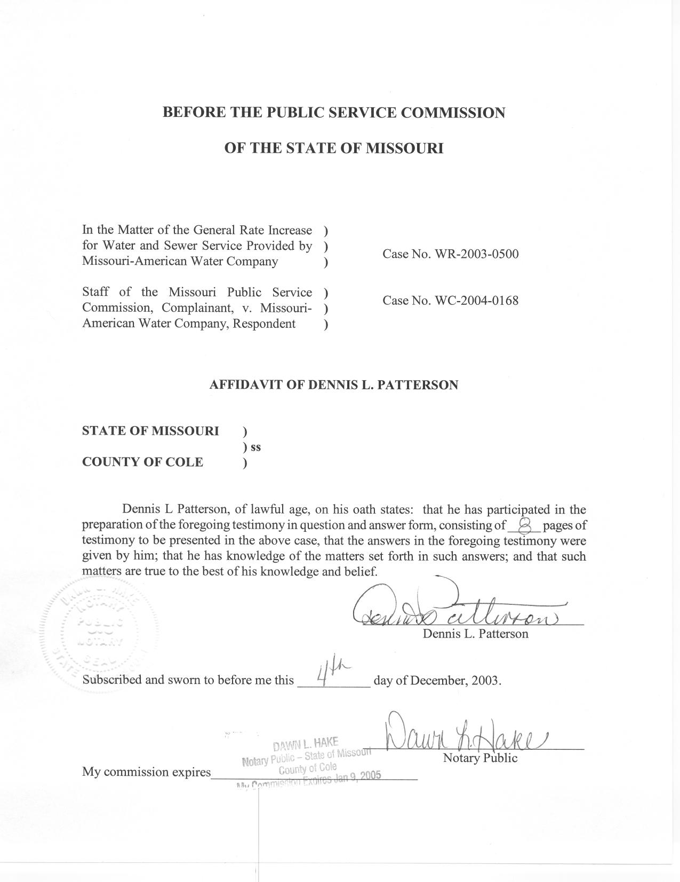
SURREBUTTAL TESTIMONY
OF
DENNIS L. PATTERSON
CASE NOS. WR-2003-0500 & WC-2004-0168

Q. Are you the same Dennis L. Patterson that has submitted direct and rebuttal testimony in this case?
A. Yes, I am.
Q. What is the purpose of your surrebuttal testimony?
A. I will address the rebuttal testimony of Company witness Edward L. Spitznagel, Jr., PhD., regarding water usage for the Quarterly Residential class of the St. Louis County (SLCW) district of the Company. In doing so, I will establish that reported test year sales for SLCW quarterly residential customers includes anomalies that are not recurring in nature.
Q. What issues from Dr. Spitznagel’s rebuttal testimony will you address?
A. I will address an erroneous assumption that underlies the following statement:
“If the equation is reliable, by setting DUMMY equal to 0, we should also be able to use it to estimate the actual consumption in 2002, including the missing quarter year’s consumption of the 14,500 Florissant customers.” (Spitznagel rebuttal, page 3, line 11.)
Q. What is the erroneous assumption that underlies this statement?
A. Dr. Spitznagel made the erroneous assumption that the DUMMY coefficient from my linear regression model accounts only for missing bills from customers that were connected after the test year had begun.
Q. What are the implications of the erroneous assumption?
A. The figures Dr. Spitznagel cites thereafter do not address the problem at hand, namely, all usage that is not accounted for in anomalous data for the test year. That is, although it addresses missing Florissant consumption, the model Dr. Spitznagel displays at his Schedule ELS-2R (Spitznagel rebuttal) is missing a coefficient for other usage that was not accounted for in the test year.
Q. How would you specify a model to address the usage not otherwise accounted for, given an estimate of unbilled usage from customers connected after the test year began?
A. I would specify an indicator variable (dummy) again. If the coefficient for the new indicator were not statistically significant, then one could assert that Dr. Spitznagel’s estimate of unbilled usage for the new customers has indeed accounted for the anomaly.
Q. Have you calculated such a regression model?
A. Yes. The results are displayed at Schedule 1. The indicator variable, UNCOUNT, has been added to the model in Dr. Spitznagel’s Schedule ELS-2R, where unbilled Florissant usages had been added to the 2002 data point.
Q. Was the coefficient for UNCOUNT statistically significant?
A. Yes. It was highly significant. Based on the assumption that there were about 310,435 customers connected during the test year, and assuming that Dr. Spitznagel’s estimate of Florissant usage is correct, almost exactly 20 gallons per customer per day were still unaccounted for in the test year.
Q. What does this indicate?
A. This indicates that the Florissant adjustment proposed by Dr. Spitznagel does not account for the entire anomaly. In fact, if the new customers are indeed responsible for the 2002 anomaly, it would appear that they are pumping water into the system through their meters. Since this is ridiculous, there must exist other factors that contribute to usage unaccounted for in the test year.
Q. Where have you addressed these factors?
A. I have addressed these factors in my supplemental direct testimony, which will be filed should the Commission grant Staff’s motion to file said testimony.
Q. What are these additional factors?
A. They include a single reduction in sales that is apparent in April of the second quarter of the test year, and several instances where thousands of customers were re-routed from one billing cycle to another during the test year.
Q. What was the nature of the reduction in April sales during the test year?
A. Monthly sales for SLCW quarterly Residential customers are charted on the graph at Schedule 2 attached to my surrebuttal testimony, while monthly customer bills for this class are charted on the graph at Schedule 3, also attached to my surrebuttal testimony. Please note that the quarterly sales for the April group of billing cycles was only 1,657,728 thousands of gallons in the test year, even though sales for most years approach 2,000,000 thousands of gallons (Schedule 2). Also, please note that the number of customers in the April cycles had changed very little from the previous quarter (Schedule 3).
Q. Have such reductions occurred before 2002?
A. Yes, but only twice since 1990. A similar reduction occurred in April of 1993 (a 500-year flood year that followed re-routing in 1992). A second such reduction occurred in 1998; however, customers were redistributed among the billing cycle routes in that sales quarter.
Q. What was the average of April sales in most billing years?
A. The average of April sales in all the remaining years between 1990 and 2001 is 1,994,263 thousands of gallons.
Q. What is the magnitude of the reduction in sales for April of the test year?
A. It would therefore appear that April sales alone are about 336,534 thousands of gallons too low in the test year (1,994,263-1,657,728 thousands of gallons).
Q. What do you believe was the cause of this anomaly?
A. Since tens of thousands of customers were redistributed among the billing cycles in the first two quarters of the test year, and since an April reduction was twice associated with similar events in previous years, I believe the customer redistribution in 2002 is an obvious cause of the anomaly.
Q. How do you believe this anomaly should be addressed?
A. This event should only be repeated infrequently in the future. Therefore, test year sales should be adjusted to reverse the reduction in April sales. That is, an adjustment of 336,534 thousands of gallons should be added to test year sales, in addition to the 219,349 thousands of gallons that Dr. Spitznagel believes should be added for missing Florissant consumption.
Q. Have you performed your calculations where the April reduction was reversed?
A. Yes. I have calculated a linear regression where 336,534 thousands of gallons for April and 219,349 thousands of gallons for Florissant, or a total of about 555,883 thousands of gallons, were added to the St. Louis County Quarterly Residential test year sales. The model still includes the indicator variable UNCOUNT. The results are displayed at Schedule 4 attached to my surrebuttal testimony.
Q. What were the results of this analysis?
A. The reversal of the April sales reduction improves unaccounted for sales in 2002, so that the UNCOUNT coefficient is now reduced to about -17 gallons per customer per day. This means that test year sales are still too low by about 1,931,149 thousands of gallons over the 12 billing months.
Q. What do you believe has caused the test year sales to be low by this amount?
A. I believe that the massive rerouting of tens of thousands of customers among the billing cycles has either caused the reduction directly by shortening the billing year for some customers (Schedule 3), or has masked some other isolated anomaly similar to the reduction in April sales that I have quantified above (graph at Schedule2; analysis at Schedule 4). I suspect it is a combination of such events.
Q. Can you quantify at least one instance where the test year was shortened for some customers?
A. Yes. Please refer to the chart at Schedule 3 and the quarterly customer bills data in Schedule 5, which are attached to my surrebuttal testimony. In the third quarter of 2002, July customers increased by 12,781 customers while August customers decreased by 5,565 customers, and while September customers decreased by 1,136 customers (Schedule 5). Therefore 5,565 customers were read in July that had formerly been read in August. As a consequence, their July bill was only two months in length. Their October bills will be the normal length, however, and will include most of the summer usage that would formerly have appeared in their November bills. Ignoring any residual summer usage, these 5,565 customers would be billed for three quarters of about 91 days and one quarter of only about 61 days. Thus, they will not be billed for 31 days each of base usage that they would normally have used during the test year. Similarly, 1,136 customers will not be billed for 61 days of the test year.
Q. What would the base usage be for one these 6,701 customers?
A. One estimate would be the average daily usage for the winter months of January, February and March of 2001, which were not disturbed by re-routing. During these three months (or 92 nominal billing days), 6,419,019 thousands of gallons were sold and 293,456 bills were issued. This works out to (6,419,019 * 1,000)/( 293,456*92) = 237.8 gallons per customer per day for base usage.
Q. What would the total reduction in annual sales be for these 6,701 customers?
A. The total reduction in annual base sales for these 6,701 customers would be: 237.8 gcd * (5,565 customers * 31 days + 1,136 customers * 61 days)/1,000 equals 57,503 thousands of gallons.
Q. Have you calculated a regression analysis where this adjustment has been applied to test year sales?
A. Yes. This adjustment leads to the regression model at Schedule 6, attached to my surrebuttal testimony. The test year volumes have risen to 32,068,258 thousands of gallons, the observed usage has risen to 282.8 GCD, and the unaccounted for usage now stands at UNCOUNT = -16.5 GCD. However, the weather-normalized GCD stands unchanged at 292.05 GCD as before.
Q. Have you calculated similar adjustments for all the rerouting events that are evident on the chart in Schedule 3?
A. No. However, the results from analysis of the third-quarter rerouting establish that the consequences would definitely be material. Just as importantly, since the reroutes are so massive in the initial two quarters of the test year, they could easily mask such events as the drop in April sales that I quantified in the discussion above and in the analysis at Schedule 4.
Q. What have you established with your discussion?
A. I have established that the test year sales included a number of very large reductions in sales that are not recurring in nature.
Q. Do you believe it is necessary to quantify every such reduction?
A. I believe this would be desirable, but that it would not be necessary given that the test year deficit is an anomaly.
Q. What do you recommend?
A. I recommend that 292.05 gallons per customer per day be used to calculate adjusted test year sales for the test year in this rate case. That is, the test year total actual sales should be adjusted upward by the number of thousands of gallons that would be calculated by using the DUMMY coefficient in the model I sponsored in my written supplemental direct testimony, which will be filed should the Commission grant Staff’s motion to file said testimony.
Q. What do you recommend to avoid contention on similar issues in the future.
A. As I state in my written supplemental direct testimony, which will be filed should the Commission grant Staff’s motion to file said testimony, I recommend that a reporting system of electronic monthly and quarterly billing cycle data be established for all districts of the Company, and that it be modeled after the successful system that has been established for Laclede Gas Company. The data should be submitted to the Staff and Public Counsel every month, in a format that could easily be analyzed with such tools as personal computer spreadsheets.
Q. Does this conclude your written surrebuttal testimony?
A. Yes, it does.

