Exhibit No.:
Issues: Weather Normalization
Witness: Dennis Patterson
Sponsoring Party: MoPSC Staff
Type of Exhibit: Direct Testimony
Case No.: ER-2002-424
Date Testimony Prepared: August 16, 2002

MISSOURI PUBLIC SERVICE COMMISSION

UTILITY OPERATIONS DIVISION

DIRECT TESTIMONY

OF

DENNIS PATTERSON

THE EMPIRE DISTRICT ELECTRIC
COMPANY

CASE NO. ER-2002-424

Jefferson City, Missouri
August, 2002

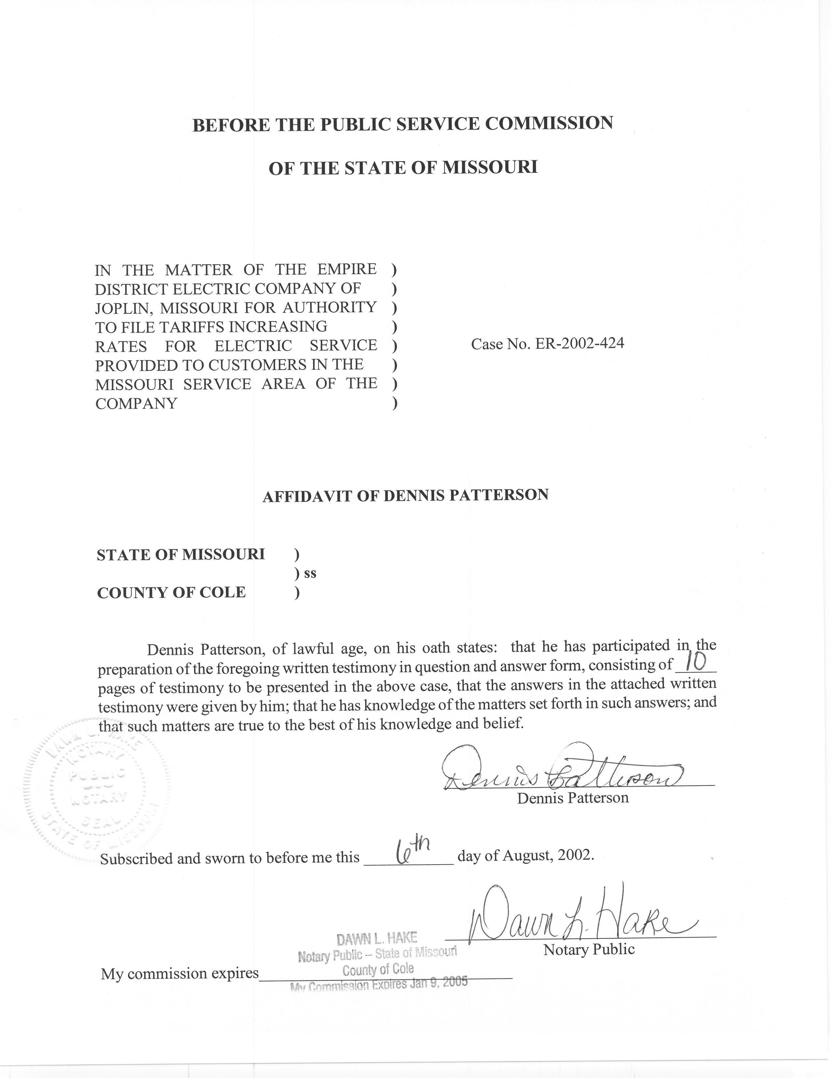
TABLE OF CONTENTS

SUMMARY 2
THE DEFINITION OF NORMAL WEATHER 3
TEMPERATURE MEASUREMENT INCONSISTENCIES 4
CALCULATION OF DAILY TEMPERATURES FOR THE NORMALS PERIOD 9

DIRECT TESTIMONY
OF
DENNIS PATTERSON
EMPIRE DISTRICT ELECTRIC COMPANY
CASE NO. ER-2002-424

Q. Please state your name and business address.
A. My name is Dennis Patterson and my business address is Missouri Public Service Commission, P. O. Box 360, Jefferson City, Missouri, 65102.
Q. What is your present position with the Missouri Public Service Commission (Commission)?
A. I am a Regulatory Economist in the Energy Department of the Utility Operations Division.
Q. Please review your educational background and work experience.
A. I was trained as an officer and aviator in the U.S. Army. I studied economics, math, sciences and languages, receiving a B.A. in Latin American Studies (University of Missouri, 1983) and an M.S. in Agricultural Economics (University of Missouri, 1989). I joined the Staff of the Commission in April, 1986. I established the Staff's centralized weather database, and have continued to maintain and improve it by obtaining data and applying methods from reliable sources. I have been employed by the Commission, the Missouri Army National Guard, the University of Missouri, U.S. Army Reserves, and the U.S. Army.

SUMMARY
Q. Please summarize the issues, position, method, process and products that you describe in your written direct testimony.
A. The relevant issue is weather normalization of test year electricity sales. The specific position I espouse in my testimony is that temperatures from the Springfield Regional Airport (SGF) should be used to perform the weather normalization in this case. I will explain my method of tabulating a history of daily maximum temperatures and daily minimum temperatures for SGF that are consistent with daily maximum and daily minimum temperatures that were measured at SGF during the test year. Where it is not otherwise explained, the term “temperatures” will refer to daily maximum temperature and daily minimum temperature.
I provided SGF temperatures to Staff witnesses Lena M. Mantle and Richard J. Campbell in the present Empire District Electric Company (EDE) rate case, Case
No. ER-2002-424. This included an observation of each day’s temperatures for all days from January 1, 1971 through March, 2002. Daily temperatures dating from January 1, 1971 through December 31, 2000 contain adjustments that bring them into agreement with published normals from the National Oceanic and Atmospheric Administration (NOAA). The large data set containing these daily temperatures for SGF is provided in my work papers. In her direct testimony, Ms. Mantle explains how she used this information to calculate normal weather variables.
Q. Are the methods you applied in this case consistent with those used in previous cases?
A. Yes. The Commission accepted this methodology in the Report and Order for the Missouri Gas Energy rate case, Case No. GR-96-285. I developed the methodology in 1992, well in advance of the 1996 report and order, and have continued to apply it consistently since 1994 for weather normalization in electric, natural gas and water cases.
Q. How is the remainder of your direct testimony organized?
A. The remainder of my written direct testimony is organized as follows:
- THE DEFINITION OF NORMAL WEATHER.
- TEMPERATURE MEASUREMENT INCONSISTENCIES.
- THE CALCULATION OF DAILY TEMPERATURES FOR THE NORMALS PERIOD.

THE DEFINITION OF NORMAL WEATHER

Q. What are weather normals?
A. “Normals have been defined as the arithmetic mean of a climatological element computed over a long time period.” (Climatography of the United States No. 81 Monthly Station Normals of Temperature, Precipitation, and Heating and Cooling Degree Days, 1971-2000, 23 MISSOURI, NOAA, National Environmental Satellite, Data, and Information Service, National Climatic Data Center, Asheville, North Carolina). NOAA applies this concept to temperature by calculating 30-year temperature normals as monthly averages for both maximum daily temperatures and minimum daily temperatures.
Q. What period is used by NOAA in its calculations of its 30-year temperature normals?
A. NOAA uses the three most recent decades, which are currently the thirty years ending December 31, 2000. International agreements among members of the World Meteorological Organization, and its predecessor, the International Meteorological Committee, have established that three-decade periods are appropriately long and uniform periods for the calculation of normals. NOAA recalculates 30-year normals at the end of each decade as a way of dealing with changes in measurement conditions and changes in the climate itself.
Q. Has the Commission made any findings with respect to the use of NOAA’s 30-year normals?
A. Yes. The use of the NOAA 30-year normals and 30-year normals period complies with a provision of the Commission’s Report and Order in the Missouri Gas Energy rate case, Case No. GR-96-285. At page 18, the Commission’s Report and Order states: “The Commission finds that NOAA’s 30-year normals is the more appropriate benchmark . . . In addition, the data upon which Staff’s recommendation is based has gone through the processes established by NOAA to ensure the best data possible.”

TEMPERATURE MEASUREMENT INCONSISTENCIES
Q. What type of weather station is maintained at SGF?
A. SGF has a first-order weather station. A first-order weather station is usually located at a regional or municipal airport, where the weather instruments are continuously monitored by professional observers. The instruments record hourly observations of precipitation, temperature, dew point, wind and other weather elements, as well as the daily maximum and minimum temperatures from which monthly normals are calculated. In contrast, cooperative weather stations are usually manned by trained volunteers who record daily observations. When monthly temperature normals are calculated for first-order stations and selected cooperative stations, special measures are taken to insure that all the years of monthly temperatures in the calculations are consistent. To achieve this consistency, NOAA makes adjustments to the historical monthly temperatures for the effects of changes in observation practice, changes in instrument type, and changes in instrument location.
Q. Are the daily maximum and minimum temperatures drawn from the hourly temperatures?
A. No. Separate liquid-in-glass instruments called extreme thermometers were formerly used to measure the maximum and minimum temperatures that had occurred since readings from the previous day. Modern instruments measure and record the 24-hour instantaneous extreme temperatures electronically. The recorded daily maximum temperature will usually be greater than the highest of the 24 hourly measurements, while the recorded daily minimum temperature will usually be less than the lowest hourly measurement. The recorded mean daily temperature is defined as the average of the daily maximum and minimum temperatures, and will usually be different than the average of the 24 hourly temperatures.
Q. When are daily temperatures published for these stations?
A. For first-order and cooperative stations, the original daily temperatures are first subjected to quality checks. When the quality checks are complete, the daily temperatures are deemed official, published on the Internet, and printed in monthly publications.
Q. What are monthly average temperatures?
A. Monthly average temperatures are the simple arithmetic averages of the daily maximum, minimum and mean temperatures over the days of each month.
Q. When are monthly average temperatures published?
A. Monthly average temperatures are published at the same time as the daily temperatures are published. At the end of each decade, NOAA makes adjustments to these monthly averages for changes in measurement conditions, and then calculates 12 monthly normal temperatures as averages from the thirty years of 12 monthly averages of daily temperature observations.
Q. Did the temperature data series for SGF include any inconsistencies?
A. Yes. The weather instruments have been moved and instrument types have been changed several times since 1971. Events of this nature are called exposure changes. Exposure changes are documented in 1980, 1985, 1986, 1988, 1994 and 1995 in the “2001 LOCAL CLIMATOLOGICAL DATA ANNUAL SUMMARY WITH COMPARATIVE DATA, SPRINGFIELD, MISSOURI (SGF)” (Asheville, North Carolina: National Climatic Data Center, 151 Patton Avenue, Rm 120, Asheville NC 28801-5001). (Annual Summary).

Q. Has NOAA calculated adjustments for all of these exposure changes?
A. No. Some of the events had no significant effects.
Q. Which years had temperatures that were adjusted and which did not?
A. NOAA applied adjustments for exposure changes that occurred in 1978, 1984, 1990 and 1995. The adjustments were applied to monthly averages of daily maximum and daily minimum temperatures from the years before 1996, and were intended to cause the temperature readings to correspond with those from the current weather instrument installation at SGF, namely, the Automated Surface Observing System (ASOS). Consequently, temperatures for the years from 1996 forward are the baseline, and contain no adjustments.
Q. Were the exposure change adjustments the same for monthly averages of daily maximum and daily minimum temperatures?
A. No. The exposure changes had different effects on the warm daytime temperature readings (when the maximum usually occurred) than they had on cool pre-dawn temperature s (when the minimum usually occurred).
Q. Were the exposure change adjustments the same in all months of each year?
A. No. The exposure changes had effects that differed among the months.
Q. How large were the temperature adjustments?
A. Recorded monthly average (mean daily) temperatures, NOAA’s adjusted monthly average (mean daily) temperatures, and adjustments calculated as the difference between the two (adjusted minus recorded) are displayed at Schedule 1-1 through 1-3. The adjustments to monthly average (mean daily) temperature varied from month to month in each year that received adjustments. Over the years, these adjustment varied in magnitude from –0.63 degrees Fahrenheit (F) to +1.60 degrees F. The more detailed adjustments for monthly averages of daily maximum and daily minimum temperatures are included in my working papers.
Q. How did NOAA calculate the adjustments for the monthly average temperatures?
A. The adjustments were calculated with reference to monthly temperatures at surrounding stations from the US Historical Climatological Network (USHCN). Monthly temperature data for USHCN weather stations have been extensively adjusted for observation times different from midnight-to-midnight, exposure changes and urban warming, and have therefore been made as consistent as possible.
Q. Does NOAA publish monthly temperature adjustments for the 1971-2000 normals period at SGF?
A. No. However, the user of the data can calculate the adjustments as differences between recorded monthly temperatures and adjusted monthly temperatures from NOAA normals products (Please see Schedules 1-1, 1-2 and 1-3). NOAA publishes these adjusted monthly average maximum temperatures and adjusted monthly average minimum temperatures for SGF in the computer file, “TD-9641: 1971-2000 SEQUENTIAL TEMPERATURE AND PRECIPITATION” (Asheville, North Carolina: National Climatic Data Center, NOAA/NESDIS/NCDC, Federal Building, 37 Battery Park Avenue, Asheville, NC, 28801-2733). I will refer to these 360 observations containing adjusted monthly average maximum temperature and adjusted monthly average minimum temperature as the “NOAA sequentials” for SGF. The adjustment process is described in an undated narrative that was supplied with the data.
Q. Do published NOAA temperature normals for SGF contain adjustments from the NOAA sequentials?
A. Yes. NOAA’s normal temperatures for each of the 12 calendar months for SGF are calculated as the average the NOAA monthly sequentials, over thirty years.
Q. Have instrument moves and type changes occurred at SGF since the 1971-2000 normals were published?
A. No. None have been documented after the automated ASOS instrumentation was installed and was commissioned at the Regional Airport site in 1995.
Q. Based on this knowledge, what is your recommendation regarding temperature adjustments?
A. In the present case, I would recommend that Springfield temperature data be used, including NOAA’s adjustments over the normals period, 1971 through 2000.

CALCULATION OF DAILY TEMPERATURES FOR THE NORMALS PERIOD
Q. What kind of normal temperatures does the Staff use for weather normalizing electricity use?
A. Ms. Mantle calculates daily temperature normals, because electricity usage varies with daily temperatures.
Q. Does NOAA calculate daily normals for SGF that are consistent with the adjusted monthly temperatures?
A. Yes. Unfortunately, however, NOAA’s daily normal temperatures are calculated from a smooth curve over the days that has been fitted to published monthly normals, by a mathematical splining process that does not regain the lost information about the distribution of daily temperatures throughout the month. Although NOAA’s daily temperature normals are appropriate for the stated purpose of averaging normal climatic values over intervals of time, they are not appropriate for the purpose of normalizing electricity usage.
Q. How are the daily temperature distributions calculated for the normals period, 1971-2000?
A. Using the recorded daily temperatures, it is possible to calculate adjustments to match monthly averages contained in the NOAA monthly sequentials for the 1971-2000 normals period. By adding adjustments similar to those shown on Schedule 1-3 to observed maximum and minimum daily temperatures, the resulting data will have the same monthly average temperature as the NOAA monthly sequentials and the same daily temperature distribution as the observed daily temperatures.
Q. How did you crosscheck your results to make sure that the adjusted daily temperatures corresponded to NOAA’s normals?
A. As a crosscheck, I verified that the adjusted monthly averages of the daily maximum and minimum temperatures were equal to the monthly sequential temperatures used by NOAA to calculate its 30-year temperature normals. I also verified that the twelve 30-year monthly averages of the adjusted daily temperatures were equal to NOAA’s 12 monthly normal temperatures for SGF. The crosschecks were successful in this case, thus insuring that the adjusted daily temperature products that I supplied to Ms. Mantle, which are the temperatures she used to calculate the normal weather variables in the present case, did indeed correspond with the NOAA’s 1971-2000 30-year normals.
Q. Does this conclude your direct testimony?
A. Yes, it does.

