Exhibit No.:
Issues: Weather
Normalization

Witness: Dennis L. Patterson
Sponsoring Party: MO PSC Staff
Type of Exhibit: Direct Testimony
Case No.: ER-2004-0034 &
HR-2004-0024
(Consolidated)
Date Testimony Prepared: December 9, 2003

MISSOURI PUBLIC SERVICE COMMISSION

Utility Operations DIVISION

Direct testimony

OF

Dennis l. Patterson

Aquila, Inc.
d/b/a Aquila Networks – MPS

and Aquila Networks – L&p

CASE NOS. ER-2004-0034 & HR-2004-0024
(CONSOLIDATED)

Jefferson City, Missouri
December 2003

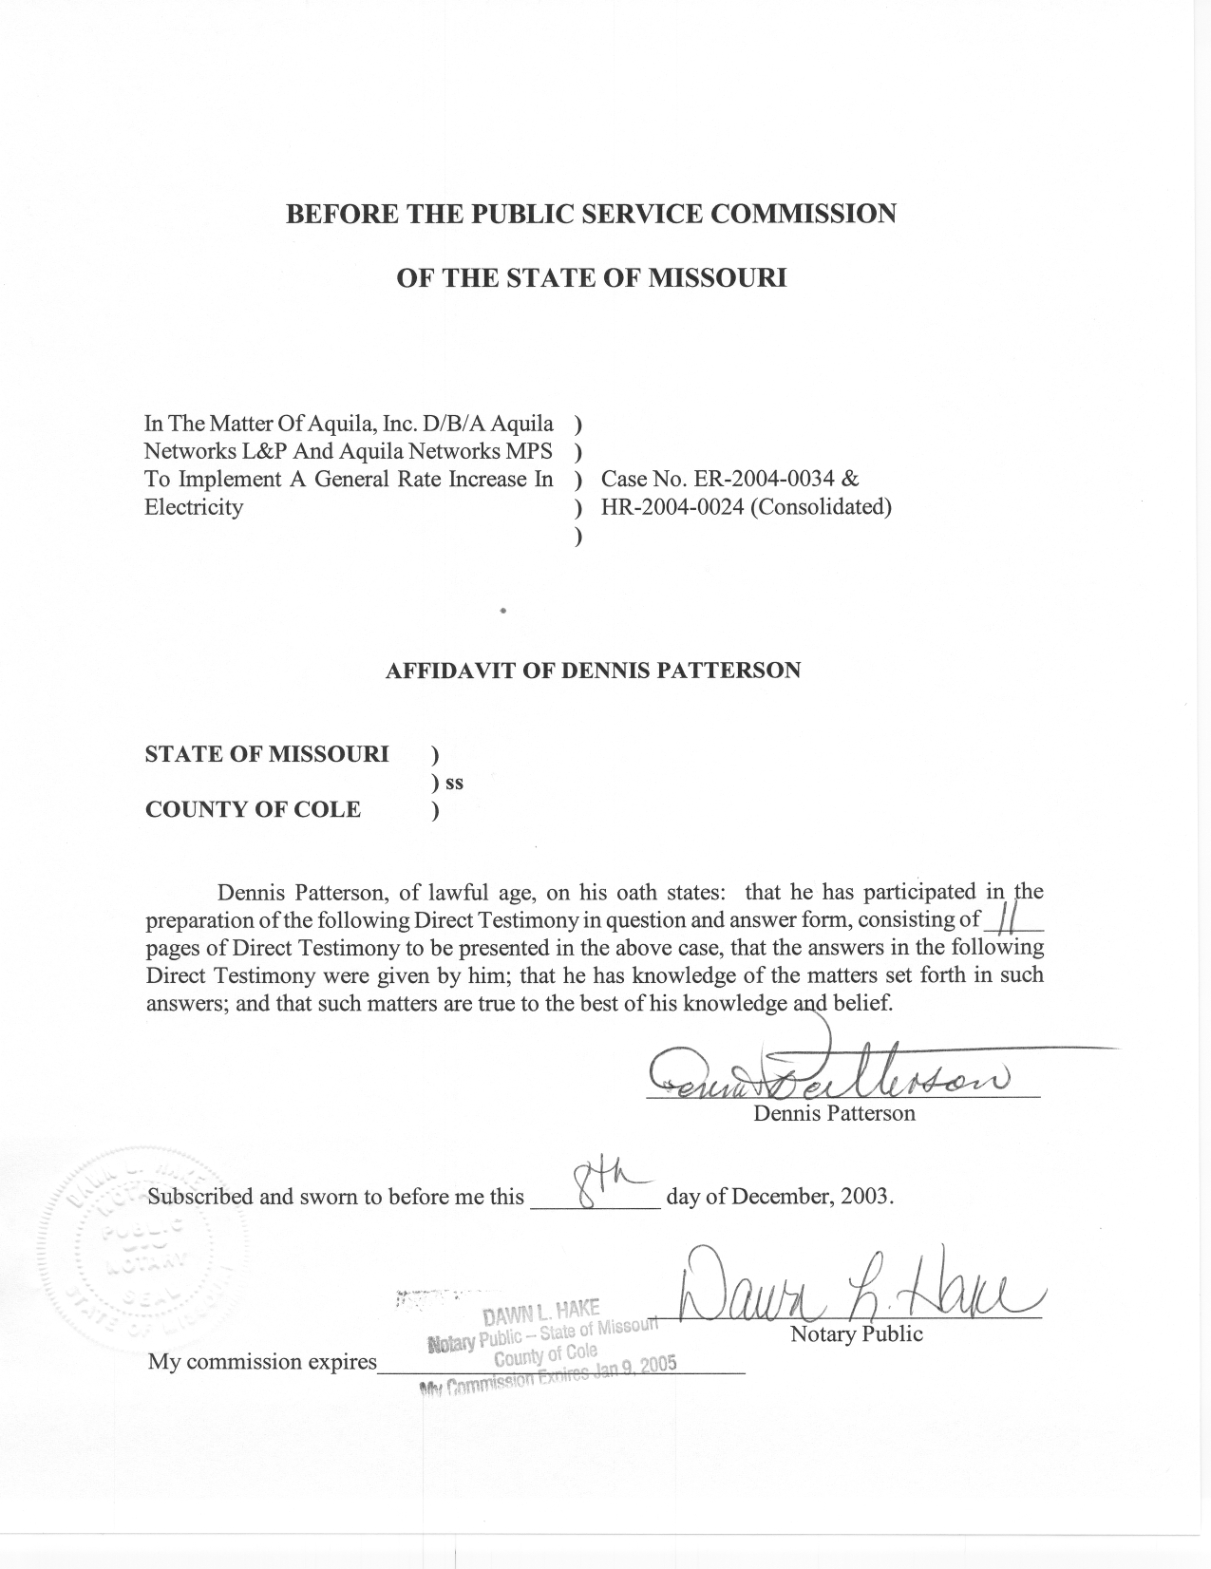
TABLE OF CONTENTS

SUMMARY 2
THE DEFINITION OF NORMAL WEATHER 3
TEMPERATURE MEASUREMENT INCONSISTENCIES 5
CALCULATION OF DAILY NORMAL TEMPERATURES 8

DIRECT TESTIMONY
OF
DENNIS L. PATTERSON
AQUILA, INC.
D/B/A AQUILA NETWORKS-MPS
AND AQUILA NETWORKS-L&P
CASE NOS. ER-2004-0034 and HR-2004-0024
(CONSOLIDATED)

Q. Please state your name and business address.
A. My name is Dennis L. Patterson and my business address is Missouri Public Service Commission, P. O. Box 360, Jefferson City, Missouri, 65102.
Q. What is your present position with the Missouri Public Service Commission (Commission)?
A. I am a Regulatory Economist in the Electric Department of the Utility Operations Division.
Q. Please review your educational background and work experience.
A. I was trained as an officer and aviator in the U.S. Army. I studied economics, math, sciences and languages at the University of Missouri, receiving an M.S. in Agricultural Economics (1989) and a B.A. in Latin American Studies (1983). I joined the Staff of the Commission in April, 1986. I established the Staff's centralized weather database, and have continued to maintain and improve it by obtaining data and applying methods from reliable sources. I have been employed by the Commission, the Missouri Army National Guard, the University of Missouri, U.S. Army Reserves, and the U.S. Army. I have retired, but continue to work part-time for the Commission.

SUMMARY
Q. To which of the Aquila, Inc. (Aquila) operations are you directing your testimony?
A. This testimony only addresses the electric operations of Aquila in Missouri.
Q. Please summarize the issues, position, method, process and products that you describe in your written direct testimony.
A. The relevant issue is weather normalization of test year electricity sales. The specific position I espouse in my testimony is that temperatures from the Kansas City International Airport (KCI) should be used to perform the weather normalization in this case. I will explain my method of tabulating a history of daily maximum temperatures and daily minimum temperatures for KCI that are consistent with daily maximum and minimum temperatures that were measured during the test year. Where it is not otherwise explained, the term “temperatures” will refer to daily maximum temperature and daily minimum temperature.
I provided the consistent history of KCI temperatures to staff witness Richard J. Campbell. The history included an observation of each day’s temperatures for all days from January 1, 1971 through the last billing month of the test year, which ends in December of 2002. The daily temperatures dating from January 1, 1971 through December 31, 2000 contain adjustments that cause them to correspond with published normals from the National Oceanic and Atmospheric Administration (NOAA). The large data set containing these daily temperatures for KCI is provided in my working papers. In his direct testimony, Mr. Campbell will explain how he used this information to calculate actual and normal weather.
Q. Are the methods you applied in this case consistent with those used in previous cases?
A. Yes. The Commission accepted this methodology in the Report and Order for the Missouri Gas Energy rate case, Case No. GR-96-285. I developed the methodology in 1992, well in advance of the 1996 Report and Order, and have continued to apply it consistently since 1994 for weather normalization in electric, natural gas and water cases.
Q. What are the contents of your written direct testimony?
A. I have organized my written direct testimony in the following sections:
I. THE DEFINITION OF NORMAL WEATHER.
II. TEMPERATURE MEASUREMENT INCONSISTENCIES.
III. THE CALCULATION OF DAILY NORMAL
TEMPERATURES.

THE DEFINITION OF NORMAL WEATHER

Q. What are weather normals?
A. “A climate normal is defined, by convention, as the arithmetic mean of a climatological element computed over three consecutive decades (WMO, 1989).” (Climatography of the United States No. 81 Monthly Station Normals of Temperature, Precipitation, and Heating and Cooling Degree Days, 1971-2000, MISSOURI, NOAA, National Climatic Data Center, Asheville, North Carolina). In this quotation, “WMO” stands for World Meteorological Organization. NOAA applies this concept to temperature by calculating thirty-year temperature normals as monthly average maximum temperature and monthly average minimum temperature, using the Fahrenheit scale.
Q. What period is used by NOAA in its calculations of its thirty-year temperature normals?
A. NOAA uses the three most recent consecutive decades, which are currently the thirty years ending December 31, 2000. International agreements among members of the World Meteorological Organization, and its predecessor, the International Meteorological Committee, have established that three-decade periods are appropriately long and uniform periods for the calculation of normals. NOAA recalculates thirty-year normals at the end of each decade as a way of dealing with changes in measurement conditions and changes in the climate itself. The 1971-2000 normals were published in February, 2002.
Q. Has the Missouri Public Service Commission (Commission) made any findings with respect to the use of NOAA’s thirty-year normal?
A. Yes. The use of the NOAA 30-year normal and 30-year normals period complies with a provision of the Commission’s Report and Order in the Missouri Gas Energy rate case, Case No. GR-96-285. At page 18, the Commission’s Report and Order states: “The Commission finds that NOAA’s 30-year normals is the more appropriate benchmark . . . In addition, the data upon which Staff’s recommendation is based has gone through the processes established by NOAA to ensure the best data possible.”

TEMPERATURE MEASUREMENT INCONSISTENCIES
Q. What type of weather station is maintained at KCI?
A. KCI has a first-order weather station. A first-order weather station is usually located at a regional or municipal airport, where the weather instruments are continuously monitored by professional observers. The instruments record hourly temperature observations. Records are also kept of the maximum and minimum temperatures for the 24-hour day ending at midnight. In contrast, cooperative weather stations are usually manned by trained volunteers who visit the instruments at scheduled hours in the morning or afternoon, to record the maximum and minimum temperatures for the 24 hours ending at the time of the observation.
When temperature normals are calculated for first-order stations and selected cooperative stations, special measures are taken to insure that all the years of temperatures in the calculations are consistent. To achieve this consistency, NOAA makes adjustments to the historical temperatures for the effects of changes in observation practice, changes in instrument type, and changes in instrument location.
Q. When are temperatures published for these stations?
A. For first-order and cooperative stations, the original daily temperatures are first subjected to quality checks. When the quality checks are complete, the daily temperatures are deemed official and printed in monthly publications. When the daily temperatures are published, monthly average temperatures are published with them. After making adjustments for changes in measurement conditions, NOAA eventually calculates normal monthly temperatures from the monthly averages of daily temperature observations.
Q. Did the temperature data series for KCI include any exposure changes?
A. Yes. There have been four exposure changes listed since 1971. First, the weather station was moved in 1972, from the urban river bottom location at the Kansas City Municipal Airport to the current prairie location at KCI. The former urban location was at 742 feet elevation, while the current location is at 1,014 feet elevation. This event is documented in the “2000 LOCAL CLIMATOLOGICAL DATA ANNUAL SUMMARY WITH COMPARATIVE DATA, KANSAS CITY, MISSOURI” (Asheville, North Carolina: National Climatic Data Center, 151 Patton Avenue, Room 120, Asheville NC 28801-5001). (Annual Summary.) Second, the Annual Summary also includes an entry for a site change of two miles in April 1979. Third, there was a thermometer type change in October 1984. Finally, the Automated Surface Observing System (ASOS) was commissioned in July of 1995. These exposure changes took place during the 1971-2000 normals period.

Q. Did NOAA calculate adjustments for the inconsistencies that occurred during the normals period?
A. Yes. NOAA calculated monthly adjustments for the 1972 station change, the site move of 1979, and the instrument type change of 1984, in such a way that all months from January, 1971 through December, 1985 contain temperature adjustments. However, the NOAA adjustment for any exposure change from the 1995 ASOS installation was zero for all months.
Q. How did NOAA calculate these adjustments?
A. NOAA calculated these adjustments with reference to monthly average temperatures at surrounding stations where no exposure changes took place for a sufficient length of time before and after the dates of the exposure change at KCI. Adjusted monthly average maximum temperatures and adjusted monthly average minimum temperatures for KCI are published by NOAA in computer tape deck (TD) files, “1971-2000 SEQUENTIAL TEMPERATURE AND PRECIPITATION,” (the “NOAA Sequentials”) that are included with the product, CLIM81 1971-2000 NORMALS, MONTHLY STATION NORMALS OF TEMPERATURE, PRECIPITATION, AND DEGREE DAYS, TD-9641C, National Climatic Data Center, Federal Building, Asheville, North Carolina, August 31, 2001 (TD-9641C). The TD-9641C Climate 81 Normals documentation and files were released in February, 2002. The TD-9641C NOAA Sequentials contain 360 observations of adjusted monthly average maximum temperature and adjusted monthly average minimum temperature for KCI for the years 1971 through 2000. The adjustment process is well described in Section 58 of TD-9641C documentation, which has been included with my work papers.
Q. Do published NOAA temperature normals for KCI contain adjustments from the NOAA sequentials?
A. Yes. NOAA’s normal temperatures for the 12 calendar months for KCI are each calculated as the average of all the adjusted temperatures observations for that month, over thirty years, from the NOAA sequentials.
Q. Has NOAA calculated adjustments for exposure changes that occurred after the year 2000?
A. No. While the earlier exposure changes were adjusted when the
1971-2000 normals were calculated, any exposure changes that occur after 2000 will not be addressed until the 1981-2010 normals are calculated and published.

CALCULATION OF DAILY NORMAL TEMPERATURES
Q. Do the NOAA monthly temperature normals contain sufficient detail for weather normalizing electricity use?
A. No, they do not. Daily temperature normals are also needed, because electricity usage varies differently at extreme daily temperatures than it does at mild ones.
Q. Does NOAA calculate daily normals for KCI that are consistent with the adjusted monthly normals?
A. Yes. Unfortunately, NOAA’s daily normal temperatures are calculated from a smooth curve that has been fitted to the monthly normals, by a mathematical splining process that does not regain the lost information about the distribution of daily extremes. Although NOAA’s daily temperature normals are appropriate for their stated purpose of averaging normal climatic values over intervals of time, they are not appropriate for the purpose of normalizing electricity usage.
Q. Is it possible to calculate daily temperature normals that include information about the distribution of extreme daily temperatures?
A. Yes. However, if daily temperature normals are to include the desired information about the distribution of days with extreme temperatures, then the daily normals must be calculated from properly adjusted daily temperature data that correspond with the NOAA normals.
Q. How is this correspondence insured?
A. Before daily temperature normals that are consistent with NOAA’s monthly normals can be calculated, it is first necessary to calculate properly adjusted daily temperature data for the NOAA normals period. Fortunately, it is possible to calculate the necessary adjustments by referring to the NOAA monthly sequentials for the 1971-2000 normals period. Thus, even though the thirty years of adjusted monthly temperature averages from the NOAA sequentials don’t provide the required information about days with extreme temperatures, they do serve a necessary and crucial function as a benchmark for making the daily temperature data consistent over the NOAA normals period.
Q. What information did you use to calculate adjusted daily temperatures for the thirty-year NOAA normals period?
A. I used two NOAA temperature data sets to make these calculations. First, I consulted the NOAA sequentials (above). This data set has 30 entries for each of the 12 calendar months, or 360 entries. As stated above, the average of these 30 adjusted values for each of the 12 months constitute NOAA’s 30-year normals. These 360 entries provide the benchmarks for adjusting actual daily temperatures in these months.
Second, I obtained official daily temperatures for the same 30-year time period from NOAA Internet sources such as the Midwest Climate Information Service and the National Climatic Data Center. The temperatures may also be compiled from other official NOAA data products and publications. The resulting data set includes the daily maximum and minimum temperatures for each day since January 1, 1971. In this data set, there are a total of 10,958 entries drawn from the 360 months in the 1971-2000 normals period. These are the actual daily temperatures that must be adjusted.
Q. How did you use the monthly sequentials to make the adjustments to daily temperatures?
A. First, over the years 1971 through 2000, I calculated monthly averages of the actual daily temperatures that had to be adjusted. This provided 360 observations containing monthly averages of both actual daily maximum temperature and actual daily minimum temperature.
Second, I calculated temperature adjustments for each month of each of the thirty years. This was done by subtracting each of the 360 monthly averages of actual daily maximum and actual daily minimum temperature that were just calculated, from the corresponding adjusted maximum and minimum temperature in the monthly sequentials described above.
Finally, I applied the temperature adjustments just calculated for each of the 360 months in the thirty years by adding them to the corresponding observations of daily actual temperatures. These calculations yielded 10,958 observations containing the adjusted daily maximum and adjusted daily minimum temperature, over the 360 months in the years 1971 through 2000.
Q. How did you crosscheck your results to make sure that the adjusted daily temperatures corresponded to NOAA’s normals?
A. For this crosscheck, I first took the monthly averages of the daily maximum and minimum temperatures that were just adjusted. I then verified that these monthly averages were equal to the benchmarks, which are the monthly sequential temperatures that were used by NOAA to calculate its 30-year temperature normals. I also verified that the twelve 30-year monthly averages of the adjusted daily temperatures were equal to NOAA’s 12 monthly normal temperatures for KCI. The crosschecks were successful in this case, thus insuring that the adjusted daily temperature products that I supplied to Mr. Campbell did correspond with the NOAA normals. The calculations and results appear in the personal computer spreadsheets that make up my work papers.
Q. Does this conclude your direct testimony?
A. Yes, it does.

