Exhibit No.:
Issues: Weather
Normalization

Witness: Dennis L. Patterson
Sponsoring Party: Mo PSC Staff
Type of Exhibit: Rebuttal Testimony
Case No.: WR-2003-0500 &
WC-2004-0168
Date Testimony Prepared: November 10, 2003

MISSOURI PUBLIC SERVICE COMMISSION

Utility Operations DIVISION

rebuttal TESTIMONY

OF

DENNIS L. PATTERSON

Missouri-American Water Company

CASE NO. WR-2003-0500 & WC-2004-0168

Jefferson City, Missouri
November 2003

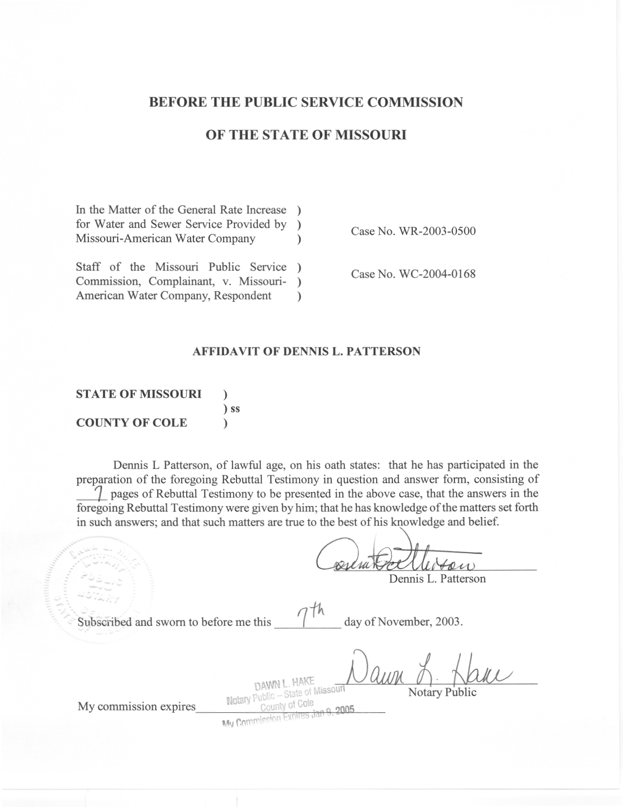
TABLE OF CONTENTS

SUMMARY 1

WHAT IS THE PDSI AND HOW IS IT CALCULATED? 2

THE NORTHEAST PRAIRIE PDSI IS INAPPROPRIATE FOR ANALYZING UTILITY WATER USAGE 2

THE NORTHEAST PRAIRIE PDSI AND CMI DO NOT APPLY TO THE ST LOUIS BILLING DISTRICT 4

THIRTY-YEAR AVERAGES OF PDSI ARE NOT CONSISTENT WITH CURRENT MEASUREMENTS 5

REBUTTAL TESTIMONY
OF
DENNIS L. PATTERSON
CASE NOS. WR-2003-0500 & WC-2004-0168
Q What is the purpose of your Rebuttal Testimony?
A. I will address the written Direct Testimony of Company witness Edward L. Spitznagel, Jr., PhD.
Q. Are you the same Dennis L. Patterson who has submitted written Direct Testimony in this case?
A. Yes, I am.

SUMMARY
Q. Please summarize your rebuttal of Dr. Spitznagel’s written Direct Testimony.
A. I will show that Dr. Spitznagel’s analysis for residential customers in the St. Louis County Water district (SLCW) is based on an inappropriate weather variable for the wrong geographical area. I will also note that the Dr. Spitznagel’s weather history was not adjusted for measurement changes to make it consistent throughout, so that averages or normals are unreliable.
Q. What weather variable did Dr. Spitznagel use in his analysis?
A. He used the Palmer Drought Severity Index (PDSI) for Missouri’s Climatological Division number 2, the Northeast Prairie division. The PDSI is also called the Palmer Drought Index (PDI). PDSI records are maintained by the National Oceanographic and Atmospheric Administration (NOAA).

WHAT IS THE PDSI AND HOW IS IT CALCULATED?

Q. What is the PDSI?
A. “The Palmer Drought Severity Index (PDSI) and Crop Moisture Index (CMI) are indices of the relative dryness or wetness effecting [sic] water sensitive economies.” (Explanation of the Palmer Drought Index, Midwestern Regional Climate Center, 11/6/2003, p. 1) (Written by NOAA’s Climate Analysis Center) (Schedule 1.) The document is available at the Midwestern Regional Climate Center web site.
Q. How is the PDSI calculated?
A. “The PDSI is based around a supply and demand model of the soil moisture at a location. The supply is the amount of moisture in the soil plus the amount that is absorbed into the soil from rainfall. The demand, however, is not so as [sic] easy to see, because the amount of water lost from the soil is [sic] depends on several factors, such as temperature and the amount of moisture in the soil.” (Documentation for the Original and Self-Calibrating Palmer Drought Severity Index used in the National Agriculture Decision Supporting System, Nathan Wells, Computer Science & Engineering, University of Nebraska-Lincoln, March 24, 2003, p. 2) (Nathan Wells) (Schedule 2.) The complete document is included in my working papers and may be found at http://nadss.unl.edu/.

THE NORTHEAST PRAIRIE PDSI IS INAPPROPRIATE FOR ANALYZING UTILITY WATER USAGE

Q. Why is the PDSI an inappropriate weather variable for the analysis of utility water usage?
A. The PDSI was not designed for the purpose.
Q. What was the PDSI designed for?
A. “The PDSI is an important climatological tool for evaluating the scope, severity, and frequency of prolonged periods of abnormally dry or wet weather. It can be used to help delineate disaster areas and indicate the availability of irrigation water supplies, reservoir levels, range conditions, amount of stock water, and potential intensity of forest fires.” (Climate Analysis Center, p. 1.)
Q. Why is the PDSI not appropriate for the analysis of utility water usage?
A. The PDSI is a monthly index, and was formulated for highlighting and evaluating “prolonged” conditions. It is therefore not useful for evaluating day-to-day changes. However, residential utility water usage varies from day to day, increasing from base household requirements to elevated lawn sprinkling levels as the soil dries in hot dry weather, and decreasing toward base usage again as the soil moisture improves in cooler and wetter weather.
Q. Are there other variables that might be more appropriate for the analysis of utility water usage?
A. Yes. Variables resembling the weekly Crop Moisture Index (CMI) might be more appropriate. “The CMI can be used to measure the status of dryness or wetness affecting warm season crops and field activities.” (Climate Analysis Center, p. 1.)
Q. Did Dr. Spitznagel attempt to use the Northeast Prairie CMI to perform his analysis?
A. Yes, it appears that he did. Dr. Spitznagel attempted to use the “available soil moisture index in Missouri at that time.” (Spitznagel Direct Testimony, page 4, line1.)
Q. Was he successful?
A. No. It “did not correlate nearly as well.” (Ibid.)
Q. Why do you believe this occurred?
A. I believe that the generalized Northeast Prairie CMI might not correlate well with water usage in a more specific area within St. Louis County.

THE NORTHEAST PRAIRIE PDSI AND CMI DO NOT APPLY TO THE ST LOUIS BILLING DISTRICT

Q. Why doesn’t the Northeast Prairie PDSI apply to the St. Louis billing district of Missouri American Water Company?
A. Neither the PDSI nor the CMI apply to specific locations. This caveat is also found in the document cited above: “Both indices indicate general conditions and not local variations caused by isolated rain.” (Climate Analysis Center, p. 1.)
Q. Do special characteristics of the St. Louis district make it different from the Northeast Prairie in general?
A. Yes. Much of St. Louis County is located in the Mississippi and Missouri River valleys, and is densely populated. St. Louis is also located at the extreme southeast corner of the Northeast Prairie division. These characteristics cause the local microclimate to be generally warmer and wetter that the higher, dryer and much more sparsely populated Northeast Prairie. The local microclimate might be distinctly different on many days because, for example, a mass of colder air from Minnesota might stall within an area as large as the Northeast Prairie, but fail to reach the remote corner where St. Louis is located.
Q. What could be the consequences of these differences on a specific summer day with precipitation?
A. Depending on temperatures and moisture levels in local air masses, conditions in the greater Northeast Prairie and in St. Louis could be quite different. On one day, thunderstorms could be prevalent in a moving Northeast Prairie squall line, while St. Louis County stayed dry. On another, the St. Louis area could be experiencing drizzle beneath a layer of Mississippi Valley stratus clouds, while the Northeast Prairie was clear, sunny and dry.
Q. Would the precipitation from such events not average out over time?
A. No. The generalized thunderstorms in the example could dump whole inches of rain in the countryside, while the local drizzle might deliver a couple of hundredths of an inch to St. Louis County. There is no reason to hope that only a few events of this diversity could compensate for each other in a period as short as a single billing year.

THIRTY-YEAR AVERAGES OF PDSI ARE NOT CONSISTENT WITH CURRENT MEASUREMENTS

Q. How did Dr. Spitznagel calculate normal PDSI?
A. He “inserted the thirty-year averages (from 1973 to 2002) of the Palmer Drought Severity Index for each of the months of April through December…” (Spitznagel Direct Testimony, page 8, line 7.) That is, he did not refer to a published NOAA normal but calculated his own.
Q. What would be the consequences of calculating normal PDSI himself?
A. By his own admission, Dr. Spitznagel calculated his normal from historical PDSI as it was recorded. If there had been changes in the way PDSI was calculated or measured, Dr. Spitznagel’s average or normal would not be consistent with measurements in the current year.
Q. Have there been any such changes?
A. Yes. Please recall that the PDSI is based on precipitation and temperature (Nathan Wells, p. 2.) Although PDSI has been calculated the same way since its inception, and although precipitation records aren’t often adjusted, there have been many changes in the way temperature measurements were recorded at the various weather stations in the Northeast Prairie division. The temperature record at each of these stations must be adjusted to match current measurement conditions before the 30 years of monthly PDSI and its 12 monthly normals might be calculated. These safeguards would ensure that the PDSI normals were consistent with the test year PDSI. It should be noted, however, that even these safeguards would not make the Northeast Prairie PDSI consistent with the St. Louis County Water service area.
Q. Where are the measurement changes and temperature adjustments described?
A. The measurement changes, need for adjustments, and the way they are calculated are described in detail in CLIM81 1971-2000 NORMALS, MONTHLY STATION NORMALS OF TEMPERATURE, PRECIPITATION, AND DEGREE DAYS, TD-9641C, National Climatic Data Center, Federal Building, Asheville, North Carolina, August 31, 2001. (Monthly Station Normals.) The title page of this document, and an extract that includes Topic 58 are attached to my written Rebuttal Testimony as Schedule 3.
Q. Where are measurement changes specifically mentioned?
A. These are first mentioned at Topic 58, page 27, of the Monthly Station Normals document: “Several adjustments were made to the data before the normals were calculated. These adjustments include estimating missing data, adjusting for time of observation bias, and adjusting for exposure changes.” Exposure changes would include changing the temperature observation schedule, moving the thermometers, changing the altitude of the thermometers, and changes in the type of thermometers that were used.
Q. Has the Public Service Commission made any findings with regard to the use of adjusted temperature data?
A. Yes. The use of historical temperature data that has been adjusted for exposure changes complies with the Commission’s Report and Order in the Missouri Gas Energy rate case, Case Number GR-96-285. In that case, Missouri Gas Energy (MGE) had calculated normal heating degree-days based on temperatures that had not been adjusted for exposure changes, while the Staff had applied NOAA’s adjustments. At Page 18 of the Report and Order, the Commission states, “In addition, the data upon which Staff’s recommendation is based has gone through the processes established by NOAA to ensure the best data possible. This safeguard is not present in MGE’s approach.”
Q. Is the safeguard present in Dr. Spitznagel’s approach?
A. No, it is not.
Q. Does this complete your written Rebuttal Testimony?
A. Yes, it does.

