Exhibit No.:
Issues: Aries Purchased
Power Agreement

Witness: Michael S. Proctor
Sponsoring Party: MO PSC Staff
Type of Exhibit: Surrebuttal Testimony
Case Nos.: ER-2004-0034
& HR-2004-0024
Date Testimony Prepared: February 13, 2004

MISSOURI PUBLIC SERVICE COMMISSION

Utility Operations DIVISION

SURREBUTTAL TESTIMONY

OF

MICHAEL S. PROCTOR

Aquila, Inc. d/b/a Aquila Networks--MPS
and Aquila Networks--L&P

CASE NOS. ER-2004-0034
& HR-2004-0024

Jefferson City, Missouri
February 2004
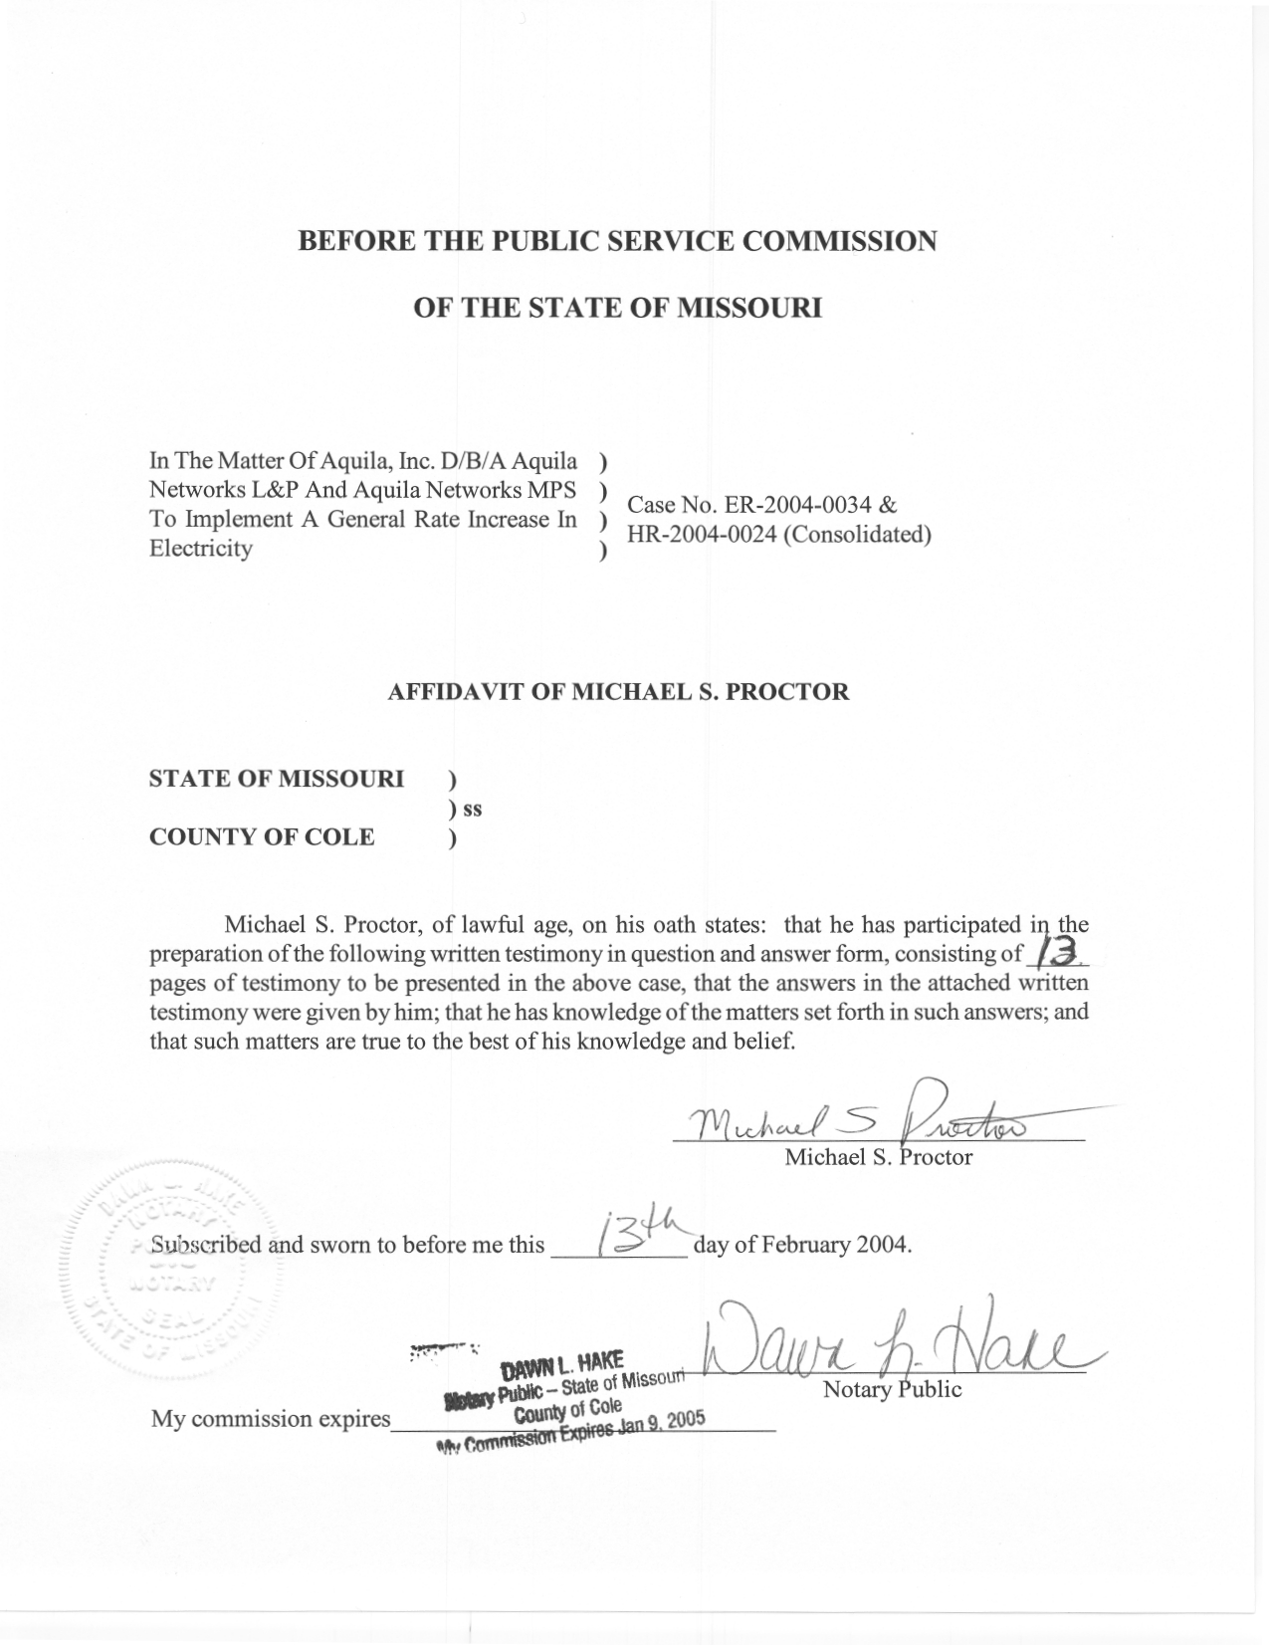
TABLE OF CONTENTS

PURPOSE AND SUMMARY OF SURREBUTTAL TESTIMONY 2
SURREBUTTAL OF MR. JON R. EMPSON 3
SURREBUTTAL OF MR. FRANK A. DEBACKER 4

SURREBUTTAL TESTIMONY
OF
MICHAEL S. PROCTOR
AQUILA, INC.
D/B/A AQUILA NETWORKS-MPS AND

AQUILA NETWORKS-L&P

CASE NOS. ER-2004-0034 AND HR-2004-0024
(CONSOLIDATED)
Q. What is your name and business address?
A. My name is Michael S. Proctor. My business address is 1845 Borman Court, Suite 101, St. Louis, MO 63146-4138.
Q. By whom are you employed and in what capacity?
A. I am employed by the Missouri Public Service Commission (Commission) as Chief Regulatory Economist in the Energy Department.
Q. What is your education background and work experience?
A. I have Bachelor and Master of Arts Degrees in Economics from the University of Missouri at Columbia, and a Ph.D. degree in Economics from Texas A&M University. Prior to coming to work for the Commission, I was an Assistant Professor of Economics at Purdue University and at the University of Missouri at Columbia. Since June 1, 1977, I have been on the Staff of the Commission and have presented testimony on various issues related to weather normalized energy usage and rate design for both electric and natural gas utilities. With respect to electric issues, I have worked in the areas of load forecasting, resource planning and transmission pricing. In 1997 and 1998, I served as the Staff Vice Chair of the Market Structure and Market Power Working Group of the Commission’s Task Force on Retail Competition. From December of 2000 to August of 2001, I served as chairman of the Forward Congestion Markets Subgroup of the Southwest Power Pool’s (SPP’s) Congestion Management Systems Working Group. I am also serving as the chairman of the Organization of Midwest ISO States (OMS) working group on congestion management and financial transmission rights allocations.
Q. What are your current duties in the Energy Department as Chief Regulatory Economist?
A. I have the responsibility of being actively involved with the development and structure of Regional Transmission Organizations (RTOs) for the purpose of increasing efficiency and reliability in the competitive supply of electricity at wholesale. From time-to-time, the Commission Staff (Staff) will request that I testify before the Commission respecting issues on which I may have specific knowledge. This surrebuttal testimony is an instance of where I have specific knowledge regarding the electric resource planning process and the power supply agreement/purchased power agreement (PSA/PPA) entered into between what is now called Aquila Networks-MPS (MPS or Company) and an affiliate. At the time the PSA/PPA was entered into, the affiliate, Missouri Energy Partners-Pleasant Hill, LLC (MEPPH), was offering capacity and energy from a combined cycle generation facility, now know as the Aries Plant.

PURPOSE AND SUMMARY OF SURREBUTTAL TESTIMONY
Q. What is the purpose of your surrebuttal testimony?
A. My surrebuttal testimony addresses issues raised in the rebuttal testimony of Mr. Jon R. Empson and Mr. Frank A. DeBacker regarding the Company’s reasons for entering into a PSA with an affiliate.
Q. What is the summary of your surrebuttal testimony?
A. First, contrary to assertions made by Mr. Empson in his rebuttal testimony, my surrebuttal is that, entering a PSA/PPA with an affiliate does not diminish the risk of stranded cost for the Company. Second, contrary to assertions made by Mr. DeBacker in his rebuttal testimony, in the Commission’s Order in Case No. EO-98-316, the Commission did not order the Company to use short-term capacity markets to acquire new supply-side resources through a competitive bidding process, and that such an interpretation of the Commission’s Order is contrary to the Commission’s policy of not pre-approving resources acquired by a regulated utility, and further is inconsistent with the Staff’s recommendation and the Commission’s order granting certain determinations regarding the PSA/PPA made in accordance with section 32(k) of the Public Utility Holding Company Act of 1935 as amended by the Energy Policy Act of 1992 [PUHCA].

SURREBUTTAL OF MR. JON R. EMPSON
Q. What rebuttal testimony of Aquila witness Mr. Jon R. Empson are you responding to?
A. At pages 2-5 of his rebuttal testimony, Mr. Empson rebuts Staff witnesses Cary G. Featherstone and Mark L. Oligschlaeger on the Staff’s position regarding the Aries Plant. This rebuttal testimony characterizes the Staff’s position as follows: “MPS, one of Aquila’s Missouri utility operating divisions, should have built the Aries Plant rather than entering into the competitively bid, low cost Purchased Power Agreement (‘PPA’) with Aquila’s affiliate
Mr. Empson cites four quotes from a report filed by the Staff on June 12, 1998 entitled, “Electric Restructuring Plan for the Competitive Supply of Generation in Missouri,” as evidence supporting the Company’s decision to enter into a PSA/PPA rather than to build a power plant. My rebuttal testimony is intended to put the Staff report in proper context, and show why this report does not support the Company’s decision to build the Aries Plant as non-regulated, Exempt Wholesale Generator (EWG) rather than as a regulated generation asset.
Q. What was the purpose of the Staff report entitled, “Electric Restructuring Plan for the Competitive Supply of Generation in Missouri?”
A. At the time, the Staff believed there was the possibility of legislation being passed in Missouri that would give open access to retail electricity customers of regulated, investor-owned utilities. The purpose of the report was to inform the Commission of the Staff’s perspectives on several issues related to this potential deregulation of retail electricity supply in Missouri. In essence, the report was not a recommendation to implement retail competition, rather a proactive set of recommendations on how best to respond to this possibility. Thus, any recommendations in this report were contingent on the decision of the state legislature to implement retail competition.
Q. As indicated by Mr. Empson, was stranded cost a major concern?
A. Recovery of stranded cost was one of the major concerns for the utilities. The Commission set up several working groups to address various issues, and specifically set up a working group to address stranded cost.
Q. Mr. Empson testifies that, because of concerns about stranded cost, he advised the Company to be concerned about commitments to build new generation. What is your response to Mr. Empson’s rebuttal testimony on this matter?
A. I have a difficult time following the logic of Mr. Empson’s rebuttal testimony. Moreover, the issue of stranded cost is one related to cost recovery from a regulated generation asset versus profitability from a non-regulated generation asset. If deregulation of generation supply to retail customers were to occur, then the generation assets formally serving retail customers under regulated rates would have to bid to serve customers under non-regulated (market-based) prices. Assuming market-based prices are lower than regulated rates, the utilities would earn less on their generation assets under deregulation. On this concept, I believe Mr. Empson and I are in agreement.
However, if the Company builds generation as an EWG under PUHCA, then it faces all the market risks of recovery as a non-regulated generation asset. Thus, the decision to build a new generation asset within the Company, but as an EWG, does not change the Company’s risk profile with respect to recovery of its costs.
Q. Do you agree that Staff, because of stranded cost, recommended in its report suggesting courses of action in the event of deregulation of generation supply to retail customers that utilities should enter into contracts for power rather than build generation plants?
A. No, I do not agree. The Staff stated in its report that “In addition to replacing existing generation capacity, all of the investor-owned utilities will need to add additional capacity to meet their growth in native load (wholesale under contract and retail). It is anticipated that much of this new generation capacity will be acquired through short-term purchased power contracts rather than from the addition of new generation capacity.” [Electric Restructuring Plan for the Competitive Supply of Generation in Missouri, p. 29, and emphasis added] This anticipation was not a recommendation by the Staff. In addition, this anticipation was based on the assumption that a Company would shift its risk of stranded cost by purchasing power from another supplier, rather than taking on that risk itself by having the generation built by an affiliate. Moreover, if the owner of the generator selling capacity and energy is an affiliate of the utility, then there is no resulting shift in risk for the Company.
Q. Why is there no shift in stranded cost risk of a new generation plant if it is built by a non-regulated affiliate of the utility?
A. First, stranded cost risk is a shareholder risk, and moving the risk from the utility company to an affiliate company, both of which are ultimately owned by the same shareholders is in essence, no shift in risk at all. Second, where deregulation of retail electricity supply has occurred, it is common for the generation assets of the utility to be placed into a non-regulated subsidiary company, leaving the utility as the distribution company. Thus, if deregulation were to occur, the distinction between regulatory generation assets and non-regulated assets would no longer exist. Thus, having generation built in a subsidiary does not mitigate stranded cost risk.
Q. Doesn’t entering into a contract for power supply shift the risk of stranded costs to the ratepayer?
A. No, it does not. The contract for power supply is not with the ratepayer; it is between the supplier and the utility. If deregulation occurs, the only insurance the utility has against stranded cost is the possibility that the contract price is close to current market prices, in which case there will be little or no stranded cost. On the other hand, if the utility builds the plant itself, or has it built by an affiliate, it may incur stranded cost to the extent that the cost of the plant is greater than what can be recovered from selling the electricity at market prices.
Q. Didn’t actions by the Company that brought Calpine in as a partner in the Aries plant result in mitigation of Aquila’s stranded cost risk for the Aries plant?
A. Yes, bringing in a partner should help to mitigate a portion of the stranded cost risk. However, the decision to bring Calpine in as a partner was made after the decision to which Mr. Empson’s rebuttal testimony is referring; i.e., the decision to enter into a PSA/PPA with a non-regulated subsidiary of MPS rather than having MPS build the generation as a regulated asset.

SURREBUTTAL OF MR. FRANK A. DEBACKER
Q. What rebuttal testimony of Aquila witness Mr. Frank A. DeBacker are you responding to?
A. Mr. DeBacker submitted thirty-four pages of rebuttal testimony that addresses the process that MPS went through before and when it entered into the PSA/PPA with its affiliate, MEPPH on February 22, 1999. Mr. DeBacker’s rebuttal testimony goes back to March 29, 1993 when the Missouri Public Service Commission issued rules for Electric Utility Resource Planning at 4 CSR 240-22. His rebuttal testimony then skips forward to early in 1998 when the Commission opened Case No. EO-98-316 regarding agreements between the Staff and Aquila (at that time, UtiliCorp) regarding allowing the utilities an alternative to making filings required by Commission Rule 4CSR 240-22. In essence, the alternative was for the Company to meet with the Staff, OPC and intervenors two times per year on resource planning and to provide briefings on changes in load forecasts, implementation plans and the Company’s analyses of various risks regarding its resource plans, including contingency plans related to those risks.
Q. Do you agree with Mr. DeBacker’s characterization of what he calls the “main elements of the supply-side acquisition process” that Aquila was ordered to follow by the Commission in Case No. EO-98-316?
A. No, I do not agree with a portion of Mr. DeBacker’s characterization of what the Commission ordered in Case No. EO-98-316. Specifically Mr. DeBacker mischaracterizes the Commission’s Order to require MPS to “use short-term capacity markets to acquire new supply-side resources through a competitive bidding process.” Instead, the Commission ordered MPS to comply with the terms of the Joint Agreement submitted by MPS, Staff and the Office of Public Counsel in Case No. EO-98-316. The terms of the Joint Agreement are clear at pages 13 and 14 where the specifics of immediate question regarding supply-side resource requirements were addressed. The Joint Agreement lists five specific elements numbered (3) through (7) in the Joint Agreement in bold.
- In its August 1998, briefing, MPS will provide Staff, OPC and intervenors with a summary report of a reoptimized supply side only plan. The report will include a presentation on the derivation of avoided costs that will be used in screening demand-side measures.

- In its August 1998 briefing MPS will provide to Staff, OPC and intervenors an update on the renegotiation of the leases for the combustion turbine generating units, including an evaluation of possible options, such as: renew lease on a short term basis, renew lease on a long term basis, purchase the units, negotiate a capacity only contract, joint ownership, or cancel the lease and replace the capacity with new units or capacity contracts. This evaluation should include the possibility of retail competition.

- In its February 1999 briefing MPS will provide to Staff, OPC and intervenors a summary report that evaluates the overall cost effectiveness of maintaining versus refurbishing versus retiring of existing generating units, taking into account the uncertainties associated with the following areas – component failure, cost of replacement power, availability for replacement power, peak load growth, environmental regulations, fuel costs, and retail competition.

- At the time MPS begins to implement a competitive bidding process to solicit capacity for its forecasted needs, MPS will provide to Staff and OPC copies of the competitive bidding RFPs at least 45 days prior to send out each FTRP. Staff and OPC will review said RFP and provide comments to MPS within 30 days of receiving the RFP.

- Thirty (30) days before awarding contracts to successful bidders, MPS will provide to Staff and OPC its evaluation of the proposals received in response to its RFP for its forecasted capacity needs. This evaluation will include the elements of risk analysis and plan selection as described in 4CSR 240-22.070.

Nowhere within any of these conditions is a requirement that “MPS should use short-term capacity markets to acquire new supply-side resources through a competitive bidding process.” Moreover, all of these requirements related directly to informational requirements that MPS should satisfy as an alternative to meeting the requirements of the Commission’s rules on Electric Utility Resource Planning (4 CSR 240-22).
At the time the Joint Agreement was entered into, the Company had made the Staff aware of its intention to issue a specific RFP for purchased capacity and energy. The last two items (6 and 7) address conditions that the Company was to fulfill if it were to pursue that course of action. Nowhere does the Joint Agreement require the Company to pursue short-term contracts for purchased capacity and energy. To do so would be totally inconsistent with the heart of the Electric Utility Resource Planning rules, which emphasize the planning process and includes no requirement for Commission pre-approval of specific resources. The Staff would never have signed a Joint Agreement in which MPS, or any utility, was told to pick one type of resource over another.
Mr. DeBacker’s characterization of the Joint Agreement on this issue is totally incorrect, as well as being inconsistent with the entire Electric Utility Resource Planning process.
Q. At page 31, Mr. DeBacker characterizes your memorandum supporting the approval MPS application for the Commission to approve the PSA with its Affiliate under Section 32(k) of PUHCA. Do you agree with Mr. DeBacker’s characterization of your recommendation?
A. Mr. DeBacker’s characterization of my recommendation is factually correct, but incomplete, leaving out a very important aspect of that recommendation – the focus of the recommendation on the process followed, not the outcome of the competitive bidding process. Moreover, the Staff was not recommending pre-approval of the PSA/PPA for ratemaking purposes, but could assure that the public interest would be protected because the ratemaking review would occur before the costs of the PSA were recovered in rates from MPS customers.
Q. Why did the Staff focus on the process followed by MPS in soliciting and evaluating the competitive bids rather than on the outcome?
A. At that time the Commission had six years prior issued rules for Electric Utility Resource Planning (4 CSR 240-22) in which the question of pre-approval versus review of the resource planning process had been at issue. The Electric Utility Resource Planning rules adopted by the Commission did not envision pre-approval, rather the purpose was to set and review minimum standards for the Electric Utility Resource Planning process. In essence, the commitment of Staff resources for pre-approval is significantly greater than those that would be required to review the planning processes being used by the electric utilities. Thus, the Staff’s usual procedure for the review of resource acquisition by an electric utility was to focus on the process, not the outcome.
In addition, in its application for Commission approval under Section 32(k) of PUHCA, the Company recognized the fact that the Staff would not be making recommendations with respect to ratemaking. Specifically, at page 6 of the MPS application, it states:
15. UtiliCorp understands that an order containing the findings required by the PUHCA with respect to the PSA shall in no way be binding on the Commission or any party to a future rate case to contest the ratemaking treatment to be afforded the PSA. [Aquila’s Application in Case No. EM-99-369, Emphasis Added]

Q. What future review for purposes of ratemaking did you anticipate at the time you submitted your recommendation.
A. The following portion of the recommendation indicates that as a part of a future review, a detailed analysis of the two proposals and other alternatives would be required.
It is important to note that the Staff has not evaluated the two proposals to determine which is least cost or whether accepting either of the two proposals would be a prudent management decision. Moreover, this Commission does not pre-approve the acquisitions of resources by electric utilities. Instead, in its 1993 rulemaking on electric resource acquisitions (4 CSR 240-Chapter 22), this Commission enacted rules that focused on the process, not the outcome. [Memorandum by Michael S.
Proctor, April 5, 1999, Case No. EM-99-369, p.8]
The first sentence in the above quote from my memorandum makes it very clear that the Staff did not make a determination that the MEPPH capacity and energy was the most cost effective supply option for MPS to meet its capacity and energy obligation, whether compared to a second alternative being evaluated by MPS or compared to other possible alternatives. Moreover, the review that I made of the PSA did not include the detailed analysis that would be required for purposes of ratemaking. This was also made explicit in my memorandum.
At this time, the Staff has not performed a detailed analysis of which of the two alternatives is least cost. Such an analysis should be done prior to the Commission approving the cost of the PSA in rates for Missouri Public Service customers. Subject to this condition, it is not necessary that this analysis be conducted at this time in order to determine whether or not the PSA is in the public interest. Moreover, to make such a determination at this time would put the Commission in the position of pre-approval of the prudency of MPS entering into the PSA, which is an approach that the Commission uniformly has rejected over many years. UtiliCorp in its Application recognizes and accepts the Commission’s historical approach, wherein at paragraph 15, UtiliCorp states as follows:
15. UtiliCorp understands that an order containing the findings required by the PUHCA with respect to the PSA shall in no way be binding on the Commission or any party to a future rate case to contest the ratemaking treatment to be afforded the PSA. [Memorandum by Michael S. Proctor, April 5, 1999, Case No. EM-99-369, p.9]

Q. In this case, has the Staff reviewed the prudency of the purchased power agreement that MPS and MEPPH entered into?
A. It is my understanding the Staff witnesses Mark L. Oligschlaeger and Cary G. Featherstone have made such a review and recommendations concerning the prudency of this contract.
Q. Does this conclude your surrebuttal testimony?
A. Yes, it does.

