Exhibit No.:
Issues: Weather
Normalization

Witness: Dennis L. Patterson
Sponsoring Party: Mo PSC Staff
Type of Exhibit: Supplemental Direct
Testimony
Case No.: WR-2003-0500 &
WC-2004-0168
Date Testimony Prepared: December 15, 2003

MISSOURI PUBLIC SERVICE COMMISSION

Utility Operations DIVISION

supplemental DIRECT TESTIMONY

OF

DENNIS L. PATTERSON

Missouri-American Water Company

CASE NO. WR-2003-0500 & WC-2004-0168

Jefferson City, Missouri
December 2003
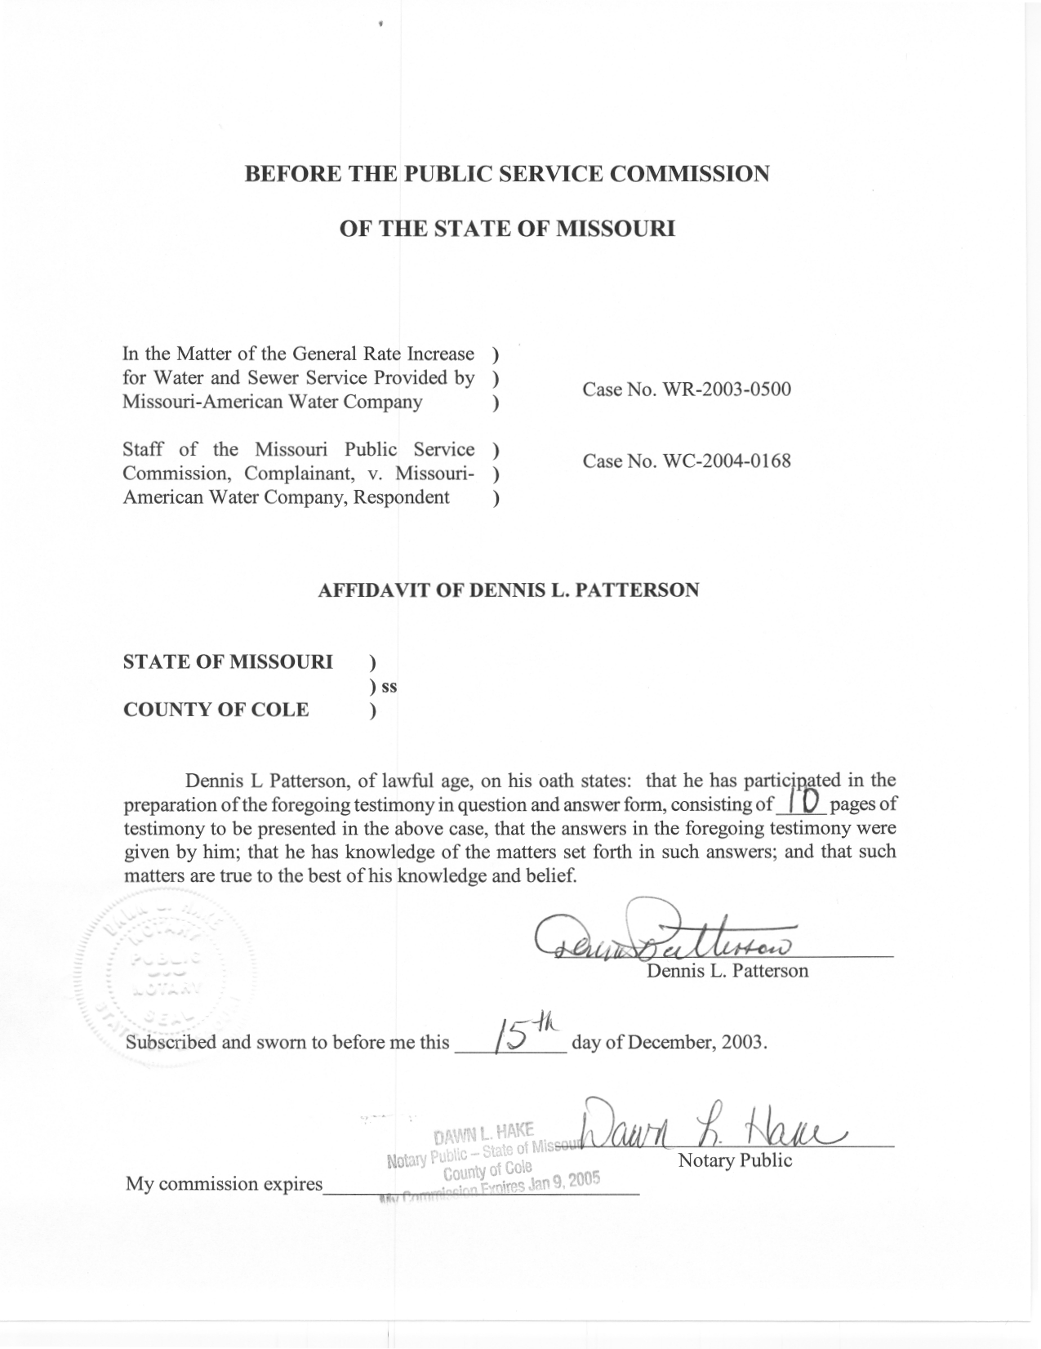
TABLE OF CONTENTS

SUMMARY 1
ERRATA 2
REVISED GMD FOR STL QUARTERLY RESIDENTIAL CUSTOMERS 2
WEATHER RESPONSE 3
DEFICIT IN TOTAL SALES 3
NEW CUSTOMER INFORMATION SYSTEM 3
VOLUMES UNACCOUNTED FOR 5
BILLING ADJUSTMENTS 6
ADJUSTMENTS FOR ADDED METERS 8
CALCULATIONS 8
RECOMMENDATION 9

SUPPLEMENTAL DIRECT TESTIMONY
OF
DENNIS L. PATTERSON

MISSOURI-AMERICAN WATER COMPANY

CASE NOS. WR-2003-0500 AND WC-2004-0168

Q. What is the purpose of your Supplemental Direct Testimony?
A. I will correct certain errata and make a material revision to my Direct Testimony.

SUMMARY
Q. Please summarize your errata.
A. I will correct the weather-normalized gallons per meter per day (GMD) for the Missouri-American Water Company (MAWC or Company) St. Louis District (STL) Monthly Residential and Quarterly Commercial customers to read 11,051.03 GMD and 965.63 GMD respectively.
Q. Please summarize your revision.
A. I will revise the weather-normalized GMD for the STL quarterly Residential customers from 290.2 GMD to 292.05 GMD.
Q. Please summarize the factors that convinced you to make the revision.
A. These factors were 1) the weather, 2) a deficit in the expected increase in sales from new customers, 3) a new customer information system, 4) a material increase in volumes unaccounted for during the test year, 5) billing adjustments during April of the test year, and 6) meters added after the test year had begun.

ERRATA
Q. Why have you submitted your errata?
A. The corrected quantities represent the results of the analyses I presented in my Direct Testimony, and should have appeared in Schedule 1-1 of my written Direct Testimony.
Q. What are the supporting data and analyses for the corrected quantities?
A. The corrected quantities are already supported in the remaining schedules of my Direct Testimony and in the working papers I have previously furnished to the Company. The corrected quantities appear at Schedule 1 attached to my Supplemental Direct Testimony. Schedule 1 is intended to replace Schedule 1-1 from my Direct Testimony.

REVISED GMD FOR STL QUARTERLY RESIDENTIAL CUSTOMERS
Q. Why was it necessary to revise your weather-normalized GMD for the STL quarterly Residential customers?
A. Test year quarterly residential Mgallons were unexpectedly low, and test year quarterly residential GMD were also unexpectedly low. I came to the conclusion that the test year billing data had been compromised by the factors summarized above, and therefore recalculated my weather normalized GMD for quarterly residential customers.
Q. How did these factors affect test year billed sales?
A. These factors and their effects are discussed below.

WEATHER RESPONSE
Q. What was the apparent weather response in the test year?
A. The apparent weather response was negative. Unadjusted STL quarterly residential customer GMD decreased dramatically from 286.8 GMD in 2001 to 277.1 GMD in 2002. However, an increase to about 299.4 GMD would have been expected because the weather was significantly hotter and drier in 2002. The expected weather-adjusted quantity is 292.05 GMD. The statistical analysis is presented at Schedule 2 attached to my supplemental direct testimony. The calculations are discussed in the CALCULATIONS section below.

DEFICIT IN TOTAL SALES
Q. Was the increase in test year sales consistent with an increase in meters connected?
A. No. Total sales rose too little when the new meters were connected: Total usage for STL quarterly residential customers increased from 30,367,468 thousands of gallons (Mgallons) in 2001 to 31,454,872 Mgallons in 2002, an increase of about 3.5%. However, the average number of meters (customers) increased from 289,867 over the 2001 test year to 310,435 over the last quarters of the test year, an increase of more than 7.0%. Thus, the increase in total sales would appear to be to small even if the weather had not been drier in 2002. (Please see Schedule 3 attached to my supplemental direct testimony.)

NEW CUSTOMER INFORMATION SYSTEM
Q. Did the Company have a new customer information system?
A Yes. The Company installed a new customer information system called “ECIS” in December of 2001 (please see item e. in the letter attached as Schedule 4).
Q. Would it be logical for billing problems to surface during the first few months of a change in billing systems?
A. Yes, it would be logical for billing problems to surface during the first few months a new system was in use.
Q. Is there any evidence of such problems in the present case?
A. Yes. Evidence of such problems exists in the apparent shifting of tens of thousands of customers between the three monthly groups of quarterly billing cycles during the initial three quarters of the test year. (Please see Schedule 5 attached to my supplemental direct testimony.) While it would not be easy to attribute errors directly to the new system, the fact that ECIS is new stands as a strong reason to question any unexpected responses, and the unstable numbers of bills are further evidence that a problem exists.
Q. How would you adjust test year volumes for the effects of using a new billing system?
A. Since the test year billed volumes are anomalous, I believe that the only recourse is to base the estimate of weather normalized test year gallons per customer per day on weather response from previous years.
Q. Did you ask the Company for the results of any study showing whether billed volumes were missed during the test year?
A. I have communicated personally with Company representatives Ed Grubb and Richard Ciottone on the subject. They indicated that such results were not available.

VOLUMES UNACCOUNTED FOR
Q. How does the Company check to see whether an acceptable percentage of all the water it pumps is actually sold?
A. The Company is constantly calculating such a crosscheck by comparing volumes sold by billing month and quarter with the volumes of water pumped between calendar dates. Schedules 6-1, 6-2 and 6-3 (attached to my supplemental direct testimony) show these comparisons for the billing years of 2000, 2001 and 2003 respectively.
Q. Did total sales correspond with system intake during the test year?
A. No. Volumes unaccounted for, or the Mgallons remaining when total STL sales for all classes are subtracted from total STL system intake, rose from 9,613,944 Mgallons in 2001 to 11,047,815 Mgallons in 2002, an increase in volumes unaccounted for of 1,433,871 Mgallons (Schedules 6-2 and 6-3). There was also an increase in volumes unaccounted for of 696,131 Mgallons from billing year 2000 to 2001 (Schedules 6-1 and 6-2). The increase in billing year 2001 could be at least partly explained by the introduction of ECIS in December.
Q. What deficits (or surpluses) in the test year of 2002 might be included in volumes unaccounted for?
A. The deficit in usage attributed to the weather might be included in the volumes unaccounted for, as might billing errors that occurred during the test year but were not adjusted within the test year. Of course, problems with the new customer information system could be responsible for these deficits.
Q. What deficits (or surpluses) in the test year might not be included in volumes unaccounted for?
A. Adjustments to test year total sales to compensate for the initial months of the test year (where added customers had not yet been connected) had originally not been present in either the billed volumes or the volumes pumped. Therefore, these deficits would not be included in volumes unaccounted for. Similarly, once a customer is no longer connected and once he is no longer billed, he has no effect on either billed volumes or volumes pumped, and so an adjustment to reflect his permanent departure would not be connected with volumes unaccounted for.

BILLING ADJUSTMENTS
Q. Did you examine the STL quarterly residential billing data for instances where billing adjustments had been or should have been made?
A. Yes. I saw one such instance in April of the second quarter of the test year.
Q. Did you examine billing cycle data to make this assessment?
A. No. However, I examined monthly aggregations of quarterly billing data where a third of the 63 billing cycles were read each month. For this discussion, the group of cycles read in January is Group A. Group B was read in February, and Group C was read in March. The groups appear in the same order in the other three quarters of the test year.
Q. Do these adjustment events often occur for these customers?
A. No. The STL quarterly residential class is vast, and individual adjustments do not usually cause noticeable errors for the entire class. However, an examination of bills and volumes for the customers billed in the first month of every quarter (Group A) showed a material deficit in the April billing month in the second billing quarter of the test year. In fact, April sales were lower in the test year than they had been for any previous year. (Please see Schedule 7 attached to my supplemental direct testimony.)
Q. Has this happened before?
A. Yes, only twice. Two such deficits have occurred for Group A customers in the past: once in April of 1993, and once in April of 1998 (Schedule 7).
Q. Were there unusual circumstances in those years?
A. Yes. 1993 was the year of a 500-year flood, and several thousand customers were rerouted in 1998.
Q. Did it appear that customers were transferring among the billing cycles during the test year?
A. It certainly did. In fact, both customer bills and sales increased significantly for March (Group C) billing cycle. But the increase in Group C customer bills did not appear to have come from Group A, and therefore it is doubtful that the additional Group C Mgallons did so. In fact, it did not appear that significant numbers of customers were transferring to and from the April (Group A) cycles during the quarter leading up to the occurrence, or in the quarter in question. (Please see Schedules 5 and 7).
Q. How large was the April 2002 billing adjustment?
A. Comparison of other April sales (from those prior billing years without unusual events) indicated that the April 2002 deficit was about 336,534 Mgallons. This deficit would be a part of volumes unaccounted for. (Please see the STL quarterly accounts and the calculation of the deficit on Schedule 8 attached to my supplementary direct testimony.)

ADJUSTMENTS FOR ADDED METERS
Q. Were additional meters connected after the test year had begun?
A. Yes. Approximately 21,000 quarterly residential meters were added during the test year. Some of these were not yet connected for the first month of the first quarter, while most were not yet connected until the beginning of the second quarter. An adjustment is needed to bring test year sales to the level that would have been achieved if the new customers were present for all months of the test year. The adjustment would be an addition to the volumes unaccounted for. Company witness Edward L. Spitznagel, Jr., PhD. is assisting the Staff in calculating this adjustment. At this stage, Dr. Spitznagel believes the adjustment for the bulk of the new customers is 2,047,050 Mgallons (Spitznagel Rebuttal Testimony, Schedule ELS-1R, “Estimated Florissant consumption for the missing fourth quarter . . .”)

CALCULATIONS
Q. How did you calculate your revised estimate without billing adjustment information?
A. I used reported annual average meter counts (customers rather than customer bills) and reported annual volumes to calculate GMD for the years 1993 through 2002. I then used linear regression to calculate weather-normalized usage in GMD, based on the years of 1993 through 2002. However, I now wished to quantify the effects of the various anomalies discussed above.
Q. Were you able to separate the effects of these events?
A. No, not in the time available. The events occurred in overlapping time periods, and I therefore chose to combine them.
Q. How were you able to calculate the combined effects?
A. In the regression model, I included a dummy (indicator) variable for 2002 to quantify the difference in response between that year and the others. I then omitted the effects attributed to the dummy variable when calculating the weather-normalized GMD estimate for 2002. This measure substitutes a reasonable estimate for missing billing information, and adjusts 2002 so that it is comparable with the prior years on a per-customer basis.
Q. What were the results of your calculations?
A. Where I had initially estimated normalized usage as 290.2 GMD for the STL Quarterly Residential rate class, I now estimate this quantity to be 292.05 GMD. The new estimate is reflected in the table at Schedule 1. The statistical analysis is presented at Schedule 2. The underlying usage data is presented at Schedule 8, while an annual aggregation of the weather data may be found at Schedule 3. I have previously furnished appropriate working papers to the Company during the pre-hearing conferences, and have forwarded updated copies with the filing of my Supplemental Direct Testimony.

RECOMMENDATION
Q. How would you recommend that the test year volumes be adjusted for a number of significant effects causing the test year to be different from previous years?
A. In the current case, I would essentially repeat what the Company did for 1992. That is, I would assign the average weather-normalized GMD from the previous years to the unreliable or anomalous year. This figure is 292.05 GMD (Schedule 1), and the anomalous billing year is the test year, namely, 2002.
Q. Does this conclude your Supplemental Direct Testimony?
A. Yes.

