BEFORE THE PUBLIC SERVICE COMMISSION
OF THE STATE OF MISSOURI

In the Matter of the Consideration of )
Adoption of the PURPA Section 111(d)(11) )
Net Metering Standard as Required by ) Case No. EO-2006-0493
Section 1251 of the Energy Policy Act of )
2005 )
)
In the Matter of the Consideration of )
Adoption of the PURPA Section 111(d)(12) ) Case No. EO-2006-0494
Fuel Sources Standard as Required by Section )
1251 of the Energy Policy Act of 2005 )
)
In the Matter of the Consideration of )
Adoption of the PURPA Section 111(d)(13) )
Fossil Fuel Generation Efficiency Standard ) Case No. EO-2006-0495
As Required by Section 1251 of the Energy )
Policy Act of 2005 )
)
In the Matter of the Consideration of )
Adoption of the PURPA Section 111(d)(14) )
Time-Based Metering and Communications ) Case No. EO-2006-0496
Standard as Required by Section 1252 of )
The Energy Policy Act of 2005 )
)
In the Matter of the Consideration of )
Adoption of the PURPA Section 111(d)(15) )
Interconnection Standard as Required by ) Case No. EO-2006-0497
Section 1254 of the Energy Policy Act of )
2005 )

APPLICATION TO INTERVENE
OF THE MISSOURI INDUSTRIAL ENERGY CONSUMERS

Comes now Anheuser-Busch Companies, Inc., The Boeing Company, DaimlerChrysler, Ford Motor Company, General Motors Corporation, Hussmann Refrigeration, J.W. Aluminum, Monsanto Company, Pfizer, Praxair, Precoat Metals, Procter & Gamble Manufacturing, Nestlé Purina and Solutia, hereafter referred to as the Missouri Industrial Energy Consumers (“MIEC”), and pursuant to 4 CSR 240-2.075 and 4 CSR 240-2.080, files its Application to Intervene. In support of its Application, the MIEC states as follows:
- The MIEC is a group of large industrial energy consumers, and the rates, terms and conditions of the MIEC’s utility service may be affected by the outcome of this case;
- The MIEC’s interest in this case is to ensure utility service under reasonable terms and conditions at just and reasonable rates;
- As a group of large utility customers, the MIEC’s interest in this proceeding is different than that of the general public;
- The MIEC does not yet have sufficient information to take a position in this case, but reserves the right to take positions on all issues that may affect its members in this case.
- Granting the MIEC’s proposed intervention would serve the public interest by assisting in the development of a more complete record for decision by the Commission.
WHEREFORE, the MIEC requests that the Commission grant its Application to Intervene herein and make it a party to this case for all purposes.
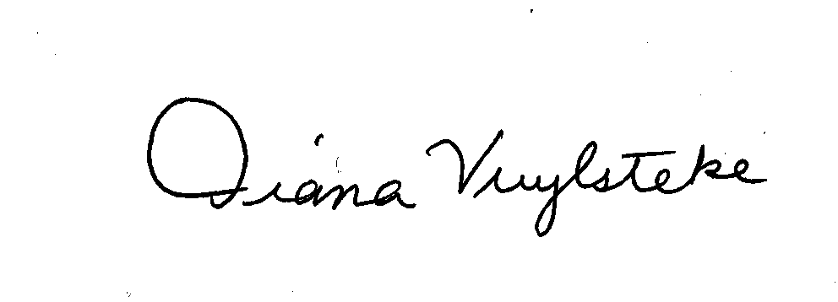
Respectfully submitted,
BRYAN CAVE, LLP
By:___________________________
Diana M. Vuylsteke, #42419
211 N. Broadway, Suite 3600
St. Louis, Missouri 63102
Telephone: (314) 259-2543
Facsimile: (314) 259-2020
E-mail: dmvuylsteke@bryancave.com

ATTORNEY FOR THE MIEC

CERTIFICATE OF SERVICE
I hereby certify that copies of the foregoing have served on all parties by electronic service this 24th day of July, 2006.
__________________________________
Diana M. Vuylsteke

