Exhibit No.:
Issues: Class Cost of Service
Rate Design
Witness: Janice Pyatte
Sponsoring Party: MoPSC Staff
Type of Exhibit: Rebuttal Testimony
Case No.: ER-2002-424
Date Testimony Prepared: September 24, 2002

MISSOURI PUBLIC SERVICE COMMISSION

UTILITY OPERATIONS DIVISION

REBUTTAL TESTIMONY

OF

JANICE PYATTE

THE EMPIRE DISTRICT ELECTRIC
COMPANY

CASE NO. ER-2002-424

Jefferson City, Missouri
September, 2002

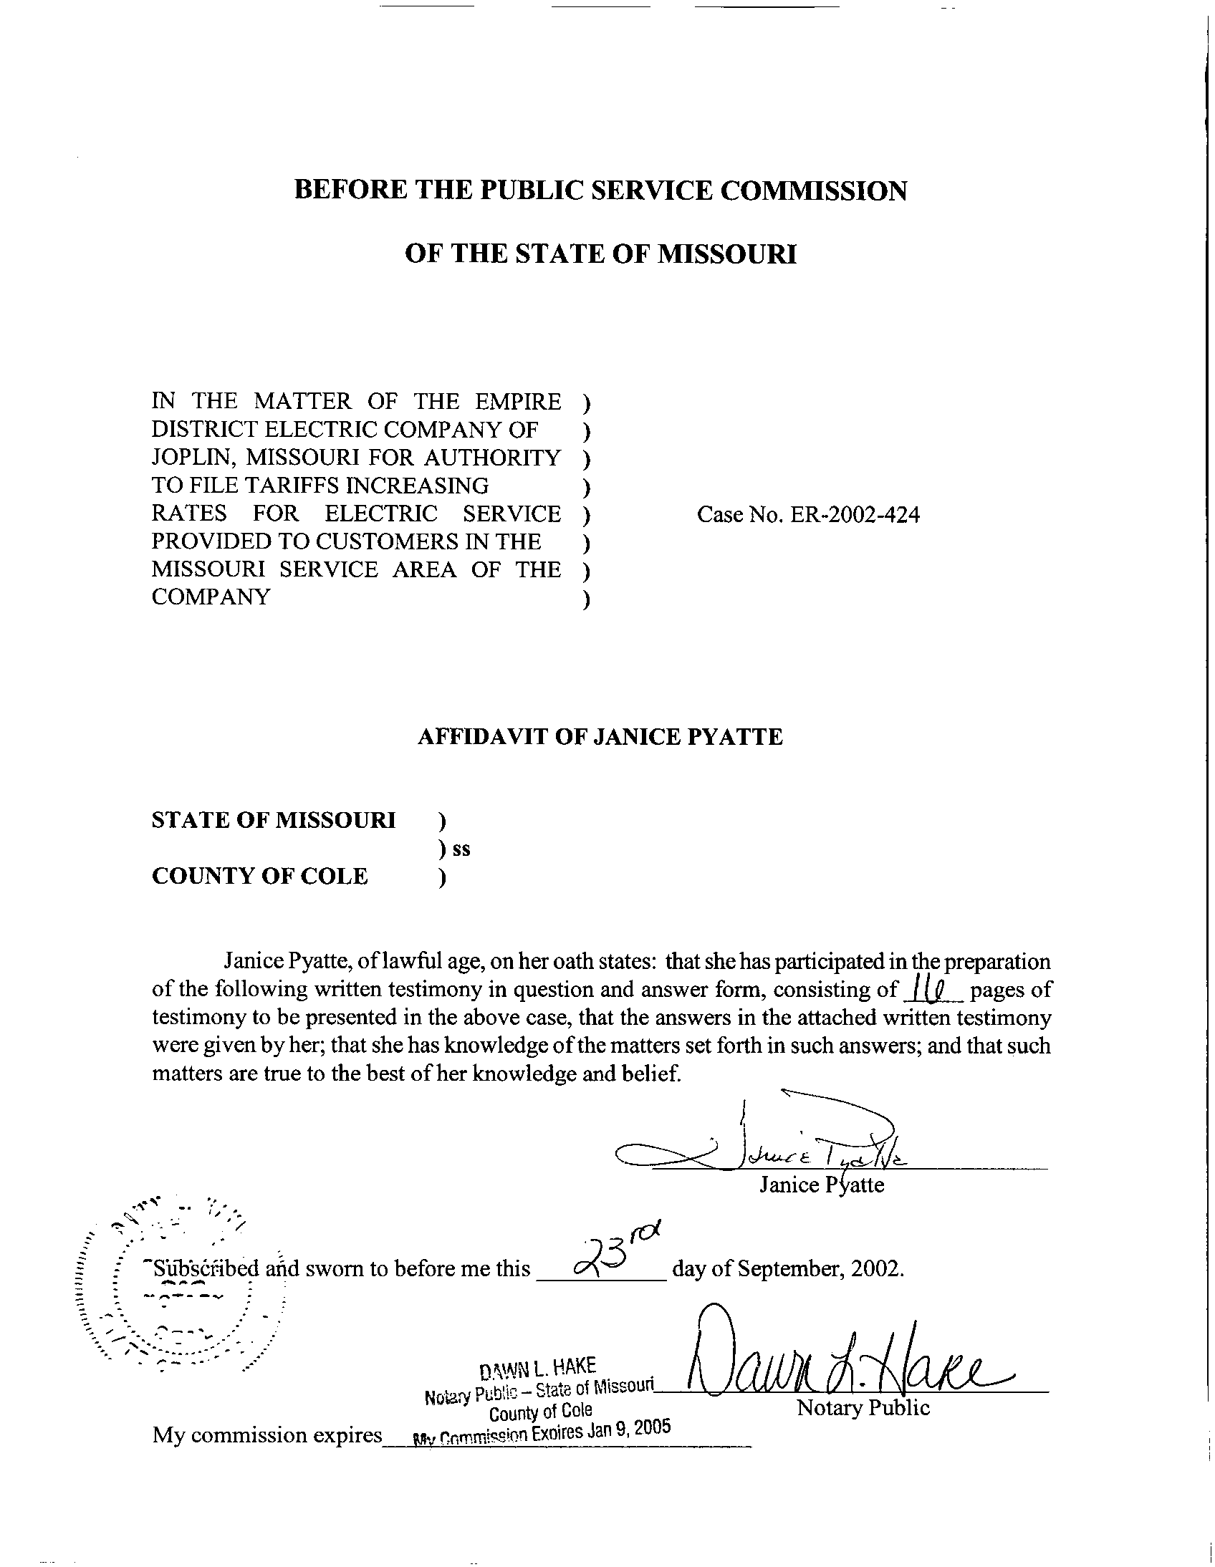
TABLE OF CONTENTS

CLASS COST OF SERVICE 2
RATE DESIGN 13

REBUTTAL TESTIMONY
OF
JANICE PYATTE
THE EMPIRE DISTRICT ELECTRIC COMPANY
CASE NO. ER-2002-424

Q. Please state your name and business address.
A. My name is Janice Pyatte and my business address is Missouri Public Service Commission, P.O. Box 360, Jefferson City, Missouri 65102.
Q. Are you the same Janice Pyatte who filed direct testimony in this case on August 22, 2002, on the issue of Sales and Revenues and on August 30, 2002, on the issue of Rate Design?
A. Yes, I am.
Q. What is the purpose of your rebuttal testimony in this case?
A. The portion of my rebuttal testimony denoted as Class Cost of Service will compare the four class cost-of-service studies sponsored by the four parties to this case: The Empire District Electric Company (“EDE” or “Empire” or “Company”); the Staff of the Missouri Public Service Commission (“Staff”); The Office of the Public Counsel (“OPC”); and Praxair, Inc. (“Praxair”). I will also compare the four proposals, by the same parties, for collecting any increase in overall electric revenues that results from this case.
The portion of my rebuttal testimony denoted as Rate Design will describe the methods proposed by the parties for adjusting EDE’s electric rates. I will also comment on EDE’s proposal to increase the proportion of residential revenue collected in the winter season through changes to the residential rate design.

CLASS COST OF SERVICE
Q. Please identify the witnesses who are sponsoring the class cost-of-service studies you are comparing.
A. Staff’s class cost-of-service study is described in the testimony of Staff witness James C. Watkins. The summary of the Staff’s class cost-of-service study results is presented as Schedule 2 attached to the August 30, 2002, direct testimony of Mr. Watkins.
The Company’s class cost-of-service study is sponsored by EDE witness Kelly S. Walters. This cost-of-service study is described on pages 18-27 of Ms. Walters’ supplemental direct testimony, filed March 29, 2002. The study itself is denoted as Section N of that same testimony. An earlier version of the Company’s class cost-of-service study was filed with Ms. Walter’s direct testimony on March 8, 2002.
OPC’s class cost-of-service study is sponsored by OPC witness Hong Hu. The description of her methodology is contained in Ms. Hu’s direct testimony, filed August 30, 2002.
Praxair’s class cost-of-service study is sponsored by Praxair witness Maurice Brubaker. Praxair’s class cost-of-service study is shown on Schedule 3 of Mr. Brubaker’s direct testimony, filed August 30, 2002.
Mr. Brubaker’s direct testimony also includes the results of a study that he denotes as the “corrected” Company study in his Schedule 1, page 2 of 2; however, EDE has not adopted either Mr. Brubaker’s “corrections” or his results.
Q. How do the four class cost-of-service studies compare in terms of basic inputs?
A. Two of the class cost-of-service studies presented in this case (Company’s and Praxair’s) are based upon accounting costs that include the Company’s $19.9 million dollar requested overall increase. OPC’s class cost-of-service study is based upon Staff accounting costs that show a $2.2 million dollar overall increase. The results of Staff’s class cost-of-service study are presented on a revenue-neutral basis, i.e., prior to any overall revenue increase.
Q. How do the four class cost-of-service studies compare in terms of the customer classes being studied?
A. The class cost-of-service studies sponsored by the Company, OPC, and Praxair calculate cost responsibility separately for most of EDE’s existing rate schedules. Staff’s study calculates cost responsibility by cost-of-service classes that are generally composed of multiple rate schedules. All studies calculated cost responsibility for Praxair, also denoted as Special Contract. A comparison of the various class and rate schedule designations is listed below.
Class/Rate Schedule | Empire | Staff | OPC | Praxair
Residential | X | X | X | X
Commercial (CB) | X |  | X | X
Space Heat (SH) | X |  | X | X
Feed Mill | X |  | X | X
MS (traffic signals) | X |  | X | X
Small General Service |  | X
General Power | X |  | X | X
Total Electric Buildings | X |  | X | X
Large General Service |  | X
Large Power | X | X | X | X
Special Contract (Praxair) | X | X | X | X
Lighting | X |  | X | X
Power Furnace | X |  | X | X
Total Non-Studied |  | X

Although OPC’s study was conducted on the rate schedules listed above, Ms. Hu has displayed her results in terms of classes similar to those used by Staff.
An additional difference among the class cost-of-service studies is that Staff did not study the three lighting rate schedules or the power furnace rate schedule. Consequently, Staff’s class cost-of-service study results do not include a measure of class cost responsibility for these rate schedules.
Q. How do the four class cost-of-service studies compare in terms of the functionalization of costs and the allocation of the functionalized costs to customer classes?
A. Staff is the only party sponsoring a functionalized class cost-of-service study in this case. (A functionalized study displays each class’s allocated costs by function - production, transmission, distribution, etc.). The class cost-of-service studies sponsored by the Company, OPC, and Praxair show the allocation of each element of rate base and expense to customer classes, but not explicitly to functions. The Staff’s functionalized costs, in total and by customer class, are shown in numeric form on Schedule 2 attached to the testimony of Mr. Watkins. The distribution of total Missouri costs of The Empire District Electric Company by function, as shown on Mr. Watkins’ schedule, is shown below in a graphical format:
The functional mix of costs for each customer class differs from the total shown above.
Because the various parties use different approaches to perform their class cost-of-service studies, it is difficult to quantify the differences between studies that are due to the functionalization of costs separately from the differences due to the allocation of those costs among the various customer classes. My experience with class cost-of-service studies done in rate design cases leads me to predict that the differences between the methods used to functionalize costs in the various studies in this case are relatively minor in terms of their dollar impact on the overall results. The large differences are typically due to the choice of methods to allocate the functionalized costs to customer classes.
Q. Are there other differences between the four class cost-of-service studies that are noteworthy?
A. In addition to the differences previously mentioned, there are a number of other dissimilarities between the four class cost-of-service studies that should be noted. These dissimilarities relate to the treatment of the investment and revenues associated with special and excess distribution facilities; the treatment of the expenses and revenues associated with off-system sales; the treatment of interruptible load and interruptible credits; and the split of distribution costs by voltage level.
Q. Please describe the issue in this case relating to the treatment of the revenues and investment associated with special and excess distribution facilities.
A. When EDE installs special facilities or facilities “in excess” of those provided via the standard rate schedule to serve a specific customer, that customer is assessed, in accordance with Rider XC, a monthly charge of 1.25% of the total cost of the facilities. The class cost-of-service studies submitted by EDE, OPC, and Praxair all fail to properly assign the costs associated with excess distribution facilities before allocating the remaining distribution costs to all customer classes. In addition, none of these parties correctly accounted for the revenue associated with Rider XC when calculating each class’s revenue increase.
Q. Please describe the issue in this case relating to the treatment of interruptible load and interruptible credits.
A. The rebuttal testimony of Mr. Watkins describes the Staff’s view of the proper and improper treatment of interruptible load. My testimony will demonstrate how sensitive class cost-of-service results are to the treatment of interruptible load and interruptible credits, and how the Praxair treatment leads to a result that is unreasonable.
Q. Have you performed the class cost-of-service studies that demonstrate how sensitive class cost-of-service results are to the treatment of interruptible load and interruptible credits?
A. No. Mr. Brubaker has submitted two class cost-of-service studies in this case that differ only with respect to the treatment of interruptible load in the allocation of costs and with respect to the treatment of interruptible credits as either an offset to production capacity costs or as negative revenue,. A comparison of the two methods is readily apparent. The Praxair class cost-of-service study shown on Mr. Brubaker’s Schedule 3 allocates functionalized production capacity costs to Praxair based upon that portion of Praxair’s load that is “firm,” i.e., non-interruptible. This study treats interruptible credits as negative revenue assigned exclusively to Praxair.
The second study, shown on Mr. Brubaker’s Schedule 1, page 2 of 2, represents Praxair’s version of EDE’s class cost-of-service study, as corrected for errors in inputs. In the cost allocation section of the Company’s study, functionalized production capacity costs were allocated to all customer classes, including Praxair, based on each class’s total load. In the Company’s study, interruptible credits were treated as an offset to production costs and were therefore allocated to all customer classes.
Q. How do the results of applying these two treatments of interruptible load and interruptible credits in a class cost-of-service study compare?
A. For purposes of this comparison, I am presenting the revenue shifts that would be required to equate class cost-of-service to class revenues, before any increase in overall revenues would be made. This measure is described in Mr. Brubaker’s testimony as “subsidies.” The two comparison class cost-of-service studies (Mr. Brubaker’s Schedule 1 and Schedule 3) show that choosing the Praxair treatment of interruptible load and interruptible credits over the Company approach results in less cost allocated to Praxair and more cost allocated to the other classes.
Customer Class | EDE C-O-S Study | Praxair C-O-S Study | Difference
Residential | $16,273,863 | $16,361,422 | $87,559
Praxair | ($218,923) | ($453,947) | ($235,024)
All Other Classes | ($16,054,939) | ($15,907,475) | $147,464
Total | $0 | $0 | $0
Q. Which of these two approaches is the proper one?
A. The treatment of interruptible load and interruptible credits that has been used in the Company study (namely, allocating production capacity costs based upon each class’s total load and treating interruptible credits as an offset to production cost) is conceptually the same as that used in the Staff’s class cost-of-service study, and is the proper approach.
Q. What is the Staff’s rationale for this treatment of interruptible load and interruptible credits?
A. Interruptible load is one of a number of ways the Company can “acquire” production capacity to meet its native load. If the Company chose to acquire production capacity by either building a generation unit or by buying capacity in the wholesale market, there would be no dispute that some portion of EDE’s total production capacity costs would be allocated to Praxair, based upon the customer’s total load. Other customer classes would also be responsible for their portion of the total costs of production capacity based upon their total load.
When evaluating whether to build a generating unit to provide additional capacity or to buy capacity on the wholesale market or to pay customers to interrupt (reduce) load, the Company should only choose the interruptible load option if it is cheaper than the other alternatives; i.e., the maximum price that the Company should pay for interruptible load is the cost it avoids by not acquiring capacity from the next cheapest alternative. Non-interruptible customers should not care what choice EDE makes, because as long as the decision makes economic sense, their responsibility for total production capacity costs should remain the same.
The situation in this case is that EDE has chosen to contract with Praxair for interruptible load as a substitute for acquiring production capacity. As compensation, the Company provides Praxair with an annual amount of $342,912 in interruptible credits.
Q. What is the flaw in the Praxair approach to interruptible load and interruptible credits?
A. Mr. Brubaker’s cost allocations reduce Praxair’s share of production capacity cost by $563,041. However, $342,912 is the dollar value of EDE acquiring interruptible load from Praxair. Thus, the Praxair approach to treating interruptible load over-estimates the benefits of interruptible load by $220,129 (equals $563,041 less $342,912). From the perspective of the other customer classes, they would be assessed $220,129 more in production capacity costs under this scenario than they would if EDE had chosen to either build a generating unit to provide additional capacity or to buy capacity on the wholesale market.
Another perspective is that, under Mr. Brubaker’s treatment of interruptible load and interruptible credits, all of the benefits of interruptible load were assigned exclusively to Praxair and none of the benefits were attributed to the other customer classes.
For this reason, the Commission should find that the Praxair treatment of interruptible load and interruptible credits leads to a result that is unreasonable.
Q. How do the four class cost-of-service studies compare in terms of their results?
A. As I have described, the parties sponsoring the various class cost-of-service studies in this case did not use the same inputs (costs, sales, revenues or demands); did not study the same customer classes; did not use the same class cost-of-service study approach; and differed substantially in their treatment of a number of important items. In order to present a meaningful comparison, I have chosen to compare the results of the various class cost-of-service studies on a revenue-neutral basis, i.e., before allocating any increase in overall revenues from this case. My comparison is shown on Schedule 1, attached to this testimony, in graphical form.
Q. Please describe the charts in Schedule 1.
A. My comparison of the results of the Company, Staff, OPC, and Praxair class cost-of-service studies is shown on Schedule 1 attached to this testimony. Each chart in this schedule shows the dollars that are required to correct any imbalances between class cost responsibility, as measured by the specific class cost-of-service study, and current class revenues. The four studies indicate that there are some significant imbalances between the Company’s costs of providing electric service to the various customer classes and the revenues/rates those classes are paying for electric service. The studies differ considerably, however, about which customer classes are “paying too much” (shown as bars below the zero dollar line) and which customer classes are “paying too little” (shown as bars above the zero dollar line). In addition, there is a disagreement between Staff and the other parties about whether using a class cost-of-service study to examine the adequacy of lighting rates is even an appropriate thing to do.
The Company’s study and Praxair’s study generally show that the Residential class is “paying too little,” while the non-residential classes are “paying too much.” The major exception to this generalization is the result for Special Contract (Praxair). The Company’s study results indicate that the costs attributed to Praxair are significantly higher than the revenues being recovered from this customer. The cost-of-service study sponsored by Praxair finds the opposite.
The Staff’s study indicates that the imbalances are primarily between the Small General Service class, which is paying significantly more than the cost to serve it, and the Large Power and Special Contract (Praxair) classes, which are paying significantly less than their attributed costs.
The results of OPC’s class cost-of-service study generally mirror the results of the Staff’s study.
Q. Please briefly describe how each party proposes to collect any additional revenues that result from this case.
A. The Staff’s proposal for collecting any additional revenues that result from this case is that any additional revenue be divided in a manner consistent with the Staff’s class cost-of-service results; namely, that the Small General Service class will not receive any portion of the increase; that the percentage increase to the Large Power & Special Contract classes be approximately twice the overall average increase; and that all other classes (Residential, Large General Service, and Lighting & Power Furnace) receive the overall average percentage increase. Examples of the class revenue increases that would result at various levels of overall revenue increase is presented on Schedule 2 of my direct testimony on the issue of Rate Design.
The Company’s proposal, presented by Kelly S. Walters, is that any additional revenue allowed by the Commission in this case should be recovered by “ . . .an equal percentage increase to each rate class.” [Walters, Supplemental Direct, page 28, lines 1-2].
OPC witness Hong Hu sponsors OPC’s methodology for increasing or decreasing class revenues. OPC’s methodology proposes a re-allocation of class revenues at lower levels of overall revenue increase, as long as such a process does not result in an overall revenue decrease to any class, followed by additional revenue being applied as an equal percentage increase to all classes. Despite the fact that OPC’s class cost-of-service study determined class cost responsibility by individual rate schedule, Ms. Hu’s rate design proposals are based upon customer classes consisting of multiple rate schedules. Presumably each rate schedule contained within a customer class should experience a uniform percentage increase. The classes and the rate schedules that OPC has linked for rate design purposes are shown on page 10 of Ms. Hu’s direct testimony.
Praxair’s proposal is contained on Schedule 6 and described on page 10 of Mr. Brubaker’s direct testimony. My understanding is that Praxair is proposing that total revenue, including any increase that may be granted, be distributed by rate schedule in proportion to column 3 of Schedule 6. It appears that implementing this proposal when the overall increase to Missouri revenue is considerably smaller than the Company’s $19.9 million request will result in decreases to some non-residential rate schedules.
Q. How do the four proposals for collecting additional revenue compare?
A. My comparison of the four rate design proposals for collecting any additional revenues that are allowed in this case is shown on Schedule 2 attached to this testimony. Each page of Schedule 2 shows, in graphical or tabular form, what each party’s proposed distribution of an increase in overall revenues would be at $5.0 million and $10.0 million.
The proposals of Staff, OPC, and Praxair are each consistent with a movement toward class cost responsibility, as measured by its class cost-of-service results, although no party advocates moving all of the way to cost of service. The Company’s rate design proposal is not based on the results of its class cost-of-service study.

RATE DESIGN
Q. Please briefly describe how each party proposes to change the individual rates on each rate schedule?
A. Staff proposes that rate levels should be determined by increasing all rate components on each rate schedule by the percentage increase in overall class revenue. [Pyatte, Direct-Rate Design, page 4, lines 14-17]. Company’s proposal is that all rate components on each rate schedule be increased by the percentage increase in Missouri retail revenue. Praxair makes no proposal on this issue. OPC’s only proposal on determining rate levels relates only to the level of the residential customer charge. Public Counsel “. . . believes that the current customer charge can be raised by the same percentage as the residential class revenue increase. . .” [Hu, Direct, page 14,
lines 17-18].
Q. Are there rate design objectives that need to be considered in addition to balancing class revenues with class cost responsibility?
A. Yes. The design of electric rate schedules is an exercise in balancing many, sometimes contradictory, objectives. Some objectives that need to be considered in crafting a rate design proposal for this case are:
- moving class revenues towards class cost responsibility, as measured by class cost-of-service results
- limiting the impacts on customers’ electric bills
- preserving the “continuity between rate schedules” feature of the existing rate design, which minimizes rate switching by customers.
In a regulated environment, it is also paramount that any rate design be shown to collect the Commission-ordered revenues on a normalized basis before Staff can find the Company’s ultimate tariff filing to be in compliance with the Report and Order in this case.
Q. Are there situations in this case where implementing a party’s proposal for collecting additional revenue may conflict with other rate design objectives?
A. Yes. One such situation can be found in Praxair’s proposal to change the revenues collected by the Small Heating (SH) rate schedule by a greater percentage than the Commercial Service (CB) rate schedule. There is also the potential that implementation of Praxair’s proposal for the General Power (GP) rate schedule and the Total Electric Buildings (TEB) rate schedule may also cause a rate design problem.
Q. Please explain what rate design problems could result from the implementation of the Praxair proposal?
A. The rate design problems that I foresee can be illustrated by the effect of Praxair’s proposal on the Commercial Service (CB) rate schedule and the Small Heating (SH) rate schedules.
Both the CB and the SH rate schedules serve small (under 40 kW) commercial customers, the distinction between them being whether the customer “ . . .permanently installs and regularly uses electric space-heating equipment for all internal space-heating comfort requirement. . .” [this language is from the Availability Section of the SH Rate Schedule.] The current rates of the two schedules are shown below:
 | CB | SH
Customer Charge | $11.74 | $11.74
Summer Energy Charge | 7.98 cents | 7.98 cents
Winter First 700 kWh | 7.98 cents | 7.98 cents
Winter Over 700 kWh | 5.43 cents | 4.15 cents
The only differences in the rates is that the winter tail block energy rate is lower for the SH customers than it is for the CB customers; the remaining rate design features are the same for both rate schedules.
Praxair’s proposal for these two rate schedules is that the revenues collected by the SH customers be increased by more than the overall average percentage increase and the revenues collected by the CB customers be increased by less than the overall average. Praxair’s witness does not specify how this should be accomplished or whether he believes that preserving the rate design features (all rates are the same except for the winter tail block energy rate) is an important consideration.
Q. Do you foresee rate design problems arising from the implementation of the rate design proposals of the other three parties (Company, Staff, and OPC)?
A. The Company’s proposal to factor all rates by the same percentage will most certainly preserve the features of the existing rate design. Staff’s proposal and OPC’s proposal will not cause the problems described above, because each party proposes uniform percentage increases for the multiple rate schedules that constitute each class. If there is a potential rate design problem with these two proposals, it is likely to be in that customers on the Large Power (LP) rate schedule may find it economically advantageous to switch to the General Power (GP) rate schedule (that serves mid-sized customers).
Q. What is Staff’s opinion of the EDE proposal to increase the proportion of residential revenue collected in the winter season?
A. EDE has proposed to increase the proportion of residential revenue collected in the winter season by increasing the winter tail block energy rate and creating a declining-block summer energy rate. Staff is opposed to declining-block summer energy charges, because it sends the wrong price signal to customers. EDE has not provided any seasonal cost information that shows that the existing relationship between summer costs and winter costs have changed for the residential or any other class.
A discussion of this issue at pre-hearing indicated that EDE’s objective is revenue stability from one season to another.
Q. Does this conclude your rebuttal testimony?
A. Yes, it does.

