Exhibit No.:
Issues: Sales & Rate Revenue

Witness: Janice Pyatte
Sponsoring Party: MO PSC Staff
Type of Exhibit: Direct Testimony
Case Nos.: ER-2004-0034
& HR-2004-0024
(Consolidated)
Date Testimony Prepared: December 9, 2003

MISSOURI PUBLIC SERVICE COMMISSION

Utility Operations DIVISION

Direct Testimony

OF

Janice Pyatte

Aquila, Inc.
d/b/a Aquila Networks--MPS
and Aquila Networks--L&P

CASE NOS. ER-2004-0034 & HR-2004-024

Jefferson City, Missouri
December 2003

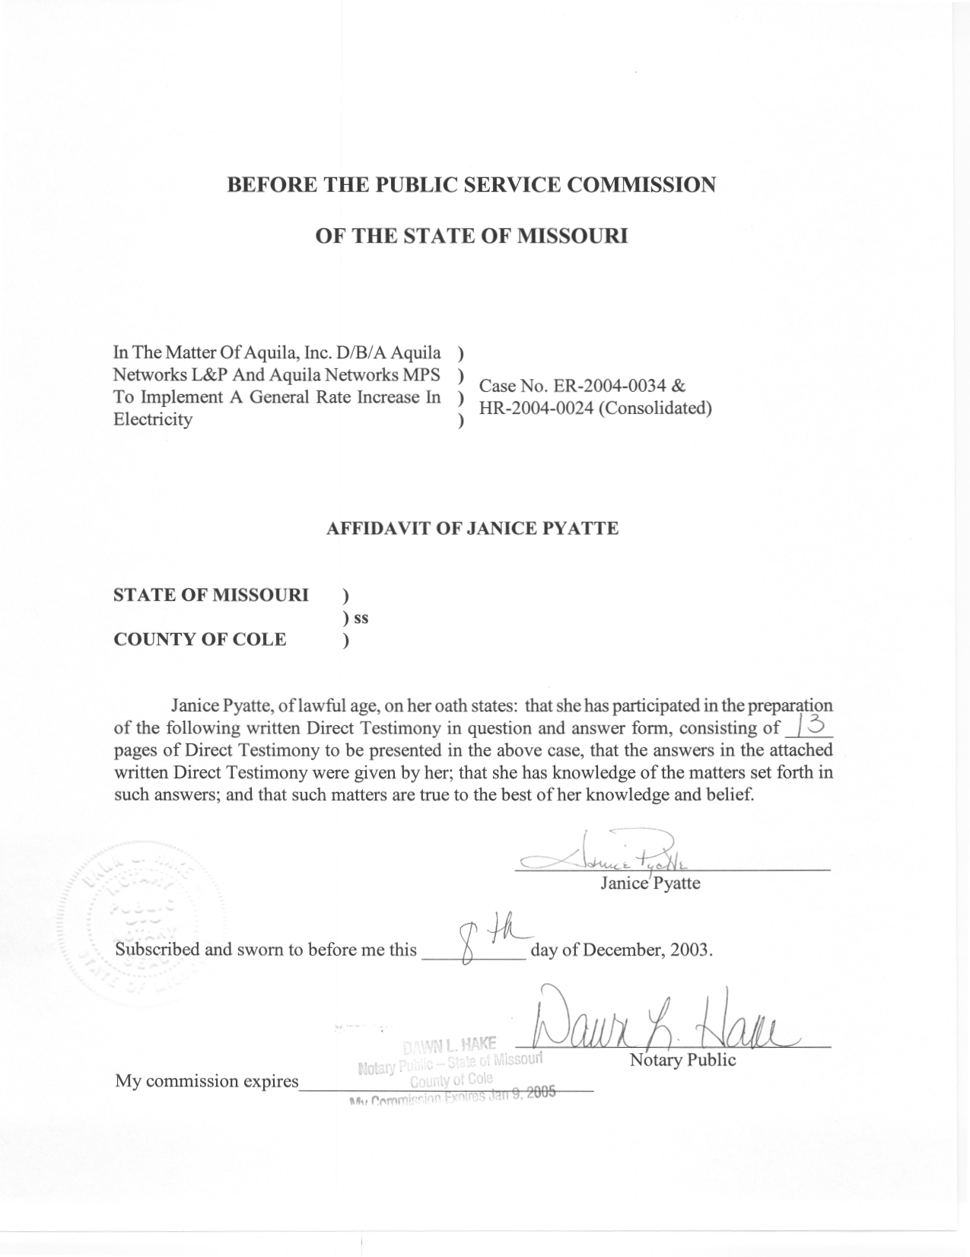
TABLE OF CONTENTS

RATEMAKING TREATMENT OF SALES AND RATE REVENUE 3
L&P ELECTRIC KWH SALES AND RATE REVENUE 5
L&P STEAM SALES AND RATE REVENUE 12

DIRECT TESTIMONY
OF
JANICE PYATTE
AQUILA, INC.
D/B/A AQUILA NETWORKS-MPS
AND AQUILA NETWORKS-L&P

CASE NOS. ER-2004-0034 AND HR-2004-0024
(CONSOLIDATED)

Q. Please state your name and business address.
A. My name is Janice Pyatte and my business address is Missouri Public Service Commission, P. O. Box 360, Jefferson City, Missouri 65102.
Q. What is your present position with the Missouri Public Service Commission?
A. I am a Regulatory Economist in the Energy-Economic Analysis Department, Operations Division.
Q. Would you please review your educational background and work experience?
A. I completed a Bachelor of Arts degree in Economics at Western Washington State College in Bellingham, Washington and a Masters of Arts (A.M.) degree in Economics at Washington University in St. Louis, Missouri. I have been employed by the Missouri Public Service Commission (Commission) since June 1977. My primary role with the Missouri Public Service Commission Staff (Staff) has been to perform analysis in the areas of rate design, class cost-of-service, rate revenue, and billing units for the regulated electric utilities in Missouri. A list of the cases in which I have filed testimony before the Commission is shown on Schedule 1.
Q. What is the purpose of your Direct Testimony in this filing?
A. My Direct Testimony on the issue of Sales and Revenue describes my role in the development of specific adjustments to Missouri jurisdictional, test year sales and revenue from sales (rate revenue) for the electric operations of Aquila Networks-L&P (“L&P Electric”) and the steam operations of Aquila Networks-L&P (“L&P Steam”).
In this filing, I present two schedules for L&P Electric’s operations and one schedule for L&P Steam’s operations that summarize Missouri sales and rate revenue by rate code, based upon a test year of January 1, 2002 – December 31, 2002, updated for known and measurable changes through September 30, 2003. The adjusted Missouri retail sales for the updated test year shown on Schedules 2 (electric) and 4 (steam) are consistent with the normalized hourly system loads used in Staff’s production cost simulation model fuel run.
The specific adjustments to L&P Electric’s revenues shown on Schedule 3 are shown as adjustments in the Staff’s Income Statement (Accounting Schedule 9) for L&P Electric.
The specific adjustments to L&P Steam’s revenues shown on Schedule 4 are shown as adjustments in the Staff’s Income Statement (Accounting Schedule 9) for L&P Steam.
Q. What is the relationship between the Missouri rate revenue shown on your Schedules 3 and 4 and the Missouri operating revenue shown on Accounting Schedule 9-Income Statement?
A. Total operating revenue, which is shown on Accounting Schedule 9-Income Statement, consists of two components: the revenue that the Company collects from the sales of electricity or steam to Missouri retail customers (“rate revenue”), which is shown on my Schedules 3 and 4; and the revenue the Company receives from other sources (“other revenue”). My testimony addresses Missouri rate revenue for L&P only. Please refer to similar schedules attached to the testimony of Staff witness Hong Hu for Missouri rate revenue for Aquila Networks-MPS (“MPS Electric”). Staff Witness Amanda McMellen sponsors any proposed adjustments to other revenue for L&P Electric, L&P Steam and MPS Electric.
Q. Do you have a recommendation for the Commission regarding L&P Electric and L&P Steam sales and rate revenue?
A. I recommend that the Commission adopt the Staff’s adjustments to booked sales and rate revenue for both L&P Electric and L&P Steam that are shown on Schedules 2, 3, and 4. If adopted, Staff’s rate revenue by rate code will be used to implement any Commission-ordered revenue change in this case.

RATEMAKING TREATMENT OF SALES AND RATE REVENUE

Q. What is the rationale for making adjustments to test year sales and revenue?
A. The historical 12-month time period (“test year”) and “update period” (if any) that the Commission determines should be used for analyzing the costs of providing service to retail customers is also used for analyzing sales and revenue, based on the “matching principle” of ratemaking. The intent of adjustments to test year revenue is to estimate the revenue that the company would have collected on an annual, normal-weather basis, based on information “known and measurable” at the end of the analysis period.
Most adjustments to test year revenue correspond to adjustments to sales that, in turn, affect the Company’s fuel and purchased power costs. Net system loads, updated for these known and measurable changes in sales, are reflected in the production cost simulation model to ensure that sufficient generation and purchases exist to meet total net system requirements. Any change to revenue from historical levels that results from changes in underlying sales will result in corresponding changes to fuel and purchased power costs that reflect that same adjustment to sales.
Q. What categories of adjustments to kWh sales and rate revenue are typically made in a rate increase or a complaint (excess earnings) case?
A. The two major categories of adjustments are known as normalizations and annualizations.
Normalizations deal with test year events that are unusual and unlikely to be repeated in the years when the new rates from this case are in effect. Test year weather is an example. It is unlikely that the weather that occurred in the test year will, on average, be repeated in the future, but what weather will actually occur is not predictable. The objective of the weather normalization process is to re-state test year sales and rate revenue on a “normal-weather” basis.
Annualizations are adjustments that re-state test year results as if conditions known at the end of the analysis period had existed throughout the entire test year. Annualizations may be sub-classified as being “test-year-related” or “update-period-related”, depending on when a “known and measurable” change occurs (i.e., during the test year or during the update period).
Q. Please provide some examples of common annualizations that may occur in an electric rate case?
A. A common example of a revenue annualization is a rate change that occurs during the test year. Actual test year revenue in this situation will be understated or overstated by the difference between the amount that was actually billed to customers and the revenue that would have been realized by the company if the rates in effect at the end of the analysis period had been in effect throughout the entire test year.
An example of an annualization that affects both sales and rate revenue is a large customer that either begins or ceases service during the analysis period. In the situation where a large customer ceases business, test year revenue should be decreased by the amount of revenue the customer provided the Company. A corresponding reduction to sales and to fuel and purchased power expense should be made to reflect the costs the company will no longer incur. Conversely, when a large customer begins service, test year revenue, kWh sales, and fuel expense should be increased to reflect both the costs and the revenue associated with serving the new customer on an annual basis.
Customer growth adjustments are annualizations that reflect any additional sales and revenue that would have occurred in the test year if customers on the system at the end of the analysis period had been customers during all 12 months of the test year.

L&P ELECTRIC KWH SALES AND RATE REVENUE

Q. Which specific adjustments to L&P Electric’s sales and rate revenue from electric operations are you recommending?
A. I recommend that the Commission adopt the Staff’s adjustments to sales and revenues shown on Schedules 2 and 3 and identified on Accounting Schedule 9-Income Statement for L&P Electric as S-1.2, S-1.5 and S-1.6. A description of these adjustments appears on Accounting Schedule 10-Adjustments to Income Statement.
Q. How does your testimony on L&P Electric sales and revenues relate to the testimony of other Staff witnesses in this case?
A. I am responsible for compiling the table labeled as Schedule 2, which summarizes the results of Staff’s work relating to Missouri sales (measured in kWh) for L&P Electric. In addition to the adjustments to kWh sales addressed in my testimony, Staff witness Richard J. Campbell addresses the normalization of kWh sales to account for the effects of deviations from normal weather in the test year, and Staff witness Amanda McMellen addresses the effect that growth (or decline) in the number of customers had on kWh sales. The annualization of kWh sales for the large customers was a collaborative effort between Ms. McMellen and myself.
I am also responsible for compiling the table labeled as Schedule 3, which summarizes the results of Staff’s work relating to Missouri rate revenue for L&P Electric. My testimony addresses the methodologies used to calculate annualized, normalized rate revenue for each affected rate code. Ms. McMellen’s testimony addresses the effect that growth (or decline) in the number of customers had on rate revenue. The annualization of rate revenues for the large customers was also a collaborative effort between Ms. McMellen and myself.
Q. Please describe the characteristics of the Missouri kWh sales and rate revenue that have been developed in this case.
A. The Missouri kWh sales and rate revenue that I am presenting have these characteristics: (i) they have been developed by both rate code and by cost-of-service class; (ii) they have been normalized to remove the effects of deviations from normal weather in the test year; (iii) they have been developed on both a billing month and a calendar year (i.e., 365-day) basis; and (iv) they have been adjusted to reflect load growth (or decline).
In addition, rate revenue has been annualized to reflect the change in economic development rider (“EDR”) credits to 2003 levels.
Q. What specific annualizations to test year kWh sales and rate revenue were done in this case?
A. The following annualizations to test year sales were made in this case: (i) annualization for 365 days (“days adjustment”); (ii) annualization for billing corrections; (iii) annualization for large customer load changes; and (iv) annualization of other customers for growth.
Each of these adjustments to kWh sales was associated with a corresponding adjustment to revenue. An additional adjustment relating to EDR credits and special facilities fees was done exclusively to test year rate revenue.
Q. Please describe the rationale and process used to calculate the days adjustment to sales and revenue.
A. One annualization that was made to test year sales and rate revenue is called either a “days” adjustment or an “unbilled” adjustment. It represents the change in kWh sales and rate revenues associated with adjusting the 12 test year billing months to the equivalent of 365 days. Mr. Campbell is sponsoring the Staff’s days adjustment to kWh sales. His annual results are shown by rate code on my Schedule 2-2. I am responsible for calculating the associated days adjustment to revenue. My annual results are shown by rate code on Schedule 3-2.
Q. What specific annualizations to test year kWh sales and rate revenue were done to reflect load changes by large customers?
A. A number of annualizations were made to individual Large Power Service customers to reflect significant increases or reductions in electric load. I computed a days adjustment for each customer, if required, to ensure that sales and revenue represented a 365-day period. I also “cleaned-up” the monthly billing information recorded in the Company’s financial records to properly reflect billing corrections.
Q. Please describe the rationale for annualizing Large Power customers individually rather than in aggregate.
A. Large Power customers are the largest electricity-using customers. This group of 60 customers is heterogeneous in terms of both size and load factor and, as a consequence, aggregate methods of analyzing them are generally not very accurate. To accommodate the pending Aquila rate design case, Case No. EO-2002-384, special care was taken in this case to reflect the unique circumstances of each customer.
Q. Please describe the process used to annualize billing corrections for individual Large Power customers.
A. A number of adjustments were made to individual Large Power customers to reflect selected billing corrections that Aquila made during the test year and/or update period. Billing corrections are recorded as a “cancel” of the original bill and a “re-bill” for the correct amount. Typically the cancel and re-bill is recorded on the Company’s books in a month subsequent to the month that the original incorrect bill was recorded. These corrections distort the monthly data required for Staff’s analysis of kWh sales and rate revenue. I adjusted the individual customer kWh sales and revenue, as recorded by Aquila, to what I believe the data would have looked like if the original bill had been correct in the first place, i.e., I moved the “cancel” and the “re-bill” to the month in which the incorrect original bill was recorded. This had no effect on annual sales and revenues, except in those instances where the incorrect original bill was for a month that was prior to the test year. The annual differences associated with this “clean-up” of test year billing data were recorded as annualizations so that it would be clear that Staff’s starting point in this case was the Aquila FERC Form 1 filing for the year 2002.
Q. Please describe the process used to annualize individual Large Power customers for significant increases or reductions in electric load.
A. The first step was to determine whether each customer experienced a significant increase or reduction in electric load that required annualizing. Each customer’s monthly demand and energy use over the test year and update period were examined graphically to determine whether a change in the “size” of the customer had occurred. Aquila provided a list of customers that it had identified as being likely to experience a significant change in load. These customers received closer scrutiny to determine whether a measurable load change had occurred.
The most common method used to annualize a specific customer that experienced a load change was to replace specific months of that customer’s January 2002-September 2002 test year data with its billing data for corresponding months in the January 2003-September 2003 update period. Care was taken to reflect the known, unique circumstances of each customer.
These annualizations are shown by rate code and cost-of-service class on Schedules 2 and 3, attached to this testimony, and, in aggregate, on Accounting Schedules 9 and 10, S-1.
Q. What normalizations to test year billed kWh sales were done in this case?
A. Mr. Campbell is sponsoring the Staff’s weather adjustment to kWh sales. This normalization re-states test year kWh sales on a “normal weather” basis; i.e., to the level of kWh sales that would have occurred in the test year if test year weather had been “normal.” His annual results are shown by rate code on my Schedule 2-2. Please refer to Mr. Campbell’s testimony for a more complete description of the weather normalization concept and methodology.
Q. What normalizations to test year rate revenue were done in this case?
A. I am responsible for calculating the adjustments to rate revenue that are associated with Mr. Campbell’s weather adjustments to kWh sales. Weather adjustments were computed for residential rate codes (MO910, MO911, MO913, MO914, MO915, MO920, MO921, MO922), small general service rate codes (MO930, MO931, MO932, MO933, MO934, MO941), and the large general service rate code (MO940).
Three different methodologies for normalizing rate revenue were used. The assumption underlying all three methodologies is that the weather normalization process has no effect on either the number of customers or on the fixed charges those customers currently pay. I assumed that weather normalization only affects the energy usage of each existing customer and thus only affects those charges directly related to kWh usage.
Q. Why were multiple methodologies used for normalizing revenue?
A The specific methodology used for normalizing rate revenue for each rate code was determined by its current rate structure.
Q. Please briefly describe each methodology and the situations where each was used.
A. In situations where only one tariffed rate applies to all monthly usage, the weather adjustment to revenue was calculated by applying that rate to Mr. Campbell’s weather normalization adjustment to kWh sales. This procedure was used to compute monthly revenue adjustments for rate codes MO922, MO930, MO932, MO934, and MO941.
There are multiple energy rate blocks for residential rate codes MO910&911, MO913&914, and MO920&MO921. Multiple rate blocks result in the average rate per kWh declining as customer usage increases. Using a statistical regression technique, I modeled the relationship between average monthly use per customer and average rate per kWh for each of the affected rate codes. After determining how the average rate per kWh changed when use per customer changed, I then applied this relationship to the monthly use per customer before and after the weather adjustment that Mr. Campbell had provided me. I then calculated the monthly weather adjustment to revenue that corresponds to Mr. Campbell’s monthly weather adjustment to kWh sales based on that relationship.
The weather adjustment to rate revenue for the remaining rate codes was calculated by an average realization method. This method applies the average energy charge per kWh for each specific month to the weather adjustment to that month’s kWh sales. The average realization method provides a reasonable estimate of the additional revenue associated with additional kWh sales by assuming that these additional sales would be priced at the same average price as all other sales in that month. This method was applied to two small general service rate codes (MO931, MO933) and to large general service rate code (MO940).
Schedule 3 shows the annual normalization adjustment to revenue for each rate code and cost-of-service class. This normalization to revenue is also included in Accounting Schedule 9-Income Statement and Accounting Schedule 10—Adjustments to Income Statement.
Q. How was the effect of customer growth on kWh sales and rate revenue accounted for?
A. Conceptually, customer growth adjustments reflect the additional kWh sales and rate revenue that would have occurred if the number of customers taking service at the end of the update period (September 30, 2003) had existed throughout the entire test year. Ms. McMellen is sponsoring the aggregate customer growth adjustment to rate revenue shown on Accounting Schedules 9 and 10. My Schedules 2-2 and 3-2 display Ms. McMellen’s results by rate code. Please refer to Ms. McMellen’s testimony for a more complete description of the customer growth concept and methodology.

L&P STEAM SALES AND RATE REVENUE

Q. Which specific adjustments to L&P Steam’s sales and rate revenue from steam operations are you recommending?
A. I recommend that the Commission adopt the Staff’s adjustments to sales and revenues shown on Schedule 4 and identified on Accounting Schedule 9-Income Statement for L&P Steam as S-1.1 and S-1.2. A description of these adjustments appears on Accounting Schedule 10-Adjustments to Income Statement.
Q. How does your testimony on L&P Steam sales and rate revenue relate to the testimony of other Staff witnesses in this case?
A. I am responsible for all adjustments to sales (measured in MMBTU), billing units, and rate revenue for L&P Steam. I am also responsible for compiling the table labeled as Schedule 4, which summarizes the result of my work relating to Missouri rate revenue for L&P Steam.
Q. Please describe the characteristics of the Missouri steam sales and rate revenue that have been developed in this case.
A. The Missouri steam sales and rate revenue that I am presenting have these characteristics: (i) they have been developed by rate code; (ii) they have been developed on a calendar year (i.e., January 1 – December 31, 2002) basis; (iii) they have been adjusted to reflect load growth (or decline); and (iv) they reflect the expiration of a special contract and the subsequent billing of selected accounts on the standard rates.
Q. What specific annualizations to test year steam sales and rate revenue were done in this case?
A. One annualization reflects large customer load changes. The method used to annualize a specific customer that experienced a load change was to replace specific months of that customer’s January 2002-September 2002 test year data with its billing data for corresponding months in the January 2003-September 2003 update period. This annualization affects both sales and revenues.
The second annualization reflects the expiration of a special contract during the test year and the switch of three accounts to being billed on the standard rates. This annualization was calculated by re-stating test year revenues as if the accounts had been billed on current rates during the entire test year.
These annualizations are shown on Schedule 4, attached to this testimony, and, in aggregate, on Accounting Schedules 9 and 10, S-1.
Q. Does this conclude your Direct Testimony on the issue of sales and rate revenue in this case?
A. Yes, it does.

