Exhibit No.:
Issues: Revenues; Total
Revenue Requirement

Witness: Janice Pyatte
Sponsoring Party: MO PSC Staff
Type of Exhibit: Direct Testimony
Case No.: ER-2004-0570
Date Testimony Prepared: September 20, 2004

MISSOURI PUBLIC SERVICE COMMISSION

UTILITY OPERATIONS DIVISION

DIRECT TESTIMONY

OF

JANICE PYATTE

THE EMPIRE DISTRICT ELECTRIC COMPANY

CASE NO. ER-2004-0570

Jefferson City, Missouri
September 2004
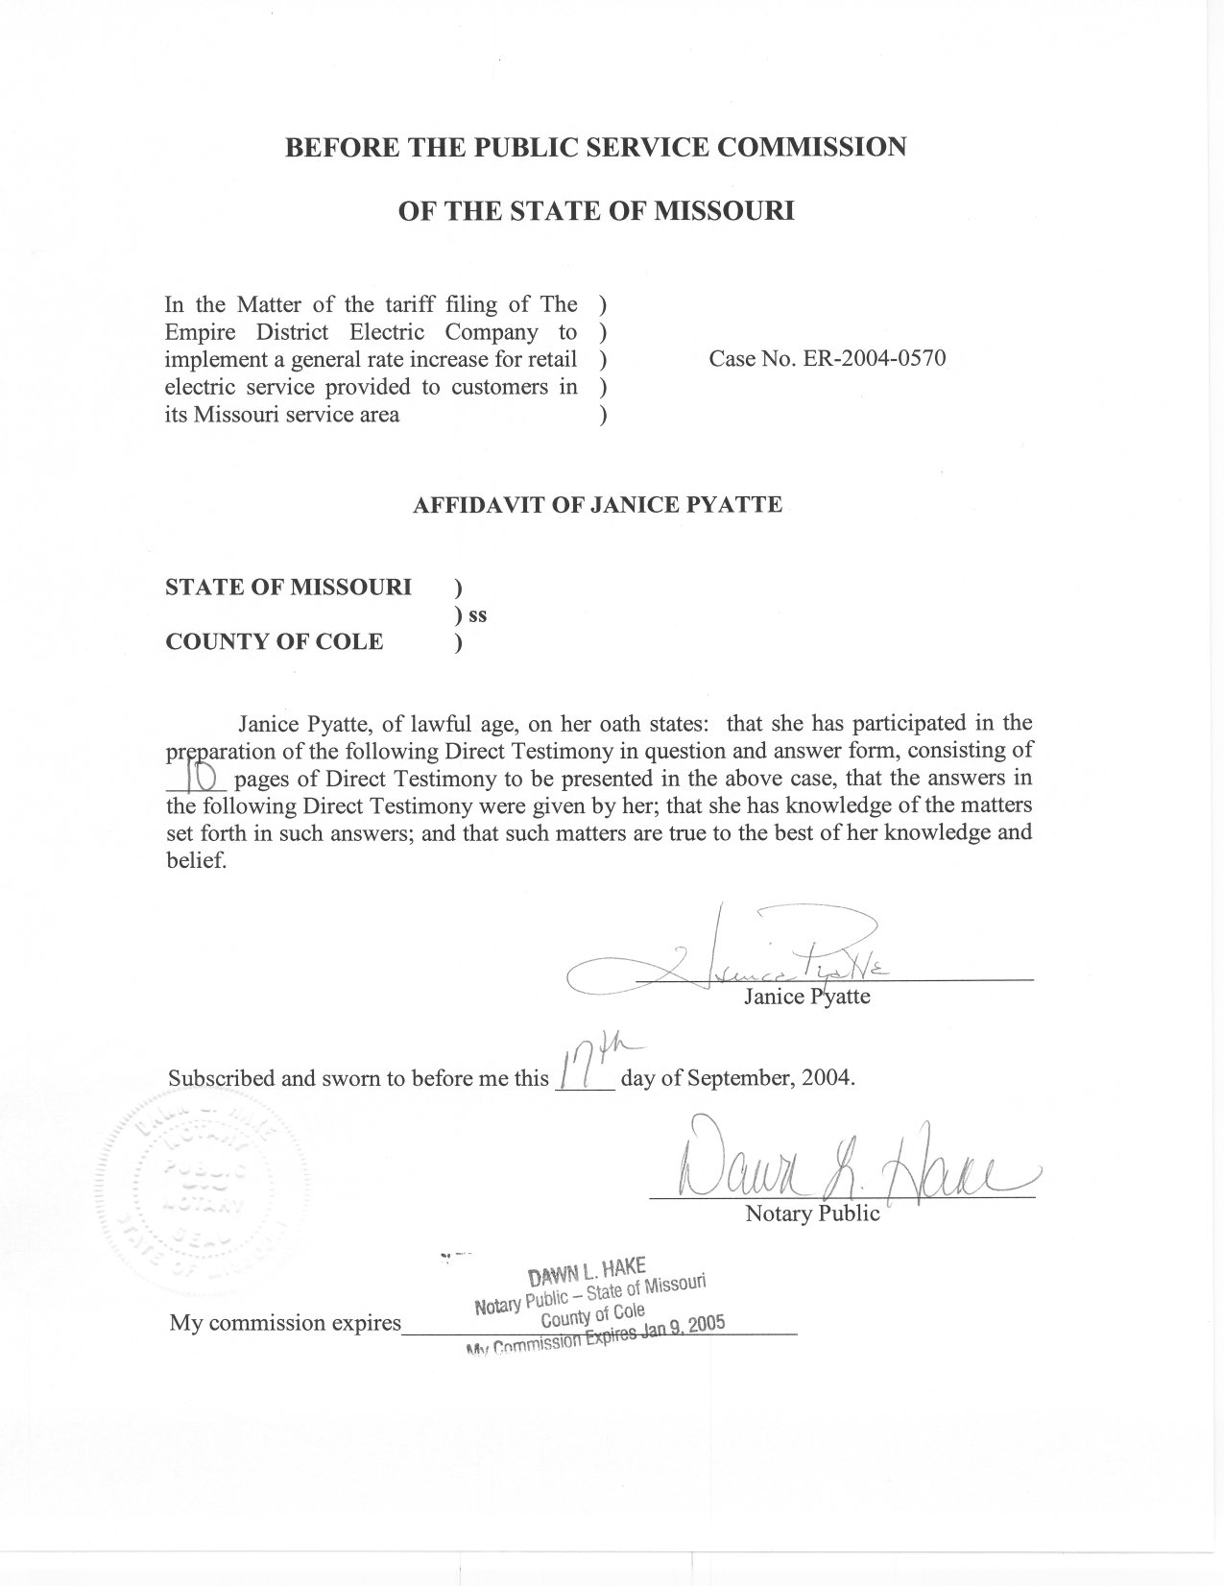

DIRECT TESTIMONY

OF

JANICE PYATTE

THE EMPIRE DISTRICT ELECTRIC COMPANY

CASE NO. ER-2004-0570

Q. Please state your name and business address.
A. My name is Janice Pyatte and my business address is Missouri Public Service Commission, P. O. Box 360, Jefferson City, Missouri 65102.
Q. What is your present position with the Missouri Public Service Commission?
A. I am a Regulatory Economist in the Economic Analysis Section, Energy Department, Operations Division.
Q. Would you please review your educational background and work experience?
A. I completed a Bachelor of Arts degree in Economics at Western Washington State College in Bellingham, Washington and a Masters of Arts (A.M.) degree in Economics at Washington University in St. Louis, Missouri. I have been employed by the Missouri Public Service Commission (Commission) since June 1977. My primary role with the Missouri Public Service Commission Staff (Staff) has been to perform analysis in the areas of rate design, class cost-of-service, rate revenue, and billing units for the regulated electric utilities in Missouri. A list of the cases in which I have filed testimony before the Commission is shown on Schedule 1.
Q. What has been your work experience in prior Empire District Electric Company (EDE or Company) rate cases?
A. I submitted testimony in each of the Company’s last four rate cases: Case No. ER-95-279, Case No. ER-97-81, Case No. ER-2001-299, and Case No.
ER-2002-424.
Q. What is the purpose of your direct testimony in this filing?
A. My direct testimony on the issue of Revenues describes my role in the development of specific adjustments to Missouri jurisdictional, test year sales of electricity (kWh sales) and the revenue from those sales (rate revenue) for the electric operations of The Empire District Electric Company. In this filing, I present two schedules that summarize EDE’s Missouri rate revenues, EDE’s Missouri retail kWh sales, and EDE’s total company retail kWh sales by rate schedule, based upon a test year of January 1, 2003 – December 31, 2003, updated for known and measurable changes through June 30, 2004. Missouri rate revenues are shown on Schedule 2. Adjusted total company (Missouri, Arkansas, Kansas, Oklahoma) retail kWh sales for the updated test year are shown on Schedule 3-2. Schedule 3-1 presents Missouri jurisdictional kWh sales by rate schedule.
Schedule 4 is a narrative that explains the basic concepts used in Staff’s ratemaking treatment of rate revenues and kWh sales.
Q. Are you sponsoring any adjustments to the revenue requirement calculation in this case?
A. Certain adjustments to EDE’s Missouri rate revenues shown on my Schedule 2 are also shown as Adjustments S-1.1, S-1.5, and S-1.7 in the Staff’s Adjustments to Income Statement-Accounting Schedule 10.
The Missouri retail kWh sales shown on my Schedule 3-1 support the Missouri rate revenues in Staff’s Income Statement-Accounting Schedule 9. The total company kWh sales shown on my Schedule 3-2 are an input into normalized hourly net system (total company) loads used in Staff’s production cost simulation model (fuel run) to calculate Missouri’s portion of fuel and purchased power expenses, which are also shown in Staff’s Income Statement-Accounting Schedule 9.
Q. What is the relationship between the Missouri rate revenues shown on your Schedule 2 and the Missouri operating revenues shown on Accounting Schedule 9-Income Statement?
A. The total operating revenues shown on Accounting Schedule 9-Income Statement, consists of two components: the revenue that the Company collects from the sales of electricity to Missouri retail customers (rate revenues), which is shown on my Schedule 2; and the revenue the Company receives from other sources (other or non-rate revenues). Non-rate revenues are generated by charges such as reconnect fees, returned check fees, late payment fees, etc. Another source of non-rate revenue may be off-system sales of electricity.
Q. How does your testimony relate to the testimony of other Staff witnesses in this case?
A. I am responsible for compiling the table labeled as Schedule 2, which summarizes the results of Staff’s work relating to EDE’s Missouri electric rate revenues. My testimony addresses the methodologies used to calculate annualized, normalized rate revenues for each affected rate schedule. The testimony of Staff Witness Doyle L. Gibbs addresses the effect that growth (or decline) in the number of customers had on rate revenues.
Staff Witness John P. Cassidy and Mr. Gibbs are responsible for any adjustments being proposed to EDE non-rate revenues.
I am also responsible for compiling the table labeled as Schedule 3, which summarizes the results of Staff’s work relating to EDE retail sales (measured in kWh). In addition to the adjustments to kWh sales addressed in my testimony, Staff witness Richard J. Campbell addresses the normalization of kWh sales to account for the effects of deviations from normal weather in the test year and for adjustments to reflect a 365-day billing year. Mr. Gibbs addresses the effect that growth (or decline) in the number of customers had on kWh sales.
Q. Please describe Staff’s ratemaking treatment of rate revenues and kWh sales.
A. Schedule 4 contains an explanation of the basic ratemaking concepts used in Staff’s treatment of rate revenues and kWh sales.
Q. Please describe the characteristics of the Missouri rate revenues and kWh sales that have been developed in this case.
A. The Missouri rate revenues and (Missouri and total company) kWh sales that I am presenting have these characteristics: (i) they have been developed by rate schedule; (ii) they have been normalized to remove the effects of deviations from normal weather in the test year; (iii) they have been developed on both a billing month and a calendar year (i.e., 365-day) basis; and (iv) they have been adjusted to reflect any growth (or decline) in class load. Each adjustment to Missouri kWh sales is associated with a corresponding adjustment to Missouri rate revenues.
In addition, Missouri rate revenues have been annualized to reflect the special treatment of the interruptible credits associated with Praxair’s contract.
Q. What specific annualizations to test year kWh sales and rate revenues were done in this case?
A. Missouri test year rate revenues and Missouri and non-Missouri test year kWh sales were annualized to reflect both the loss and gain of customers within the test year and within the update period. Mr. Gibbs is sponsoring the adjustments for those rate schedules serving smaller customers (RG, CB, SH, GP, TEB), which were computed based upon the Staff customer growth methodology. My Schedules 2 and 3 display
Mr. Gibbs’ results by rate schedule. His customer growth adjustment to Missouri rate revenues is shown in aggregate on Staff’s Adjustments to Income Statement-Accounting Schedule 10.
I am responsible for the annualizations done to those rate schedules that contain large customers (LP, PT, Praxair, PF) in all EDE jurisdictions. These annualizations were done on an individual customer (account) basis. They reflect significant increases or reductions in electric use, the exit from or transfer into the class by specific customers, and a 365-day adjustment. The annualizations are shown by rate schedule on Schedules 2 and 3. The large customer annualization to Missouri rate revenues is also shown in aggregate as Adjustment S-7 on Staff’s Adjustments to Income Statement-Accounting Schedule 10.
Q. Please describe the process used to annualize individual large customers.
A. The first step was to determine whether each customer account required annualizing. Each account’s monthly demand and energy use over the six months prior to the test year, the 12 months of the test year, and the six month update period were examined graphically to determine whether a change in the size and usage pattern of the customer had occurred. EDE provided considerable information on those accounts Staff had identified as having likely experienced changes that were significant enough to result in a recognizable change to EDE’s total kWh sales and revenues.
The most common method used to annualize a specific account was to replace specific months of that customer’s 2003 test year billing data with its billing data for corresponding months in the January 2004-June 2004 update period. Care was taken to reflect the known, unique circumstances of each customer.
Large customers who have permanently left EDE’s system were removed from the analysis. This was the situation with all three Power Furnace accounts, as well as two Missouri Large Power accounts.
An accounting was also done of existing customers who switched into or out of the Large Power class.
Q. Please describe the rationale for annualizing Large Power accounts individually rather than in aggregate.
A. Large Power accounts are the largest electricity-using customers. This group of 34 customers is heterogeneous in terms of both size and load factor and, as a consequence, aggregate methods of analyzing them are generally not very accurate.
Q. What special treatment was given to the interruptible credits associated with Praxair’s contract?
A. Although Praxair’s interruptible credits were increased from $3.76 per kW to $4.86 per kW as a result of Case No. ER-2001-299, I annualized them in this case at the pre-October 2, 2001 rate. This treatment of Praxair’s interruptible revenues is in accordance with paragraph 6 of the Unanimous Stipulation And Agreement Regarding Fuel And Purchased Power Expense And Class Cost Of Service And Rate Design, filed in Case No. ER-2001-299, which states:
6. In addition to the rate changes described above, Praxair’s current monthly credit for interruptible demand will be increased by an amount equivalent to $100,000.00 per year. This will be reflected on P.S.C. Mo. No. 5, Sec. 2, Sheet No. 9b of Empire’s Missouri rate schedules by striking the words “and beyond” in the line for 5 year contracts beginning in 1998 and by adding the following provisions:
For 5 year contracts beginning in 2001.............................$4.86
For 5 year contracts beginning in 2002 and beyond..........$3.76
For the purposes of calculating the Company’s revenue requirement during the pendency of the 5-year interruptible contract entered into between Empire and Praxair beginning in 2001, Empire agrees that it will calculate Praxair’s revenue as if the interruptible credit were $3.76. The effect of this increase in Praxair’s interruptible credit and Empire’s agreement will be to reduce the revenues collected by Empire by $100,000.00 per year, which $100,000.00 will not affect the rates of Empire’s other Missouri retail customers or be recovered from Empire’s other Missouri retail ratepayers. [emphasis added]
Q. What normalizations to test year billed kWh sales were done in this case?
A. Mr. Campbell has calculated the Staff’s weather adjustments and days adjustments to Missouri and non-Missouri kWh sales for the weather-sensitive rate schedules. The weather normalization re-states test year kWh sales on a “normal weather” basis; i.e., to the level of kWh sales that would have occurred in the test year if test year weather had been normal. Please refer to Mr. Campbell’s testimony for a more complete description of the weather normalization concept and methodology.
The days adjustment represents the change in kWh sales associated with adjusting the 12 test year billing months to the equivalent of 365 days. Mr. Campbell computed days adjustments for the RG, CB, SH, GP, and TEB rate schedules as part of the weather normalization process. I computed a days adjustment for each of the Large Power customers. EDE’s computation of annual unbilled sales was used as the days adjustment for the remaining rate schedules. The normalization adjustments to kWh sales are shown by rate schedule on my Schedule 3.
Q. What normalizations to Missouri test year rate revenues were done in this case?
A. I am responsible for calculating the adjustments to rate revenues that are associated with Mr. Campbell’s weather and days adjustments to kWh sales. Two different methodologies for normalizing rate revenue were used, one for the Residential (RG), Commercial (CB), and SH (Small Heating) rate schedules, and the other for the General Power (GP) and Total Electric Buildings (TEB) rate schedules. The assumption underlying both methodologies is that the weather normalization process has no effect on either the number of customers or on the fixed charges those customers currently pay. I assumed that weather normalization only affects the energy usage of each existing customer and thus only affects those charges directly related to kWh usage.
Q. What methodology was used to normalize rate revenues for the Residential (RG), Commercial (CB), and SH (Small Heating) rate schedules?
A. Each of these rate schedules has a fixed monthly customer charge and a two-block energy charge (First 600 kWh and Over 600 kWh). One characteristic of a multi-block rate structure is that the proportion of kWhs being priced in the first rate block declines (and the proportion being priced in the remaining rate blocks increases) as average use per customer increases. Using test year data and a statistical technique known as a regression, I modeled the relationship between average use per customer and the percentage of test year kWhs that are priced in the first rate block. I then applied this relationship to the monthly use per customer before and after the weather adjustment that Mr. Campbell had provided me. This computation resulted in normalized kWhs by rate block, which were then converted to total normalized revenues by multiplying rate block kWh by the appropriate rates.
Q. What methodology was used to normalize rate revenues for the General Power (GP) and Total Electic Buildings (TEB) rate schedules?
A. The weather adjustment to rate revenues for the GP and TEB rate schedules was calculated by an average realization methodology, excluding customer and demand charges. This methodology assumes that the weather adjustment to kWh sales in each month is distributed into the rate blocks in proportion to the distribution of actual test year energy. Another interpretation of this average realization methodology is that any additional kWh sales due to weather normalization should be priced at the same average price as all other sales in that month.
EDE’s computation of annual unbilled revenues was used as for the remaining rate schedules, which are not weather-sensitive and therefore required no adjustments due to weather.
Schedule 2 shows the annual normalization adjustment to Missouri rate revenues for each rate schedule. This normalization to rate revenues is shown in aggregate in Adjustments to Income Statement-Accounting Schedule 10, S-1.7.
Q. Do you have a recommendation for the Commission regarding EDE electric rate revenues and kWh sales?
A. I recommend that the Commission adopt the Staff’s adjustments to EDE booked rate revenues and kWh sales that are shown on my Schedules 2 and 3. If adopted, Staff’s Missouri rate revenues and kWh sales by rate schedule will be used to compute and implement any Commission-ordered revenue change in this case. If adopted, Staff’s total company kWh sales will be used as an input into the calculation of Missouri fuel and purchased power expenses.
Q. Does this conclude your direct testimony on the issue of Revenues in this case?
A. Yes, it does.

