Exhibit No.:
Issues: Rate Design

Witness: Janice Pyatte
Sponsoring Party: MO PSC Staff
Type of Exhibit: Direct Testimony
Case Nos.: ER-2004-0034
& HR-2004-0024
(Consolidated)
Date Testimony Prepared: December 18, 2003

MISSOURI PUBLIC SERVICE COMMISSION

Utility Operations DIVISION

Direct Testimony

OF

Janice Pyatte

Aquila, Inc.
d/b/a Aquila Networks--MPS
and Aquila Networks--L&P

CASE NOS. ER-2004-0034 & HR-2004-0024

Jefferson City, Missouri
December 2003
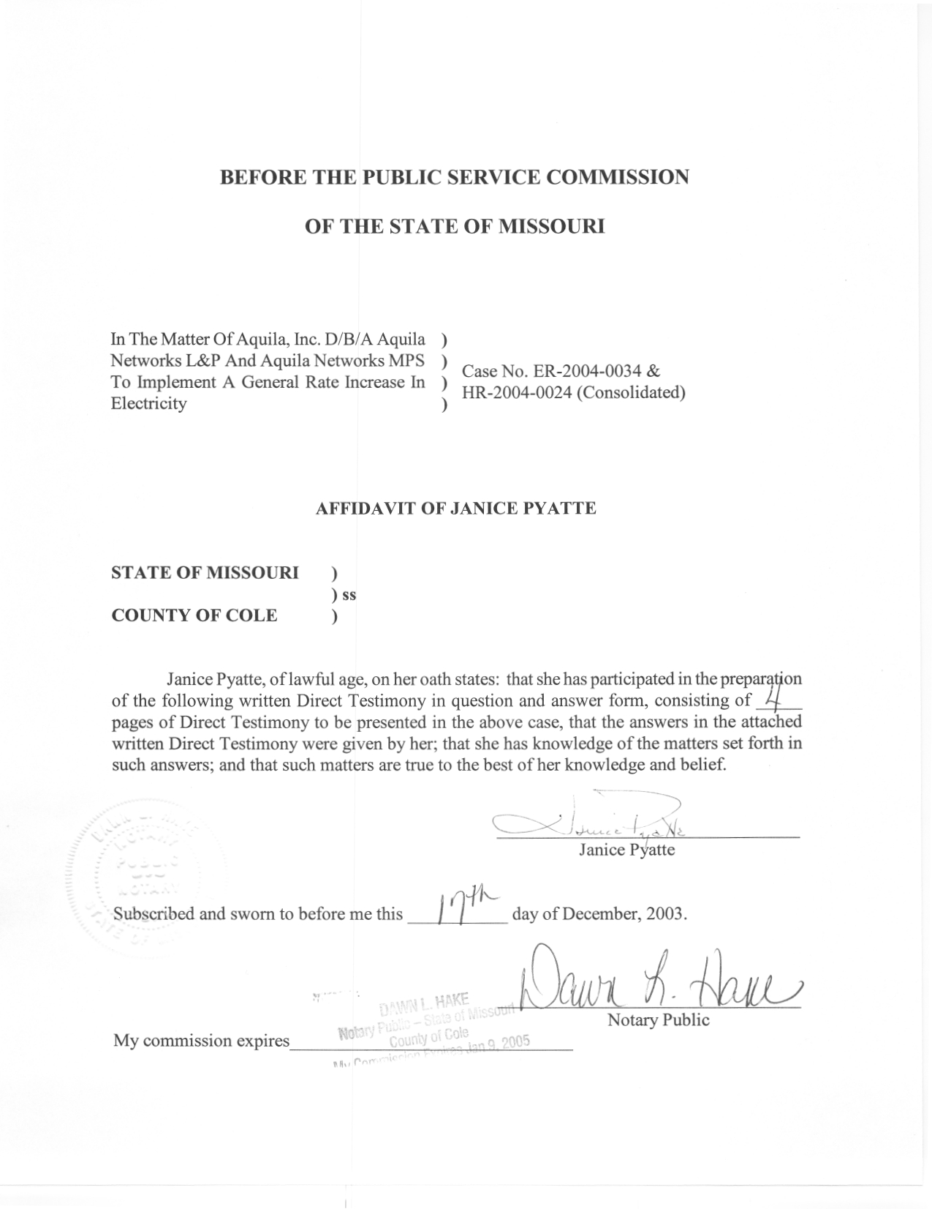

DIRECT TESTIMONY
OF
JANICE PYATTE
AQUILA, INC.
D/B/A AQUILA NETWORKS-MPS
AND AQUILA NETWORKS-L&P

CASE NOS. ER-2004-0034 AND HR-2004-0024
(CONSOLIDATED)

Q. Are you the same Janice Pyatte who filed direct testimony on December 9, 2003 on the issue of Sales and Rate Revenue?
A. Yes, I am.
Q. What is the purpose of your direct testimony in this filing?
A. The purpose of this testimony is to present the Staff’s rate design recommendation for Aquila, Inc. d/b/a Aquila Networks-L&P (“L&P”) steam service.
The rate designs for Aquila Networks-L&P electric operations and Aquila Networks-MPS electric operations are presented in a Non-Unanimous Stipulation and Agreement Pertaining to Rate Design and Class Cost of Service, filed separately in this case.
Q. Please describe L&P’s steam operations.
A. The steam operations of L&P provide service to a small number of industrial customers located in the vicinity of the Lake Road power plant in St. Joseph, Missouri. Prior to December 30, 2000, these customers were served by St. Joseph Light & Power Company (“SJLP”). UtiliCorp, United acquired SJLP, including its steam operations, on December 30, 2000, and, in February 2002, UtiliCorp changed its name to Aquila, Inc. Aquila, Inc. is authorized by this Commission to provide electric and steam service in the St. Joseph, Missouri area as Aquila Networks—L&P.
Q. Please provide a brief history of L&P’s steam rate case activity since 1988.
A. The steam rates for SJLP that resulted from Case No. HR-88-116 were in effect from 1988 until 1993. In 1993, the Commisssion, in Case No. HR-94-177, authorized SJLP to increase its steam revenue by $800,000 annually.
In 1995 the Staff, the Office of the Public Counsel, SJLP, and Ag Processing, Inc. (“AGP”) participated in Case No. EO-94-36. The purpose of this case was to evaluate the cost assignment of plant and expenses for common uses between SJLP’s electric, industrial steam and natural gas operations. Detailed allocation procedures were developed and approved by the Commission in that proceeding. In the associated case (Case No. EO-93-351) that implemented these allocation procedures, the Commission ordered a $550,000 reduction in revenue from SJLP’s industrial steam operations, a $500,000 increase in SJLP’s electric revenue, and a $50,000 increase in SJLP’s gas revenue.
In Case No.HR-99-245, steam revenue was reduced by $25,000. The steam rates resulting from this case are still in effect.
Q. Please describe the L&P steam rate schedules.
A. L&P has three steam rate schedules: Steam Service (Schedule 810); Standby or Supplementary Service (Schedule 811); and Contract Service (Schedule 812).
All but one of the current industrial steam customers was served under Schedule 810 during the entire test year. The remaining customer was served under Schedule 812 during the first part of the test year and under Schedule 810 during the later months of the test year. Staff has annualized rate revenue, treating all customers as if they had been served under Schedule 810 during all months of the test year, to more accurately depict required revenue on a going-forward basis. For more information on the annualizations to steam rate revenue included in Staff’s case, please see my direct testimony on the issue of Sales and Rate Revenue filed December 9, 2003.
Q. Please describe Staff’s analysis of the overall revenue adequacy of L&P’s steam revenue.
A. Staff filed direct testimony on December 9 and Accounting Schedules on December 10, 2003 that quantified the revenue shortfall associated with L&P’s industrial steam operation at approximately $1.7 million. As a result, an increase in annual steam revenue of $1.7 million (24.7%) would be required to cover the total costs of providing industrial steam service, based on Staff’s recommended level of annualized revenue.
Q. Do you have a recommendation for the Commission regarding how any increase in L&P steam revenue should be applied to rate components?
A. I recommend that any overall increase in annual steam rate revenue be achieved by increasing all rate components on the steam service rate schedules by an equal percentage.
Q. Has Aquila proposed tariff sheets to increase annual steam revenue?
A. Yes. Aquila proposed to increase each rate component of its steam tariff by 19.3%, which is $1.8 million less than Aquila’s determination of the steam customer’s actual cost of service.
Q. Have you prepared illustrative steam tariff sheets to show the results of implementing the Staff’s proposed rate design?
A. No. The Company’s proposed tariff sheets were developed by increasing all rate components by an equal 19.3% percentage and, if adopted, would implement the Staff’s proposed rate design for the rate increase requested by the Company. Staff is not proposing a larger revenue increase in annual steam revenue than Company has requested.
Q. Does this conclude your direct testimony on rate design issues in this case?
A. Yes, it does.

