Exhibit No.:
Issues: Interim Energy
Charge

Witness: Janice Pyatte
Sponsoring Party: MO PSC Staff
Type of Exhibit: Surrebuttal Testimony
Case No.: ER-2004-0034 &
HR-2004-0024
(Consolidated)
Date Testimony Prepared: February 20, 2004

MISSOURI PUBLIC SERVICE COMMISSION

Utility Operations DIVISION

SURREBUTTAL TESTIMONY

OF

JANICE PYATTE

Aquila, Inc.
d/b/a Aquila Networks -- mps
and Aquila Networks --l&P

CASE NOS. ER-2004-0034 & HR-2004-0024
(CONSOLIDATED)

Jefferson City, Missouri
February 2004
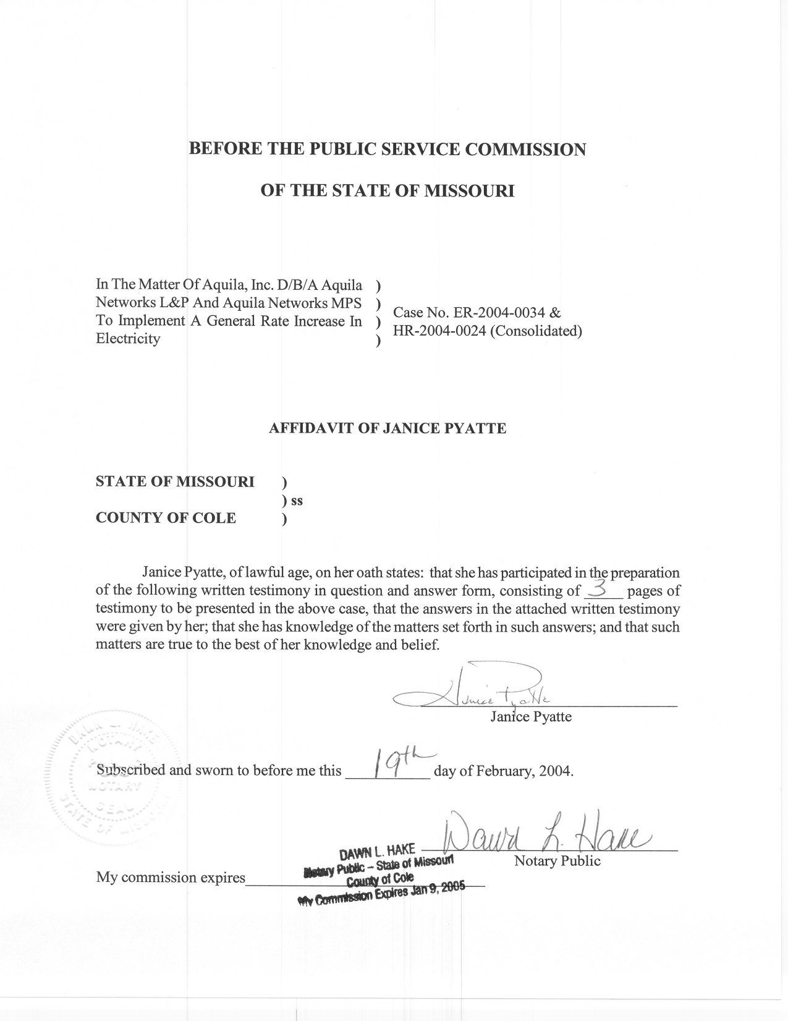
SURREBUTTAL TESTIMONY
OF
JANICE PYATTE
AQUILA, INC.
D/B/A AQUILA NETWORKS-MPS
AND AQUILA NETWORKS-L&P

CASE NOS. ER-2004-0034 AND HR-2004-0024
(CONSOLIDATED)

Q. Please state your name and business address.
A. My name is Janice Pyatte and my business address is Missouri Public Service Commission, P. O. Box 360, Jefferson City, Missouri 65102.
Q. Are you the same Janice Pyatte who previously filed testimony in this case?
A. Yes, I am.
Q. How does your testimony relate to the testimony of other Staff witnesses in this case?
A. The surrebuttal testimony of Staff witness James C. Watkins presents Staff’s proposal to recover some of Aquila’s Missouri fuel and purchased power costs on an interim, subject to refund, basis. Mr. Watkins’s testimony describes this fuel cost recovery mechanism as an Interim Energy Charge (IEC). His testimony also presents the total Missouri revenues that Staff is proposing be collected via the IEC by Aquila division (MPS, L&P) and operation (electric, steam).
Q. What is the purpose of your testimony in this case?
A. My testimony presents the calculation of the IEC surcharge, expressed as a percent of revenues, and illustrates the effects on class revenues of implementing such a surcharge.
Q. What amount of fuel and purchased power expense is Staff proposing be recovered through interim rates?
A. According to the testimony of Mr. Watkins, interim revenues would be $20,708,832 for MPS (electric), $2,894,273 for L&P (electric), and $2,203,402 for L&P (steam).
Q. How were interim rates developed once interim revenues were known?
A. In accordance with the Non-Unanimous Stipulation and Agreement Pertaining to Rate Design and Class Cost of Service, the IEC surcharge is to be collected as a percent of revenue. The IEC surcharge will be different for each Aquila division (MPS, L&P) and operation (electric, steam). However, all customers of a single division/operation will have the same additional x% added to their monthly bills.
My computations, presented on Schedules 1 and 2 attached to this testimony, result in an IEC surcharge of 6.67% for MPS (electric), 3.28% for L&P (electric), and 31.82% for L&P (steam).
Q. Please describe Schedules 1 and 2.
A. Schedule 1 illustrates the distribution of class revenues that would result from the application of a 6.67% IEC surcharge to all Aquila Networks-MPS (electric) Missouri retail electric customers. Schedule 2 shows similar information for a 3.28% IEC surcharge for Aquila Networks-L&P electric customers. Schedule 2 also illustrates a 31.82% IEC surcharge for L&P (steam) customers.
Q. Does this conclude your surrebuttal testimony?
A. Yes, it does.

