Exhibit No.:
Issues: Rate Design
Witness: Janice Pyatte
Sponsoring Party: MoPSC Staff
Type of Exhibit: Direct Testimony
Case No.: ER-2002-424
Date Testimony Prepared: August 30, 2002

MISSOURI PUBLIC SERVICE COMMISSION

UTILITY OPERATIONS DIVISION

DIRECT TESTIMONY

OF

JANICE PYATTE

THE EMPIRE DISTRICT ELECTRIC
COMPANY

CASE NO. ER-2002-424

Jefferson City, Missouri
August, 2002
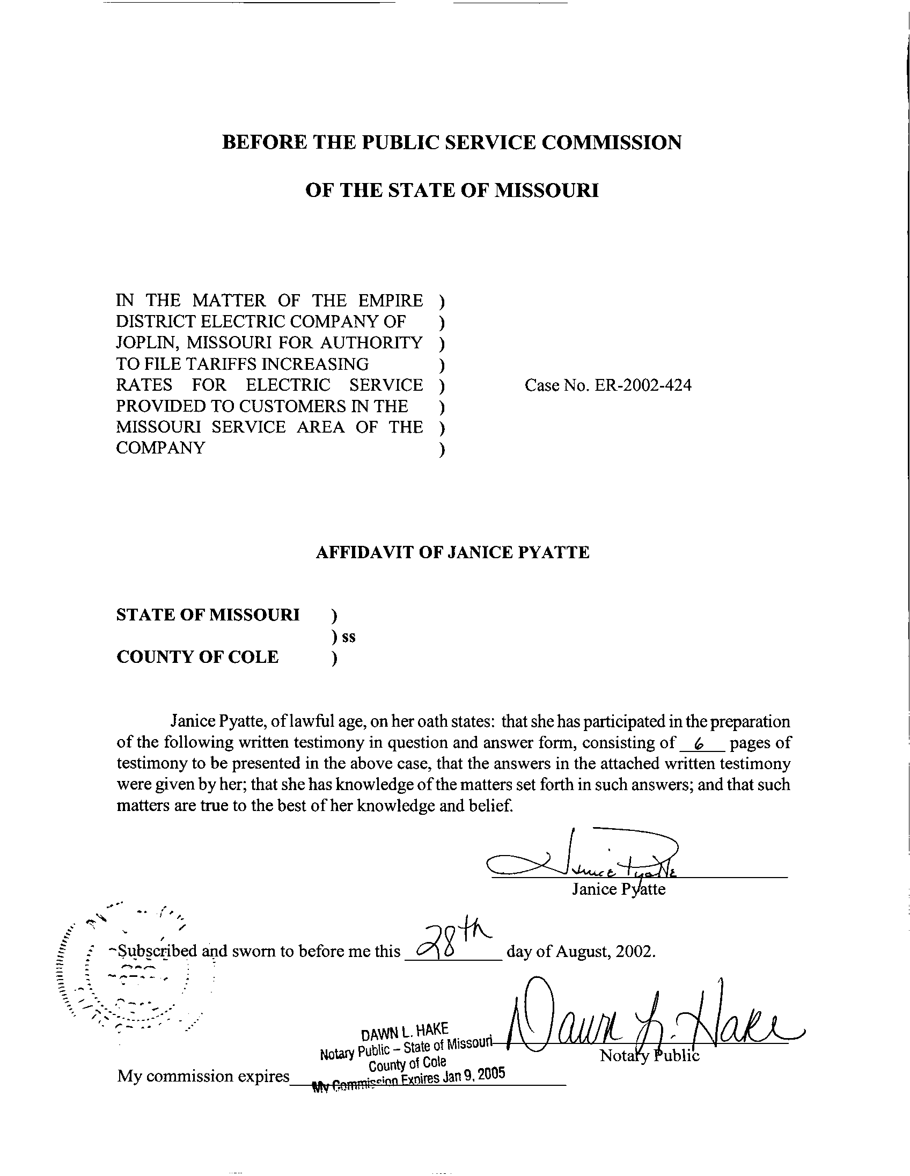
TABLE OF CONTENTS

REVENUE INCREASES TO RATE CLASSES 2
RATE LEVELS 4
OTHER CHARGES AND CREDITS 5

DIRECT TESTIMONY
OF
JANICE PYATTE
THE EMPIRE DISTRICT ELECTRIC COMPANY
CASE NO. ER-2002-424

Q. Please state your name and business address.
A. My name is Janice Pyatte and my business address is Missouri Public Service Commission, P. O. Box 360, Jefferson City, Missouri 65102.
Q. Are you the same Janice Pyatte who previously filed prepared direct testimony on the issue of Sales and Revenues in this case?
A. Yes, I am.
Q. What is the purpose of your direct testimony in this filing?
A. This filing of direct testimony addresses the issue of Rate Design for The Empire District Electric Company’s (“Company” or “EDE”) Missouri jurisdiction. My testimony illustrates the outcome of applying Staff’s rate design recommendations in this case, as described in the direct testimony of Staff witness James C. Watkins, to various increases in EDE’s Missouri rate revenues. My testimony will also address the rate design implications of Staff’s recommendation to terminate the Interim Energy Charge (Rider IEC), as proposed in the direct testimony of Staff witness Cary G. Featherstone.
Q. What has been your work experience on the issue of Rate Design in prior Empire District Electric Company cases?
A. I filed testimony on the design of electric tariffs for The Empire District Electric Company in Case No. EO-91-74, EDE’s last rate design case (later consolidated with Case No. ER-94-174). I also filed rate design testimony in each of the Company’s last three rate cases: Case No. ER-95-279, Case No. ER-97-81, and Case No. ER-2001-299.
Q. What rate classes are used in your illustrations of the outcome of applying Staff’s rate design recommendations?
A. My illustrations of the outcome of applying Staff’s rate design recommendations cover all of Empire’s rate schedules and are grouped into the following seven rate classes: (1) Residential (RES); (2) Small General Service (Small GS or SGS);
(3) Large General Service (Large GS or LGS); (4) Large Power Service (LPS); (5) Special Contracts (SC or Praxair); (6) Power Furnace; and (7) Lighting. The first five of these rate classes were analyzed in Staff’s class cost-of-service study.
Q. What is the relationship between Staff’s rate classes and EDE’s existing rate schedules?
A. Each Staff rate class corresponds to one or more of EDE’s existing rate schedules. The relationship between rate schedules and Staff rate classes is displayed on Schedule 1.

REVENUE INCREASES TO RATE CLASSES
Q. What is Staff’s recommendation for applying any increase in overall Missouri revenue to rate classes?
A. Staff’s proposal, described on pages 3-4 of Mr. Watkins’ direct testimony, is that each rate class’s share of any increase in overall Missouri revenue be determined as follows:
(1) the Residential, Large General Service, Lighting, and Power Furnace classes will receive the overall average percentage increase;
(2) the Small General Service class will not receive any increase;
(3) the Large Power Service and Special Contracts (Praxair) classes will be increased by whatever percentage collects the remainder of the revenue increase, with the same percentage increase applying to both classes.
Q. What revenue increases to the rate classes will result from implementing Staff’s rate design recommendations?
A. Schedule 2 displays the results of applying Staff’s recommendations to various overall increases in Missouri retail revenue. Three of the scenarios correspond to the results of Staff Accounting Schedule 1, filed August 22, 2002; namely, the rows entitled “$106,274 increase”,“$2,174,891 increase”, and “$4,337,539 increase”, which correspond, respectively, to the overall revenue increase required at the Staff’s low, mid-point, and high rate of return.
Q. What revenue increases will be assigned to each rate class if the Commission determines that the Staff’s mid-point of $2,174,891 overall revenue increase should be implemented in accordance with Staff’s rate design recommendations?
A. At an overall revenue increase of $2,174,891, rate classes would experience the following revenue increases:
Class | Revenue Increase | Percent Increase
Residential | $996,531 | 0.98%
Small GS | $0 | 0.00%
Large GS | $537,858 | 0.98%
Large Power | $551,385 | 2.12%
Special Contracts (Praxair) | $47,912 | 2.12%
Lighting | $40,323 | 0.98%
Power Furnace | $881 | 0.98%
Total Missouri | $2,174,891 | 0.98%

RATE LEVELS
Q. What is Staff’s recommendation for determining the rate levels that should be contained on each rate schedule?
A. Staff’s recommendation, described on page 3 of Mr. Watkins’ direct testimony, is that rate levels on each rate schedule should be determined by increasing the level of all rate components by the same percentage increase that is applied to the associated rate class’s revenues.
Q. What specific rate values would result if the Commission ordered a $2,174,891 overall revenue increase to be implemented in accordance with Staff’s rate design recommendations?
A. The resulting rate values, plus a comparison between these proposed rates and current rates, are shown on Schedule 3.
Q. Will Staff’s rate design recommendation result in increases or decreases to any rate values if the Commission determines that no overall revenue increase should be granted to EDE?
A. No. Under Staff’s rate design proposal, rates will remain at existing levels if EDE’s overall revenues are not increased.

OTHER CHARGES AND CREDITS
Q. What is Staff’s recommendation for the charges and credits that currently appear on EDE Missouri electric bills but are not generated by the proposed rates shown on Schedule 3?
A. Staff’s recommendations will not change any charges or credits associated with: (1) credit action fees (Schedule CA); (2) interruptible credits (Rider IR); (3) interruptible credits (Praxair); (4) special or excess facilities (Rider XC); or (5) facilities charges associated with lighting rate schedules. These charges and credits will remain at current tariffed levels.
Q. What is Staff’s recommendation for the Interim Energy Charge (Riders IEC and CIEC)?
A. Staff’s position on the Interim Energy Charge is that “…the Commission should terminate the IEC tariff as of the effective date of the Report And Order in this case..” [Featherstone, direct, page 15, lines 6-7].
If the Commission adopts Staff’s proposal to terminate the IEC, customers will no longer be subject to the charge on their electric bills. In addition, at some future time, customers may receive a refund for some portion of the IEC that was paid in the past.
Q. Do your calculations account for Staff’s recommendations on other charges and credits and the IEC charge?
A. Yes. The rate class revenues shown on Schedule 2, attached to this testimony, include only those components of revenue that Staff is proposing to change in this case. The breakdown of revenues associated with these other charges and credits and the Interim Energy Charge, can be seen on Schedule 3-1, attached to my direct testimony on the issue of Sales and Revenues.
Q. Does this conclude your direct testimony on the issue of Rate Design in this case?
A. Yes, it does.

