Exhibit No.:
Issues: Tariff Issues

Witness: James M. Russo
Sponsoring Party: MO PSC Staff
Type of Exhibit: Rebuttal Testimony
Case No.: GC-2004-0216
Date Testimony Prepared: May 10, 2004

MISSOURI PUBLIC SERVICE COMMISSION

UTILITY OPERATIONS DIVISION

REBUTTAL TESTIMONY

OF

JAMES M. RUSSO

MISSOURI GAS ENERGY

CASE NO. GC-2004-0216

Jefferson City, Missouri
May 2004
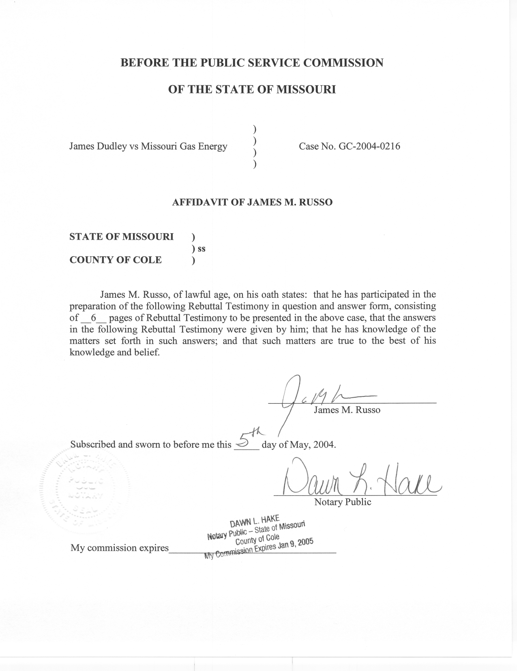

REBUTTAL TESTIMONY

OF

JAMES M. RUSSO

MISSOURI GAS ENERGY

CASE NO. GC-2004-0216

Q. Please state your name and business address.
A. James M. Russo, P. O. Box 360, Jefferson City, Missouri 65102.
Q. Are you the same James M. Russo who filed Direct Testimony in Case No. GC-2004-0216?
A. Yes I am.
Q. What is the purpose of your Rebuttal Testimony?
A. The purpose of my Rebuttal Testimony is to rebut portions of the Direct Testimony of James Dudley (Complainant) in this proceeding.
Q. What do you believe are Mr. Dudley’s primary assertions stated in his Direct Testimony?
A. I believe Mr. Dudley’s primary assertions are the transfer of prior unpaid gas bills accrued at 4024 Prospect Avenue, Kansas City, Missouri (4024 Prospect), to his account for gas service at 4231 Tracy Avenue, Kansas City, Missouri (4231 Tracy), and if Missouri Gas Energy (MGE or Company) violated any portion of the Rules of the Commission or it’s tariff by disconnecting and refusing to provide service to Mr. Dudley.
Q. Have you made an examination and study of Rules 4 CSR 240-13.045 and 4 CSR 240-13.050, in addition to MGE tariff sections 8.01, 8.06 and 8.08 as cited by Mr. Dudley in his pre-filed Direct Testimony?
A. Yes I have. These rules and tariff sections are attached to my Rebuttal Testimony as Schedule 1.
Q. What are the corresponding dollar amounts, property addresses, time periods and name on the account of the unpaid gas bills Mr. Dudley is disputing?
A. The unpaid gas bills Mr. Dudley is disputing are: $2,099.96 at 4024 Prospect Avenue for the time period of October 2000 thru April 2001 for gas service in the name of Sara Chappelow; $104.63 at 4024 Prospect Avenue for the time period of July 2001 thru April 2002 for gas service in the name of James Dudley and $305.54 at 4231 Tracy for the time period of January 2002 thru June 2002 for gas service that is also in the name of James Dudley. The total of the three unpaid gas bills are $2,510.13.
Q. Does Staff agree with Mr. Dudley on the disputed amount?
A. Mr. Dudley’s Direct Testimony is unclear as to what is exactly in dispute. Staff believes the disputed amount is the $2,099.96 that was accrued during the time period of October 2000 thru April 2001 by an individual claiming to be Sara Chappelow.
Q. Why is Staff unclear of the amount Mr. Dudley is disputing?
A. Mr. Dudley states in item numbers 11 and 12, on page 2 of his Direct Testimony:
11. Respondent applied the $2,099.96 from 4024 Prospect along with the $305.00 that was the June Bill for 4231 Tracy on June 24, 2002.
12. Complainants received a gas bill for $2,510.00 at 4231 Tracy on July 10, 2002.

The original complaint, Mr. Dudley’s answer to MGE’s Answer and the Pleading for Complainant, are documents filed by Mr. Dudley that refer to Sara Chappelow’s bill. Staff believes the disputed amount is that portion of Mr. Dudley’s delinquent bills that relate to Sara Chappelow in the amount of $2,099.96. Mr. Dudley does not address the $104.63 that he accrued for gas service in his name at 4024 Prospect Avenue. In addition, Mr. Dudley refers to the $305.00 as the June bill for gas service at 4231 Tracy which was an account in his name.
Mr. Dudley states that MGE violated 4 CSR-240-13.045 (1) which states:
A customer shall advise a utility that all or part of a charge is in dispute by written notice, in person or by a telephone message directed to the utility during normal business hours. A dispute must be registered with the utility at least twenty-four (24) hours prior to the date of proposed discontinuance for a customer to avoid discontinuance of service as provided by these rules.
Q. Did Mr. Dudley comply with the Rule?
A. Yes. Mr. Dudley did contact the utility on July 24, 2002, as required by Section 1 of the above rule. Staff has reviewed MGE’s records and verified MGE complied with Section 2 of this rule by notating the call in the Company’s computer system. It is Staff’s understanding that MGE requested additional information at this point in time, including a copy of the lease for 4024 Prospect Avenue. Mr. Dudley did not provide these items to MGE. Mr. Dudley did contact the Commission’s Consumer Services Staff on July 29, 2002, which is within the five-day requirement cited in Section 3 of this rule. Staff also points out that the undisputed portion of the bill in the amount of $410.17 (the sum of the amount of $104.60 at 4024 Prospect and $305.54 at 4231 Tracy) was not paid as required by section 5 of this rule. Staff believes MGE discontinued service within the scope of Section 7 of this rule.
Mr. Dudley states that MGE violated 4 CSR-240-13.050, items 1 through 5 by failing to give proper notice.
Section (1) of this rule states service may be discontinued for any of the following reasons. Section (1)(A) states nonpayment of an undisputed bill. Section 2 addresses the reasons service may not be disconnected, while sections 3 thru 5 refer to proper notice requirements. MGE notified the customer of a pending disconnect on July 10, 2002, and, July 16, 2002. MGE is not in violation of sections 3 thru 5 of this rule.
Mr. Dudley states MGE violated Sections 8.01, 8.06 and 8.08 of the General Terms and Conditions for Gas Service of MGE’s current tariff. Please explain these sections.
Section 8.01 refers to the basic rules for complaints and disputed claims to be followed by the Company and the customer. The section also sets forth the Company’s rights when a customer fails to cooperate in the investigation of the dispute.
Section 8.06 refers to the Company advising the Complainant he has the right to register an informal complaint with the Commission. In addition, the Company must provide the Complainant with the address and telephone number where the customer may file an informal complaint.
Section 8.08 refers to discontinuance of service by the Company until a decision is made on a disputed charge. Specifically, the Company shall not discontinue residential service or issue a notice of discontinuance relative to the matter in dispute pending the decision of a hearing officer or other Commission personnel.
Q. Does Staff believe MGE violated any portion of the Commission Rules or MGE’s tariff by disconnecting and refusing to provide service to Mr. Dudley?
A. No. Staff does not believe that MGE has violated its tariffs or any Commission Rules by disconnecting and refusing service to Mr. Dudley. As stated earlier, Staff believes the disputed bill amount was $2,099.96. Staff also believes that the two remaining balances of $104.63 and $305.54 are not in dispute. In addition, Staff notes that Mr. Dudley had outstanding delinquent gas bills owed to MGE on properties he owns at 3514 Bales and 3312 Moulton that were subsequently transferred to the Tracy account in October of 2002.
Rules 4 CSR 240-13.045 and 4 CSR 240-13.050, and MGE tariff sections 8.01, 8.06 and 8.08 do not apply to these other delinquent accounts to prevent discontinuance of service. Rather, Staff believes the sections are quite clear in allowing MGE to disconnect service for the non-payment of undisputed amounts. Specifically,
4 CSR 240-3.045 (7) states:
Failure of the customer to pay to the utility the amount not in dispute within four (4) working days from the date that the dispute is registered or by the delinquent date of the disputed bill, whichever is later, shall constitute a waiver of the customer’s right to continuance of service and the utility may then proceed to discontinue service as provided in this rule.
In addition, 4 CSR 240-13.050 (1) and (1) (A) state: service may be discontinued for the following reasons: (A) Nonpayment of an undisputed delinquent charge. Finally, Staff believes MGE tariff section 8.06 is not applicable in any scenario because Mr. Dudley did file a timely informal complaint as it relates to the Sara Chappelow bill.
Q. What does Mr. Dudley presently owe on the property located at 4231 Tracy according to MGE’s records?
A. As of April 26, 2004, the amount is $2,895.91.
Q. You earlier stated that MGE’s records indicated Mr. Dudley owed $2,510.13. Can you reconcile the difference?
A. Yes. The $2,510.13 was the balance as of June 25, 2002. The difference is attributable to the usage of additional gas at 4231 Tracy, the transfer of two more delinquent residential accounts on other property owned by Mr. Dudley less payments made to Mr. Dudley’s account. Listed below are summaries of the charges for gas service and charges by property location that comprise the $2,895.91.
Summary of Gas Charges
Balance as of June 30, 2002 $2,510.13
Additional charges 883.43
Transfer from 3514 Bales 250.20
Transfer from 3312 Moulton 324.15
Payment on September 2, 2002 -290.00
Payment on October 2, 2002 -190.00
Energy Assistance January 22, 2003 -592.00
Total of Gas Charges $2,895.91

Summary by Property Location
4024 Prospect Avenue $2,099.96
4024 Prospect Avenue 104.63
4231 Tracy 116.97
3514 Bales 250.20
3312 Moulton 324.15
Total $2,895.91

Q. Does this conclude your Rebuttal Testimony?
A. Yes, it does.

