Exhibit No.:
Issues: Acquisition Adjustments;
Security Accounting
Authority Order;
Old St. Joseph Treatment Plant
Witness: Stephen M. Rackers
Sponsoring Party: MoPSC Staff
Type of Exhibit: Surrebuttal Testimony
Case Nos.: WR-2003-0500
and WC-2004-0168
Date Testimony Prepared: December 5, 2003

MISSOURI PUBLIC SERVICE COMMISSION

UTILITY SERVICES DIVISION

SURREBUTTAL TESTIMONY

OF

STEPHEN M. RACKERS

MISSOURI-AMERICAN WATER COMPANY

CASE NOS. WR-2003-0500 AND WC-2004-0168

Jefferson City, Missouri
December 2003
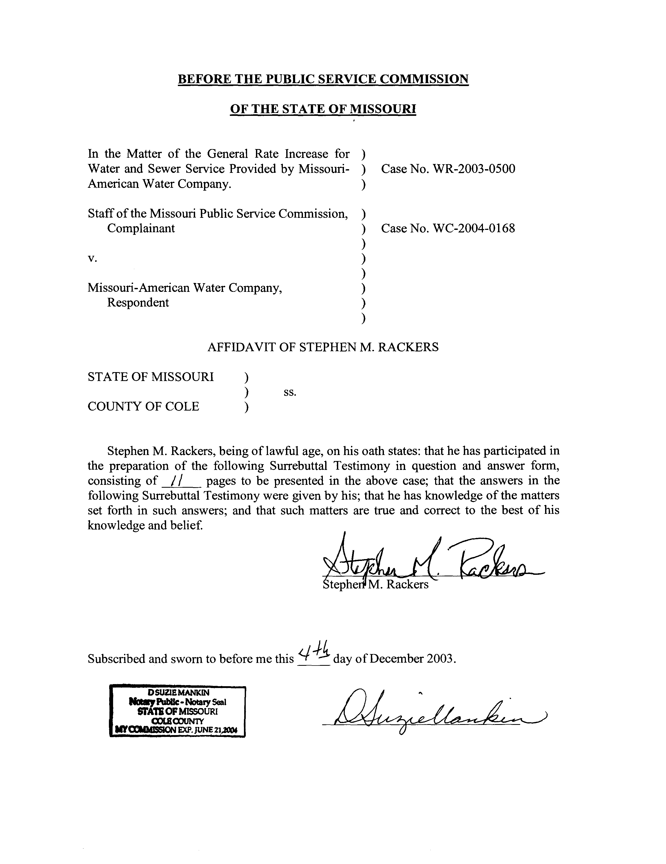
TABLE OF CONTENTS OF
SURREBUTTAL TESTIMONY OF
STEPHEN M. RACKERS
MISSOURI-AMERICAN WATER COMPANY
CASE NOS. WR-2003-0500
AND WC-2004-0168

SECURITY AAO 1
OLD ST. JOSEPH TREATMENT PLANT 6
ACQUISITION ADJUSTMENTS 8

SURREBUTTAL TESTIMONY
OF
STEPHEN M. RACKERS
MISSOURI-AMERICAN WATER COMPANY
CASE NOS. WR-2003-0500
AND WC-2004-0168
Please state your name and business address.
Stephen M. Rackers, 1845 Borman Court, Suite 101, St. Louis, Missouri 63146.
Are you the same Stephen M. Rackers who previously filed direct testimony in this case?
Yes, I am.
What is the purpose of this surrebuttal testimony?
This surrebuttal testimony will address the rebuttal testimony of
Missouri-American Water Company (MAWC or Company) witnesses Edward J. Grubb regarding the security accounting authority order (Security AAO) and the recovery of the Old St. Joseph Treatment Plant; and James M. Jenkins regarding acquisition adjustments.

SECURITY AAO
In his rebuttal testimony on page 25, line 27 through page 26, line 7, Mr. Grubb states that the Company should be allowed to recover the legal costs that were incurred as a result of MAWC’s application to establish an AAO for the deferral of security costs. Do you agree?
No. As I stated in my direct testimony, the Company was given the authority to defer costs related to the security improvements and enhancements. Legal costs simply do not fit this definition.
Are the legal costs incurred to request an AAO for security costs indicative of an ongoing expense item?
No. To my knowledge, Case No WO-2002-273 was the only time the Company has ever requested an AAO to defer security costs. I do not expect the Company to incur such costs again, certainly not in the near future. Therefore, the legal expenses should not be included in the ongoing cost of service, since they represent
one-time nonrecurring costs.
On page 26, lines 9 through 11 of his rebuttal testimony, Mr. Grubb refers to his testimony rebutting the Staff’s disallowance of a portion of the allowance for funds used during construction (AFUDC) capitalized on plant. Do you believe the AFUDC cost portion of this issue should follow the Commission’s decision regarding the proper AFUDC rate for plant?
Yes. I have used the AFUDC rates determined by Staff witness Lisa K. Hanneken for her adjustment to the amount of AFUDC capitalized as a portion of the cost of plant. The AFUDC issue for the deferred cost associated with the Security AAO should follow the Commission’s decision regarding the proper AFUDC rates to use for plant. I participated in preparing the list of issues filed on December 3 and I believe the parties have agreed to follow this procedure with regard to the AFUDC issue.
On page 26, lines 23 through 27 of his rebuttal testimony, does Mr. Grubb appear to agree, in certain situations, with the use of the Commission’s standard of sharing the effect of regulatory lag associated with the AAO deferral by allowing only a “return of” the amounts deferred and not a “return on” the amounts deferred?
Yes. Mr. Grubb states that the Company believes the Commission can use this standard, which the Staff has proposed, if the deferral represents amounts that benefit both ratepayers and shareholders. In such cases he apparently agrees that it is appropriate to exclude the unamortized balance of AAO deferrals from rate base, as the Commission ordered in Case No. GR-98-140 for Missouri Gas Energy. However, he states that this standard is not appropriate with regard to the Security AAO, because the deferral of those costs solely benefit ratepayers.
Were the costs deferred through the Security AAO solely of benefit to the ratepayers?
No. This statement has absolutely no merit. In fact, Mr. Grubb contradicts himself in the very next sentence when he states on page 26 of his rebuttal testimony, that the security expenditures were made to protect our customers and the assets that serve them. The assets that serve the customers are owned exclusively by the shareholder. These assets represent investments made by the shareholder in the Company and the security costs protect these assets. Therefore, costs incurred to protect shareholder investments are clearly benefiting shareholders. As a result, the Commission’s standard of sharing the effect of regulatory lag associated with the amounts deferred through an AAO by allowing only a “return of” the amounts deferred and not a “return on” the amounts deferred is entirely appropriate in this situation.
Has the Company accepted the Commission’s standard regarding the unamortized balance of the deferrals accumulated through infrastructure AAOs approved in previous rate cases involving St. Louis County Water Company (SLCWC), now the St. Louis District of MAWC?
Yes. The Company has not included the unamortized balance of the infrastructure AAOs in its rate base in this case.
On page 27, lines 6 through 12 of his rebuttal, Mr. Grubb attempts to draw a parallel between the Commission’s standard of sharing the effect of regulatory lag by allowing only a “return of” the amounts deferred and not a “return on” the amounts deferred, and the Commission’s denial of the Company’s proposal to share the savings that it expected to realize from the merger between MAWC and SLCWC. Is such a comparison valid?
No. The Staff sees no similarity, other than the word “share”, in the Commission’s denial of a proposal by SLCWC to share estimated savings potentially resulting from a merger and the exclusion of unamortized AAO deferrals from rate base as a means to share the effects of regulatory lag. This comparison by the Company does not justify a departure from the Commission’s standard regarding the recovery of costs deferred through an AAO.
In his rebuttal on page 27, lines 19 through 27, Mr. Grubb accuses the Staff of “double dipping” the Company by including the deferred taxes, associated with the amortization of the deferred Security AAO costs, as a reduction to rate base. Is this treatment part of the standard for the recovery of AAO deferrals established by the Commission in Case No. GR-90-140?
Yes.
Is the recognition of deferred taxes, associated with the amortization of the deferred AAO costs, as an offset to rate base dependent on recognition of the unamortized balance of the Security AAO deferrals in rate base?
No. The deferred income taxes are created by the Company expensing the amortization of the deferral of Security AAO costs and recognizing the tax deduction during the amortization period on its books, while recognizing the entire Security AAO costs as a deduction for the actual tax payment when they were incurred, is what creates the deferred taxes. This is referred to as a timing difference, since the Company is recognizing the expense on it books during a different time period than it is recognizing the expense as a tax deduction for income tax purposes. Whether the Commission includes or excludes the balance of the unamortized Security AAO deferral in rate base does not change the existence of the timing difference or the associated deferred taxes.
How have deferred taxes historically been treated in the regulatory process in Missouri?
If income tax expense included in the calculation of revenue requirement, associated with a tax timing difference, reflects the income taxes that are booked by the company, the associated deferred income taxes have also been recognized in rates. This is referred to as normalizing the tax timing difference. If income tax expense included in the calculation of revenue requirement, associated with a tax timing difference, reflects the income taxes that are paid to the government, the associated deferred income taxes have not been recognized in rates. Instead, the lower income tax resulting from the recognition of a tax deduction at the time the cost is incurred is reflected in rates. This is referred to as flowing through the tax timing difference. With regard to the Security AAO, the Staff has normalized the associated tax timing difference by reflecting the income tax expense booked by the Company. Therefore, the deferred income taxes associated with the Security AAO have been included as a reduction to the rate base.
Is the Staff’s normalization treatment of the tax timing difference associated with the AAO benefiting the Company by increasing revenue requirement?
Yes. If the Staff had flowed through the tax timing difference associated with the Security AAO costs, income tax expense would be lower and the revenue requirement in this case would be lower.

OLD ST. JOSEPH TREATMENT PLANT
Please provide the current status of the court proceedings regarding the Company’s appeal of the Commission’s decision to disallow any recovery of the undepreciated balance and the cost of removal and salvage associated with the Old St. Joseph Treatment Plant in Case No. WR-2000-281.
The Cole County Circuit Court (Circuit Court) has ruled that the Commission's order regarding the undepreciated balance and the cost of removal and salvage for the Old St. Joseph Treatment Plant was "reversed as to the 'premature retirement' issue and remanded to the Public Service Commission for further proceedings consistent with this opinion." The Commission has not yet issued a new report and order in Case No. WR-2000-281, to comply with the Circuit Court's order of remand.
Has the Commission given any indication that it no longer supports its initial ruling?
No. In fact the Commission has indicated that it continues to support its initial ruling. Following the ruling of the Circuit Count, the Commission filed a notice of appeal with the Western District Court of Appeals (Western District).
What has the Western District done with that appeal?
The Western District was unable to address the appeal, because the Circuit Court's ruling that reversed the Commission's decision on the "Premature Retirement" was not a final judgment.
Has the Circuit Court entered a final judgment?
No, not to my knowledge.
Has the Company presented any new evidence or arguments that were not considered in the last case?
No. The justification for recovery presented in this case is similar to what was presented in Case No. WR-2000-281.
Does the Staff believe it is appropriate to consider this item in the current case?
No. Considering that the Company is providing no new evidence, that there is no change in the circumstances regarding the retirement of the Old St. Joseph Treatment Plant and that the Commission in indicating its continued support of its ruling in Case No. WR-2000-281 through its notice of appeal, the Staff believes it is inappropriate to propose an adjustment that is contrary to the Commission’s Order for this item, in this case.

ACQUISITION ADJUSTMENTS
On page 9, lines 19 through 23 of his rebuttal testimony, Mr. Jenkins states that denial of recovery of the acquisition adjustments in this case, based on reliance on historical Commission precedent, without any investigation of the circumstances involving the current case, is insufficient. Do you agree?
No. The Commission precedent is an adherence to original cost in the determination of the appropriate investment to include in the cost of service. The use of original cost prevents the situation where ratepayers are forced to pay for the same plant investment more than once. This argument for adherence to original cost is not invalidated by any circumstances that exist in the current case. The ratepayers in the Jefferson City, Florissant, Webster Groves and Valley Park Systems continue to be served by and pay for the same plant before and after the acquisition by MAWC.
Adherence to the original cost of the investment also serves the following two purposes with regard to the acquisition price. First, if the recovery of acquisition adjustments were allowed, there would be no incentive to negotiate the best price for the acquired property. Second, approval of acquisition adjustments places the Commission in the situation of having to determine the prudence of the acquisition price paid by the purchasing utility. These arguments for adherence to original cost are not invalidated by any circumstances that exist in the current case.
Adherence to the original cost of the investment also provides an incentive to utilities to operate the acquired system in the most efficient manner. Revenue increases and cost savings that are realized from the time the system is acquired until the next rate case are retained by the utility. The additional revenue and cost savings can be used as a mechanism for recovery of any acquisition premium incurred by the utility, until it files a rate case. This argument for adherence to original cost is not invalidated by any circumstances that exist in the current case. In fact, the increased revenues and cost savings realized by MAWC since it acquired the Jefferson City, Florissant, Webster Groves and Valley Park Systems, have provided recovery of the acquisition adjustment.
On page 18, line 18 through page 19, line 2 of his rebuttal testimony, Mr. Jenkins disputes the Staff’s claim that the acquisition premiums have been recovered through increased revenues. Is he correct?
No. The table below clearly shows that the increase in revenues experienced by MAWC as a result of charging the ratepayers in Florissant, Webster Groves and Valley Park retail rates, as opposed to charging wholesale rates to these municipalities, will have generated more than enough funds by the time rates from the current case go into effect (4/16/2004) to pay for the combined acquisition adjustments in Jefferson City, Florissant, Webster Groves and Valley Park.
ANNUAL REVENUES REALIZED REVENUE SINCE ACQUISITION ACQUISITION SYSTEM INCREASE THROUGH 4/16/2004 ADJUSTMENT

Florissant $ 2,051,000 $ 4,618,964 $ 4,835,441
Webster Groves 1,531,000 3,317,866 2,875,057
Valley Park 179,000 523,268 (839,395)
Jefferson City 1,063,144

TOTAL $ 3,761,000 $ 8,460,099 $ 7,934,247
Other than the increase in revenues, are there cost savings that the Company is realizing as a result of the acquisitions that will serve to offset any associated cost increases the company is experiencing?
Yes. In addition to the over $500,000 of net increased revenues, Mr. Jenkins describes in his rebuttal testimony the costs savings the Company is realizing as a result of the acquisitions. On page 12, lines 13 through 17 Mr. Jenkins states that MAWC’s cost savings achieved through the consolidation occurred in the areas of labor and corporate overheads. On page 15, line 19 through 22 Mr. Jenkins acknowledges the annual payroll savings enjoyed by MAWC as a result of the acquisition of the Jefferson City system. This reduction in payroll cost alone generates annual cost savings of over $500,000. Mr. Jenkins continues on page 15, lines 3 through 7 by describing the recurring savings that the Company is realizing in “reduced corporate and administrative costs, reduced fleet requirements and improved purchasing efficiencies.” All of these cost savings will continue to be retained by the Company until the rates from this case are effective in April of 2004. These realized cost savings offset cost increases the Company is experiencing as a result of the acquisitions, over and above the net increased revenues that MAWC is receiving.
On page 19, lines 6 through 14 of his rebuttal testimony, Mr. Jenkins states that MAWC has not had the opportunity to recover the acquisition adjustments due to the increasing cost of the “legacy” system. Is this argument persuasive?
No. The Staff has examined the recovery of the acquisition adjustments through increased revenues and cost savings realized by MAWC as a result of the specific purchases of the Jefferson City, Florissant, Webster Groves and Valley Park Systems. Mr. Jenkins is trying to relate cost increases the Company is experiencing in the MAWC system other than the acquired areas, “legacy system”, with the costs and benefits realized specifically as a result of the acquisition of the Jefferson City, Florissant, Webster Groves and Valley Park Systems. This not an appropriate comparison. The Company has had the opportunity to file a rate case to address increases in the cost of service for its “legacy system”. The rates from the last rate case associated with the MAWC system, exclusive of St. Louis and Jefferson City, became effective September 14, 2000. The rates from the last rate case associated with MAWC’s St. Louis district became effective May 13, 2001.
For all the reasons stated above and in my Direct Testimony the Commission should continue to adhere to the recognition of original cost and deny MAWC's request to recover the acquisition adjustment associated with the Jefferson City, Florissant, Webster Groves and Valley Park Systems.
Does this conclude your surrebuttal testimony?
Yes, it does.

