Exhibit No.:
Issues: Rate Design; Class Cost of Service
Witness: James M. Russo
Sponsoring Party: MO PSC Staff
Type of Exhibit: Direct Testimony
Case No.: GR-2003-0517
Date Testimony Prepared: October 31, 2003

MISSOURI PUBLIC SERVICE COMMISSION

Utility Operations DIVISION

DIRECT TESTIMONY

OF

JAMES M. RUSSO

UNION ELECTRIC d/b/a

AMERENUE

CASE NO. GR-2003-0517

Jefferson City, Missouri
October, 2003
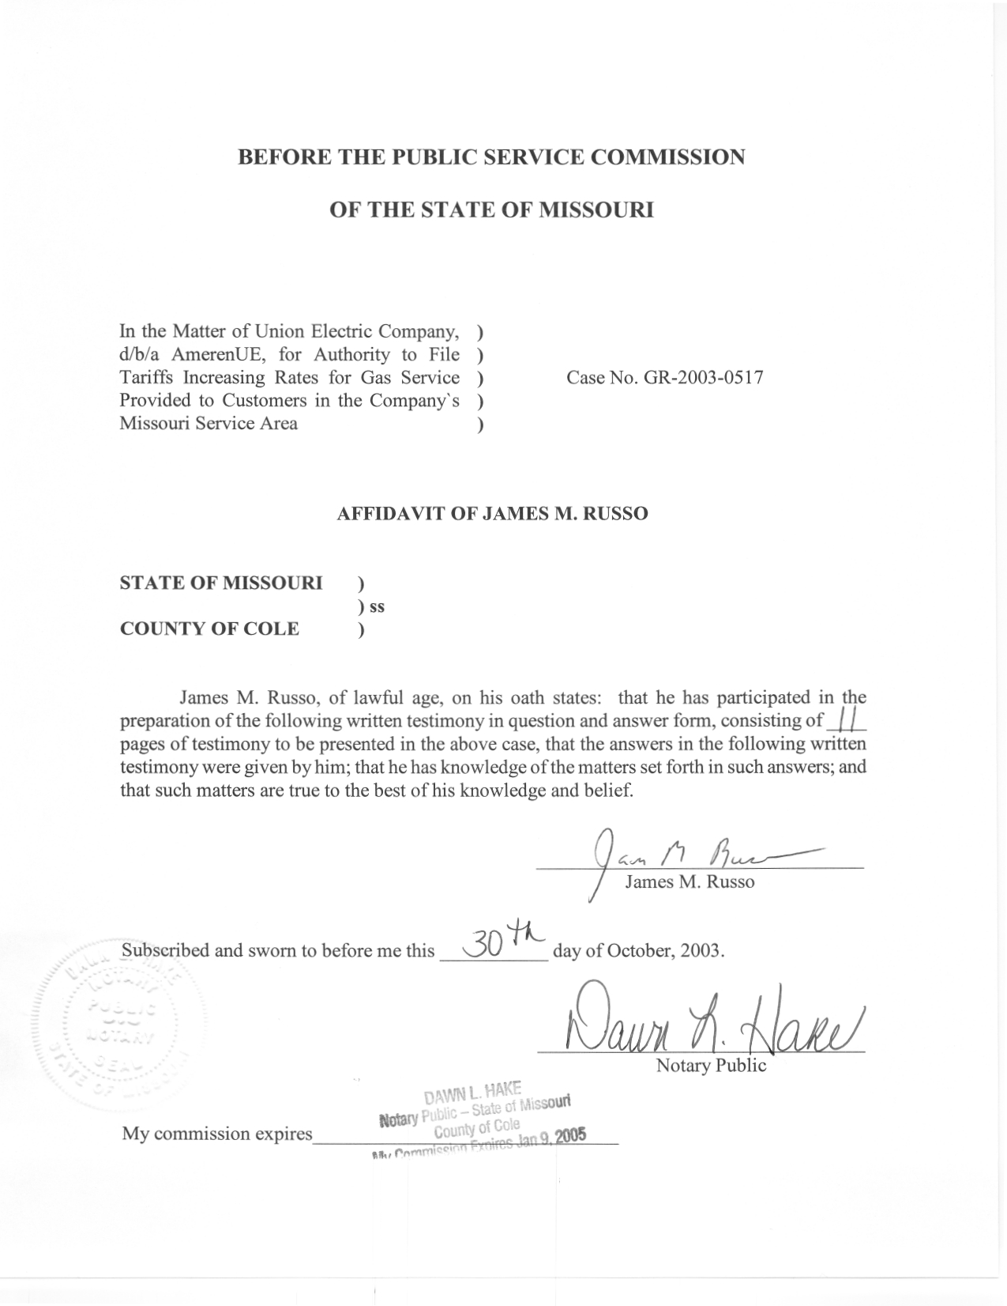
TABLE OF CONTENTS FOR
JAMES M. RUSSO
UNION ELECTRIC COMPANY
d/b/a AMERENUE
CASE NO. GR-2003-0517
LATE PAYMENT CHARGE 2
CLASS COST OF SERVICE 4
RATE DESIGN 8

DIRECT TESTIMONY
OF
JAMES M. RUSSO
UNION ELECTRIC COMPANY
d/b/a AMERENUE
CASE NO. GR-2003-0517
Q. Please state your name and business address.
A. James M. Russo, P.O. Box 360, Jefferson City, Missouri 65102.
Q. By whom are you employed and in what capacity?
A. I am a Regulatory Auditor IV with the Missouri Public Service Commission (Commission).
Q. Please describe your educational background and other qualifications.
A. I graduated from California State University-Fresno, Fresno, California, and received a Bachelor of Science degree in Accounting. Prior to my employment with the Commission, local elected officials in county government employed me in various capacities. I was the assistant treasurer-tax collector for San Joaquin and El Dorado Counties in California. My responsibilities included all financial dealings of the counties and all accounting activities of the agency. In addition, I was the supervising accountant auditor in El Dorado County for two years. My division was responsible for internal audits of all county agencies, special districts, and franchise/lease agreements.
Q. What has been the nature of your duties with the Commission?
A. From April 1997 to December 2001, I worked in the Accounting Department of the Commission, where my duties consisted of directing and assisting with various audits and examinations of the books and records of public utilities operating within the State of Missouri; under the jurisdiction of the Commission. On December 16, 2001, I assumed the position of Regulatory Auditor IV in the Energy Tariffs/Rate Design Department where my duties consist of analyzing applications, reviewing tariffs, and making recommendations based upon these evaluations.
Q. Have you previously filed testimony before this Commission?
A. Yes. A list of cases in which I have filed testimony before this Commission is attached as Schedule 1 to my direct testimony.
Q. With reference to Case No. GR-2003-0517, have you made an examination and study of the material filed by Union Electric Company d/b/a AmerenUE (AmerenUE or Company) relating to its proposed increase in gas rates?
A. Yes, I have.
Q. What is the purpose of your direct testimony?
A. The purpose of my direct testimony is to present the Commission Staff’s (Staff) position relating to the late payment charge, class cost-of-service (COS) for AmerenUE, and Staff’s position on rate design.

LATE PAYMENT CHARGE
Q. What change is Staff proposing to the late payment charge on delinquent bills?
A. Staff is proposing that the late payment charge on delinquent bills be reduced from 1 and ½ percent, compounded per month, to a simple ½ percent per month of the original net amount due on the delinquent bill. In other words, the late payment charge would not be applied to a previous late charge balance, thus eliminating the compounding effect of the late payment charge. This proposed late payment charge rate would be a simple annual rate of 6 percent. The current annual late payment charge rate is equal to 18 percent, and when compounded, could easily exceed the 18 percent per annum.
Q. Why is Staff proposing this change?
A. Staff believes this change reduces the late penalty charge for delinquent bills to correctly reflect current interest rates and the cost to the Company to carry a customer’s bill for an additional billing period. The Company is currently borrowing money at or below the 6 percent rate proposed by the Staff. As noted above, the current late payment charge rate could exceed 18 percent when computed on an annual basis. This compounds the difficulty customers have when paying their gas bills.
Q. What is the financial impact of this proposed change?
A. Staff calculates the financial impact to be $103,145 and has accounted for this amount in Staff’s proposed rate design.
Q. Does Staff have any recommendations on the late penalty charge being assessed to customers applying for assistance through the Low Income Home Energy Assistance Program (LIHEAP)?
A. Yes. The Staff is recommending that the late payment charges that accrued during the time that the energy assistance money (LIHEAP or ECIP) is being credited against a customer’s bill should be waived by the Company. The Staff recognizes that there exists a time lag between customer’s bills and the distribution of the energy assistance grants. During this time lag, the Staff does not feel a customer should be required to pay late payment charges.

CLASS COST OF SERVICE
Q. What customer classes are used in Staff’s class COS study?
A. The customer classes used in this study are as follows:
Residential
General Service
Interruptible Service
Transportation Service

Q. Are these the same as the Company’s current tariff designations?
A. Yes they are.
Q. What is the purpose of Staff’s class COS?
A. The purpose of Staff’s class COS is to determine and to provide the Commission with a measure of relative class cost responsibility for the overall revenue requirement of AmerenUE. For individual items of cost, class cost responsibility can be either directly assigned or allocated to customer classes using reasonable methods for determining the class responsibility for that item of cost. The results are then summarized so that they can be compared to revenues being collected from each class on current rates.
Q. How were the usage levels and class peak demand levels used in your class COS study developed?
A. The annualized usage levels and customer bill counts for the Residential and General Service sales classes were provided by Staff witness Leasha Teel of the Auditing Department, and are addressed in her direct testimony. The annual usage levels and customer bill counts for Interruptible and Transportation customers were developed by Staff witness Anne Ross of the Energy Economic Analysis Department and will be addressed in her testimony. Staff witness Daniel I. Beck of the Energy Engineering Department will address the class peak demand levels in his direct testimony.
Q. What is the source of accounting information used in your class COS study?
A. The study was developed using costs determined by the Commission’s Auditing Department, which is based on a test year ending December 31, 2002, updated for known and measurable changes through June 30, 2003.
Q. Please describe how you categorized the individual items of cost in the Staff’s class COS study.
A. Categorization of costs into functional areas is called cost functionalization. I allocated costs to the functions that cause the costs. The rate base and expense accounts are assigned to one of the following functional categories:
Transmission
Storage
Liquefied Natural Gas
Purchased Gas
Distribution Mains
Distribution Measuring and Regulating
Distribution Meters
Distribution Regulators
Distribution Services
Customer Service
Billing
Meter Reading
Revenue Related

Those costs, which cannot directly be assigned to any specific functional category, are divided among several functions based upon some relational factor. For example, it is reasonable to assume that property taxes are related to gross plant costs and can, therefore, be funtionalized in the same manner as gross plant costs.
Q. How were Transmission costs allocated?
A. Transmission costs were allocated using the Capacity Utilization allocator developed by Staff witness Daniel I. Beck of the Energy Engineering Department.
Q. How were Storage costs allocated?
A. Storage is primarily used in winter months; therefore, storage costs were allocated to all sales customers (excluding transportation customers) using sales volumes from the months of November through March.
Q. How were the costs associated with the Liquefied Natural Gas plant allocated?
A. This type of plant is used primarily on peak days, so these costs were allocated to customers using their contribution to peak day demand.
Q. How were Purchased Gas costs allocated?
A. Even though purchased gas costs are not part of this rate proceeding, there is a certain level of purchased gas costs included as a component of cash working capital. These costs were allocated between the class COS classes using gas volumes.
Q. How were the costs of Distribution Mains allocated?
A. Distribution Main costs were allocated using the Capacity Utilization allocator developed by Staff witness Beck.
Q. How were the costs of Distribution Meters and Distribution Regulators allocated?
A. Staff used the Company’s allocation factors for Distribution Meters and Distribution Regulators.
Q. How were the costs of Distribution Service Lines allocated?
A. Distribution Service Line costs were allocated using the service line allocator developed by Staff witness Beck.
Q. How were costs associated with Distribution Measuring and Regulating Equipment allocated?
A. This type of cost is associated with equipment used to measure and regulate natural gas before it reaches individual customer’s service lines, so these costs were allocated using annualized Ccf volumes.
Q. How were Customer Service costs allocated?
A. These costs are associated with the number of customers being served; therefore, they were allocated using the number of annual bills for each customer class.
Q. How were the costs of the Customer Billing function allocated?
A. These costs were allocated by the number of annual bills for each customer class.
Q. How were Meter Reading costs allocated?
A. These costs were allocated by using the weighted customer numbers. The weighted numbers used reflect the average length of a distribution service line for each customer class.
Q. How were the Revenue Related costs allocated?
A. These costs were allocated using Staff’s annualized margin revenues.
Q. What are the results of your class COS study?
A. The results are shown on Schedule 2, and are presented in terms of class revenue requirements before any increase in AmerenUE’s revenue requirement.
Q. How have you compared the class COS study results to current revenues?
A. Revenue requirement is a major component in this case and the Commission must have a recommendation about class revenue requirements that it can apply to any increase in revenue requirement that is ultimately decided. In order to make such a recommendation, I have factored the Staff’s class COS to be equal to the revenue level collected from current rates. The same factor was applied to the allocated costs for each class (i.e., each class’ costs were decreased by an equal percentage). When subtracting the results from current revenues, a revenue deficiency (-) or revenue surplus (+) for each class is reflected.
Q. What is the impact of your class COS study on the various customer classes?
A. The class COS study shows that revenues should be collected differently than is occurring under current rates.

RATE DESIGN
Q. Did you compute customer charge levels based on your COS study?
A. Yes. The customer charge levels indicated by the COS study are shown in Schedule 3.
Q. How were the customer charges determined in your class COS study?
A. My class COS study identified a customer charge based on the direct costs associated with distribution service lines, distribution meters and regulators, billing, meter reading and customer service expenses.
Q. What customer charge are you proposing for the Residential class?
A. I am proposing a customer charge of $10.20 for the Residential class.
Q. What are you proposing as a customer charge for the General Service class?
A. I am proposing a customer charge of $23.60 for the General Service class. This recommendation is based on the fact that a significant number of General Service customers are served by the same size meter, regulator and service lines that serve the Residential Class while others are served by equipment that typically serves large customers. Creating two classes of customers in the General Service Class should be considered in the Company’s next rate case.
Q. What customer charge are you proposing for the Interruptible class?
A. I am proposing that the Interruptible Class customer charge be the same percentage increase as the increase that is assigned to this class. This will lessen the revenue impact within the class.
Q. What are you proposing as a customer charge for the Transportation class?
A. This class is made up of two rate classes: the Standard Transportation rate and the Large Volume Transportation rate. Staff proposes that the customer charge for each of these classes increase by the same percentage increase as the percent increase assigned to this class.
Q. Is Staff proposing any other changes to the customer charge?
A. Yes, Staff is proposing additional tariff language be added requiring the Company, upon request by the customer, to pro-rate the customer charge for the amount of time the customer is without service for circumstances beyond the customer’s control. Staff proposes that the pro-ration would start 24 hours after the customer is initially without service.
Q. How would Staff define items beyond the customer’s control?
A. Staff believes the definition would include, but not be limited to, such items as natural disaster and service line breaks not due to the action of the customer.
Q. What is the financial impact of this change?
A. Staff is not able to quantify the financial impact. However, Staff believes the impact, if any, would be minimal.
Q. How were the margin commodity rates from your class COS study calculated?
A. To determine the margin commodity rates from the class COS study, I subtracted the dollars collected from the customer charges from each class’ revenue requirement. I then subtracted the revenue requirement associated with Storage and Liquefied Natural Gas facilities, and divided the remaining class revenue requirement by the total class Ccf volumes. This resulted in a base rate that is applicable to the Transportation customers. I calculated an adder to this rate by dividing the Storage and Liquefied Natural Gas costs by the sales Ccf volumes to arrive at a margin commodity rate to be collected from Sales customers.
Q. Are these the final rates that will collect the revenue requirements that the Commission will allow in this case?
A. No. The revenues used to design these rates do not include any of the rate increase being requested by the Company.
Q. What is your recommendation regarding revenue shifts between classes at Staff’s current revenue requirement increase?
A. At Staff’s current revenue requirement increase, Staff recommends an equal percentage increase in class revenues for the all classes. The results of the COS for each class results in a major impact on Residential and General Service customers, therefore, the Staff’s proposal will lessen the impact on these specific customer classes.
Q. Since you did not recommend movement to COS for each class, what factors did you take into account?
A. Staff took into account the level of the revenue requirement increase, the significant increase in the General Service Customer Charge and the significant increase in the cost of gas (those collected through the Purchased Gas Adjustment/ Actual Cost Adjustment (PGA/ACA) process). Since the level of the revenue requirement increase has not been determined by the Commission, and the level of the winter PGA/ACA rates have not been established, Staff recommends that the Commission take these factors into account when determining the final revenue shifts between classes.
Q. Does this conclude your direct testimony?
A. Yes it does.

