Exhibit No.:
Issues: Rate Design

Witness: Janice Pyatte
Sponsoring Party: MO PSC Staff
Type of Exhibit: Rebuttal Testimony
Case No.: ER-2004-0570
Date Testimony Prepared: November 4, 2004

MISSOURI PUBLIC SERVICE COMMISSION

UTILITY OPERATIONS DIVISION

REBUTTAL TESTIMONY

OF

JANICE PYATTE

THE EMPIRE DISTRICT ELECTRIC COMPANY

CASE NO. ER-2004-0570

Jefferson City, Missouri
November 2004
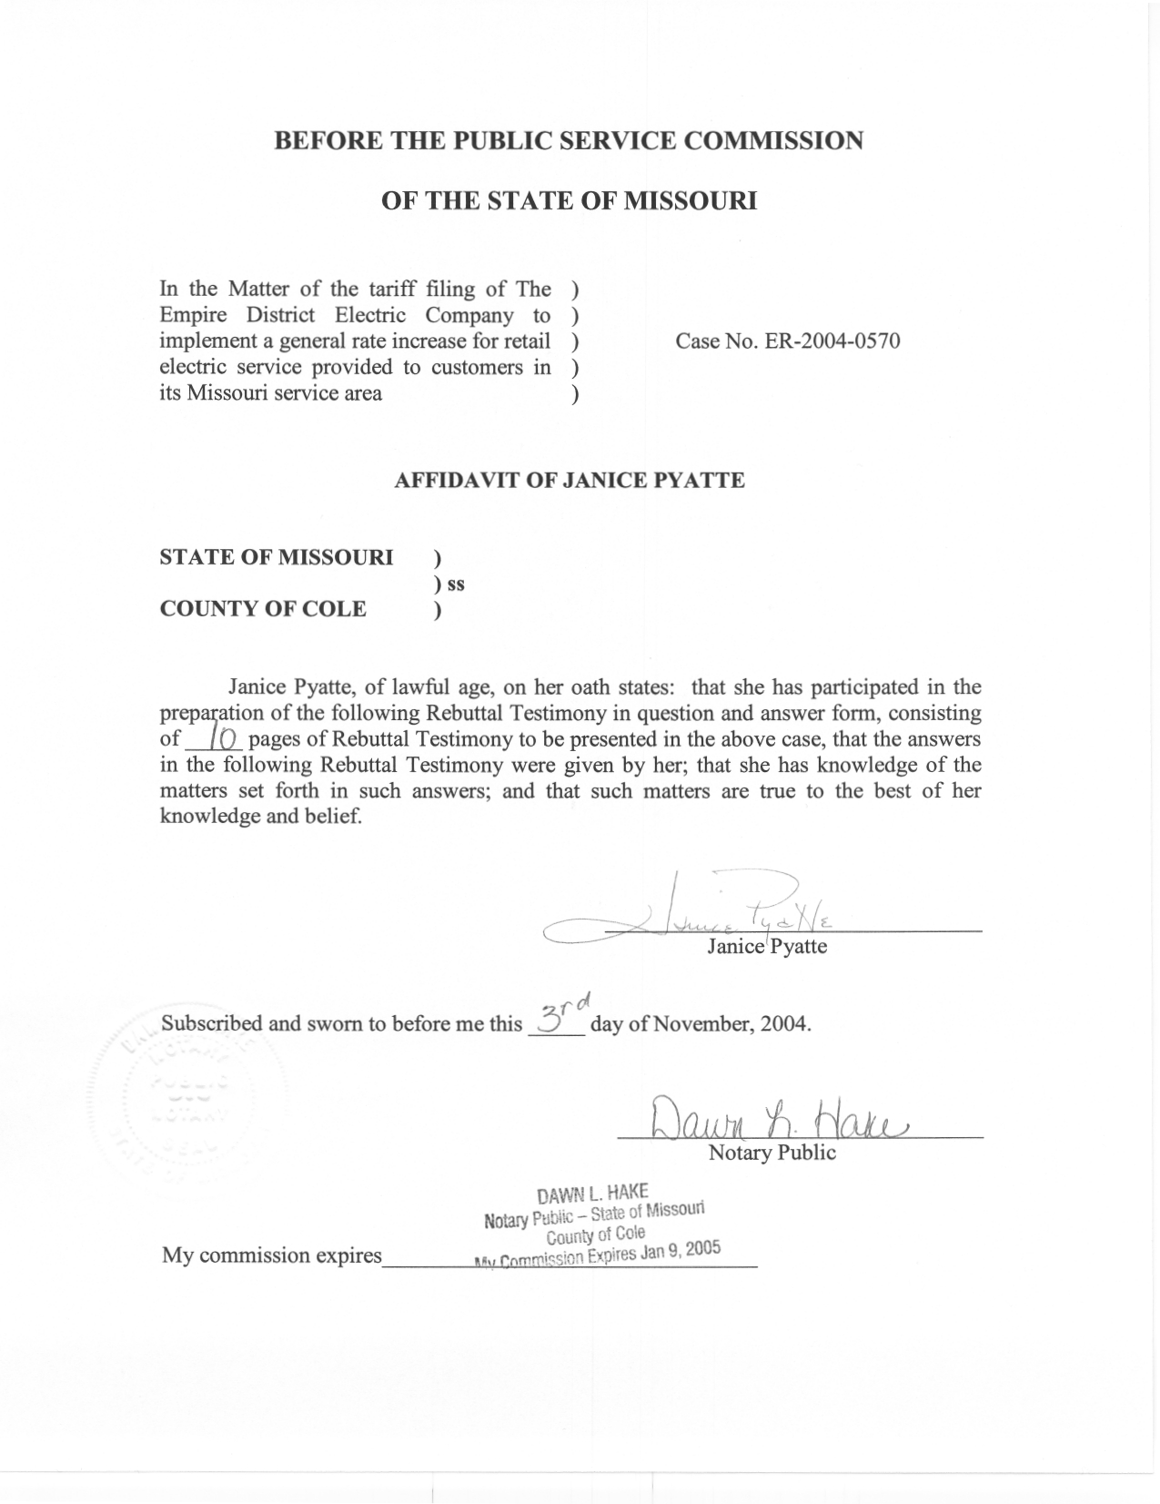

TABLE OF CONTENTS

Rebuttal To EDE Witness H. Edwin Overcast 2
Rebuttal To Explorer Pipeline/Praxair Witness Maurice Brubaker 6

REBUTTAL TESTIMONY

OF

JANICE PYATTE

THE EMPIRE DISTRICT ELECTRIC COMPANY

CASE NO. ER-2004-0570

Q. Please state your name and business address.
A. My name is Janice Pyatte and my business address is Missouri Public Service Commission, P.O. Box 360, Jefferson City, Missouri 65102.
Q. Are you the same Janice Pyatte who previously filed prepared Direct Testimony on the issue of Revenues on September 20, 2004, and on the issue of Rate Design on October 4, 2004?
A. Yes, I am.
Q. What is the purpose of your Rebuttal Testimony?
A. My Rebuttal Testimony will address the rate design proposals and approach offered by The Empire District Electric Company (“EDE” or “Company”) witness H. Edwin Overcast (“Dr. Overcast”).
My Rebuttal Testimony will address Explorer Pipeline/Praxair (“Praxair”) witness Maurice Brubaker’s proposal to implement a high voltage credit to the Large Power rate schedule.
My testimony will present revised schedules containing revenues, kWh sales, and billing units by rate schedule that were originally filed in my Direct Testimony and have been subsequently updated.
Q. Which schedules from your prepared Direct Testimony are you presenting?
A. I am presenting updated versions of Schedule 2 (rate revenues) and Schedule 3 (kWh sales) from my Direct filing on Revenues and Schedule 2 (billing units) from my Direct filing on Rate Design. Minor changes to these schedules were made to reflect computational errors discovered subsequent to the filing of Direct Testimony. Rate Design revised Schedule 2 also incorporates the facilities demand units required for Staff’s proposed facilities charge.

Rebuttal To EDE Witness H. Edwin Overcast
Q. How is your rebuttal to Dr. Overcast’s Direct Testimony organized?
A. Dr. Overcast has proposed to:
- Substantially increase the proportion of revenues recovered through fixed charges and concomitantly substantially reduce the proportion of revenues recovered through variable charges.
- Implement a declining-block energy charge in the summer for the Residential and Small General Service rate schedules.
- Reduce the seasonal differential in existing energy rates.
- Eliminate the seasonal differential in existing demand rates.
Rather than address each proposal separately, I intend to focus on the inter-relatedness of these proposals and what the results convey about Dr. Overcast’s (and the Company’s) priorities. I will then address the one rate design proposal that I find most objectionable.
Q. Please describe the overall difference in approach between Staff and EDE to the design of rates?
A. As Dr. Overcast’s Direct Testimony has noted, there are a number of objectives important to a sound rate design. Three of the objectives mentioned are:
- Cost of service (i.e., whoever causes the cost should pay the cost).
- Economic efficiency (i.e., prices based upon marginal cost).
- The impact of rate changes on customers’ electricity bills.
Achieving each of these objectives, in and of itself, may be desirable, but the reality is that one cannot simultaneously achieve all of these objectives. Choices need to be made about the relative importance of each objective, and the resulting rate design will vary based on those choices.
The rate design issue between the Staff and the Company that is being presented to the Commission in this case is how to balance the many, sometimes contradictory, objectives and, at the same time, collect the Commission-ordered revenues.
Q. What approach has Dr. Overcast recommended be used in the design of the Residential and Small General Service rates?
A. Dr. Overcast has proposed a rate design for the Residential and Small General Service rate schedules that consists of high customer charges, little or no difference between summer and winter rate levels, and declining-block energy rates in both seasons. These proposals, taken together, indicate that Dr. Overcast’s primary emphasis is on economic efficiency.
Q. What approach has Staff recommended be used in the design of the Residential and Small General Service rates?
A. Staff’s rate design approach to the Residential and Small General Service rate schedules is characterized by relatively low customer charges, summer rate levels that are higher than winter rate levels, a flat summer energy rate, and a declining-block winter energy rate. These proposals place more emphasis on cost of service, i.e., whoever causes the cost should pay the cost.
Q. Did either Dr. Overcast or Staff provide the Commission with information on how its rate proposals will affect the annual electricity bills of individual customers?
A. No. It is unfortunate that the Commission has not been provided quantitative measures of rate impact to use in its deliberations. Clearly both the Staff’s and the Company’s proposed rate design changes will have a non-uniform effect on customer bills, even if the overall revenue requirement were to remain unchanged. To the extent that Staff’s recommendations are similar to the existing rate design, rate impacts will be much less extreme under Staff’s proposal than under Company’s proposal.
Q. Please describe the issue between Staff and EDE regarding the rate structure of the Residential and Small General Service rate schedules during the summer billing months.
A. Under the current EDE residential (RG) and small general service (CB, SH) rate schedules, each kWh of electricity used is priced at the same rate during the summer billing months. This uniform rate-per-kWh is generally referred to as a “flat” energy rate.
Under EDE’s rate design proposal, summer electricity usage would be subject to two different rates: one rate for an initial amount of electricity used and a second rate for any usage in excess of the initial amount. This rate structure, known as a “blocked” rate structure, is as follows:
Rate Component | Current Summer Rate | EDE Proposed Summer Rate
First 600 kWh | 7.19 cents per kWh | 8.35 cents per kWh
Additional kWh | 7.19 cents per kWh | 6.06 cents per kWh

Since EDE is proposing that the price charged for usage in the second rate block be lower than the price charged for usage in the initial rate block, this proposal would generally be described as a “declining-block” rate structure.
The issue in this case is whether EDE should continue charging a uniform energy rate for each kWh of electricity usage used by small customers during the summer billing months or whether a declining-block rate structure, where customer usage in excess of an initial amount is priced at a lower rate, should be implemented.
Q. What effect does a declining-block rate structure have on the average price-per-kWh paid by each customer?
A. One characteristic of a declining-block rate structure is that, over a certain amount of usage within any given billing month, additional usage results in a lower average price per kWh. On a flat rate structure, increased usage is always charged the same rate per kWh. Thus the cost of increased usage is lower on a declining-block rate structure than in a flat rate structure.
Q. Why is Staff opposed to implementing a declining-block rate structure in the summer billing months for the Residential and Small General Service rate schedules?
A. One of the objectives of a sound rate design is that it send customers the proper “price signals” relating to consumption decisions. I believe that sending a price signal that, on a marginal basis, increased electrical usage is less costly is poor social policy. Increased demand for electricity in the summer creates a need for additional generation capacity and causes higher rates for all customers.
Q. Do other Missouri regulated utilities have declining-block rate structures in the summer for Residential and Small General Service customers?
A. No. All but one of Missouri’s regulated utilities charges a uniform rate-per-kWh in the summer for residential and small general service customers. The one exception is the residential rate schedule for Aquila Networks-MPS, which has an inverted-block rate structure, where customer usage over an initial amount is priced at a higher rate.

Rebuttal To Explorer Pipeline/Praxair Witness Maurice Brubaker
Q. What is the purpose of your rebuttal to the Direct Testimony of Explorer Pipeline/Praxair witness Maurice Brubaker?
A. My Rebuttal Testimony addresses Mr. Brubaker’s proposal to implement a high voltage credit to the Large Power (“LP”) rate schedule. There are two aspects of this proposal that I will address: (1) whether implementing such a credit is appropriate; and (2) how the value for such a credit should be determined.
Q. How do EDE’s existing rate schedules address situations where customers take service at a voltage level that is non-standard for the rate schedule?
A. EDE’s existing Missouri rate schedules account for voltage level differences (ownership of facilities) between non-residential customers through a series of discounts and adders. The two most common voltage level scenarios are:
- Primary accounts served on a secondary rate schedule: discount of 21.1 cents per kW.
- Secondary accounts served on a primary rate schedule: adder of 20.5 cents per kW.
Whether a customer is considered to be primary or secondary depends on whether the customer owns its voltage transformation equipment (primary) or uses voltage transformation equipment provided by the Company (secondary). Rate schedules have been designed assuming that all customers are at the most common voltage level, and discounts and adders account for the customers who are exceptions. So, a primary customer (who does not use Company-owned voltage transformation equipment) served on a secondary rate schedule (which assumes the customer does uses Company-owned voltage transformation equipment), is entitled to a discount. Conversely, a secondary customer (who uses Company-owned voltage transformation equipment) served on a primary rate schedule (which assumes the customer does not use Company-owned transformation equipment), is required to pay an additional amount (“adder”) per kW. A primary customer served on a primary rate schedule would be considered a “standard” customer for billing purposes and would neither pay an extra amount nor receive a discount.
Q. Do EDE’s existing Missouri rate schedules have a similar method for accounting for primary and transmission voltages?
A. The discount/adder method of accounting for voltage level differences between primary and transmission only partly exists on EDE’s current Missouri rate schedules---primary accounts served on a transmission rate schedule pay an adder of 30 cents per kW.
Mr. Brubaker’s proposal is that an additional voltage-level scenario be added; namely, transmission accounts served on a primary rate schedule should receive a discount of $1.50 per kW.
Q. What is Staff’s position on the implementation of a high voltage credit to the Large Power rate schedule?
A. As I stated in my Direct Rate Design Testimony on the treatment of voltage level in EDE’s existing rate design [page 16, line 10 through page 18, line 14], I believe that it is appropriate that rate schedules account for voltage level differences between customers. The argument in favor of a discount for transmission customers (who do not use Company-owned substations) served on a primary rate schedule (which assumes that customers do use Company-owned substations) is the same as the primary-secondary argument. The difference is that the facilities in question are substations rather than transformers.
Prior to reading Mr. Brubaker’s Rate Design Testimony, I was unaware that there were existing customers who qualify for service at transmission voltage that have opted for service on the Large Power (primary) rate schedule rather than on the Special Transmission rate schedule.
After verifying that three transmission voltage level customer accounts do exist, I agree with Mr. Brubaker that a transmission voltage level credit to the LP rate schedule should be implemented.
Q. Does Staff agree with Mr. Brubaker’s recommendation that the transmission voltage level credit should be valued at $1.50 per kW?
A. No. I believe that Mr. Brubaker’s analysis is flawed because it computes the transmission discount based upon fully-allocated embedded cost, rather than the replacement cost, of the facilities in question. Consequently, his proposed discount of $1.50 per kW is too high.
Q. What rate value would Staff recommend for a transmission voltage level credit?
A. EDE’s tariffs already provide for a 30 cents-per-kW adder for primary accounts served on a transmission rate schedule. Staff recommends that a 30.1 cents-per-kW discount be applied to transmission accounts served on a primary rate schedule.
Q. How should the existing Large Power rate schedule be modified to accommodate transmission voltage level customers?
A. Staff recommends that the following provisions be added to the Large Power rate schedule:
Substation Ownership: Where the Customer supplies all facilities (other than metering equipment) for utilization of service at the Company’s transmission line feeding to such location, a reduction of 30.1 cents per kW will apply to the demand charge.
Metering Adjustment: The above rate applies for service at primary voltage. Where service is metered at the voltage of the transmission line feeding to such location, adjustment for billing will be made by decreasing metered kilowatt-hours and kilowatts by 0.35%.
Q. If the Commission was to adopt Mr. Brubaker’s $1.50 per-kW recommendation, how should the current 30 cents-per-kW adder on the transmission rate schedules be adjusted?
A. The adder should be adjusted to $1.50[we need the correct number here] per kW (voltage adjusted) to maintain symmetry.
Q. Has Staff computed the billing units that correspond to a transmission voltage level discount?
A. Yes. I have modified Large Power billing units to reflect this situation. These modified billing units are shown on Rate Design Revised Schedule 2, attached to this testimony.
Q. Does this conclude your Rebuttal Testimony?
A. Yes, it does.

