Exhibit No.:
Issues: General Information
Witness: James M. Russo
Sponsoring Party: MoPSC Staff
Type of Exhibit: Testimony
Case No.: GT-2003-0031
Date Testimony Prepared: September 10, 2002

MISSOURI PUBLIC SERVICE COMMISSION

Utility Operations DIVISION

TESTIMONY

OF

JAMES M. RUSSO

SOUTHERN MISSOURI GAS COMPANY, L.P.

CASE NO. GT-2003-0031

Jefferson City, Missouri
September, 2002

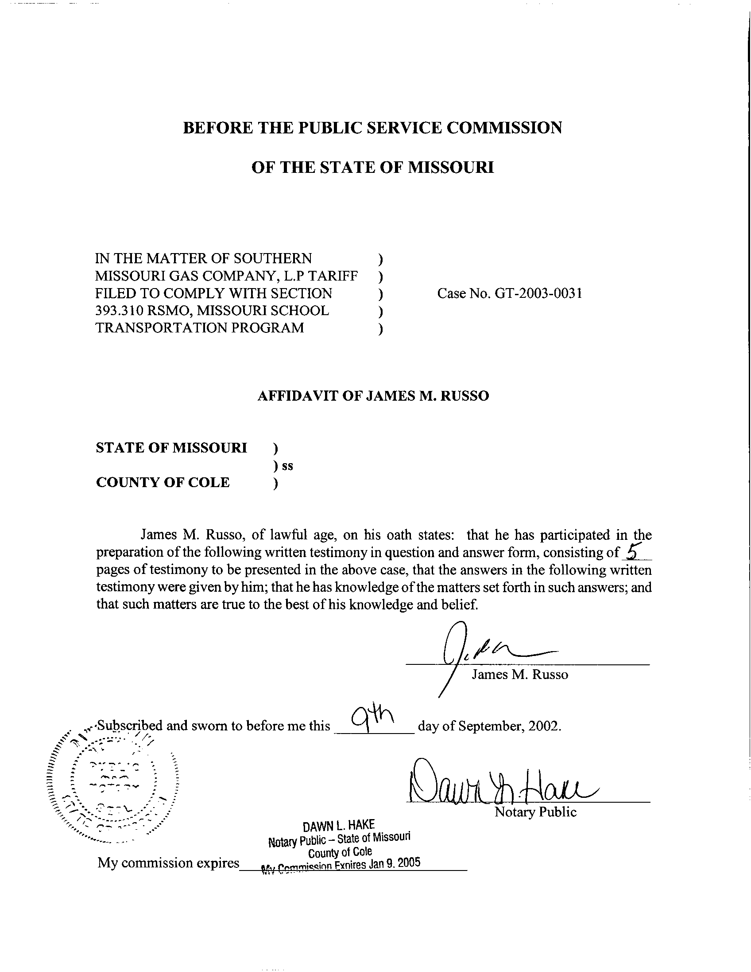
TESTIMONY
OF
JAMES M. RUSSO
SOUTHERN MISSOURI GAS COMPANY, L.P.
CASE NO. GT-2003-0031
Please state your name and business address.
James M. Russo, P. O. Box 360, Jefferson City, Missouri 65102.
By whom are you employed and in what capacity?
I am a Regulatory Auditor IV with the Missouri Public Service Commission (Commission).
Please describe your educational background and other qualifications.
I graduated from California State University-Fresno, Fresno, California, and received a Bachelor of Science degree in Accounting. Prior to my employment with the Commission, I was employed in various capacities by local elected officials in county government. I was the assistant treasurer-tax collector for San Joaquin and El Dorado Counties in California. My responsibilities included all financial dealings of the counties and all accounting activities of the agency. In addition, I was the supervising accountant auditor in El Dorado County for two years. My division was responsible for internal audits of all county agencies, special districts, and franchise/lease agreements.
What has been the nature of your duties with the Commission?
From April 1997 to December 2001, I worked in the Accounting Department of the Commission, where my duties consisted of directing and assisting with various audits and examinations of the books and records of public utilities operating within the State of Missouri; under the jurisdiction of the Commission. On December 16, 2001, I assumed the position of Regulatory Auditor IV in the Energy Tariffs/Rate Design Department where my duties consist of analyzing applications, reviewing tariffs, and making recommendations based upon these evaluations.
Have you previously filed testimony before this Commission?
Yes, I have. Please refer to Schedule 1, which is attached to this testimony, for a list of cases in which I have filed testimony.
With reference to Case No. GT-2003-0031, have you made an examination and study of the material filed by Southern Missouri Gas Company, L.P. (SMG or Company) relating to its proposed tariff sheets?
Yes, in conjunction with other members of the Commission Staff (Staff).
Please describe your principal area of responsibility in this case.
My principal area of responsibility is the review of the aggregation tariff to determine any negative impact (detriment) on the gas corporation, other customers, or local taxing authorities.
Have you also reviewed the portions of House Bill (HB) No. 1402 that pertain to Section 393.310 RSMo?
Yes.
Is the Staff aware of any detriment to SMG caused by its proposed aggregation tariffs?
No. However, the Staff wants the Commission to be aware that the $.004 per therm fee allowed for aggregation and balancing services may not be sufficient for SMG to recover all of its incremental costs. The $.004 per therm fee cap is designed for SMG to recover the incremental costs of SMG and the fee is capped at $.004 per therm for the first year of the Experimental School Transportation Program (ESTP). SMG will be allowed to charge more, up to its actual incremental cost of providing aggregation and balancing services, in subsequent years. The Staff believes this potential detriment can be mitigated if Staff’s true-up proposal discussed below is put into effect.
How does Staff define incremental costs?
Staff believes incremental costs are those costs that occur ONLY because of the ESTP and are those costs that can be directly documented to the ESTP. If the incremental cost would exist without the ESTP, than it is not an incremental cost related to the ESTP.
Does Staff have any concerns on the tracking and reporting of incremental costs by SMG?
Yes. Staff believes it is going to be difficult to track and document the incremental costs related to the ESTP. However, Staff believes if the Commission approves the true-up mechanism discussed below, that Staff should have adequate time to review the documentation provided by SMG.
Is the Staff aware of any detriment to the other customers of SMG?
No. However, the other customers of SMG could face a potential detriment if SMG is not able to recover all of its costs related to the ESTP. It is likely SMG would attempt to pass any un-recovered gas costs on to other customers thru the Actual Cost Adjustment (ACA) process. Staff does not anticipate any significant detriment to other customers of SMG if the true-up mechanism discussed below is put into effect.
Is the Staff aware of any detriment to the local taxing authorities?
No. Staff believes the collection of franchise taxes as discussed in the Testimony of Staff Witness Jennifer Markway of the Energy Tariffs/Rate Design Department will minimize any detriment. However, Staff plans to monitor the payments to municipalities. Franchise taxes are set as a percentage of actual gas sales of the gas corporation in the municipality. The amount of franchise taxes collected will vary from heating season to heating season, reflecting the volume of gas sold and the price of natural gas. Staff wants the Commission to be aware that variations in payments to municipalities in itself may not be a detriment under this statute.
Has the Staff considered any options that will mitigate any unforeseen detriment to SMG and its other customers?
Yes. The Staff requests the Commission consider the possibility of a true-up mechanism that allows SMG to recover any under collection of documented costs in years two and three of the ESTP. Staff requests that the Commission require SMG to provide the Staff with status reports by June 1st of each year of the ESTP, so Staff can monitor the effects of the program and assess what changes to the rates associated with the ESTP may be appropriate during the program. Staff expects these reports to include all supporting documentation of actual program revenues and costs.
How will any under collections be recovered by SMG?
Staff suggests that any under collection of revenues in the first year be collected over a period of 12 to 24 months. If the Commission decides that a true-up mechanism and status reports by SMG are appropriate, the Staff hopes to audit the program for the current over or under recovery of the program costs at the end of the 2nd year of the ESTP in order to make adjustment to rates for the 3rd year of the program. The ESTP expires on June 30, 2005, so the 3rd year of the program will currently be the final year of the ESTP.
Will a true-up mechanism prevent any significant detriment from occurring to SMG or its other customers?
Yes. The true-up mechanism could minimize any mismatch of program costs and program revenues.
Does this conclude your testimony?
Yes, it does.
RATE CASE PROCEEDING PARTICIPATION

JAMES M. RUSSO

COMPANY CASE NO.
Union Electric Company GR-97-393
Gascony Water Company WA-97-510
St. Joseph Light and Power Company EC-98-573
St. Joseph Light and Power Company HR-99-245
St. Joseph Light and Power Company GR-99-246
St. Joseph Light and Power Company ER-99-247
UtiliCorp United Inc./St. Joseph Light and Power Company EM-2000-292
UtiliCorp United Inc./Empire District Electric Company EM-2000-369
Osage Water Company WR-2000-557
Osage Water Company SR-2000-556
Missouri Gas Energy GR-2001-292
Environmental Utilities WA-2002-65
Laclede Gas Company GR-2002-356
Laclede Gas Company GA-2002-429
Missouri Gas Energy GT-2003-0033
Aquila Networks L & P GT-2003-0038

