Exhibit No.:
Issues: Tariff Issues

Witness: James M. Russo
Sponsoring Party: MoPSC Staff
Type of Exhibit: Direct Testimony
Case No.: GC-2004-0216
Date Testimony Prepared: April 22, 2004

MISSOURI PUBLIC SERVICE COMMISSION

Utility Operations DIVISION

Direct TESTIMONY

OF

JAMES M. RUSSO
missouri gas energy
CASE NO. GC-2004-0216

Jefferson City, Missouri
April, 2004

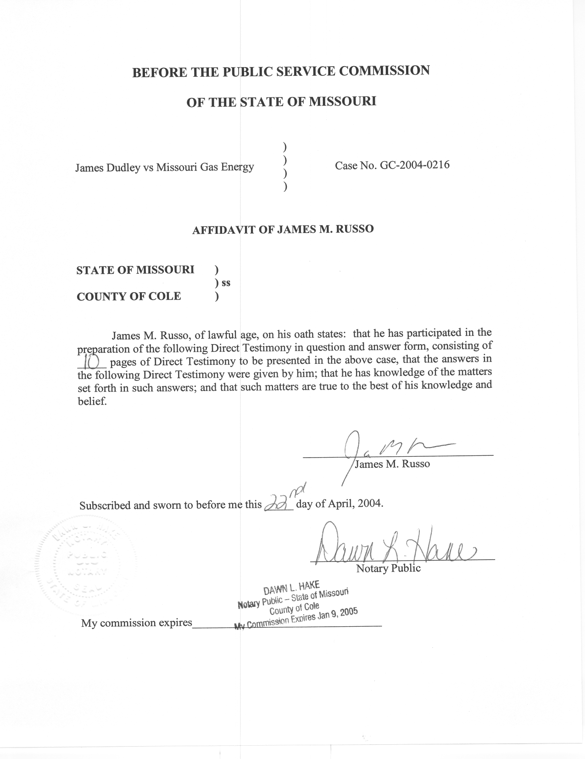
TABLE OF CONTENTS

BACKGROUND 3
TARIFFS 6
SUMMARY OF STAFF FINDINGS 8

DIRECT TESTIMONY
OF
JAMES M. RUSSO
MISSOURI GAS ENERGY
CASE NO. GC-2004-0216
Q. Please state your name and business address.
A. James M. Russo, P.O. Box 360, Jefferson City, Missouri 65102.
Q. By whom are you employed and in what capacity?
A. I am a Regulatory Auditor IV with the Missouri Public Service Commission (Commission).
Q. Please describe your educational background and other qualifications.
A. I graduated from California State University-Fresno, Fresno, California, and received a Bachelor of Science degree in Accounting. Prior to my employment with the Commission, local elected officials in county government employed me in various capacities. I was the assistant treasurer-tax collector for San Joaquin and El Dorado Counties in California. My responsibilities included all financial dealings of the counties and all accounting activities of the agency. In addition, I was the supervising accountant auditor in El Dorado County for two years. My division was responsible for internal audits of all county agencies, special districts, and franchise/lease agreements.
Q. What has been the nature of your duties with the Commission?
A. From April 1997 to December 2001, I worked in the Accounting Department of the Commission, where my duties consisted of directing and assisting with various audits and examinations of the books and records of public utilities operating within the State of Missouri; under the jurisdiction of the Commission. On December 16, 2001, I assumed the position of Regulatory Auditor IV in the Energy Tariffs/Rate Design Department where my duties consist of analyzing applications, reviewing tariffs, and making recommendations based upon these evaluations.
Q. Have you previously filed testimony before this Commission?
A. Yes. A list of cases in which I have filed testimony before this Commission is attached as Schedule 1 to my direct testimony.
Q. With reference to Case No. GC-2004-0216, have you reviewed and studied the complaint filed by the Complainant (Mr. Dudley) and the documentation provided by the Commission’s Consumers Service Staff (CSS) and Missouri Gas Energy (MGE or Company)?
A. Yes, I have.
Q. What other steps did you take in reviewing and studying this complaint?
A. I discussed the complaint with the Complainant, CSS and MGE. In addition, I reviewed MGE’S current tariff on file with the Commission.
Q. What is the purpose of your direct testimony?
A. The purpose of my direct testimony is to present the Commission Staff’s (Staff) findings relating to the complaint filed by the Complainant.
Q. What does Staff believe is the basis of the complaint?
A. Staff believes the complaint is whether MGE’s tariff allows MGE to deny Complainant’s service and charge Complainant for prior indebtness of bills accrued by a tenant who lived in one of the Complainant’s rental properties.

BACKGROUND
Q. Please provide the history of this complaint.
A. The Complaint was filed on November 7, 2003, by Mr. James Dudley for property located at 4024 Prospect Avenue, Kansas City, Missouri (4024 Prospect Avenue.) MGE filed their response on December 16, 2003. Staff filed its recommendation on January 20, 2004. MGE filed its response to the Staff’s recommendation on February 3, 2004. Mr. Dudley filed a Pleading for Complainant on April 2, 2004.
Q. What information did the Energy Department Staff (EDS) review from CSS?
A. EDS reviewed the documentation collected by the CSS Staff as it relates to this case. This includes the information entered by CSS in the Consumer Complaint Inquiry program, faxes between CSS and MGE and all the documentation CSS received from the Complainant and MGE.
Q. What information did the EDS review from the Complainant?
A. The EDS reviewed the correspondence, complaint, and the supporting documentation filed by the Complainant. In addition, Staff talked with Mr. Dudley concerning his complaint. Mr. Dudley confirmed to Staff that the information filed in his complaint was correct. He stated to Staff that he rented the property to a person named Diane. He did not remember her last name. He did not have a copy of the lease because his briefcase was stolen from his automobile. He further stated that he had no reason to visit his rental property because he would meet Diane to collect the rent.
Q. What information did the EDS review from MGE?
A. EDS reviewed the documentation MGE provided to Staff, MGE’s answer filed with the Commission on December 2003 and the EDS discussion of the complaint with MGE personnel.
Q. Who did MGE show as the customer for the property located at 4024 Prospect Avenue during the time period of October 2000 to April 2001.
A. Sara Chappelow.
Q. How did Ms. Chappelow become listed as the customer?
A. Staff discussed this with MGE personnel and was told that a person came into a MGE customer service center in October 2000 and provided information identifying them self as Sara Chappelow. MGE verified to Staff that when an individual is seeking service they attempt to verify the identity of the person seeking or receiving service. MGE requests identification such as a drivers license and a social security number. They do not allow an individual to initiate service on behalf of someone else. Service was started by MGE in Ms. Chappelow’s name on October 3, 2000. In addition, Ms. Chappelow was accepted by MGE into an even pay bill plan on December 5, 2000.
Q. Did anyone make payments on this account?
A. Yes. MGE’s records indicate MGE received payments of $12.00 on November 2, 2000, $66.00 on December 5, 2000 and $80.34 on January 4, 2001. MGE was able to verify that these payments were made at their customer service center and at least the first two payments were paid in cash.
Q. Did MGE continue to provide service to Sara Chappelow at 4024 Prospect Avenue after January 4, 2001?
A. Yes, MGE continued to provide service to Ms. Chappelow until MGE disconnected service at 4024 Prospect Avenue for non-payment on April 26, 2001. The balance owed by Ms. Chappelow for the time period of October 2000 thru April 2001 was $2,099.96.
Q. What happened to the service at 4024 Prospect Avenue after April 27, 2001?
A. In July of 2001, Mr. Dudley requested service be turned on at 4024 Prospect Avenue because he wanted to clean up the property. Service was turned on and continued until April 2002, when the gas service was disconnected for non-payment.
Q. What was the amount owed by Mr. Dudley at the time of disconnect?
A. The amount owed by Mr. Dudley for the time period of July 2001 thru April 2002 was $104.63.
Q. What did MGE do with the delinquent balance owed by Ms. Chappelow?
A. The delinquent amount owed by Ms. Chappelow was transferred to Mr. Dudley’s account on June 25, 2002.
Q. Was the true Sara Chappelow the person receiving gas service at 4024 Prospect Avenue for the time period of October 2000 to April 2001?
A. It is doubtful. It appears that MGE is the victim of a fraud by an individual claiming herself to be Sara Chappelow. MGE informed Staff that a Ms. Chappelow provided MGE documentation, including a signed lease agreement, showing that she lived in Independence, Missouri from May 2000 to May 2002. In addition, additional documentation attached to Mr. Dudley’s complaint includes a copy of a police report dated April 26, 2001, that was filed with the Independence Missouri Police Department and a letter dated May 10, 2001, that was signed by Sarah E. Chappelow. The police report stated that on September 15, 2000, Ms. Chappelow had several items stolen from her day planner located on the front seat of her vehicle. Two of the stolen items were her driver’s license and social security card. The letter informed the reader of the theft and the status of the police investigation.
Q. What information did the EDS review from other sources?
A. As stated earlier, the EDS reviewed the Company’s tariffs presently on file with the Commission.

TARIFFS
Q. What are the specific tariff sections that the EDS believe apply to this complaint?
A. The following sections from the rules and regulation section of MGE’s tariffs apply: Section 1.04 located on sheet number R-6, titled Customer, Section 3.02 located on sheet numbers R-19 and R-20, titled Prior Indebtness of Customer and Section 3.07 located on sheet numbers R-21 thru R-23, titled Discontinuance of Service.
Q. What does Section 1.04 state?
A. Section 1.04 provides for the definition of customer. Customer is defined as a person or legal entity responsible for payment for service except one denoted as a guarantor. The term customer is also used to refer to an applicant for gas service.
Q. Is guarantor defined in MGE’s tariff?
A. No.
Q. Did the EDS find a definition for the word guarantor?
A. Yes. The American Heritage Dictionary, Second College Edition, defines guarantor as, “One that makes or gives a guarantee.”
Q. What does Section 3.02 state?
A. Section 3.02 states:
Company shall not be required to commence supplying gas service if at the time of application, the applicant, or any member of applicant’s household (who has received benefit from previous gas service), is indebted to Company for such gas service previously supplied at the same premises or any former premises until such indebtedness shall have been made.

Q. What does Section 3.07 state?
A. This section provides the conditions that the Company may discontinue service. Before listing the conditions for discontinuance, the section states:
Company shall have the right to discontinue gas service to a customer and remove its facilities, or any portion thereof, from customer’s premises upon default by customer of any provision of the service agreement. In addition to any other legal remedies, Company reserves the right to refuse to reconnect gas service to any customer until such default shall have been remedied by customer. Any one or more of the following may be considered as a default.

- Non-payment of an undisputed charge.
- Failure to post a security deposit or guarantee acceptable to Company.
- Unauthorized interference, diversion or use of the gas service situated or delivered on or about customer’s premises.
- Failure to comply with the terms and conditions of a settlement agreement.
- Refusal after reasonable notice to permit inspection maintenance, replacement or meter reading of utility equipment. If the utility has a reasonable belief that health or safety is at risk, notice at the time inspection is attempted is reasonable.
- Misrepresentation of identity for the purpose of obtaining gas service.
- Violation of any other General Terms and Conditions for Gas Service of Company on file with and approved by the Commission which adversely affects the safety of customer or other persons, or the integrity of Company’s delivery system.
- Failure to pay cost of additional service line, or replacement of a customer-owned service line or lines as provide for in Sections 3.14 and 3.15 herein.
- As provided by state or federal law.

The tariff continues with six conditions that would not cause sufficient cause for the Company to discontinue service. These conditions are not applicable to this case with the possible exception of the condition lettered (D) that states: “The failure to pay the bill of another customer whose service is sought to be discontinued received substantial benefit and use of the service.” Copies of the tariffs cited above have been attached to my Direct Testimony as Schedule 2.

SUMMARY OF STAFF FINDINGS
Q. Does Staff believe that MGE has the authority to transfer the delinquent amount at 4024 Prospect Avenue for the time period of October 2000 thru April 2001 in the amount of $2,099.96 to Mr. Dudley’s account?
A. No. Staff does not believe that the facts in the case show Mr. Dudley is responsible under MGE’s existing tariffs for any of the gas usage during the time period of October 2000 to April 2001. Mr. Dudley was not the customer as defined in Section 1.04 of MGE’s tariff, nor did he have any agreement with MGE making Mr. Dudley the guarantor for the property located at 4024 Prospect Avenue.
Staff believes it is erroneous to interpret Section 3.02 of MGE’s tariff to expand receiving benefit of service to individuals who are not the customer and/or persons outside the customer’s household since the tariff is explicitly limited to the customer and/or members of the customer’s household.
Staff does not believe Section 3.07 of MGE’s tariff would allow the Company to discontinue service to Mr. Dudley because of MGE’s outstanding bill of Mr. Dudley’s tenant, Ms. Chappelow during the October 2000 to April 2001 time period. Staff believes that a landlord of a property whose tenant has contracted for gas service is not considered a member of the tenant’s household and has not received the benefit and use of service that would allow MGE to seek collection from the landlord of the tenant’s unpaid bill.
Q. Does Staff believe that MGE has the authority to pursue collection and/or transfer the delinquent amount at 4024 Prospect Avenue for the period of July 2001 thru April 2002 in the amount of $104.63 to Mr. Dudley’s account?
A. Yes. Staff believes Mr. Dudley was a customer as defined in Section 1.04 of MGE’s tariff and did receive use and benefit of the gas service during this time period.
Q. Does Staff believe MGE must provide service to Mr. Dudley?
A. Staff believes MGE must provide service to Mr. Dudley after Mr. Dudley resolves his outstanding obligations with MGE. This would require Mr. Dudley to pay for all arrearages that he owes on all of his properties, or, enter into a mutually agreed repayment plan with MGE.
Q. Does this conclude your direct testimony?
A. Yes it does.
RATE CASE PROCEEDING PARTICIPATION

JAMES M. RUSSO

COMPANY CASE NO.
Union Electric Company GR-97-393
Gascony Water Company WA-97-510
St. Joseph Light and Power Company EC-98-573
St. Joseph Light and Power Company HR-99-245
St. Joseph Light and Power Company GR-99-246
St. Joseph Light and Power Company ER-99-247
UtiliCorp United Inc./St. Joseph Light and Power Company EM-2000-292
UtiliCorp United Inc./Empire District Electric Company EM-2000-369
Osage Water Company WR-2000-557
Osage Water Company SR-2000-556
Missouri Gas Energy GR-2001-292
Southern Missouri Gas Company, L.P. GR-2001-0388
Environmental Utilities WA-2002-65
Laclede Gas Company GR-2002-356
Laclede Gas Company GA-2002-429
Missouri Gas Energy GT-2003-0033
Aquila Networks L & P GT-2003-0038
Southern Missouri Gas Company, L.P. GT-2003-0031
Atmos Energy Corporation GT-2003-0037
Fidelity Natural Gas, Inc. GT-2003-0036
Laclede Gas Company GT-2003-0032
Union Electric Company GT-2003-0034
Union Electric d/b/a AmerenUE GR-2003-0517
Missouri Gas Energy GT-2004-0049
Aquila, Inc. d/b/a Aquila Networks MPS & Aquila Networks L&P GR-2004-0072

