Exhibit No.:
Issue: Financial Aspects
Witness: Stephen M. Rackers
Sponsoring Party: MoPSC Staff
Type of Exhibit: Direct Testimony

Case No.: GT-2003-0117
Date Testimony Prepared: November 19, 2002

MISSOURI PUBLIC SERVICE COMMISSION

UTILITY SERVICES DIVISION

DIRECT TESTIMONY

OF

STEPHEN M. RACKERS

LACLEDE GAS COMPANY

CASE NO. GT-2003-0117

Jefferson City, Missouri
November 2002
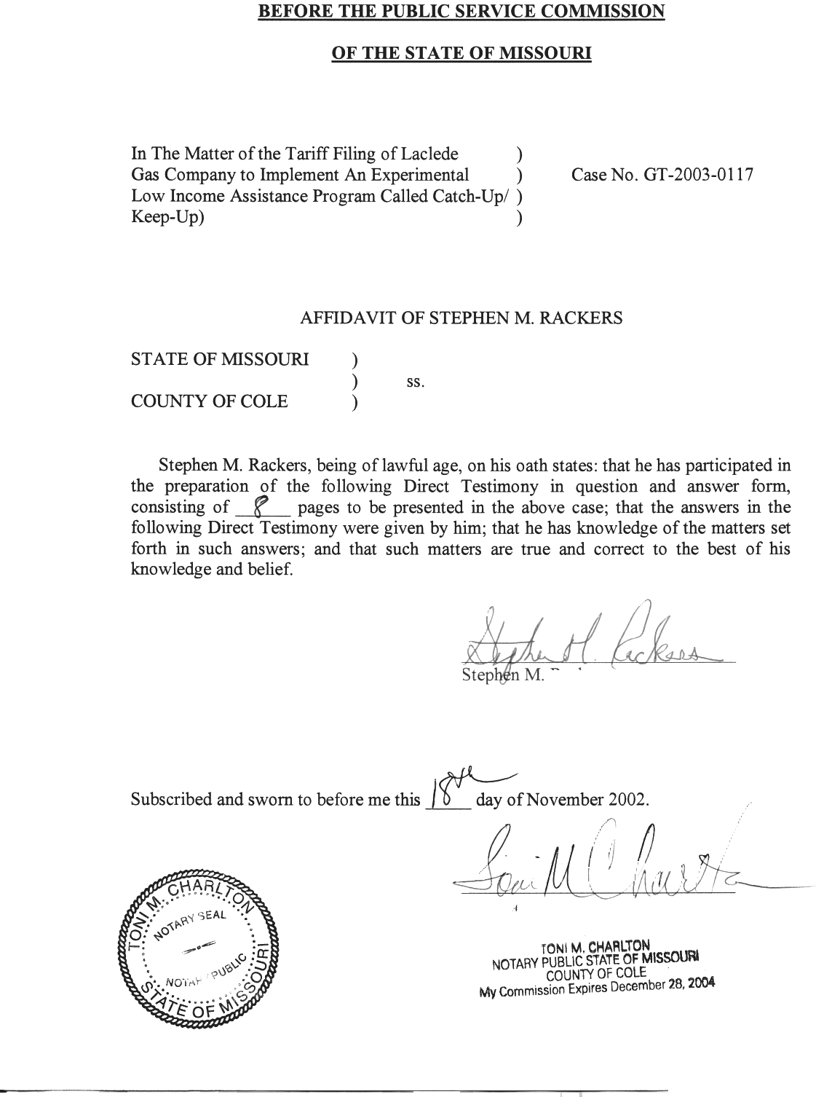

DIRECT TESTIMONY
OF
STEPHEN M. RACKERS
LACLEDE GAS COMPANY
CASE NO. GT-2003-0117

Please state your name and business address.
Stephen M. Rackers, 815 Charter Commons Drive, Suite 100B, Chesterfield, Missouri 63017.
By whom are you employed and in what capacity?
I am employed by the Missouri Public Service Commission (Commission) as a Regulatory Auditor V.
Please describe your educational background.
I attended the University of Missouri – Columbia, where I received a Bachelor of Science degree in Business Administration with a major in Accounting in 1978. I have passed the Uniform Certified Public Accountant examination and am licensed to practice in the state of Missouri.
What has been the nature of your duties while in the employ of this Commission?
I have conducted and assisted with the audits and examinations of the books and records of utility companies operating within the state of Missouri.
Have you previously filed testimony before the Commission?
Yes, I have. Please refer to Schedule 1, attached to this direct testimony, for a list of cases in which I have previously filed testimony.
With reference to Case No. GT-2003-0117, have you investigated the books and records of Laclede Gas Company (Laclede or Company) related to its application to institute the Catch-up/Keep-up (CU/KU) Plan?
Yes, with the assistance of other members of the Commission Staff (Staff).
What is your area of responsibility in this case?
My responsibility in this case is to provide the Commission with information regarding the financial aspects of the CU/KU Plan. In his direct testimony, Staff witness John P. Cassidy, has provided analyses of the Company’s accounting for bad debts. My testimony will show how the CU/KU Plan can be used by the Company to manipulate its accounting for bad debts and as a result, its earnings. My testimony will show that the CU/KU Plan will allow Laclede to double charge its customers for bad debt expense and keep the resulting profits. Laclede will accomplish this result by diverting pipeline discounts into a new fund that it will use to reduce bad debt expense that is already included in its permanent rates and keeping the increase to its profits from the double recovery. Laclede is proposing to return to customers only the unused portion of the new fund that it is creating, through a difficult refund mechanism at the end of the program, which was proposed with no termination date. Laclede is not proposing to prohibit any recovery through the new fund of bad debt expense that would be recovered through its permanent rates.
Please discuss the process of realizing and recording bad debt expense.
The process begins with an estimate of the amount of revenues for utility service that will eventually be written-off by the Company. Until the customer pays for the service, the amount owed is reflected in the accounts receivable balance. The portion of the accounts receivable balance that is estimated to eventually be written-off is recorded as a credit balance in the reserve for uncollectibles accounts (bad debts). The debit side of this entry is a charge to bad debt expense and a reduction in net income and earnings. When an account is written-off, the balance in the reserve for uncollectibles accounts is reduced. If this write-off causes the balance in the reserve for uncollectibles accounts to be insufficient to cover the estimated amount of future write-offs that are currently reflected in the accounts receivable balance, a reduction to earnings through a charge to bad debt expense is required to restore the reserve to an appropriate level. Therefore, account write-offs and/or an increase in the estimated amount of bad debts that is included in the accounts receivable balance can result in a reduction to earnings, as illustrated below:
Reserve For Uncollectible Accounts Balance $1,000,000
Account Write-off - 100,000
Reserve For Uncollectible Accounts Balance After Write-off 900,000
Estimated Required Reserve For Uncollectible Accounts Balance 1,000,000
Bad Debt Expense – Reduction to Net Income $100,000
Why is this discussion significant regarding the CU/KU Plan?
If a plan can be put in place by the Company to avoid charges to bad debt expense to restore the reserve for uncollectible accounts due to previous write-offs or estimated future write-offs, earnings will not be reduced for the estimated uncollectible accounts that are currently reflected in the accounts receivable balance. CU/KU is just such a plan.
Please explain how the CU/KU Plan will allow Laclede to manipulate its earnings by avoiding charges to bad debt expense.
As of September 30, 2002, Laclede’s accounts receivable balance included approximately $7,300,000 that was 90 days past due for service provided to customers who are no longer active (receiving service). In addition, the accounts receivable balance includes approximately $1,600,000 that was 60 days past due for inactive customers. Since Laclede has a practice of writing-off inactive customer accounts 126 working days after the final bill, it is logical to believe that a significant portion of this $8,900,000 ($7,300,000 + $1,600,000) represents a bad debt that should be reflected in the reserve for uncollectible accounts. However, the balance in the reserve at September 30, 2002 was only approximately $3,400,000. Therefore, absent an alternative process, a charge to bad debt expense and a reduction in earnings of approximately $5,500,000 ($8,900,000 - $3,400,000) would be appropriate to restore the reserve for uncollectible accounts. However, the CU/KU Plan provides $6,000,000 designated for debt forgiveness, which will be available to supplement the reserve for uncollectible accounts and avoid the need to record additional bad debt expense and reduce earnings.
- Is there an additional way the CU/KU Plan affects the uncollectible (bad debt) process and earnings?
A. Yes. The CU/KU Plan will result in the delay of account write-offs to a subsequent period and less recovery of past due balances from customers. In order to be reactivated for service under the Cold Weather Rule (CWR), a customer may be required to pay a significant portion of their past due balance. Once reactivated, it is unlikely the customer will be disconnected until April 1 of the following year. Write-off of such a customer’s account would not occur until 126 working days following April 1, or approximately October 1. Under the CU/KU plan a qualifying customer is allowed to be reactivated without making any payment associated with their past due balance. As a result, additional write-offs are delayed to a subsequent period, because some customers, who would have been written-off due to the inability to make the initial payment, will now be eligible for reactivation. This delay in write-offs avoids the reduction in earnings in the current period as a result of recording additional bad debt expense to restore the reserve for uncollectible accounts.
Since the initial payment that was required for reactivation under the CWR is not required under the CU/KU Plan, these funds will be available to make payments for current service and qualify the customer for debt forgiveness. This debt forgiveness will eliminate the reduction in earnings associated with the need to record additional bad debt expense to restore the reserve for uncollectible accounts in future periods.
As discussed in Staff witness Cassidy’s testimony, Laclede’s rates currently include $7,250,000 for the recovery of bad debt (uncollectible) expense. In addition, he states that Laclede’s rates also include $750,000 for the recovery of bad debts resulting from the Emergency Cold Weather Rule. (ECWR). Does the CU/KU Plan provide yet another source of funds for the recovery of bad debts and as a result, an opportunity to increase company earnings?
Yes. The CU/KU Plan is funded by $6,000,000 in pipeline discounts that currently flow directly to ratepayers in the form of reduced gas cost. Through debt forgiveness, the CU/KU plan diverts these pipeline discounts for the recovery of customers’ past-due balances. The $6,000,000 available through the CU/KU Plan, the $750,000 associated with the ECWR included in rates and the $7,250,000 included in the cost of service used to determine rates provide three sources of funds, totaling $14,000,000, which is available for the recovery of bad debts. As Mr. Cassidy points out, Laclede has not experienced a level of annual write-offs (bad debts) in the last ten fiscal years equal to the $14,000,000 that would be provided by permanent rates and the CU/KU Plan. If Laclede were able to recover $6,000,000 through the CU/KU Plan and $8,000,000 in rates, while only experiencing $11,300,000 in write-offs (the highest level experienced during the last ten fiscal years), the Company would realize an additional $2,700,000 in earnings.
Bad Debts Recovered Through Permanent Rates $ 7,250,000
Bad Debts Recovered through ECWR 750,000
CU/KU Debt Forgiveness 6,000,000
Total Bad Debt Recovery $ 14,000,000
Actual Bad Debts (Highest Level In The Last Ten Fiscal Years) 11,300,000
Over Recovery of Bad Debts /Additional Earnings $ 2,700,000
Will the situation described above provide Laclede with an incentive to maximize the CU/KU Plan at the expense of ratepayers?
Yes. If the CU/KU Plan can be used to forgive the same bad debt that is being recovered in rates, earnings will be higher than earnings would have been had the CU/KU plan not been in existence. To fund the debt forgiveness envisioned by the CU/KU Plan, Laclede proposes to divert funds that previously flowed directly to ratepayers in the form of reduced gas cost. Since gas cost is recovered dollar for dollar from ratepayers, any increase in gas cost results in an increase in the rates paid by customers. As a result, any debt forgiveness that occurs through the CU/KU Plan will result in a flow of funds to the Company’s shareholders rather than Laclede’s customers. Since the rates currently include a component designed to fund the ongoing level of bad debts, any bad debt recovery through the CU/KU Plan will increase the Company’s earnings above what would have been realized if the CU/KU Plan was not in existence.

Pipeline Discounts REDUCING GAS COST IN CUSTOMERS RATES
↓
pIPELINE DISCOUNTS DIVERTED TO THE CUKU PLAN
↓
INCREASED Customer Rates
↓
CU/KU PLAN DEBT FORGIVENESS
↓
REDUCED BAD DEBT EXPENSE
↓
INCREASED EARNINGS TO SHAREHOLDERS
Is it possible to assess the true financial impact of the CU/KU Plan?
A. No. Through data requests the Staff attempted to gather information regarding the costs to the Company and the benefits Laclede would realize as a result of implementing the CU/KU Plan. In response to these data requests the Company stated that it:
- Had not quantified the administrative costs of the CU/KU Plan;
- Had made no estimates regarding the success or failure of the CU/KU Plan, including the number of customers that would participate and the affect the plan would have on write-offs; and
- Had made no estimates regarding the benefits that would be realized by Laclede as a result of the CU/KU Plan.
In addition, the Company’s responses to the Staff’s data requests indicate that Laclede has not tracked the bad debts related to the ECWR. The amount of additional bad debts and the amount recovered by the Company are required to be trued-up in August of 2003. The Staff has serious concerns regarding the Company’s administration of the CU/KU Plan in light of the fact that it has no estimates regarding the costs, benefits, success or failure of the CU/KU Plan and its lack of tracking associated with the ECWR.
- Does this conclude your direct testimony?
A. Yes, it does

RATE CASE PROCEEDING PARTICIPATION
STEPHEN M. RACKERS

Company Case Number
Bowling Green Gas Company | GR-78-218
Central Telephone Company | TR-78-258
Empire District Electric Company | ER-79-19
Fidelity Telephone Company | TR-80-269
St. Louis County Water Company | WR-80-314
Union Electric Company | ER-81-180
Laclede Gas Company | GR-81-245
Great River Gas Company | GR-81-353
Union Electric Company | ER-82-52
Laclede Gas Company | GR-82-200
St. Louis County Water Company | WR-82-249
Union Electric Company | ER-83-163
Union Electric Company | ER-84-168
Arkansas Power and Light Company | ER-85-20
Kansas City Power and Light Company | ER-85-128
Arkansas Power and Light Company | ER-85-265
Union Electric Company | EC-87-114
Union Electric Company | GR-87-62
Southwestern Bell Telephone Company | TC-89-14
St. Louis County Water Company | WR-89-246
Laclede Gas Company | GR-90-120
Missouri Cities Water Company | WR-91-172
St. Louis County Water Company | WR-91-361
Laclede Gas Company | GR-92-165
Missouri Pipeline Company | GR-92-314
St. Louis County Water Company | WR-92-204
St. Louis County Water Company | WR-94-166
St. Louis County Water Company | WR-95-145
Union Electric Company | ER-95-411
Union Electric Company d/b/a AmerenUE | EM-96-149
St. Louis County Water Company | WR-96-263
St. Louis County Water Company | WR-97-382
Laclede Gas Company | GR-99-315
Missouri-American Water Company | WR-2000-281 et al
St. Louis County Water Company | WR-2000-844
Laclede Gas Company | GR-2001-629
Union Electric Company d/b/a AmerenUE | EC-2002-1
Union Electric Company d/b/a AmerenUE | EC-2002-1025
Laclede Gas Company | GR-2002-356

