Exhibit No.:
Issues: Tariff Issues
Witness: James M. Russo
Sponsoring Party: MoPSC Staff
Type of Exhibit: Rebuttal Testimony
Case No.: GT-2004-0049
Date Testimony Prepared: October 8, 2003

MISSOURI PUBLIC SERVICE COMMISSION

Utility Operations DIVISION

REBUTTAL TESTIMONY

OF

JAMES M. RUSSO

MISSOURI GAS ENERGY

CASE NO. GT-2004-0049

Jefferson City, Missouri

October, 2003

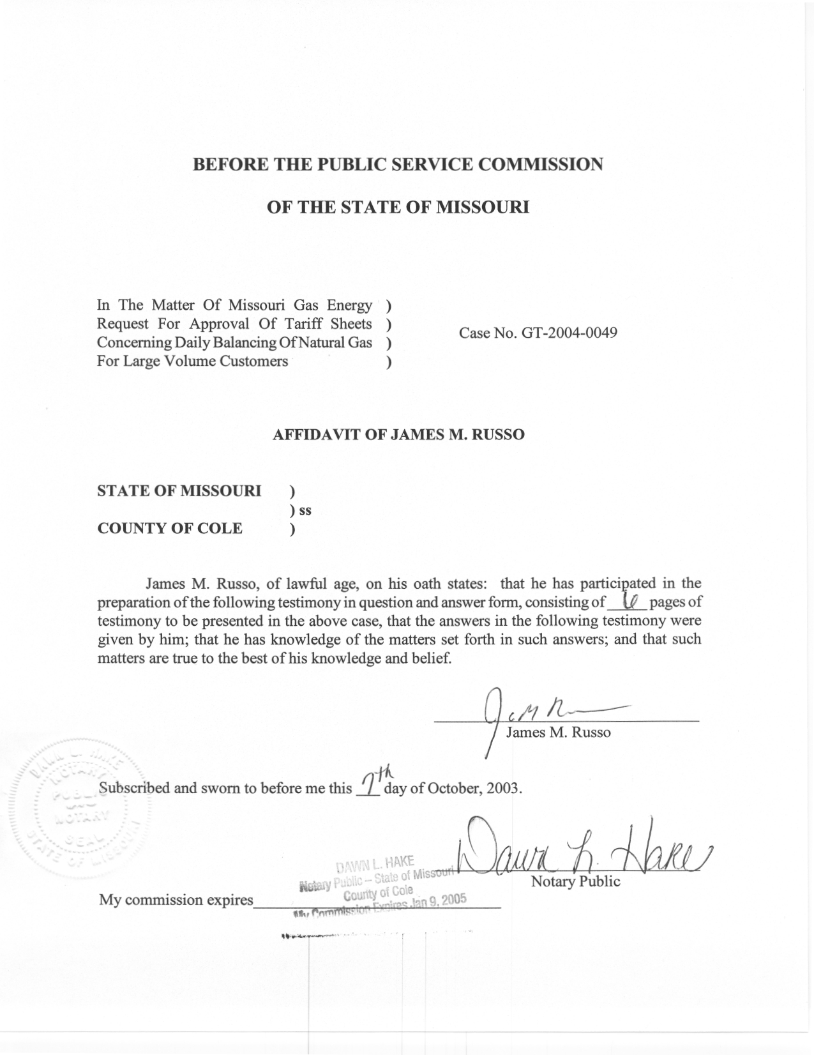
REBUTTAL TESTIMONY
OF
JAMES M. RUSSO
MISSOURI GAS ENERGY
CASE NO. GT-2004-0049
Q. Please state your name and business address.
A. James M. Russo, P.O. Box 360, Jefferson City, Missouri 65102.
Q. By whom are you employed and in what capacity?
A. I am a Regulatory Auditor IV with the Missouri Public Service Commission (Commission).
Q. Please describe your educational background and other qualifications.
A. I graduated from California State University-Fresno, Fresno, California, and received a Bachelor of Science degree in Accounting. Prior to my employment with the Commission, local elected officials in county government employed me in various capacities. I was the assistant treasurer-tax collector for San Joaquin and El Dorado Counties in California. My responsibilities included all financial dealings of the counties and all accounting activities of the agency. In addition, I was the supervising accountant auditor in El Dorado County for two years. My division was responsible for internal audits of all county agencies, special districts, and franchise/lease agreements.
Q. What has been the nature of your duties with the Commission?
A. From April 1997 to December 2001, I worked in the Accounting Department of the Commission, where my duties consisted of directing and assisting with various audits and examinations of the books and records of public utilities operating within the State of Missouri; under the jurisdiction of the Commission. On December 16, 2001, I assumed the position of Regulatory Auditor IV in the Energy Tariffs/Rate Design Department where my duties consist of analyzing applications, reviewing tariffs, and making recommendations based upon these evaluations.
Q. Have you previously filed testimony before this Commission?
A. Yes. A list of cases in which I have filed testimony before this Commission is attached as Schedule 1 to my direct testimony.
Q. With reference to Case No. GT-2004-0049, have you made an examination and study of the proposed tariff sheets filed by Missouri Gas Energy (MGE or Company)?
A. Yes, I have.
Q. What is the purpose of your rebuttal testimony?
A. The purpose of my rebuttal testimony is to present the Commission Staff’s (Staff) position concerning the need for the tariff changes and Staff’s position that the Commission should approve the proposed tariff sheets.
Q. What is your understanding of why MGE filed these proposed tariff sheets?
A. The primary reason for the filing of these tariff sheets is to accommodate termination of MGE’s Pre-determined Allocation Agreement (a/k/a Burner Tip Balancing Agreement) with Southern Star Central Gas Pipeline (Southern Star) f/k/a Williams Gas Pipeline-Central. Southern Star filed tariff sheets at the Federal Energy Regulatory Commission (FERC) that are expected to be implemented on November 1, 2003. If implemented as expected, these changes will effectively terminate the Burner Tip Balancing Agreement between Southern Star and various local distribution companies, including MGE. In its FERC tariffs, Southern Star has proposed various conditions related to pipeline balancing. If the Commission approves MGE’s proposed tariff changes, the Company’s proposed tariffs will implement generally the same conditions on the Company’s Large Volume Transportation (LVS) customers as Southern Star imposes on MGE by a daily allocation on the Southern Star system. To state it another way, MGE proposes to amend its tariffs to reflect changes in Southern Star’s FERC tariffs so that generally the same conditions imposed on MGE for daily balancing are also imposed on MGE’s customers.
Q. Did you compare the proposed tariff sheets filed by the Company with the proposed tariff sheets filed by Southern Star with the FERC?
A. Yes.
Q. Are you providing the explanation of the type of changes that occurred in the Southern Stars tariff?
A. No, Mr. Craig M. Branum of the Federal Issues/Policy Analysis Staff of the Energy Department of the Commission performed this review and will address this in his Rebuttal Testimony in this case.
Q. Does Staff agree with the Company’s proposed changes in this tariff filing?
A. Yes. Staff agrees with the proposed changes by the Company in this tariff filing.
Q. Does the proposed filing by MGE account for the changes Southern Star filed with the FERC?
A. Essentially they do. However, there are a few differences. The factors used by MGE for the Monthly Cash Out do not exactly match the factors that Southern Star is charging MGE. There is the possibility that MGE’s proposed cash out amounts to MGE’s customers could be greater or less than the cash out amount charged to MGE by Southern Star. In addition, Southern Star offers a tolerance level of 10% before a shipper is out of balance and MGE does not. Another MGE difference requires the cashing out of imbalances monthly while Southern Star allows the shipper two months to resolve the imbalance before the cash-out provisions apply.
Q. Please explain what is meant by Monthly Cash Outs.
A. Please refer to the Rebuttal Testimony of Mr. Branum for an explanation of this term.
Q. Please explain the difference in the monthly cash out factors listed on MGE’s proposed tariff sheet number 61.2.
A. MGE’s proposed cash out amount is 1.2 times the index price, as compared to Southern Star’s 1.3 times the index price, if the nomination imbalance is less than the delivery in the 10% to 15% range of actual usage. In addition, MGE proposes a cash-out amount of 1.4 times the index for any imbalance greater than 15% of actual usage, while Southern Star’s cash out amount is increased to 1.5 times the index for any imbalance greater than 20%.
The proposed tariff also has MGE’s cash out amount at 0.8 times the index price, as compared to Southern Star’s 0.7 times the index price, if the nomination imbalance is greater than the delivery in the 10% to 15% range of actual usage. Furthermore, MGE proposes a cash out amount of 0.6 times the index for any imbalance greater than 15% of actual usage, while Southern Star’s cash out amount is 0.5 times the index for any imbalance greater than 20%.
Q. Please define the meaning of the term “index price,” which you used in the preceding paragraph.
A. Index price is defined in MGE’s proposed tariff as the arithmetic average of spot market prices published in the first-of-the-month Inside FERC’s Gas Market Report, for Southern Star Central Gas Pipeline, Inc. (Texas, Kansas, Oklahoma) and Panhandle Eastern Pipe Line Company (Texas and Oklahoma).
Q. Please explain Staff’s position on MGE’s proposal to require monthly cash out.
A. Staff is not opposed to MGE tightening the controls to allow it to maintain a proper balance on its system. Furthermore, Staff believes it is the responsibility of the Local Distribution Company (LDC) to take whatever steps are necessary to ensure the integrity of its distribution system.
Q. Will MGE benefit from the revenues generated from the collection of penalties under this proposed tariff?
A. No. The proposed tariff provides MGE the specific authority needed to recover penalties imposed on MGE by Southern Star. Section B (6) of the Transportation Provisions on MGE’s proposed tariff sheet number 65 provides that all revenues received from unauthorized use charges in this process will continue to flow thru MGE’s Purchased Gas Adjustment (PGA)/Actual Cost Adjustment (ACA) process for the benefit of all firm sales customers.
Q. Will MGE be responsible for any under collection of penalties from its transportation customers when Southern Star charges to MGE are greater than what they recover from their transportation customers?
A. There is no provision in MGE’s proposed tariff that allows recovery of any under collection of penalties from any of MGE’s transportation customers. However, Staff believes that the other provisions of MGE’s proposed tariffs, if approved, make it unlikely that this scenario would occur.
Q. Will this tariff, as filed, pass additional costs on to the other LVS customers who are not directly affected by penalties?
A. No. The Staff believes that it is unlikely that additional costs would be passed on to the other LVS customers or any other of MGE’s customers. Staff believes that the Commission should approve MGE’s proposed tariffs, because the changes will result in the costs or penalties that result from Southern Star’s FERC tariff changes being assessed to the customers who cause the cost.
Q. Does this conclude your rebuttal testimony?
A. Yes it does.

RATE CASE PROCEEDING PARTICIPATION
JAMES M. RUSSO

COMPANY CASE NO.

Union Electric Company GR-97-393
Gascony Water Company WA-97-510
St. Joseph Light and Power Company EC-98-573
St. Joseph Light and Power Company HR-99-245
St. Joseph Light and Power Company GR-99-246
St. Joseph Light and Power Company ER-99-247
UtiliCorp United Inc./St. Joseph Light and Power Company EM-2000-292
UtiliCorp United Inc./Empire District Electric Company EM-2000-369
Osage Water Company WR-2000-557
Osage Water Company SR-2000-556
Missouri Gas Energy GR-2001-292
Southern Missouri Gas Company, L.P. GR-2001-0388
Environmental Utilities WA-2002-65
Laclede Gas Company GR-2002-356
Laclede Gas Company GA-2002-429
Missouri Gas Energy GT-2003-0033
Aquila Networks L & P GT-2003-0038
Southern Missouri Gas Company, L.P. GT-2003-0031
Atmos Energy Corporation GT-2003-0037
Fidelity Natural Gas, Inc. GT-2003-0036
Laclede Gas Company GT-2003-0032
Union Electric Company GT-2003-0034

