Exhibit No.:
Issues: Basic Local Service

Witness: Bill Peters
Sponsoring Party: MO PSC Staff
Type of Exhibit: Surrebuttal Testimony
Case No.: TO-2005-0035
Date Testimony Prepared: January 21, 2005

MISSOURI PUBLIC SERVICE COMMISSION

Utility Operations DIVISION

Surrebuttal TESTIMONY

OF

Bill Peters

Southwestern Bell Telephone, L.P.,
D/B/A SBC Missouri

CASE NO. TO-2005-0035

Jefferson City, Missouri
January 21, 2005

**Denotes Highly Confidential Information**

NP
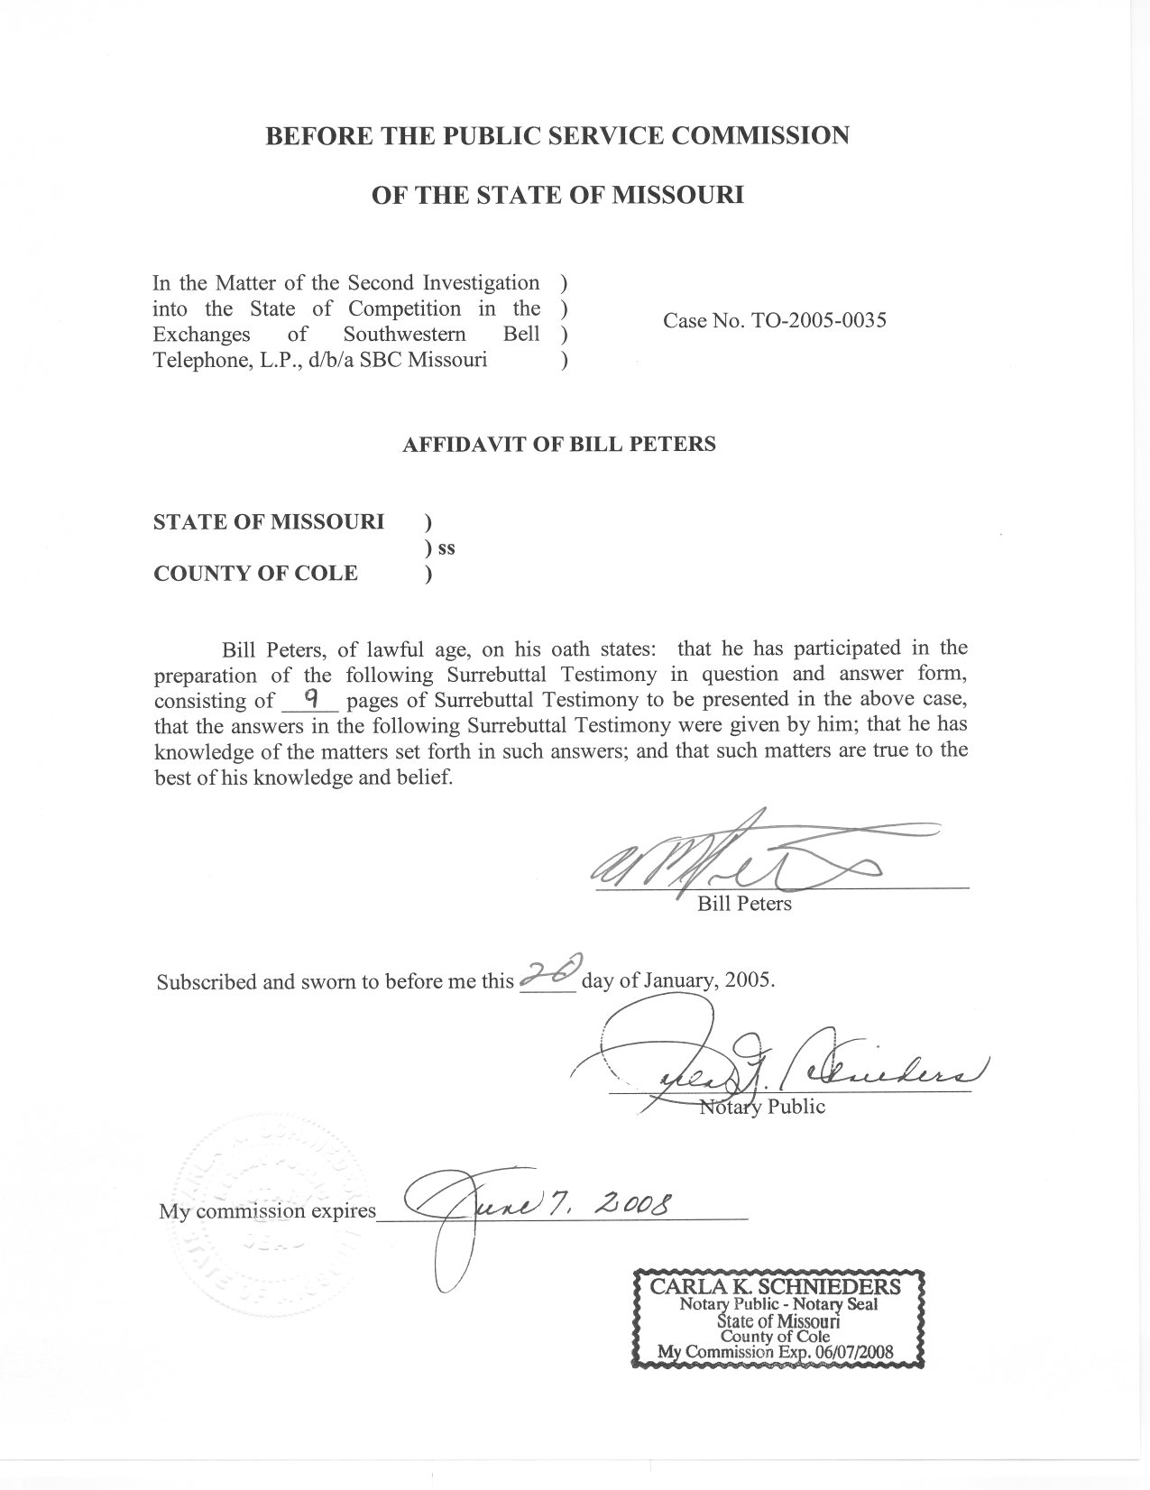

SURREBUTTAL TESTIMONY

OF

BILL PETERS

SOUTHWESTERN BELL TELEPHONE, L.P.,
D/B/A SBC MISSOURI

CASE NO. TO-2005-0035

Q. Are you the same Bill Peters that filed Rebuttal Testimony in this case?
A. Yes, I am.
Q. What is the purpose of your Surrebuttal Testimony?
A. The purpose of my Surrebuttal Testimony is to respond to the Rebuttal Testimony of Ms. Barb Meisenheimer on behalf of the Office of the Public Counsel, Mr. Matthew Kohly on behalf of Socket Telecom, LLC and Mr. Edward Cadieux on behalf of NuVox Communications of Missouri, Inc. My Surrebuttal Testimony will also explain Staff’s rationale for removing the business exchanges of Farley, Greenwood, Grain Valley, and Smithville from its recommendation to support SBC’s request for a finding of effective competition.
Q. Ms. Meisenheimer’s testimony suggests that, although in and of itself not conclusive, the Herfindahl-Hirschman Index (HHI) may be used to measure the absence or presence of effective competition? Does Staff agree with this testimony?
A. No, the HHI merely reflects the two data sources from which it is derived. To measure market concentration, the HHI sums the squares of competitor market shares. According to Department of Justice (DOJ) criteria, markets with an HHI of 1800 or more are considered concentrated. Transactions that increase the HHI by 100 or more in concentrated markets presumptively raise antitrust concerns under Horizontal Merger Guidelines issued by DOJ and the Federal Trade Commission. Importantly, these thresholds are intended to call attention to antitrust concerns and were not developed as a guide to effective competition as defined in the Missouri Statues and determined by the Commission.
The resulting measure takes into account the number of firms in the relevant market and their respective market shares. These two pieces of information are certainly worthy of inclusion in an investigation of effective competition. However, thresholds established by the Department of Justice (to indicate degrees of market concentration) are somewhat misplaced if applied to measuring effective competition.
For example, if an ILEC (Incumbent Local Exchange Company) were to face one facilities-based competitor (equal to the ILEC in all significant aspects) in an exchange and both the ILEC and the CLEC (Competitive Local Exchange Carrier) held 50 percent of the market’s access lines, the resulting HHI of 5000 indicates a concentrated market under DOJ criteria. If a market had 5 CLECs with 1% market share each and an ILEC with the rest, the HHI would be 9030. In a Market with five CLECs and an ILEC, each with equal market shares of 16.6%, the HHI would be 1667. Both Market Share and number of competitors are needed in combination to get HHI, but breaking below 1800, for a moderately concentrated market, requires at least 6 competitors with relatively similar market shares.
The Commission has determined that effective competition exists in exchanges where an ILEC faces one significant facilities-based competitor, such as the exchange of Norborne, where the Commission found that Sprint Missouri faces effective competition from Green Hills Telecommunications Company. Using the access line counts from December 2001, Staff calculated an HHI of 5648 in the Norborne residential market and 5200 in the Norborne business market. These HHIs indicate a highly concentrated market under criteria developed by the Department of Justice for analysis of mergers; however, based on a combination of factors that include method of access line provision, number of competitors, and their approximate market shares, the Commission determined effective competition exists in Norborne despite the HHI.
Q. What is Staff’s response to Ms. Meisenheimer’s Schedule 2 HC?
A. The purpose and origin of this schedule is unclear from reading Ms. Meisenheimer’s testimony. From the title of the schedule, “Updates to CLEC Review Conducted in TO-2001-0467”, it appears that Ms. Meisenheimer has presented an update of a schedule provided in the previous investigation of competition in SBC Missouri exchanges. The schedule itself appears to be a modification of the list of CLECs published on the Commission’s website. Current versions of this list can be found at: http://www.psc.mo.gov/telecommunications-CLEC.asp.
The list Ms. Meisenheimer was working from includes many companies who have since filed bankruptcy, are no longer in business, or have never indicated any intention of serving in SBC areas. Staff has informed Public Counsel of errors in the schedule.
Q. Socket witness Matthew Kohly alleges in his Rebuttal Testimony that e911 data may actually overstate the number of access lines served in a particular exchange. (The testimony is not marked with page and line numbers for a direct citation.) Does this information change Staff’s recommendation in any significant way?
A. Yes it does. Mr. Kohly’s testimony adds yet another wrinkle to the use of e911 data as a proxy for competition in particular exchanges. Until his testimony, Staff was not aware of a situation where e911 data might overestimate the quantity of access lines served in an exchange. In order to better understand the matter, Staff interviewed CLECs by telephone about how the companies report access lines to the e911 database.
Q. What did Staff find out as a result of these interviews?
A. Through telephone interviews, which due to time constraints and other mitigating factors do not constitute the entire array of CLECs in SBC Missouri territory, Staff learned that at least two CLECs follow a procedure which lists all telephone numbers in PBX situations. For those instances, the number of e911 listings would certainly overstate the number of access lines provided. In a situation where a customer requested 10 access lines serving 40 extensions with telephone numbers, for example, these companies would list all 40 numbers in the e911 database; yet, there are only 10 lines available at any one time.
However, Staff also learned that for inbound access lines serving Internet Service Providers (ISPs) at least one CLEC does not list those lines in the e911 database. In such a situation, the e911 database would underestimate the number of access lines sold in an exchange. If the CLEC held all dialup access line traffic in an exchange, none of those lines would be represented by a corresponding e911 listing, clearly understating the access lines in that exchange.
In interviews with Staff, another CLEC identified itself as a “carrier’s carrier”. This CLEC indicated that its lines are only listed in the e911 database at the third party carrier’s request.
As far as Staff can ascertain, e911 listings at times overestimate access lines and at times understate the level of access line penetration in an exchange, with no clear rationale that can be applied to determine when these occurrences might happen.
Q. Did Staff review any other information in an effort to verify accuracy of e911 data as a proxy for access lines?
A. Staff also reviewed the Annual Reports of each CLEC identified in SBC’s motion to open this case. To verify how well the e911 database approximates access lines, Staff reviewed the annual reports to compare CLEC access line reports to the CLEC e911 listings from Unruh Schedule 13HC. The results of these reviews are presented in my HC Schedule 12.
HC Schedule 12 is designed to aggregate CLEC access lines reported, by method of provision, in SBC exchanges. Exchange-level data are presented and used to calculate totals by company and SBC exchange. Total facilities-based lines reported in the residential and business market are compared to SBC access lines derived from Unruh Schedule 13HC. A ratio of CLEC over total facilities-based access lines is also calculated in order to summarize relative facilities-based CLEC penetration in SBC Missouri exchanges.
Q. Please summarize Staff’s findings in these reviews.
A. Staff found problems when comparing e911 data to Annual Report data.
One problem with comparing Annual Report data with e911 data is that the two sets of data were collected at times that differs by 6 months. The e911 data is a snapshot of that database at June 2004, and the Annual Report data is a snapshot of CLEC reported access lines on December 31, 2003. Though, one would expect that where effective competition exists, there would be significant data in each of those time periods. However, it becomes even more difficult to compare the data because the two data sets are not measuring the same piece of information.
The e911 listings measure the counts of e911 listings and Annual Reports measure the number of voice grade equivalent access lines in an exchange. As Staff has found, one does not necessarily lead to the other. On the whole, when Staff compares the data side-by-side, exchanges that show a relatively high number of e911 listings also show a relatively high CLEC Annual Report access line count.
Q. Did Staff identify any problems with the Annual Report data?
A. Yes. Although the Annual Report instructs companies to list access lines by exchange, Staff encountered instances where line count was reported by municipality, metropolitan area, and simply by providing a statewide Missouri figure. Staff, to the best of its ability attempted to locate and revise the data in order to compare it to the exchange data in the e911 database. Additionally, the data included in Staff’s Annual Report summary, HC Schedule 12 may not be all inclusive of competition in SBC exchanges, but include companies identified as competitors by SBC Missouri.
Q. Can you summarize your findings on the e911 database information?
A. It seems there is no clear way to discern the accuracy of the e911 database in approximating lines. Interviews with CLECs reveal that CLECs do not have a consistent process in place for determining how their access line numbers are reflected in their e911 database listings. At times when a customer is served by a PBX-type system, the e911 database could over-represent the number of access lines served. In other instances, such as an ISP direct inward dial line, access lines may not be represented at all in e911 data. It is not possible to judge for certain how well e911 listings approximate competition. Without a comparison of all CLEC access lines and their respective e911 listings, it is difficult to predict how accurately e911 data approximates CLEC access lines.
Q. Does this knowledge change your recommendation as to those exchanges where effective competition exists in SBC exchanges?
A. Yes, after reviewing CLEC Annual Report data along with the additional information gained about CLEC e911 data, Staff finds it necessary to revise its recommendation. Where significant evidence of facilities-based competition was found in both sets of data, Staff feels most confident in recommending effective competition. Because of inherent problems with both sets of data, where only one set of data show significant facilities-based competition, Staff is reluctant to recommend effective competition for that exchange. When analyzing Annual Report data, specific attention was paid to CLEC facilities-based market penetration and the number of active facilities-based CLECs in the exchange.
Staff, in Rebuttal Testimony, recommended effective competition for business access lines and their related services in the exchanges of Farley, Greenwood, Grain Valley, and Smithville. These particular exchanges showed little to no supporting facilities-based evidence based in the CLEC Annual Reports reviewed. Therefore, Staff modifies its recommendation to remove these exchanges from the list of SBC exchanges where Staff supports SBC’s request for effective competition.
The remaining exchanges of Harvester, Fenton, Chesterfield, Springfield, Kansas City, St. Louis, Valley Park, Manchester, St. Charles, Marionville, Pond, Eureka, Imperial, High Ridge, and Maxville showed significant facilities based competition under both sets of data. Finally, after additional review, Staff makes no changes to its recommendations in the residential market.
Q. Edward Cadieux, in his Rebuttal Testimony, ultimately recommends, “…that the Commission suspend the proceedings for at least 12 months and then allow additional evidence and hearings” because new FCC UNE rules and possible legal challenges to those rules will impact the CLEC market significantly. Does Staff agree with this recommendation?
A. No. Staff has taken the uncertainties of UNE rules into account in its analysis. The future of UNE-P, in particular, appears to be threatened by the anticipated, new FCC rules. In fact, the FCC’s press release indicates that UNE-P would not be available in 18 months and its price would increase in this proposed transition period. Staff has consequently given little credit to any access lines currently being provided by UNE-P.
Q. You discuss the weight given to UNE-P in Staff’s recommendation. Did Staff also consider the future existence of UNE-loops?
A. The provision of UNE loops appears to still be obligated under the Act and Staff has seen no indication that access to UNE loops will significantly change. Staff gives credit, when considering the impact on effective competition, to access lines provided by UNE loop where the CLEC has to maintain at least some facilities, including switching.
Q. Does this conclude your Surrebuttal Testimony?
A. Yes it does.
SCHEDULE 12 IS DEEMED
HIGHLY CONFIDENTIAL
IN ITS ENTIRETY

