BEFORE THE PUBLIC SERVICE COMMISSION
OF THE STATE OF MISSOURI

In the Matter of the Application of )
Union Electric Company, doing business )
As AmerenUE, for an Order Authorizing )
The Sale, Transfer and Assignment of )
Certain Assets, Real Estate, Leased ) Case No. EO-2004-0108
Property, Easements and Contractual )
Agreements to Central Illinois Public )
Service Company, doing business as )
AmerenCIPS, and, in connection therewith, )
Certain Other Related Transactions. )

POSITION STATEMENT
OF THE MISSOURI INDUSTRIAL ENERGY CONSUMERS

Comes now Alcoa Foil Products, Anheuser-Busch Companies, Inc., The Boeing Company, DaimlerChrysler, Ford Motor Company, General Motors Corporation, Hussmann Refrigeration, ISP Minerals, Monsanto Company, Pfizer, Precoat Metals, Procter & Gamble Manufacturing, Nestlé Purina and Solutia, hereafter referred to as the Missouri Industrial Energy Consumers (“MIEC”), and offers the following Position Statement regarding the issues presented in the Lists of Issues of the Commission Staff, Office of the Public Counsel and AmerenUE:
The MIEC is continuing to review surrebuttal evidence in this case, but at this time has not developed positions on these issues. The MIEC reserves the right to develop and assert positions on these issues at the hearing in this case.

Respectfully submitted,
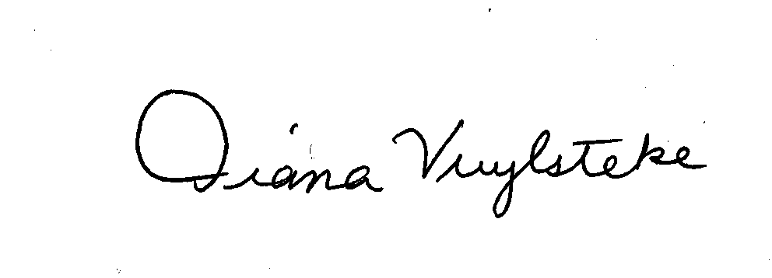
BRYAN CAVE, LLP
By:___________________________
Diana M. Vuylsteke, #42419
211 N. Broadway, Suite 3600
St. Louis, Missouri 63102
Telephone: (314) 259-2543
Facsimile: (314) 259-2020
E-mail: dmvuylsteke@bryancave.com

CERTIFICATE OF SERVICE

I hereby certify that copies of the foregoing have been served electronically to all persons required by the Commission to be served, this 17th day of March, 2004.
__________________________________
Diana M. Vuylsteke

