Exhibit Number: | ________
Issues: | 1) Cedar Hill Quality of Service
 | 2) Comparison of Cedar Hill to Warren County Water & Sewer
Witness Name: | Dale W. Johansen
Type of Exhibit: | Direct Testimony
Sponsoring Party: | MoPSC Staff
Case Number: | SM-2004-0275
Date Testimony Prepared: | August 9, 2004

Missouri Public Service Commission

Utility Operations Division

Water & Sewer Department

Direct Testimony

of

Dale W. Johansen

Case No. SM-2004-0275

Missouri-American Water Company
and Cedar Hill Utility Company, Inc.

Jefferson City, Missouri
August 2004
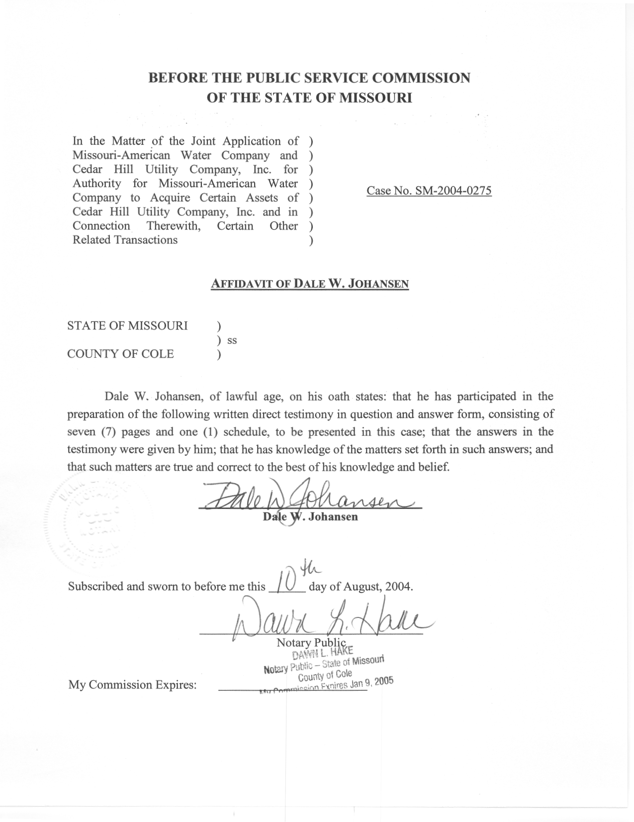

Table of Contents for the Direct
Testimony of Dale W. Johansen

Case No. SM-2004-0275
Missouri-American Water Company
and Cedar Hill Utility Company, Inc.
Introduction 1
Involvement in This Case 2
Purpose of Testimony 2
The Cedar Hill Situation 3
The Warren County Situation 4
Comparison of the Cedar Hill & Warren County Situations 6

Introduction
Q. Please state your name and business mailing address.
A. Dale W. Johansen, P.O. Box 360, Jefferson City, Missouri 65102.
Q. By whom are you employed and in what capacity?
A. I work for the Missouri Public Service Commission (Commission) and my position at the Commission is Manager of the Water & Sewer Department (W/S Dept) in the Utility Operations Division.
Q. How long have you worked in the capacity as Manager of the W/S Dept?
A. Just over nine years.
Q. Please briefly describe your job responsibilities.
A. My responsibilities include general administrative and supervisory duties for the overall operation of the W/S Dept, and direct participation in water and sewer utility cases before the Commission regarding both technical and policy matters.
Q. What are your educational and work experience backgrounds?
A. Please refer to Schedule DWJ – 1 attached to this testimony for a summary of my education and work experience backgrounds.
Q. Have you previously testified before this Commission?
A. Yes, I have, on numerous occasions.

Involvement in This Case
Q. What has been the nature of your involvement in this case?
A. I am one of the Commission Staff members involved in the review of the Joint Application that is the subject of this case. In that regard, I have reviewed the Joint Application and the related attachments, and have also been involved in several meetings and conference calls regarding the issues surrounding the Joint Application. I was involved in the drafting of the Stipulation of Facts and Request for Commission Ruling that the parties to this case filed with the Commission, and have also been involved in the development of a possible supplement to that pleading. Lastly, I have assisted in the review process related to the preparation of the pre-filed direct testimony of Staff witness John Cassidy, and am thus familiar with that testimony.

Purpose of Testimony
Q. What is the purpose of this pre-filed direct testimony that you are presenting in this case?
A. I will be presenting testimony on the following matters: (1) an overview of the service that Cedar Hill Utility Company, Inc. (Cedar Hill) is providing to its customers; (2) an overview of the service that Warren County Water & Sewer Company (Warren County) previously provided to its customers; and (3) a comparison of the factual circumstances of Cedar Hill's current situation versus the factual circumstances of the Warren County situation.

The Cedar Hill Situation
Q. First of all, as Manager of the W/S Dept would you normally receive or be notified of any service complaints or operational problems related to systems operated by Commission-regulated water and sewer utilities?
A. Yes. I would receive or be made aware of these kinds of situations either directly or through communications with my staff or other Staff members.
Q. In your years as Manager of the W/S Dept, has it been your experience that if a water and sewer utility is not providing safe and adequate service to its customers or is having problems delivering service to its customers that customers will complain about the situation to the Commission?
A. Yes.
Q. Regarding the service currently provided by Cedar Hill, are you aware of any past or pending service-related customer complaints or inquiries?
A. No, I am not.
Q. Regarding Cedar Hills facilities, are you aware of any deficiencies or operational problems?
A. No, I am not.
Q. What type of research did you conduct to reach the conclusions stated above regarding the service that Cedar Hill is providing?
A. I reviewed the complaint/inquiry data maintained in the Commission's electronic filing and information system, which includes such data beginning sometime in calendar year 2002. In reviewing this data, I discovered no records of any type of customer complaints or inquiries regarding Cedar Hill.
Q. What type of research did you conduct to reach the conclusions stated above regarding Cedar Hill's facilities?
A. I reviewed the reports from the most recent operational inspections of Cedar Hill's systems, which were conducted by Steve Loethen of the W/S Dept. In reviewing those reports, I discovered that Cedar Hill's facilities are generally in good working condition, that the facilities have adequate capacity to serve the existing certificated service areas, and that properly qualified personnel are operating the facilities in an acceptable manner.
Q. Based on your research noted above, what is your conclusion regarding Cedar Hill's service and facilities?
A. It is my conclusion that Cedar Hill is providing safe and adequate service, and that it is utilizing facilities that are safe and adequate.

The Warren County Situation
Q. Please provide a brief overview of the situation involving the Warren County Water & Sewer Company.
A. Warren County is a Commission-regulated water and sewer utility that has been placed into receivership by the Warren County Circuit Court, and thus is now being operated under the supervision of a court-appointed receiver. This action was taken pursuant to a series of activities that included a formal complaint before the Commission, which the Office of the Public Counsel (OPC) filed, and in which the OPC alleged that Warren County was not providing safe and adequate service. As a result of that complaint, the Commission found that Warren County was not providing safe and adequate service, and ordered the Commission's General Counsel to file a petition to have Warren County placed into receivership.
Also, the purchase of Warren County's utility assets by Missouri-American Water Company (MAWC) was the subject of Case No. WM-2004-0122 before the Commission, and I believe that certain aspects of that case are relevant to this case.
Q. Why do you believe that certain aspects of WM-2004-0122 are relevant to this case?
A. I have three basic reasons for this. First, in WM-2004-0122 MAWC requested that the proposed purchase price for Warren County's utility assets be established as the rate base for the Warren County systems for future ratemaking purposes. That has not been done in this case. Second, the known rate base for Warren County did not accurately reflect what the rate base would be for MAWC after the purchase, and it could thus not be determined for certain whether an acquisition premium existed or what the amount of any such premium might be. That is not the situation in this case. Third, the situation regarding the level of service that Warren County was providing, the conditions of its systems, and the need for system improvements could be considered mitigating factors in the determination of whether the public interest was being served by MAWC's purchase of the system. That is certainly a different situation than exists in this case.

Comparison of the Cedar Hill & Warren County Situations
Q. Based upon the information presented above, do you believe there are any similarities between the current Cedar Hill situation and the situation involving Warren County?
A. Absolutely not. Cedar Hill's situation is markedly different because it has been, and continues to be, a well-managed system that has historically delivered, and continues to deliver, safe and adequate service.
Q. Do you believe the differences between Cedar Hill's situation and Warren County's situation should have an impact on the decisions the Commission may be making in the instant case?
A. Yes, I do.
Q. Why is that?
A. Basically, the Warren County system was in complete disarray, its facilities were decaying and insufficient from a capacity viewpoint, and customer complaints were escalating. Because of these factors, the sale of the system was necessary to implement proper management and to ensure that safe and adequate service was going to be provided to Warren County’s customers on a going forward basis. That is not at all the case with Cedar Hill, because all available information shows that Cedar Hill has been and continues to be a well-managed utility company, and that it has provided and continues to provide safe and adequate service. The mitigating factors that existed in the Warren County situation for the determination of whether the public interest was being served by MAWC's purchase of the system simply do not exist in Cedar Hill's situation. And this should certainly be considered by the Commission when making its determination of whether to condition the approval of the Cedar Hill sale on MAWC not being allowed to recover the acquisition premium through future rate increases, as is recommended by the Staff in this case.
Q. Does that conclude your pre-filed direct testimony?
A. Yes, it does.
Education & Work Experience
Summary of Dale W. Johansen

College Education

Associate of Arts in Pre-Engineering Studies
State Fair Community College – Sedalia, Missouri

Bachelor of Science in Agricultural Engineering
School of Engineering – University of Missouri @ Columbia

Regulatory/Utility Work Experience

Missouri Public Service Commission
Manager – Water & Sewer Department
Utility Operations Division
June 1995 to Present

Johansen Consulting Services
Utility & Regulatory Consultant
February 1994 to June 1995

Missouri One Call System, Inc.
Executive Director
January 1992 to February 1994

Missouri Public Service Commission
(service prior to current position)

Director – Utility Services Division
November 1990 to January 1992

Case Coordinator – Utility Division
November 1987 to November 1990

Assistant Manager – Engineering
Gas Department – Utility Division
October 1980 to November 1987

Gas Safety Engineer
Gas Department – Utility Division
May 1979 to October 1980

