Exhibit No.:
Issues: Weather Normalization

Witness: Dennis Patterson
Sponsoring Party: MO PSC Staff
Type of Exhibit: Direct Testimony
Case No.: GR-2004-0072
Date Testimony Prepared: January 6, 2004

MISSOURI PUBLIC SERVICE COMMISSION

Utility Operations DIVISION

Direct testimony

OF

DENNIS PATTERSON

Aquila, Inc. d/b/a Aquila Networks MPS
and Aquila Networks L&p

CASE NO. GR-2004-0072

Jefferson City, Missouri
January 2004

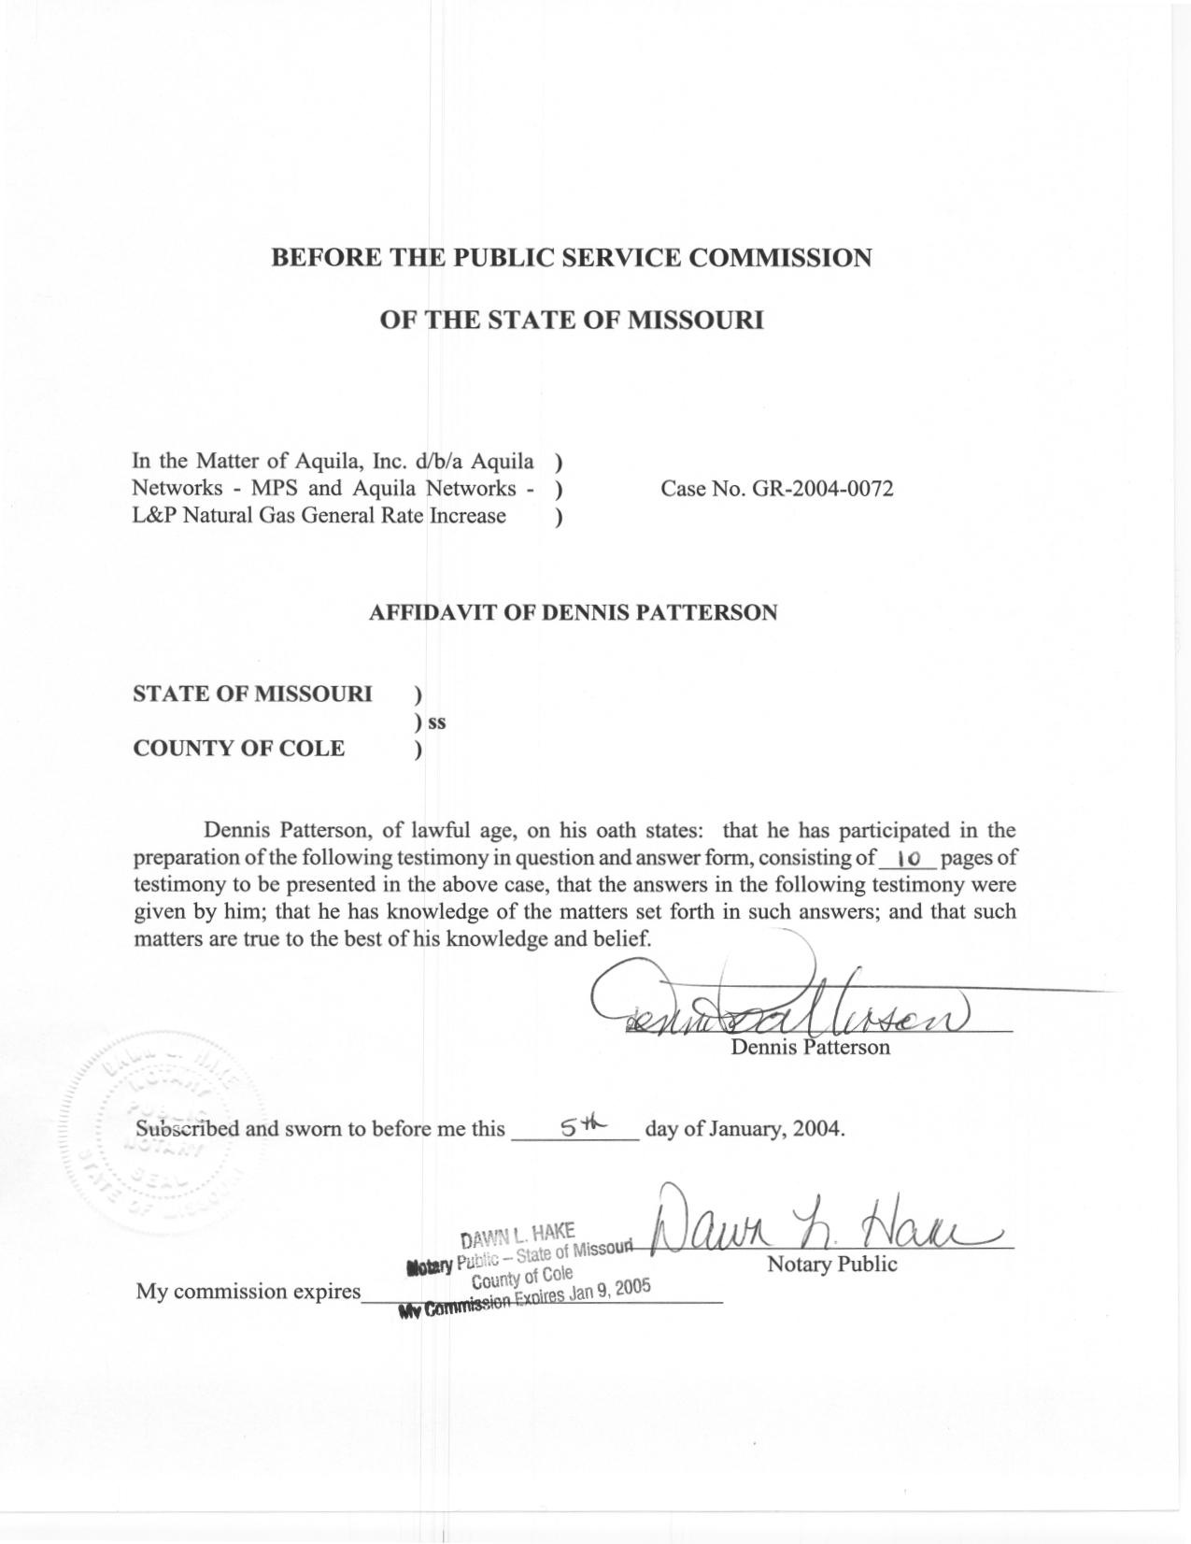
TABLE OF CONTENTS

SUMMARY 2
DEFINITION OF HEATING DEGREE DAYS (HDD) 3
CALCULATION OF HDD 3
SELECTION OF WEATHER STATIONS 4
TYPES OF WEATHER STATIONS 5
TEMPERATURE DATA QUALITY 5
CALCULATION OF ACTUAL AND NORMAL HDD VARIABLES 6
COMPOSITE WEATHER STATIONS AND CUSTOMER WEIGHTS 9

DIRECT TESTIMONY
OF
DENNIS PATTERSON
AQUILA, INC.
D/B/A AQUILA NETWORKS-MPS
AND AQUILA NETWORKS-L&P
CASE NO. GR-2004-0072
Q. Please state your name and business address.
A. My name is Dennis Patterson and my business address is Missouri Public Service Commission, P. O. Box 360, Jefferson City, Missouri, 65102.
Q. What is your present position with the Missouri Public Service Commission (Commission)?
A. I am a Regulatory Economist in the Energy Department of the Utility Operations Division.
Q. Please review your educational background and work experience.
A. I was trained as an officer and aviator in the U.S. Army. I studied economics, math, sciences and languages, receiving a B.A. in Latin American Studies (University of Missouri, 1983) and an M.S. in Agricultural Economics (University of Missouri, 1989). I joined the Staff of the Commission in April 1986. I established the Staff's centralized weather database, and have continued to maintain and improve it by employing official weather data and accepted methods of calculating normals. The Commission, the Missouri Army National Guard, the University of Missouri, U.S. Army Reserves, and the U.S. Army have employed me. I have retired, but continue part-time employment with the Commission.
Q. What is the purpose of your testimony?
A. I will explain my calculations of actual and normal heating degree-day (HDD) variables, which I furnished to Staff witness James Gray.

SUMMARY

Q. How is your testimony organized?
A. I have organized my testimony in the following sections: Definition of Heating Degree Days (HDD), Calculation of HDD, Selection of Weather Stations, Types of Weather Stations, Temperature Data Quality, Calculation of Actual and Normal HDD Variables, and Composite Weather Stations and Customer Weights.
Q. What are composite weather stations and customer weights?
A. To simplify calculations for two service areas of the Company that cover several counties apiece, the Staff constructed a single weather series for each by averaging actual and normal temperature data for the days in test year over multiple weather stations in the service area. For brevity, the Staff refers to the resulting data series as if it represented a single composite weather station for that area. The choice of weather stations and the calculation of weighted averages are explained in greater detail below.
Q. Have you attached any schedules to your Direct Testimony?
A. Yes. Staff’s paper, “Method For Calculating Daily Normal Temperature For Gas And Electric Utilities,” is attached as Schedule 1. Specific calculations of HDD variables for the selected service areas of the Company are attached as Schedules 2-1 through 2-4.
Q. Are your calculations explained in greater detail elsewhere?
A. Yes. Additional detail is included in my working papers.

DEFINITION OF HEATING DEGREE DAYS (HDD)

Q. What are HDD?
A. HDD are a weather measure that was devised to explain the pattern of natural gas used for residential heating. HDD are used to calculate the increased amount of natural gas that would be used in the next 24 hours if the average temperature were to be one degree colder than the previous daily average.
Q. How are HDD calculated?
A. HDD are calculated from mean daily temperature (MDT), where MDT is the average of the day’s maximum and minimum temperatures (TMAX and TMIN). HDD for the day are calculated as the number of degrees MDT is below 65 degrees Fahrenheit (F), and are set equal to zero when MDT is above 65 F. The data containing TMAX and TMIN are acquired from the National Oceanic and Atmospheric Administration (NOAA). They were acquired for the test year (January, 2002 to December, 2002), and for the current NOAA normals period (January, 1971 through December, 2000).

CALCULATION OF HDD

Q. How did you calculate actual daily HDD for the test year?
A. I calculated actual daily HDD from reported daily TMAX and TMIN during the test year.
Q. How did you calculate normal HDD for the 1971-2000 normals period?
A. The methods that I applied to produce daily HDD normals are described in Schedule 1, attached to my Direct Testimony. This method complies with provisions of the Commission’s Report and Order in Missouri Gas Energy rate Case No. GR-96-285, in which it adopted NOAA’s 30-year normals as a measure of normal weather. NOAA’s 30-year normals were based on temperatures that have been adjusted for exposure changes, such as the difference in temperatures between the current location and a former one. Since HDD are calculated from TMAX and TMIN, I adjusted daily TMAX and TMIN over the 30-years of 1971 through 2000 to match NOAA’s series of adjusted monthly TMAX and TMIN for a given weather station, then calculated 30-years of adjusted daily HDD from these, from which I finally calculated daily normal HDD for that station. Should data from two stations be combined, the proper procedure would be to average daily HDD for each day in the entire 30-years before calculating a normal for the combination.

SELECTION OF WEATHER STATIONS

Q. How did you select the weather stations to be used in the present case?
A. Staff witness Henry Warren and I collaborated on the choice of weather stations, which were based on the geographic distribution of the Company’s customers.
Q. Where were the Company’s customers?
A. The Company’s customers were divided into four groups: a Light & Power district in the northwest corner of Missouri; a Northern district that included the cities of Chillicothe, Brookfield and Salisbury; a Southern district that included Platte City, Marshall, Sedalia and Nevada; and an Eastern district in the vicinity of Rolla.
Q. Were single weather stations used for each group of customers?
A. No. Data from multiple stations were combined to form composite HDD series for the groups of customers in the Company’s Northern and Southern systems. I calculated the composite HDD series using customer weights I obtained from Mr. Warren. The weighting will be discussed in a separate section below.
Q. What were the weather stations for which you calculated 1971-2000 adjusted HDD histories in the present case?
A. These weather stations were Brookfield, Columbia, Conception, Kansas City (Kansas City International Airport), Marshall, Nevada, Salisbury and Sedalia.

TYPES OF WEATHER STATIONS

Q. What types of weather stations are maintained at the selected locations?
A. Both Columbia and Kansas City are first-order stations. The remaining locations have cooperative weather stations.
Q. What are first-order weather stations?
A. First-order weather stations are usually located at regional or municipal airports, where professional observers continuously monitor the weather instruments. The instruments record daily TMAX and TMIN, along with hourly observations of precipitation, temperature, dew point, wind and other weather elements. In contrast, trained volunteers usually man cooperative weather stations, where they record daily observations of TMAX, TMIN and rainfall.

TEMPERATURE DATA QUALITY

Q. Were the reported daily temperatures complete for the selected weather stations?

A. No. Although the test year had complete temperature data, most stations have had occasional short periods of missing days since 1971. The treatment of these missing values is discussed at Schedule 1.
Q. Were the reported daily temperatures measured the same way throughout the period 1971 through the test year?

A. No. These temperatures were measured at numerous locations and on varying daily schedules at each weather station, with instruments that were periodically replaced and updated. It is important to note that temperatures vary by location, and that daily TMAX and TMIN temperatures for a 24-hour period will vary depending on what hour the 24 hours begins and ends. It is also important to note that temperatures measured under otherwise identical conditions, but by different instruments, will vary as well.
Q. What measures were taken to correct for the resulting inconsistencies?
A. These measures were unique for each weather station, depending on the historical events that are described in the weather station documents found in my working papers. Examples of these events might be updating an airport weather station’s instruments to an automatic observation system, or the movement of a cooperative station to a new location because the volunteer observer passed away or decided to retire. The corrective measures generally followed are described in Schedule 1.

CALCULATION OF ACTUAL AND NORMAL HDD VARIABLES
Q. Which HDD variables did you calculate for the present rate case?
A. I calculated the actual and normal daily HDD quantities that could be used to explain the difference between the Company’s sales given actual test year weather, and the Company’s sales given normal test year weather. I also calculated the daily HDD quantities that could be used to explain the difference between the Company’s peak day demands given actual weather on the coldest day of the test year, and the peak day demands given the worst weather that could normally be expected on the coldest day of the test year. For presentation and to enable crosschecking, I also performed this calculation for the coldest day that could normally be expected in every month in the test year. Calendar month summaries of actual and normal HDD and MDT for the test year are presented for Columbia, Conception, a Northern System composite station and a Southern System composite station at Schedules 2-1 through 2-4 respectively, attached to my Direct Testimony. The weather stations and weighting used to construct the data for the composite stations are described in a separate section below.
Q. How did you calculate daily HDD for the actual and normal test years?
A. Following the definition of HDD set forth above, I calculated daily heating degree-days (HDD) below the base MDT of 65 F, for every day of the test year. I then calculated HDD for each day of the 1971-2000 historical period by the same method, using MDT based on NOAA’s adjusted daily TMAX and TMIN values. From these 1971-2000 HDD, I calculated daily normal HDD for each day of the 365-day normal year, by averaging HDD chronologically for each day over the 30-year period, i.e., over 30 observations of January 1, 30 observations of January 2, and so on.
Q. How did you calculate the actual HDD for the test year’s coldest day?
A. The actual HDD value for the test year’s coldest day was selected from the weather data for the test year.
Q. How did you calculate the normal HDD for the test year’s coldest day (peak day)?

A. The normal HDD value for the normal year’s coldest day was calculated as the average of the 30 coldest days over all the January days in the 30-years of the normals period, where daily HDD during the normals period were calculated from adjusted TMAX and TMIN as discussed above.
Q. Why did you elect to calculate peak day normal HDD in this manner?
A. This value was selected as the statistical expectation of the most severe January day’s HDD over 30 years. The 30 years of January HDD data were ranked from highest to lowest, but without regard to year of origin. Finally, the average was calculated for the 30 highest HDD values, the 30 second-highest values, and so on. The resulting ranked normals for 1971-2000 follow the statistical distribution of January HDD from the 30-year history daily temperatures, and thus must add up to average January HDD over the 30 years in the normals period.
Q. Why is this method superior to other ranking methods?
A. This method reduces the tendency to underestimate normal HDD for the peak day. First, because the weather was severe on January 1 in some years, and mild in others, the simple average over 30 instances of January 1 would be too low. Similarly, the simple average over the 30 instances of the coldest January day would also be too low because even the coldest January day may be mild in some years. Ranking over all the days in the 30 years without regard to month of origin would otherwise be ideal, but leads to considerable difficulty in reassignment of ranked normals among months, and then to days within a test year. Since January is the coldest month on the average, choosing the average of the 30 coldest January days without regard to date or year of origin is a straightforward compromise. The effect of the compromise is to be conservative by a couple of HDD for the expected peak day, while benefiting from a realistic picture of the distribution of extreme days over the months.
Q. How did you calculate actual and normal HDD for the coldest day of each month in the test year?

A. The peak day normal HDD just described for January was calculated for the 11 remaining months.
Q. What were the daily normal peak day HDD for the test year and each of the 12 calendar months?

A. Summaries of actual and normal peak day HDD are presented for Columbia, Conception, a Northern System composite station and a Southern System composite station at Schedules 2-1 through 2-4 respectively. The stations and weights used to construct the data for the composite stations are discussed in the following section.

COMPOSITE WEATHER STATIONS AND CUSTOMER WEIGHTS

Q. What weather stations and customer weights did you use to construct the data for the composite weather stations?

A. I used Brookfield HDD with a customer weight of 85.54%, and Salisbury HDD with a customer weight of 14.46% to calculate actual and normal HDD for the Northern System composite weather station. I used Kansas City (MCI), Marshal, Nevada and Sedalia HDD with customer weights of 17.23%, 22.69%, 11.96% and 48.12% respectively to calculate actual and normal HDD for the Southern System. Actual and normal HDD for the individual weather stations that make up the composites are found in my working papers.
Q. How did you choose the weather stations to be used in the composites?
A. I chose these stations in collaboration with Staff witness Henry Warren, PhD.
Q. How did you choose the customer weights that were used to calculate the actual and normal HDD for the composite weather stations?

A. Dr. Warren calculated the customer weights by the method he describes in his written Direct Testimony.
Q. Does this conclude your Direct Testimony?
A. Yes, it does.

SCHEDULE 1

METHOD FOR CALCULATING DAILY NORMAL TEMPERATURES

FOR GAS AND ELECTRIC UTILITIES

Objective. To derive normal temperatures, heating degree-days (HDD) for each day of the test year that equate to the official thirty-year normal daily maximum and daily minimum temperatures (TMAX and TMIN) that are published by the National Oceanographic and Atmospheric Administration (NOAA).

Method. To adjust actual daily maximum and minimum temperature values for NOAA’s normals period so that the monthly averages of the adjusted daily temperature values are equal to the adjusted monthly average temperatures that NOAA uses to calculate the monthly station normals.

References. The contents of this schedule are based on the narrative portion of the most recent NOAA normals publication. (CLIM81 1971-2000 NORMALS, MONTHLY STATION NORMALS OF TEMPERATURE, PRECIPITATION, AND DEGREE DAYS, TD-9641C, National Climatic Data Center, Federal Building, Asheville, North Carolina, August 31, 2001) (Monthly Station Normals). The data sets containing the adjusted monthly average TMAX and TMIN that NOAA uses to calculate the Monthly Station Normals are published as a data tape and a companion station name tape (TD-9641: 1971-2000 SEQUENTIAL TEMPERATURE AND PRECIPITATION; TD-9641: 1971-2000 NORMALS NAME TAPE) (monthly sequentials and normals name tape). This narrative and the data are included in their entirety in my working papers. The documentation that is packaged with the monthly sequentials includes (and cites extensively from) the narrative portion of NOAA’s Monthly Station Normals.

Definitions.

- Normals, the NOAA Normals Period, and Publication of NOAA Normals. A normal is simply an average over a long period of time. For example, the thirty-year normal for annual TMAX is simply the average of thirty observations of average annual TMAX. The NOAA thirty-year normals period is defined as the most recent three full decades. As of 2002, the most recent three decades are the years 1971 through 2000. The 1971-2000 Monthly Station Normals were made available to the public in 2002.

- Cooling Years and Heating Years. The calendar year is used as the basis for calculating normals for the cooling year, because the entire cooling season is included in the calendar year. For the same reason, a 12-month year that begins on July 1 and ends the following June 30 is used as the basis for calculating normals for the heating year. The 12-month heating year is preferable statistically because calendar years often contain parts of one extreme winter and one mild one. As a result, a sample of thirty calendar years generally exhibits a larger minimum 12-month total HDD and a smaller maximum 12-month total HDD than the correct ones that would be calculated from a sample of thirty 12-month heating years. In practice, this difference is small and often ignored.

- Quantities Derived from TMAX and TMIN.

  - Mean Daily Temperature (MDT). The day’s MDT is defined as the simple average of the day’s TMAX and TMIN. To prevent bias, daily MDT values should not be rounded in the calculation of monthly normals.

  - HDD. HDD for the day are derived from the day’s MDT as follows: if MDT is less than 65 F, then MDT is subtracted from 65 and the day’s HDD are set equal to the remainder; otherwise HDD are set equal to zero. Also to prevent bias, daily HDD should not be rounded in the calculation of monthly normals.

- Measurement Conditions and Exposure Change Adjustments. When measurement conditions change at a NOAA weather station, an exposure change is said to occur. When official thirty-year normal TMAX and TMIN are calculated for the twelve calendar months, exposure changes over the thirty-year normals period are taken into account with exposure change adjustments. For example, the official weather station at Columbia was moved some 13.5 miles in distance and 100 feet in elevation in October, 1969, from the former Municipal Airport to the current Regional Airport location. In order to calculate normal monthly TMAX and TMIN that were consistent with the location after 1969, it was first necessary to calculate adjustments for monthly average TMAX and TMIN for all months prior to the month of the move in 1969, by referring to the differences between Cosmopolitan Airport temperatures and those at surrounding stations. This change, among others, is noted as occurring on 15 October 1969, in the weather station history for Columbia Regional Airport (1999 LOCAL CLIMATOLOGICAL DATA, Annual Summary With Comparative Data, Columbia, Missouri (COU), National Climatic Data Center, 151 Patton Avenue, Rm 120, Asheville, NC 28801-5001). Exposure changes for NOAA normals stations are also documented in the 1971-2000 Normals Name Tape cited above.

History: Because the NOAA Monthly Station Normals are based on weather data that has been adjusted for exposure changes, the Public Service Commission found that these normals should serve as a benchmark for the weather normalization of annual sales for regulated Missouri utilities (Report and Order, Missouri Gas Energy rate case, Case No. 96-285).

Conditions: The method described below applies for those weather stations where no significant exposure changes have occurred or been discovered since the most recent NOAA normals were published. If such exposure changes have occurred, and if their effects are significant, then the method should be revised to account for the additional information.

Need for Daily Normals: Because utility customer meters are read on staggered schedules, utility rate analysis must look at the differences between actual daily temperatures or degree-days and normal ones on each day in a test year. However, the NOAA normals products don’t include daily HDD normals with the characteristics that are needed for the analysis of natural gas sales data. It is therefore necessary to calculate daily normals of HDD that do possess the necessary characteristics. However, in keeping with the Commission’s findings, the analysis must also insure that these daily normals equate with NOAA monthly normal TMAX and TMIN.

Types of Daily Normals That Are Needed: Natural gas and electricity sales are sensitive to changes in temperature, but respond differently. Temperature and degree-day normals must be distributed among the days in a test year in the manner that best suits these responses. In particular, natural gas usage responds uniformly to temperature changes below a certain base temperature. The thirty-year averages of adjusted HDD for the heating year that extends from July 1, and continues from July 2, and so on through June 30, would be suitable for this type of response. The Staff accordingly calculates daily HDD normals from thirty of these heating years. As of 2003, these heating years would run from July 1 of 1971 through June 30 of 2001.

NOAA’s Calculation of Monthly Normal TMAX and TMIN. NOAA climatologists tabulate 30 years of actual monthly average TMAX and TMIN for each weather station from the actual daily observations. The resulting 360 monthly observations are adjusted for exposure changes, to make them consistent with the most recent measurement conditions. NOAA publishes the resulting data set of adjusted monthly average TMAX and TMIN in Monthly Sequential Temperatures and Precipitation (monthly sequentials). The monthly sequentials provide the benchmark for calculating adjusted daily MDT and HDD for the historical heating years from which the daily normals are calculated.

Procedure for Calculating Daily Normal TMAX, TMIN, MDT and HDD. The daily normals can be calculated in three steps: tabulation of the historical data, adjustment of the historical data, and calculation of daily normals. Daily normals may be calculated (a) by calendar day, (b) for the annual peak day, and (c) for monthly peak days.

- Tabulation of Daily Actual Temperatures. This involves data retrieval and filling in missing values.

- Retrieve Daily Maximum and Minimum Temperature Data. The data for the desired weather station are retrieved electronically via the Internet from the archives at the Midwestern Climate Center at Champaign, IL. Since there are usually a few periods of missing temperature readings during the normals period, actual daily temperatures from three alternate weather stations are also retrieved. For first-order stations, where there are extended periods of missing data during the test year, hourly readings are also retrieved for those days.

- Fill Missing Observations. Missing observations are handled differently depending on whether they are sparse or grouped, whether they occur during the normals period or during the test year, and whether the desired station is a cooperative station or a first-order station.

- Groups of missing values during the test year. During the test year, groups of missing daily actual TMAX and TMIN are filled (where possible) with the highest and lowest reported hourly temperatures from that station. This method is the best available for approximating both the daily temperature levels and the day-to-day temperature patterns of TMAX and TMIN. For cooperative stations that do not report hourly temperatures, and for first-order stations whose hourlies were not reported for the period of missing daily TMAX and TMIN, it will be necessary to use substitutions from nearby stations (below).

- Groups of missing daily values during the normals period. For convenience, groups of missing daily temperatures are usually filled with averages of daily TMAX and TMIN from three nearby stations during the thirty-year normals period. NOAA normals serve as the benchmark for the average temperature level for a month, while the daily temperatures from nearby stations provide an approximation of the proper day-to-day temperature patterns. NOAA employs this method of substitution when the normals of monthly TMAX and TMIN are developed.

- Occasional singles and pairs of missing daily values. During the normals period and during the test year, an isolated missing value (or a pair if there are two in a row) is usually filled with an interpolation(s) between its value for the day before and the one for the day after. This method has little effect on the temperature level and day-to-day patterns.

- Adjustment of Daily Actual TMAX and TMIN. This involves calculating a set of temperature averages, subtracting them from a set of benchmarks to calculate adjustments, applying those adjustments to the daily actual temperatures that underlie the original temperature averages, minimizing rounding errors, and performing checks and balances.

