November 1, 2012

Secretary / Chief Regulatory Law Judge
Missouri Public Service Commission
200 Madison Street
Jefferson City, MO 65102

Re: Summit Natural Gas of Missouri, Inc. (SNG) Winter PGA Filing for the territory previously known as Southern Missouri Natural Gas, L.P.

Attached are the electronic copies of P.S.C. MO No.1, Thirtieth Revised Sheet 27, reflecting a change in the Purchased Gas Cost, the Actual Cost Adjustment, and Total PGA for each of the various Schedules listed in the SNG Purchased Gas Adjustment (PGA) Clause for the territory previously known as Southern Missouri Natural Gas. The territory previously known as Missouri Gas Utility, Inc. will be included in a separate filing as the company is currently maintaining two separate tariff sheets for the territory previously known as Missouri Gas Utility, Inc. and the territory previously known as Southern Missouri Natural Gas, L.P.
The Purchased Gas Adjustment Clause requires the filing, between October 15 and Nov 4 each year, of the Regular Purchased Gas Adjustment (RPGA), which is defined on P.S.C. MO No.1, Second Revised Sheet 23 as the Company’s best estimate of the volumes and gas costs for the next period from the date of the first full billing after the filing is approved until the date of the first full billing after approval of a subsequent PGA filing. The Clause also requires a reconciliation of the PGA cost from the prior period with the actual costs incurred, and from that information and the projected volumes, the calculation of the annual Actual Cost Adjustment.
Attachment 1 is provided for the SNG territory previously known as Southern Missouri Natural Gas, L.P. and presents the spreadsheet used to calculate the RPGAs for the next PGA period and is titled accordingly.
Attachment 2 is the spreadsheet used to calculate the Actual Cost Adjustment balance by month for the prior PGA period, along with the amortization of that balance over the next PGA period volumes for the SNG territory previously known as Southern Missouri Natural Gas, L.P. Interest, calculated in accordance with Second Revised Sheet 26 instructions, are imbedded in the monthly Account 191 balances as shown on Attachment 2.
Attachment 3 is also provided for the SNG territory previously known as Southern Missouri Natural Gas, L.P. reflects the seasonal revenue impact of the change in Total PGA between existing and proposed gas cost factors. The seasonal revenue impact for the SNG territory previously known as Southern Missouri Natural Gas is an increase of $66,689 or 1.48%.
The proposed increase will cause an average winter month residential gas bill to increase by approximately $ 0.87. This represents a 0.77% increase for the average month in the heating season.
Summit Natural Gas of Missouri, Inc. respectfully requests that these rates become effective for its territory previously known as Southern Missouri Natural Gas for volumes sold on and after November 1, 2012.

Sincerely,
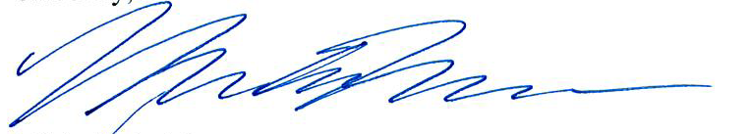

Michelle A. Moorman
Manager Regulatory Affairs

