Exhibit No.:
Issues: Capacity Release and Hedging

Witness: David M. Sommerer
Sponsoring Party: MoPSC Staff
Type of Exhibit: Direct Testimony
Case Nos.: GR-2001-382, GR-2000-425,
GR-99-304 and GR-98-167
(Consolidated)

Date Testimony Prepared: January 15, 2003

MISSOURI PUBLIC SERVICE COMMISSION

UTILITY SERVICES DIVISION

DIRECT TESTIMONY

OF

DAVID M. SOMMERER

MISSOURI GAS ENERGY

CASE NOS. GR-2001-382, GR-2000-425,
GR-99-304 AND GR-98-167
(CONSOLIDATED)

Jefferson City, Missouri
January 2003
**Denotes Highly Confidential Information** NP
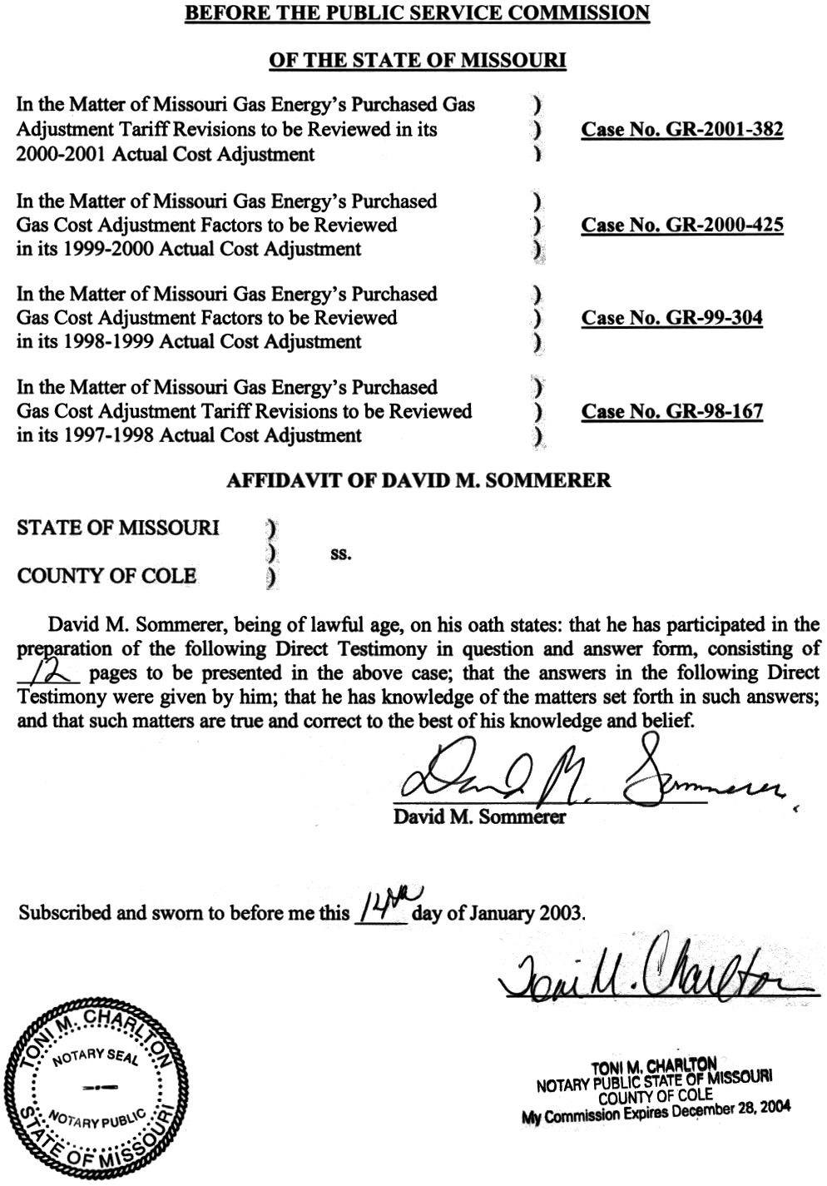

TABLE OF CONTENTS
DIRECT TESTIMONY OF
DAVID M. SOMMERER

CASE NOS. GR-2001-382, GR-2000-425,

GR-99-304 AND GR-98-167

(CONSOLIDATED)

Capacity Release 4
History of Hedging in Missouri 6
Purchasing Practices 11

DIRECT TESTIMONY

OF

DAVID M. SOMMERER

MISSOURI GAS ENERGY

CASE NOS. GR-2001-382, GR-2000-425,

GR-99-304 AND GR-98-167

(CONSOLIDATED)

Please state your name and business address.
David M. Sommerer, P.O. Box 360, Jefferson City, Mo. 65102.
By whom are you employed and in what capacity?
I am the Manager of the Procurement Analysis Department with the Missouri Public Service Commission.

Please describe your educational background.
In May 1983, I received a Bachelor of Science degree in Business and Administration with a major in Accounting from Southern Illinois University at Carbondale, Illinois. In May 1984, I received a Master of Accountancy degree from the same university. Also, in May 1984, I sat for and passed the Uniform Certified Public Accountants examination. I am currently a licensed CPA in Missouri. Upon graduation, I accepted employment with the Commission.
What has been the nature of your duties while in the employ of the Commission?
From 1984 to 1990 I assisted with audits and examinations of the books and records of public utilities operating within the State of Missouri. In 1988 the responsibility for conducting the Actual Cost Adjustment (ACA) audits of natural gas utilities was given to the Accounting Department. I assumed responsibility for planning and implementing these audits and trained available Staff on the requirements and conduct of the audits. I participated in most of the ACA audits from early 1988 to early 1990. On November 1, 1990, I transferred to the Commission’s Energy Department. Until November of 1993, my duties consisted of reviews of various tariff proposals by electric and gas utilities, Purchased Gas Adjustment reviews, and tariff reviews as part of a rate case. In November of 1993, I assumed my present duties of managing a newly created department called the Procurement Analysis Department. This Department was created to more fully address the emerging changes in the gas industry especially as they impacted the utilities’ recovery of gas costs. My duties have included managing the five member staff, reviewing ACA audits and recommendations, participating in the gas integrated resource planning project, serving on the gas project team, serving on the natural gas commodity price task force, and participating in matters relating to natural gas service in the State of Missouri.
Have you previously testified before this Commission?
Yes. A list of cases and issues in which I have filed testimony is included as Schedule 1 of my testimony.
Did you make an examination and analysis of the books and records of Missouri Gas Energy (MGE or Company) in regard to matters raised in this case?
Yes. I have examined these records in the context of the issues I am addressing in this case.
What matters will you address in your testimony?
A. I will address Missouri Gas Energy’s (MGE’s) failure to release capacity on Kansas Pipeline Company (KPC). I will also discuss the history of natural gas hedging in Missouri and MGE’s specific history with regard to hedging. Finally, I provide an overview of the Staff purchasing practice disallowance.
What knowledge, skill, experience training or education do you have in these matters?
I have been assigned and testified in many of the historical price stabilization cases in Missouri. I was directly involved with the development and review of MGE’s fixed price program and have reviewed numerous ACA filings. I have also attended conferences and seminars related to the natural gas futures market and other natural gas issues.
What is the purpose of your direct testimony in this case?
I will discuss the Staff’s adjustment for MGE’s failure to post capacity release on the KPC system. I will also provide the historical background for hedging programs and MGE’s past programs. Finally, I provide an overview of the Staff purchasing practice disallowance.
Please provide an overview of the consolidated cases.
After the Staff filed its recommendation in this 2000-2001 ACA Case (Case No. GR-2001-382), this case was consolidated with Case Nos. GR-2000-425, GR-99-304 and GR-98-167 which are MGE’s 1999-2000, 1998-1999 and 1997-1998 ACA cases, respectively. Case No. GR-2001-382 has been designated the lead case number. The only issue that remains in Case Nos. GR-99-304 and GR-98-167, is the MKP/Riverside issue. Case No. GR-96-450, the 1996-1997 ACA case, also addressed the MKP/Riverside issue. Certain aspects of that case are still under court review. The Staff believes that since aspects of the MKP/Riverside issue are still under appeal, the issue should be held open in subsequent ACA periods, pending additional direction from the courts and the Commission.
In addition to the MKP/Riverside issue, Case No. GR-2000-425 has an issue regarding the Staff recommendations on MGE’s reliability report. Finally, Case No. GR-2001-382, the lead case, has the deferred MKP/Riverside issue, the purchasing practices disallowance, the capacity release adjustment, and the reliability recommendation issues.

Capacity Release
Please describe the capacity release process?
Capacity release transactions occur when the Company has idle pipeline transportation capacity that is temporarily not needed for system requirements, and it makes that capacity available to other shippers. The Federal Energy Regulatory Commission (FERC) requires that capacity release transactions be posted for bid to the relevant interstate pipeline’s electronic bulletin board unless certain conditions are met. Capacity release deals may occur on a pre-arranged basis or be auctioned to the highest bidder. The “replacement shipper” pays the interstate pipeline for the capacity. The interstate pipeline then credits the transportation invoice of MGE. These credits are made possible because MGE must pay the interstate pipeline fixed fees, called reservation charges, for firm pipeline capacity.
Please describe the Staff’s adjustment for capacity release.
MGE has a fixed amount of capacity on KPC for each month of the year. MGE pays reservation charges to reserve this level of capacity and pays these charges each month of the year regardless of whether MGE uses the capacity. The Staff reviewed several years of MGE’s operating experience on this pipeline. Starting in the summer of 1998, MGE no longer transported any gas over KPC for the months of April through October. The Staff would have expected MGE to post this capacity for release on KPC’s system, but MGE did not even make an attempt to release this capacity. See Schedule 2. When the Staff sought an explanation of why such a release had not been posted, MGE indicated that the economics on KPC’s system did not support such a release. See Schedule 3. To enhance marketability of the KPC capacity, MGE could have enhanced the value of such a release by issuing the release on a non-recallable basis. If the KPC system’s economics still did not support such a transaction, MGE should have evaluated the alternative of a non-recallable release on the Williams Pipeline system and then sourced replacement gas on KPC.
How did Staff calculate the adjustment to account for MGE’s failure to release capacity on KPC?
The Staff evaluated release rates on Williams pipeline. The Staff used Williams’ pipeline’s capacity release data for the review of release rates since this information was readily available to staff and contained numerous capacity release transactions. These release rates were almost entirely based upon recallable capacity. Recallable capacity indicates that “strings are attached” to the capacity so that the capacity can be “re-called” at the option of the releasing shipper. This reduces the value of such capacity. The Staff’s adjustment assumes a release of the KPC capacity from April through October at 75% of the maximum Williams’ FERC rate. This discount to maximum FERC rates reflects the fact that the capacity would have greater value than a non-recallable release but also recognizes that a replacement shipper would not likely pay 100% maximum FERC rates for release capacity. Given the scarcity of non-recallable releases, an estimate of the value of this type of capacity was required. The discount of 25% reflects the fact that the capacity is not available for an entire year.
Are there other considerations that you reviewed related to this adjustment?
Yes. MGE was under an incentive sharing mechanism related to capacity release for this ACA period. For most of the period, MGE was allowed to keep 30% of capacity release credits that exceed $900,000. The Staff has amended its recommended disallowance to reflect the fact that MGE would have shared in some of the KPC release credits. See Schedule 4.

History of Hedging in Missouri
Please provide a background on hedging practices in Missouri for LDCs?
Most Missouri LDCs have access to natural gas storage either through lease type arrangements with interstate pipelines or through locally owned storage. One of the positive aspects of storage is that injections usually occur in the summer months when natural gas prices tend to be lower. If storage is filled prior to the winter heating season, an LDC knows in advance what the cost of that portion of its gas supply will be since the gas has already been purchased. Thus, the cost of this gas will be fixed heading into the heating season. The utility can also put in place fixed price contracts and futures and other derivatives prior to the heating season to reduce the price uncertainty associate with volumes to be required during the heating season.
Accordingly, many Missouri LDCs have also used fixed price contracts for many years. These fixed price contracts were primarily used to simply obtain some diversification in its contract mix and not rely totally on “index pricing.” At the time, not much review was conducted on how much of the total expected purchases should be covered by fixed price contracts. Yet, it was generally understood that it was reasonable to consider including some level of fixed price contracts in the contract mix.
Please describe the meaning of the term “index pricing?”
Index pricing generally refers to tying a natural gas contract’s pricing provision to a published index. This index can be developed on a monthly or daily period and is intended to reflect a survey of actual market prices on a particular interstate pipeline system. Index pricing was one of the predominant forms of pricing in the 1990s.
What specific hedging practices did Missouri LDCs employ in the 1990s?
Besides storage and fixed pricing, some Missouri LDCs participated in the use of financial instruments.
Please explain the meaning of the term “financial instrument.”
As used in this context, the term means futures contracts, options contracts, and other similar derivatives that help mitigate natural gas price volatility. AmerenUE was one of the first Missouri LDCs to use these types of instruments in the early to mid 1990s as part of an experimental program to learn about the effects of financial instruments on natural gas procurement costs. Other large LDCs (MGE and Laclede) participated in programs of a similar nature after the difficult winter of 1996-1997.
What happened in the winter of 1996-1997?
Natural gas prices more than doubled compared to historical levels based upon spikes in monthly price indexes. Many customer complaints arose as LDCs’ monthly Purchased Gas Adjustment (PGA) quickly reflected the underlying volatile prices in the wholesale price of gas. Calls for investigations into the wholesale markets abounded, as well as for a change in the PGA process. As a result of this intense outcry for change, an agreement was crafted that put strict limits on the number of PGA filings allowed per year. Often, this meant a reduction from over 12 PGA changes per year to two. In addition, these agreements developed criteria that were adopted by the largest LDCs to use financial instruments as a tool for hedging gas costs.
Please explain the basic parameters of these programs.
The programs generally related to the use of financial instruments to cap the price of natural gas for a certain portion of the Company’s gas supply. A discrete level of funding was determined for each LDC in order to acquire the instruments. Finally, broad discretion was provided in terms of how and when the instruments were acquired.
When were these programs first implemented?
The programs were first implemented for the winter of 1997-1998. The programs were implemented by Missouri’s three largest LDCs: Laclede Gas Company, AmerenUE and MGE.
What was the experience under these price stabilization programs?
After the winter of 1996-1997, gas prices tended to stabilize. Although there were no significant realized gains from the programs, there was significant price protection reflecting the nature of the stabilization programs, which were generally analogous to an insurance policy. After the first two years of implementation, the three largest Missouri LDCs then tended to take different courses with respect to these programs. AmerenUE chose not to renew the price stabilization program after the first two years. Yet, it continued to address the price risk exposure of its customers in a variety of ways. On the other hand, Laclede developed an alternative program that contained certain incentive benchmarks and protection parameters that allowed the Company to share in gains from the program. MGE continued to request renewal of the standard financial instrument program with slight modifications to the original program.
Please give a description of the circumstances that were occurring leading up to the winter of 2000-2001?
In the spring of 2000, natural gas prices and call option prices (the prices for caps to ensure against natural gas price increases) were still relatively low. Negotiations with MGE continued regarding its fixed price commodity incentive program. During May of 2000, after more than a year of discussions, a Stipulation And Agreement in MGE Case No. GO-2000-705 was filed (Schedule 5) that required MGE to fix the commodity price of its gas if certain market conditions prevailed.
Please summarize that Stipulation And Agreement.
The major highlights of the agreement were as follows:
- MGE was required to fix the commodity cost of gas if prices on the New York Mercantile Exchange (NYMEX) reached a certain trigger.
- Sharing mechanisms and benchmarks were developed for capacity release, off-system sales, and pipeline discounts.
- The existing parameters of MGE’s price stabilization program were kept in place until September 30, 2000.
- Prudence reviews were addressed in the agreement.
Please continue with your description of events during the summer of 2000?
Prices increased from their levels in the spring during the summer of 2000. By June 1, 2000, natural gas prices had moved from $2.25 historical levels to an unprecedented $4.00. MGE’s fixed price commodity incentive program was not approved until August of 2000. During July of 2000, the Staff organized a workshop to discuss the dramatic increase in prices.
Had the Staff given any warnings about the risks of relying too heavily on index based or spot market pricing prior to the summer of 2000?
Yes. A Commission roundtable was held in May of 1997, discussing the problem of high natural gas price volatility in the markets. This roundtable was held at the same time efforts were underway to reform the PGA process. In June of 1997 the Staff filed a recommendation in Case No. GR-96-78 recommending that MGE not rely too heavily on index pricing (Schedule 6). Also in June of 1997, the Staff filed testimony in MGE Case No. GO-97-409 warning that indexed based contract contained no real cap against spot market prices and that fixed priced contracts should be considered (Schedule 7). On September 24, 1999, a Staff recommendation criticized MGE for its late filing to extend its price stabilization program and reaffirmed that MGE already had authority to hedge gas costs without prior Commission authorization (Schedule 8).
What events took place later in the late summer and fall of 2000?
In late September 2000, MGE requested various modifications to its price stabilization program (Schedule 9). The Staff opposed this request, advising the Commission that MGE already had existing authority to hedge its gas costs. The Staff recommended that MGE be advised to take appropriate steps to review hedging without pre-approval. The Commission affirmed that concept in October 2001 (Schedule 10).
Did MGE recognize that its own management was responsible and would be held accountable for the Company’s approach to hedging natural gas costs?
Yes. In a letter to then-Chair Lumpe, MGE’s president, Steven Cattron, reassured the Commission that MGE recognized its management responsibility with regard to hedging gas costs. That letter, excluding attachment, is provided as Schedule 11.

Purchasing Practices
Please provide an overview of the Staff’s disallowance related to MGE purchasing practices.
The Staff reviewed the natural gas hedging plans in place for Missouri LDCs. It also reviewed the actual practice of Missouri LDCs and the various tools available to address natural gas price volatility. The Staff issued an RFP to obtain assistance in its evaluation of Missouri LDC hedging practices. It is the Staff’s policy that if an LDC did not have a reasonable plan in place to address price volatility for the winter of 2000-2001 and did not meet an absolute minimum of 30% hedging for each month of the heating season (either through storage or fixed prices) a disallowance would be quantified. As discussed by Staff witnesses John Herbert and Lesa Jenkins, 30% represented an achievable minimum even for LDCs relatively new to the concept of hedging.
The vast majority of Staff’s proposed disallowance is associated with MGE’s planned and actual use of storage. Although storage can be used to mitigate price volatility, its planned and actual use early in the heating season can have a dramatic effect on how much storage remains to meet a portion of future monthly natural gas demands later in the heating season. In order to serve as an effective hedge, storage must be used prudently throughout the heating season. In particular, if significant levels of storage have been used by December, little may be left to meet a portion of monthly natural gas demands and dampen natural gas price volatility later in the heating season. MGE’s planned and actual operation of storage for heating season 2000/2001 in combination created significant price risk exposure for its customers. Staff witness Lesa Jenkins addresses MGE’s use of storage in her testimony.
Does this conclude your direct testimony?
Yes.
LISTING OF CASES IN WHICH TESTIMONY WAS FILED

DAVID M. SOMMERER

COMPANY ISSUES CASE NO.

Missouri-American Water Co. Payroll WR-85-16
Great River Gas Company Payroll, Working Capital GR-85-136
Grand River Mutual Telephone Cash Working Capital TR-85-242
Associated Natural Gas Company Revenues, Gas Cost GR-86-86
Empire District Electric Company Revenues WR-86-151
Grand River Mutual Tel. Company Plant, Revenues TR-87-25
Great River Gas Company Lease application GM-87-65
KPL Gas Service Company ACA gas costs GR-89-48
KPL Gas Service Company ACA gas costs GR-90-16
KPL Gas Service Company Service line replacement GR-90-50
Associated Natural Gas Company Payroll GR-90-152
United Cities Gas Company PGA tariff GR-90-233
United Cities Gas Company PGA tariff GR-91-249
Laclede Gas Company PGA tariff GR-92-165
United Cities Gas Company PGA tariff, billing adjustments GR-93-47
Western Resources Inc. PGA tariff, billing adjustments GR-93-240
Union Electric Company ACA gas costs GR-93-106
Missouri Public Service Cost of Gas GA-95-216
Missouri Gas Energy Incentive Plan GO-94-318
Missouri Gas Energy PGA Clause GO-97-409
United Cities Gas Company PGA Clause GO-97-410
Missouri Gas Energy ACA Gas Costs GR-96-450
Missouri Gas Energy Complaint Gas Costs GC-98-335
COMPANY ISSUES CASE NO.
Laclede Gas Company Price Stabilization GO-98-484
Laclede Gas Company PGA clause GR-98-374
Laclede Gas Company Complaint PGA GC-99-121
Laclede Gas Company Incentive Plan GT-99-303
Laclede Gas Company ACA Gas Cost GR-98-297
Laclede Gas Company Incentive plan GT-2001-329
Laclede Gas Company Price Stabilization GO-2000-394
Laclede Gas Company Inventory, Off-System sales GR-2001-629
Laclede Gas Company Inventory, Off-System sales GR-2002-356
Laclede Gas Company ACA Price Stabilization GR-2001-387

Laclede Gas Company Low-Income Program GT-2003-0117
SCHEDULE 4

IS DEEMED

HIGHLY CONFIDENTIAL

IN ITS ENTIRETY

