Exhibit No.:
Issues: Rate Design

Witness: Janice Pyatte
Sponsoring Party: MO PSC Staff
Type of Exhibit: Surrebuttal Testimony
Case No.: ER-2004-0570
Date Testimony Prepared: November 24, 2004

MISSOURI PUBLIC SERVICE COMMISSION

UTILITY OPERATIONS DIVISION

SURREBUTTAL TESTIMONY

OF

JANICE PYATTE

THE EMPIRE DISTRICT ELECTRIC COMPANY

CASE NO. ER-2004-0570

Jefferson City, Missouri
November 2004
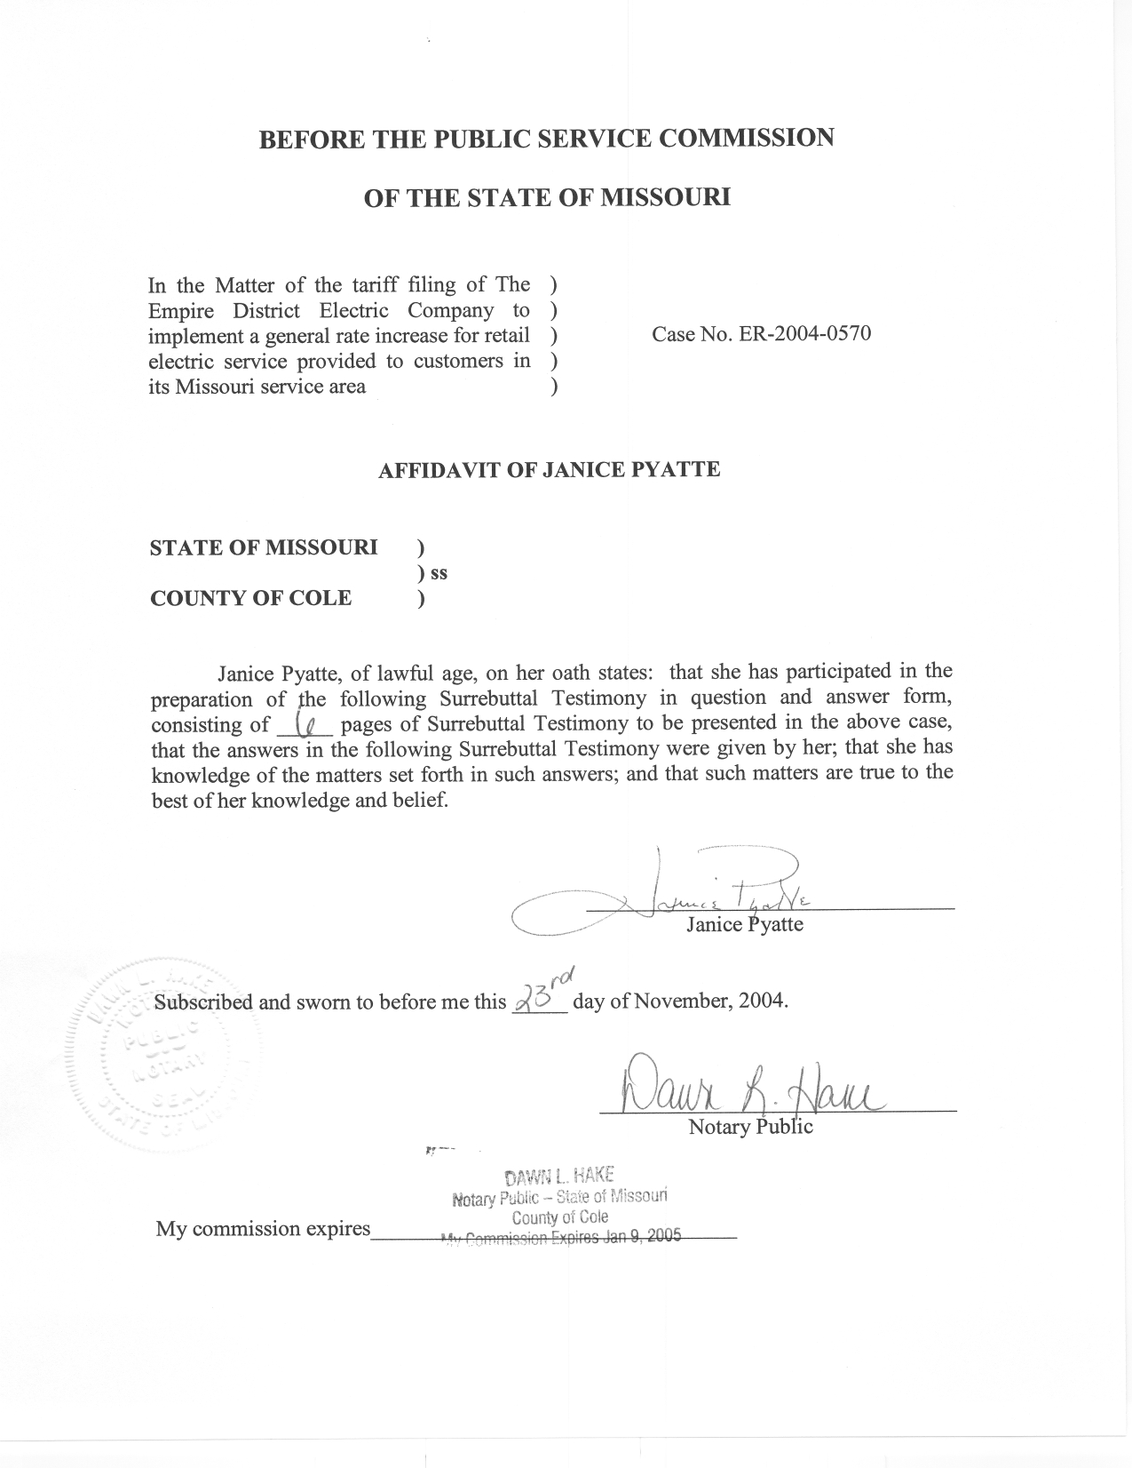

SURREBUTTAL TESTIMONY

OF

JANICE PYATTE

THE EMPIRE DISTRICT ELECTRIC COMPANY

CASE NO. ER-2004-0570

Q. Please state your name and business address.
A. My name is Janice Pyatte and my business address is Missouri Public Service Commission, P. O. Box 360, Jefferson City, Missouri 65102.
Q. Are you the same Janice Pyatte who previously filed prepared direct and rebuttal testimony in this case?
A. Yes, I am. I filed direct testimony on the issue of Revenues on September 20, 2004, direct testimony on the issue of Rate Design on October 4, 2004, and rebuttal testimony on the issue of Rate Design on November 4, 2004.
Q. What is the purpose of your surrebuttal testimony?
A. My surrebuttal testimony responds to the rebuttal testimony of The Empire District Electric Company (“EDE”) witness William G. Eichman.
Q. Please briefly describe the issue being addressed in your surrebuttal testimony?
A. The issue being addressed is: What is the appropriate ratemaking treatment of customers receiving service at a non-standard voltage level?
The origin of this issue is the two new Explorer Pipeline Company (“Explorer”) accounts that were added to EDE’s service territory during the test year. Both accounts have opted to be served at a transmission voltage level. However, rather than choose service under the Special Transmission (“ST”) rate schedule, both accounts have opted to be served on the Large Power (“LP”) rate schedule, which currently does not provide a discount for service at higher-than-primary voltage levels.
Q. What is the Explorer/Praxair position on this issue?
A. In his direct rate design testimony, Explorer/Praxair witness Maurice Brubaker proposed that the Large Power rate schedule be modified to accommodate the two Explorer accounts that take service at a transmission voltage level. His proposed modification was that Explorer be provided with a $1.50 per-kW-per-month discount to the LP demand charge that accounts for “...the fact that it [Explorer] allows Empire to avoid distribution system costs...” [page 10, lines 15-16].
Q. What is the Staff position on this issue?
A. My rebuttal testimony to Mr. Brubaker explained in considerable detail how EDE’s existing rate structure uses discounts and adders to account for providing service to customers at non-standard voltage levels. I recommended that the LP rate schedule be modified so that Explorer and similarly situated customers would be provided a 30 cents-per-kW-per-month discount plus a 0.35% adjustment to metered units to account for substation losses. I also recommended that the level of the discount for transmission service on a primary rate schedule should be equivalent, in absolute value, to the level of the adder for primary service on a transmission rate schedule, even in the situation where the Commission was to adopt Mr. Brubaker’s $1.50 recommendation.
Q. What is EDE’s position on modifying the LP rate schedule to provide a discount for Explorer?
A. In his rebuttal testimony, Mr. Eichman argues that a discount for Explorer and similarly situated customers on the LP rate schedule is warranted.
Q. Did Mr. Eichman propose a specific cents-per-kW amount for the discount to Explorer?
A. He stated that the specific amount cannot be calculated until the overall revenue requirement from this case is known.
Q. Did Mr. Eichman propose a methodology to be used to calculate the discount to Explorer?
A. Mr. Eichman stated that Mr. Brubaker’s approach to determine a demand-based distribution credit for Explorer that recognizes “...the avoided distribution investment and associated O&M costs...” [page 3, lines 10-11] [emphasis added] is the correct one.
Q. Do you agree that the approach advocated by Mr. Eichman and Mr. Brubaker is the proper methodology?
A. It is Staff’s contention that the level of the discount should have been computed based upon replacement cost, rather than embedded cost, because replacement cost more closely represents the cost that EDE “avoids”. This is true whether the service is provided by “old” or “new” equipment since, in the event that the particular equipment in question ceases to function, the Company is obligated to replace it at no additional cost to the customer.
Q. What alternative methodology did Mr. Eichman describe?
A. Mr. Eichman contrasts Mr. Brubaker’s “correct” methodology with the “direct assignment” methodology (examining the depreciated cost of a specific substation) that was used in 1995 to determine the amount of the existing adder to the Special Transmission rate schedule.
Q. What is your response to Mr. Eichman’s claim that the existing adder to the ST rate schedule was calculated using a direct assignment methodology in 1995?
A. Although I was not personally involved in this issue in 1995 and was unaware of the details, I have no reason to doubt Mr. Eichman’s account of the origin of this charge. I agree with Mr. Eichman that the direct assignment methodology, using embedded cost, is inappropriate.
Q. Why is the origin of the existing adder to the Special Transmission Service-Schedule ST and Special Transmission Service Contract: Praxair-Schedule SC-P (“ST-P”) rate schedules significant to this discussion?
A. The significance of the origin of the existing adder, which assumes that each customer provides its own transmission-to-primary transformation equipment, is that it represents the amount that Praxair is currently paying to compensate EDE for providing that equipment. Since it is Staff’s contention that the only legitimate reason why the amount of the discount on the LP rate schedule should differ from the amount of the adder on the SC-P rate schedule is to reflect the difference in the assumed metering voltage, I believe that the “Explorer issue” is also a “Praxair issue”.
Q. Please summarize why the ratemaking treatment of the Explorer situation is inextricably connected to the ratemaking treatment of Praxair.
A. Explorer Pipeline Company is priced on a rate schedule (Large Power) that assumes that EDE provides transmission-to-primary transformation equipment. Explorer has chosen to provide its own transmission-to-primary transformation equipment.
Praxair Inc. is priced on a rate schedule (Special Transmission-Praxair) that assumes that the customer provides its own transmission-to-primary transformation equipment. Praxair has chosen not to provide its own equipment, but instead to have the Company own this equipment.
The transmission-to-primary transformation equipment provides the same service in both situations, and the credit to a customer providing its own equipment should be equal to the charge a customer pays for not providing its own equipment.
Q. Does Mr. Eichman’s rebuttal testimony connect the Explorer situation with the Praxair situation?
A. Only indirectly. In his criticism of Staff, Mr. Eichman argues that the level of the discount for transmission service on a primary rate schedule (the Explorer situation) should not be “pegged” to the amount of the adder for primary service on a transmission rate schedule (the Praxair situation) because the existing 30 cents-per-kW adder was computed using a direct assignment methodology that Mr. Eichman (and Staff) rejects. What Mr. Eichman fails to acknowledge is that, if the Commission were to adopt his “correct” methodology for valuing transmission-to-primary transformation services for Explorer Pipeline Co., the Commission must also conclude that the current charge for providing transmission-to-primary transformation services to Praxair is too low.
Q. Please describe the Company’s second criticism of Staff’s proposal for ratemaking treatment of customers receiving service on a non-standard voltage level.
A. Mr. Eichman’s second criticism of Staff’s proposal is that the costs of ancillary distribution facilities, as well a substation costs, needs to be included in the computation of the Explorer discount to the LP rate schedule. Presumably he is referring to primary lines.
Q. What is your response to this criticism?
A. The Company’s primary voltage system is a series of substations and primary lines that are located throughout its service territory in such a way as to provide service to all customers collectively at the overall least cost. From a pricing perspective, whether an individual customer is served directly off a substation or through primary lines or some combination of each is irrelevant because all customers receive the same primary service from the Company. It would be incorrect to charge one customer more or less than another based upon physical proximity to a substation.
Q. What is Staff’s recommendation to the Commission regarding this issue?
A. Staff recommends that the Commission set a discount level for transmission service on a primary rate schedule that is equivalent, in absolute value, to the level of the adder for primary service on a transmission rate schedule and which is based on the replacement cost of the equipment.
Q. Does this conclude your surrebuttal testimony?
A. Yes, it does.

