Exhibit No.:
Issues: Other Telephone
Specific Issues

Witness: Michael S. Scheperle
Sponsoring Party: Mo PSC Staff
Type of Exhibit: Additional Rebuttal
Testimony
Case No.: TC-2002-1077
Date Testimony Prepared: October 9, 2003

MISSOURI PUBLIC SERVICE COMMISSION

Utility Operations DIVISION

additional Rebuttal Testimony

OF

Michael S. Scheperle

BPS Telephone Company Et. Al.

CASE NO. TC-2002-1077

Jefferson City, Missouri
October 2003

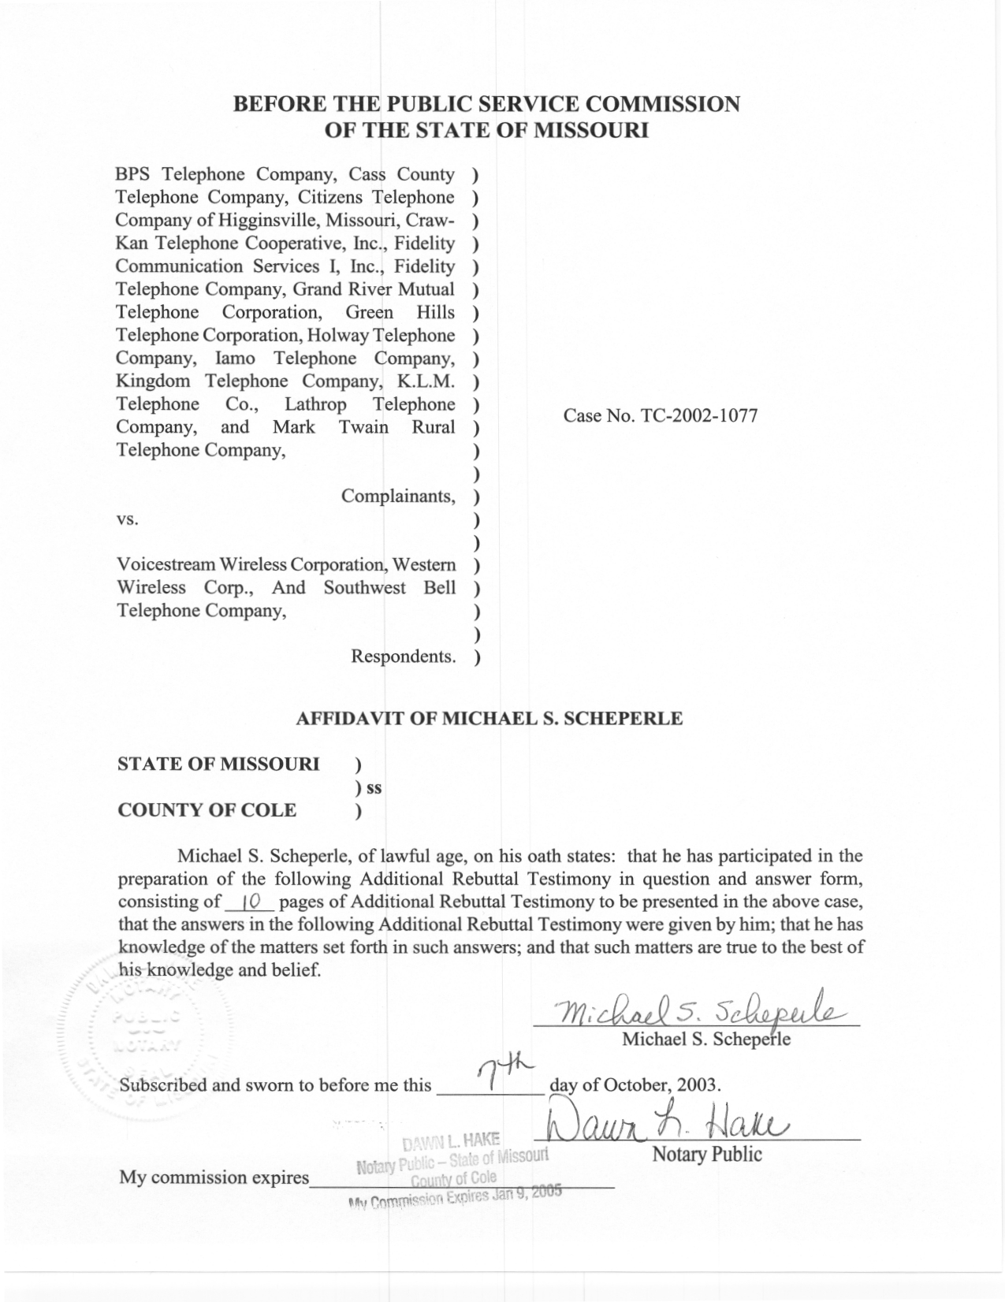

TABLE OF CONTENTS
REOPENED RECORD 1
PURPOSE OF ADDITIONAL REBUTTAL TESTIMONY 2
HAVE VOICESTREAM AND WESTERN AND COMPLAINANTS’ AGREED TO INTERMTA FACTORS? 2
STAFF’S UNDERSTANDING OF WHAT WOULD BE REQUIRED TO ASCERTAIN A PERCENTAGE OF TRAFFIC THAT IS INTERMTA 3
PREVIOUS REBUTTAL TESTIMONY 8
SUMMARY 9

ADDITIONAL REBUTTAL TESTIMONY
OF
MICHAEL S. SCHEPERLE

CASE NO. TC-2002-1077

- Please state your name, employer and business address.
A. My name is Michael S. Scheperle and I am employed in the Telecommunications Department Staff (“Staff”) of the Missouri Public Service Commission (“Commission”). My business address is Post Office Box 360, Governor Office Building, Suite 500, 200 Madison Street, Jefferson City, Missouri 65102-0360.
Q. Are you the same Michael S. Scheperle who filed Rebuttal Testimony in this case on behalf of Staff?
A. Yes, I am. I filed Rebuttal Testimony on September 23, 2002.

REOPENED RECORD

Q. Why was the record reopened?
A. By Commission Order dated May 5, 2003, the Commission reopened the record for purposes of receiving additional evidence concerning the proportion of wireless-originated traffic that is interMTA and the proportion that is intraMTA. Also, the Commission Order noted that in the event that the parties are unable to adduce this evidence in any other way, the Commission will require that they cooperate in the performance of a traffic study or studies. Since the Commission Order of May 5, 2003, the Complainants (14 LECs, listing on Staff Rebuttal Testimony, Schedule 1) VoiceStream Wireless Corporation (“VoiceStream”) and Western Wireless Corporation (“Western”) have filed direct testimony.

PURPOSE OF ADDITIONAL REBUTTAL TESTIMONY

Q. What is the purpose of your Additional Rebuttal Testimony in this case?
A. The purpose of Staff’s Additional Rebuttal Testimony is to respond to the Direct Testimonies of Robert Schoonmaker representing the Complainants and Ronald Williams representing VoiceStream and Western as follows:
- Have VoiceStream and Western and Complainants agreed to interMTA factors?
- Explaining Staff’s understanding of what would be required to ascertain a percentage of traffic that is interMTA.

HAVE VOICESTREAM AND WESTERN AND COMPLAINANTS’ AGREED TO INTERMTA FACTORS?

Q. Have VoiceStream and Complainants negotiated interMTA factors?
A. Yes. Mr. Schoonmaker submits Direct Testimony that VoiceStream and Complainants have negotiated interMTA factors (discussion of interMTA versus intraMTA will follow) to identify the portion of total traffic terminating to them that would be identified and billed as interMTA traffic under the Complainants’ access tariffs. The negotiated interMTA factors for VoiceStream and the Complainants are included in Schedule RCS-3 attached to Mr. Schoonmaker’s Direct Testimony and also filed in the non-unanimous stipulation filed July 11, 2003. Staff supports the concept of these parties agreeing to interMTA factors.
Q. Have Western and Complainants negotiated interMTA factors?
A. At this time, it appears that Western and Complainants have not agreed on any interMTA factors. Neither, Mr. Williams or Mr. Schoonmaker, in their Direct Testimony, discuss interMTA factors agreed to between Western and Complainants.

STAFF’S UNDERSTANDING OF WHAT WOULD BE REQUIRED TO ASCERTAIN A PERCENTAGE OF TRAFFIC THAT IS INTERMTA

Q. Why is the jurisdiction of the wireless-originated traffic important?
A. Wireless-originated traffic, at issue in this case, originates and terminates either within the same Major Trading Area (“MTA”) (i.e., intraMTA traffic) or between various MTAs (i.e., interMTA traffic). Wireless-originated interMTA calls are subject to access charges, just like all long distance calls, while wireless-originated intraMTA calls are considered local calls and subject to the respective Complainant’s Wireless Termination Tariff rate absent an interconnection agreement between the wireless provider and the Complainants.
Q. Can the jurisdiction of the wireless-originated traffic be easily obtained to determine if a call is interMTA or intraMTA?
A. No. The wireless-originated traffic, at issue in this case, is terminated to Complainants within the LATA over trunk groups owned by Southwestern Bell Telephone Company (“SWBT”). At this point in time, none of the carriers, the wireless carriers (VoiceStream or Western), the transiting carrier (SWBT) or the Complainants, create records to know the jurisdiction (interMTA or intraMTA) of the calls. Currently, Commercial Mobile Radio Service (CMRS) provider switches are not capable of determining the cell site MTA location and placing this information in any kind of call detail record for identifying the jurisdiction of the traffic. In his Direct Testimony, Mr. Williams (representing VoiceStream and Western) notes that wireless systems are not set up to track originating and terminating jurisdiction. Likewise, in his Direct Testimony, Mr. Schoonmaker (representing Complainants) notes that Southwestern Bell creates Cellular Transiting Usage Summary Reports (“CTUSRs”) for the wireless-originated traffic but there is no information passed to Southwestern Bell to identify the location where the wireless call originates and therefore, whether the traffic is interMTA or intraMTA.
Q. How do carriers solve this jurisdictional situation?
A. In the past, to solve this situation, wireless carriers and Local Exchange Carriers (“LECs”) negotiated interMTA factors in interconnection agreements. Staff supports the concept that interMTA factors be negotiated and agreed to by the originator of the traffic (VoiceStream or Western) and the respective individual Complainant.
Q. What is Staff’s recommendation concerning the jurisdiction of the traffic?
A. As the Commission noted in reopening the record, in the event the parties are unable to adduce evidence concerning the proportion of the traffic at issue that is interMTA or intraMTA traffic, the Commission will require that the parties cooperate in the performance of a traffic study or studies. Therefore, Staff recommends the Commission order the following information be supplied to all parties for any wireless carrier and LEC that cannot negotiate and agree to an interMTA factor.
- That the wireless carrier provide a listing of all cell sites outlining the county of the cell site with a map showing the wireless company service area and cell site locations which are used to serve Missouri customers.
- That the wireless carrier provide an explanation of how the wireless cell sites route traffic to the Mobile Switching Center (“MSC”) of the wireless carrier.
- That the wireless carrier provide information on how each MSC routes traffic to Southwestern Bell switches that are transited to the network of the terminating LEC.
- That the wireless carrier identify the IXC where the wireless carrier may route certain interLATA traffic detailing the number of calls and terminating minutes of use by that IXC for calls terminated to the LEC.
- That the LEC provide a detailed listing of the exchanges served by LECs outlining the LATA, MTA and the number of access lines in each exchange.
Q. Please state why Staff believes that its five-point recommendation will help in developing an interMTA factor should a wireless carrier and a LEC not agree to an interMTA factor.
A. Staff’s first recommendation is that the wireless carrier provide a listing of all cell sites outlining the county of the cell site with a map showing the wireless company service area and cell site locations, which are used to serve Missouri customers. This is to understand the wireless company’s service territory and cell sites in relation to the four LATA boundaries in Missouri as well as the four MTAs in the state. (See Schedule 1 for map of LATAs and MTAs in Missouri). Specifically, MTA boundaries follow county lines and Staff wants to identify the MTA area of each cell site.
Staff’s second recommendation is that the wireless carrier provide an explanation of how the wireless cell sites route traffic to the MSCs of the wireless carrier. Staff seeks this information to understand the routing of wireless calls from the cell sites to the MSCs and whether the MSC is in the same MTA as the cell site. Some wireless carriers have multiple MSCs because cell sites are in different MTAs.
Staff’s third recommendation is that the wireless carrier provide information on how each MSC routes traffic to Southwestern Bell switches that are transited to the network of the terminating LEC. In combining recommendation two and three, Staff seeks an understanding of how a wireless-originated call is routed to a cell site; to a MSC; to a Southwestern Bell tandem switch or end office; and, to a terminating LEC. This information will allow Staff to fully understand all switching and routing of the calls.
Staff’s fourth recommendation is that the wireless carrier identify the IXC where the wireless carrier may route certain interLATA traffic, detailing the number of calls and terminating minutes of use by that IXC for calls terminated to the LEC. There is a concern that certain wireless traffic may route to a different LATA through MSC wireless switches and not routed by an IXC carrier, thereby potentially disguising interMTA traffic as intraMTA traffic. This would allow a wireless carrier to potentially pay a lower intraMTA rate than the access rate. Mr. Schoonmaker notes that in discussions with wireless carriers, wireless carriers have indicated that the traffic is switched to IXCs to carry and deliver across LATA boundaries. If this is the case, Staff supports this scenario, however, Staff seeks this assurance through this fourth recommendation.
Staff’s fifth recommendation is that the LEC provide a detailed listing of the exchanges served by LECs outlining the LATA, MTA and the number of access lines in each exchange. A LEC’s service territory may involve different LATAs and different MTA area(s) with the possibility that a certain exchange may be in two MTAs. For example, Grand River Mutual Telephone Corporation (a Complainant) has 32 exchanges all served by the Kansas City 524 LATA, 25 exchanges are in the Kansas City MTA, one exchange is in the St. Louis MTA and six exchanges have access lines in both the St. Louis MTA and Kansas City MTA. This scenario happens because LATA boundaries are exchange specific and MTA boundaries are county specific.
Q. Does Staff believe that a wireless carrier and the Complainants should be able to negotiate and agree to interMTA factors from this information?
A. Yes. Staff believes that this information should be helpful for development of an interMTA factor to be agreed to by a wireless carrier and the Complainants. If the parties cannot agree to an interMTA factor, then Staff will have information available for development of an interMTA factor.
Q. Mr. Scheperle, do you think a traffic study is sufficient to determine the jurisdiction of the wireless-originated traffic?
A. No. A traffic study, in and of itself, lets a company know the originating and terminating detail information of each call. However, the concern is that a wireless-originated call may originate from many locations and the origination of the call (connects to cell site) is not currently available for analysis. Without the cell site information, the traffic study is not the complete answer to understand the jurisdiction of the traffic. Mr. Williams, representing VoiceStream and Western, alluded to this concern where he noted that whether the traffic originated or terminated within the same MTA is very difficult to account for as wireless systems are not set up to track originating and terminating jurisdiction. Mr. Schoonmaker, representing the Complainants, noted that since wireless handsets are portable, the originating number may not give a correct indication of the actual physical location of the call.
Therefore, based on Staff’s understanding, since the cell site information for the origination of a wireless call is not available, a traffic study is not helpful for identifying interMTA wireless-originated traffic as would a traffic study for wireline to wireline traffic.

PREVIOUS REBUTTAL TESTIMONY

Q. Did you file Rebuttal Testimony in this case on behalf of Staff?
A. Yes. I filed Rebuttal Testimony in September 2002. In that testimony, Staff presented five recommendations for Commission consideration due to the fact that VoiceStream and Western were not compensating the Complainants for terminating wireless-originated traffic on the Complainants’ networks. Staff’s recommendations addressed what steps could be taken if a wireless carrier fails to compensate a local exchange carrier for terminating a wireless to landline call.
Q. What were Staff’s recommendations for dealing with the situation where a wireless carrier is not compensating Complainants?
A. Staff recommended the following:
- Staff asserts the Complainants are entitled to compensation for terminating the wireless traffic from VoiceStream and Western.
- Staff asserts the Complainants’ respective wireless termination tariffs apply to this traffic.
- Staff supports the Complainants request that the wireless termination tariff provisions apply, allowing late charges and reasonable attorney fees from VoiceStream and Western.
- Staff does not agree that Southwestern Bell (transiting carrier) is secondarily liable for any unpaid amounts by VoiceStream and Western.
- Staff suggests it is appropriate for traffic to be blocked in the event of a delinquency.
Q. Does Staff still support these recommendations?
A. Yes. Staff supports its recommendations made in September 2002. Further, Staff understands that if the jurisdiction of a wireless-originated call is an interMTA call, appropriate access charges are due and not the intraMTA rate.

SUMMARY

Q. Please summarize your Additional Rebuttal Testimony.
- Staff asserts that VoiceStream and the Complainants have agreed on interMTA factors and Staff supports the concept of VoiceStream and Complainants negotiating and agreeing on interMTA factors.
- At this time, Staff asserts that there is no evidence that Western and Complainants’ have agreed on any interMTA factors. Staff recommends that Western and Complainants agree to interMTA factors or the Commission order Western and Complainants to supply information as listed below and previously outlined in Staff’s five point recommendation.
- That the wireless carrier provide a listing of all cell sites outlining the county of the cell site with a map showing the wireless company service area and cell site locations which are used to serve Missouri customers.
- That the wireless carrier provide an explanation of how the wireless cell sites route traffic to the MSC of the wireless carrier.
- That the wireless carrier provide information on how each MSC routes traffic to Southwestern Bell switches that are transited to the network of the terminating LEC.
- That the wireless carrier identify the IXC where the wireless carrier may route certain interLATA traffic detailing the number of calls and terminating minutes of use by that IXC for calls terminated to the LEC.
- That the LEC provide a detailed listing of the exchanges served by LECs outlining the LATA, MTA and the number of access lines in each exchange.
Q. Does this conclude your Additional Rebuttal Testimony?
A. Yes, it does.

