Commissioners

STEVE GAW

Chair

CONNIE MURRAY

ROBERT M. CLAYTON III

JEFF DAVIS

LINWARD “LIN” APPLING

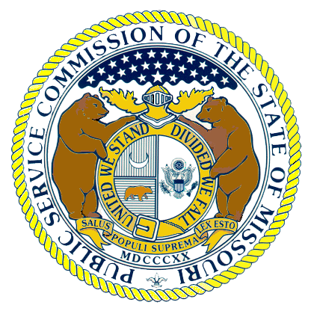

Missouri Public Service Commission

POST OFFICE BOX 360
JEFFERSON CITY MISSOURI 65102
573-751-3234
573-751-1847 (Fax Number)
http://www.psc.mo.gov

December 7, 2004

ROBERT J. QUINN, JR.

Executive Director

WESS A. HENDERSON

Director, Utility Operations

ROBERT SCHALLENBERG

Director, Utility Services

DALE HARDY ROBERTS

Secretary/Chief Regulatory Law Judge

DANA K. JOYCE

General Counsel

Judge Dale Hardy Roberts
Secretary/Chief Regulatory Law Judge
Missouri Public Service Commission
P.O. Box 360
Jefferson City, Missouri 65102

RE: Case No. ER-2004-0570 Empire District Electric Company Electric Rate Increase Tariff Filing

Dear Judge Roberts:

Yesterday from the Bench, Regulatory Law Judge Kevin Thompson requested that the Staff file an updated Reconciliation and appropriate updated Accounting Schedules reflecting the revenue requirement issues for which the various parties in this case have recently reached resolution. The Staff is hereby filing the requested updated Reconciliation and updated Accounting Schedule 1 reflecting the revenue requirement issues that have been resolved. The parties are working on the language regarding a Stipulation And Agreement on these items and language regarding a Stipulation And Agreement respecting a settlement of rate design, not including the IEC rate design which is still scheduled for hearing. The parties anticipate filing these Stipulations And Agreements soon.

Very truly yours,

/s/ Steven Dottheim
Attorney for Staff of the
Missouri Public Service Commission
(573) 751-7489
(573) 751-9285 (Fax)
steve.dottheim@psc.mo.gov
SD/cs
Enclosures

cc: Regulatory Law Judge Kevin Thompson
All Counsel of Record

