Exhibit No.:
Issues: Geographic Market
Definition

Witness: Walter Cecil
Sponsoring Party: MO PSC Staff
Type of Exhibit: Rebuttal Testimony
Case No.: TO-2004-0207
Date Testimony Prepared: January 9, 2004

MISSOURI PUBLIC SERVICE COMMISSION

Utility Operations DIVISION

Rebuttal Testimony

OF

Walter Cecil

IN THE MATTER OF A COMMISSION INQUIRY INTO
THE POSSIBILITY OF IMPAIRMENT WITHOUT UNBUNDLED LOCAL CIRCUIT SWITCHING WHEN SERVING THE MASS MARKET

CASE NO. TO-2004-0207

Jefferson City, Missouri
January 9, 2004

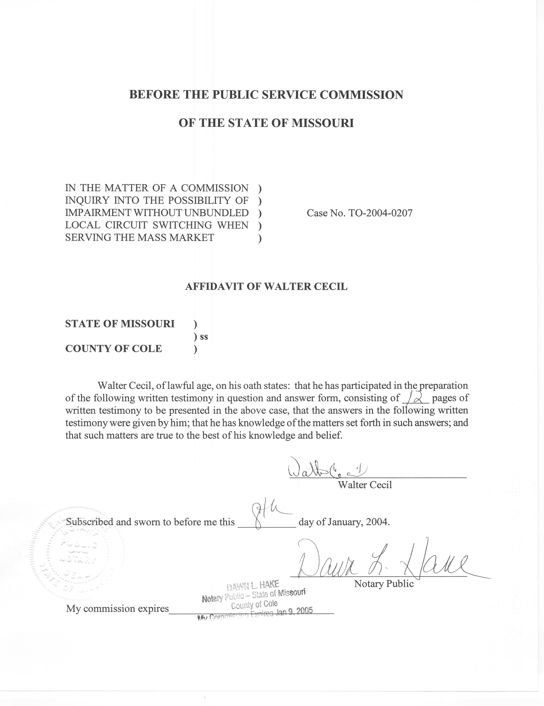
REBUTTAL TESTIMONY
OF
WALTER CECIL
CASE NO. TO-2004-0207

Q. Please state your name and give your business address.
A. My name is Walter Cecil. My business address is: Governor Office Building, Suite 500, 200 Madison St., Jefferson City, Missouri 65101.
Q. By whom and in what capacity are you employed?
A. I am employed by the Missouri Public Service Commission (Commission). I assumed the position of Regulatory Economist I with the Commission’s Telecommunications Department Staff (Staff) in 1999. I was promoted to Regulatory Economist II in March 2000.
Q. Please describe your educational background and employment history.
A. I hold an M.A. degree in Economics from the University of Kansas and a B.A. in Business Administration from Baylor University. I have held positions as an adjunct instructor of economics at William Jewell College and Longview Community College. Prior to my graduate studies, I was employed in a managerial position by a small Kansas City manufacturing firm.
Q. What are your duties at the Commission?
A. My duties include the investigation, analysis, and review of various controversial and contested telecommunications firms’ proposals, interconnection agreements, and tariffs. I have participated in cases where the Commission was called
upon to arbitrate unbundled network element terms and rates within interconnection agreements between CLECs and Southwestern Bell Telephone Company, Inc. (SBC) I also perform various research projects for the Commission which have included an analysis of the state of competition in SBC and Sprint exchanges and the economic impact of municipal ownership of cable television networks and telecommunications networks. I am also involved with Relay Missouri Advisory Committee functions.
Q. Have you previously filed testimony before the Commission?
A. Yes. I have filed testimony in Case Nos. TO-2000-374, TT-2001-347, TO-2001-455, TT-2002-108/130, TT-2002-222, and TT-2002-227.
Q. What is the purpose of your testimony?
A. Direct testimony presented by parties to this case recommended finding the appropriate geographic market for impairment analysis of local switching in the mass-market to be either wire centers or metropolitan statistical areas. My testimony will define the terms market, wire center and metropolitan statistical area and provide some background regarding the relevance of these concepts in this case. In contrast to recommendations for wire centers or metropolitan statistical areas, I will recommend the Commission use the exchange area as defined in Section 386.020(16) RSMo, 2000, as the appropriate definition for defining the appropriate geographic market. Staff witness Christopher Thomas’ testimony will further develop and offer analytical support for Staff’s proposed local exchange alternative definition.
Q. What is a market?
A. Loosely, a market is a socially defined framework through and by which economic information is produced and buyers and sellers transact with one another. In many instances, there is no fixed location wherein one may find “the” market, such as the used car market, while other markets are so formal that the buyer and seller do not directly communicate with each other but rather employ recognized intermediaries such as in the stock market.
For the purpose of this proceeding, the Federal Communications Commission (FCC) has provided the following guidance in its Triennial Review Order:
The triggers and analysis described below must be applied on a granular basis to each identifiable market. State commissions must first define the markets in which they will evaluate impairment by determining the relevant geographic area to include in each market. State commissions have discretion to determine the contours of each market, but they may not define the market as encompassing the entire state. Rather, state commissions must define each market on a granular level, and in doing so they must take into consideration the locations of customers actually being served (if any) by competitors, the variation in factors affecting competitors’ ability to serve each group of customers, and competitors’ ability to target and serve specific markets economically and efficiently using currently available technologies. While a more granular analysis is generally preferable, states should not define the market so narrowly that a competitor serving that market alone would not be able to take advantage of available scale and scope economies from serving a wider market. State commissions should consider how competitors’ ability to use self-provisioned switches or switches provided by a third-party wholesaler to serve various groups of customers varies geographically and should attempt to distinguish among markets where different findings of impairment are likely. The state commission must use the same market definitions for all of its analysis. (Emphasis added and Footnotes omitted)

Q. What is Staff’s interpretation of the guidance as presented in the preceding portion of the TRO?
A. States have the responsibility of defining the market on a granular level while considering economic and operational efficiencies. In this phase, the Commission has the task to determine the size and shape of the market so that in the next phase when the impairment analysis is conducted relevant data may be obtained and applied.
Q. What proposals are currently before this Commission to define the market?
A. In light of the FCC’s instruction, the parties are proposing the Commission define the market based on two different geographic areas. One proposal would define the market based on wire center while the other proposal defines the market based on metropolitan statistical area.
Q. Are the parties’ proposals consistent with the FCC’s order?
A. Yes. The parties’ proposals offer the Commission market defined spaces, the wire center and the metropolitan statistical area, that the Commission may reshape at will. Furthermore, both the wire center and metropolitan statistical area lend themselves to granular analysis (in terms of locations of customers, variation in factors affecting competitors’ ability to serve each group of customers and competitors’ ability to target and serve specific markets).
Q. What is a wire center?
A. A wire center is a structure where the telephone company terminates its subscriber cable plant. That is, the wires connecting the subscriber’s location to the telephone company extend from this structure and terminate at the end-users’ premises. Although there is diversity of opinion on the subject, a wire center is often referred to as a central office although the two terms are not necessarily synonymous.
Q. What is a metropolitan statistical area?
A. The metropolitan statistical area is a construct of the federal Office of Management and Budget (OMB) and is used to enable the OMB to collect statistics and data relevant to its mission. The current definition was established using standards set in December 2000:
Metropolitan Statistical Area.—A Core Based Statistical Area associated with at least one urbanized area that has a population of at least 50,000. The Metropolitan Statistical Area comprises the central county or counties containing the core, plus adjacent outlying counties having a high degree of social and economic integration with the central county as measured through commuting.
Q. Which Missouri counties are part of the St. Louis, Kansas City and Springfield metropolitan statistical areas?
A. The St. Louis metropolitan statistical area includes the City of St. Louis and the following Missouri counties: Franklin, Jefferson, Lincoln, St. Charles, St. Louis, Warren, and Washington.
The Kansas City metropolitan area includes the following counties: Bates, Caldwell, Cass, Clay, Clinton, Jackson, Lafayette, Platte, and Ray.
The Springfield metropolitan statistical area includes the following counties: Christian, Dallas, Greene, Polk and Webster.
The Kansas City and St. Louis metropolitan statistical areas also include areas in Kansas and Illinois. For a complete list of exchanges and rate centers in each of the metropolitan statistical areas, please see the Rebuttal Testimony of Staff witness Christopher Thomas, Schedule 3.
Q. Why are the parties supporting the wire center and metropolitan statistical area as definitions of the unbundled local switching market for purposes of the FCC’s Triennial Review Order?
A. The parties supporting wire centers and the parties supporting metropolitan statistical areas have both used the Department of Justice’s Horizontal Merger Guidelines to defend their respective positions supporting the adoption of wire centers and metropolitan statistical areas as the appropriate geographic definition for local telecommunications services and specifically for mass-market unbundled local switching. In applying the Horizontal Merger Guidelines definition, the parties seek to define the market by “drawing the circle” just large enough to include an acceptable substitute for the product in question at tolerable prices.
Evidently, those parties supporting the wire center definition are minimizing the geographic size of the “circle” defining the local telecommunications market for purposes of the impairment analysis. Absent plans such as extended area services and metropolitan calling area, the length of the wires extending from the wire center determines how far a local call can travel, and by virtue of being “local” may define the size of this market. However, keeping the geographic area of this market compact necessarily means that the self-provisioning and wholesale triggers are unlikely to be satisfied in every wire center and a finding of impairment for each market becomes more likely.
Those parties favoring the metropolitan statistical area definition seek to ensure the self-provisioning and wholesale provider triggers are satisfied. By using the metropolitan statistical area, the geographic “circle” defining the market becomes so large that it is likely that competitive switching will be found and unlikely that a finding of impairment could be made.
Q. Do you have any comments regarding the use of the Department of Justice’s respective rationale for using wire centers or MSAs in defining the market for this proceeding?
A. Yes. Staff has two thoughts regarding the use of the Department of Justice’s Horizontal Merger Guidelines. First, the competitive local exchange carriers (CLECs) and the incumbent local exchange carriers (ILECs) use the same section in the Horizontal Merger Guidelines to defend their differing conclusions. Second, Staff does not hold the use of the Horizontal Merger Guidelines as appropriate in this case. The Horizontal Merger Guidelines were developed as a platform to determine the effects of mergers on markets. In so doing, the guidelines define markets, in terms of products and geography, and attempt to ascertain whether or not merging firms are able or likely to exercise market power for anti-trust purposes. Section 1.2 of the Horizontal Merger Guidelines “Geographic Market Definition” is appended as Schedule WC-1.
The definition, as highlighted in Schedule WC-1, seems to imply that firms are producing products that are later made available at specific locations, such as stores, to customers who are mobile and may choose to go to other locations and seek substitute products if they find the price too high or do not like some other product characteristic. Generally speaking, the end-users appended to the triennial review impairment investigation do not have the ability to go to another store if they do not like the price. Their homes and business locations are fixed. Business and residential customers do not move across town to get a cheaper telephone rate. Telecommunications service carriers providing service over the traditional wireline network must connect their networks to the end-user’s equipment. Therefore, with respect to traditional wireline telephony, customers have no geographic mobility, so if there is competition, it must come from other service providers offering similar services who choose to enter that region. Consequently, the size of the traditional wireline market is not determined by customer mobility. Hence, the Horizontal Merger Guidelines definitions are inappropriate in this investigation.
Q. In the Staff’s view and in the context of the Triennial Review Order, is the wire center an appropriate geographic definition for unbundled local switching mass-market local telecommunications services?
A. No. If in this context, the geographic limits of the telecommunications market is found to be very small, or as in this case, the wire center, then it is more likely the Commission will find the self-provisioning and wholesale triggers unsatisfied; therefore, it will be obliged to perform studies examining potential deployment, and economic and operational barriers to entry facing CLECS (in all ILEC exchanges where unbundled local switching is or becomes an issue). If the results of such analyses are aggregated to form an area smaller than an exchange, such areas in the St. Louis, Kansas City and Springfield exchanges could be found to be markets. If this were the case, these areas, smaller than an exchange, potentially would face limited scope and scale economies available to larger markets and may require CLECs to unnecessarily replicate portions of the ILECs’ networks.
Q. Does Staff have concerns with the metropolitan statistical area definition for the local telecommunications market? If so, explain.
A. Yes. Metropolitan statistical areas encompass many wire centers and exchanges. Although one CLEC switch can conceivably serve a wider area through the use of appropriate transport and extended enhanced links, it may be likely that more rural and remote exchanges will be underserved or completely bypassed while still being technically, but not practically, part of the market. There are several ILECs in each of the metropolitan statistical areas in the State. There are also areas of the State that do not fall into any metropolitan statistical area. By defining the market as the metropolitan statistical area, for example, a finding of no impairment in the St. Louis metropolitan statistical area due to the satisfaction of either trigger or potential deployment analysis in the St. Louis exchange would necessarily impose a finding of no impairment in the Steelville exchange of Huzzah where there have been no claims of competition.
Q. It appears that Staff favors neither the wire center nor the metropolitan statistical area as the definition of the local telecommunications market for mass-market unbundled local switching. Does Staff have a recommended definition for the market in this investigation?
A. Yes. Staff recommends the Commission define the mass-market local telecommunications market for unbundled local switching based on an exchange area. The term “exchange” is defined by Section 386.020(16) RSMo, 2000: "’Exchange’, a geographical area for the administration of telecommunications services, established and described by the tariff of a telecommunications company providing basic local telecommunications service.”
Q. What is the difference between a wire center and an exchange?
A. In many instances a wire center and an exchange share the same boundary. For example, an exchange with one central office will encompass the same geographic area for either the wire center definition or the exchange definition. Prior to the advent of basic local telecommunications service competition, in situations involving one central office within an exchange the central office served all subscribers within the exchange area.
In contrast one exchange can be comprised of several wire centers. For instance in some areas such as St. Louis, Kansas City and Springfield, there is one large exchange consisting of multiple central offices each with its own outside cable plant (alternatively, a wire center). These wire centers do not span the entire exchange and do not serve all local subscribers within the exchange.
Q. Why should an exchange boundary be the appropriate geographic area for defining the market in this proceeding?
A. Staff believes this recommendation is a reasonable compromise between the two proposals set forth by the parties in this investigation. The three largest exchanges in the state, St. Louis, Kansas City, and Springfield, consist of many wire centers but are surrounded by exchanges consisting of a single wire center. By using the exchange definition, multiple wire centers in a single exchange will be served on an efficient basis while remote or smaller exchanges may be evaluated for impairment on an individual basis as the need arises. Also, by using the exchange definition, less populated and more rural exchanges and wire centers that may be practically but not technically impaired under the metropolitan statistical area definition would be considered markets and impairment or nonimpairment findings could be established individually.
Q. Please explain how the exchange definition is better than either the wire center or metropolitan statistical area definitions.

A. The exchange is a defined concept. Wire center is a concept with multiple definitions lending it to semantic confusion. As mentioned in Staff witness Christopher Thomas’ testimony, exchange is a commonly used term and is defined and applied by Missouri statues, rules and tariffs.
Staff’s concern with the wire center definition is economies of scope and scale will be less available than at either the exchange or metropolitan statistical area level for very large exchanges. Staff’s concern with the metropolitan statistical area is that small exchanges included in the metropolitan statistical area will be defined as part of the market and will be found as not impaired but are very likely to be underserved. By defining the market as an exchange, the Commission has the opportunity to examine each market on the basis of its own merits and not by virtue of the characteristics of a larger metropolitan area.
Q. How does the exchange definition comply with the FCC’s guidance for defining the market?
A. The exchange is a defined area about which parties already have much information for stand-alone practical granular analysis (in terms of locations of customers, variation in factors affecting competitors’ ability to serve each group of customers and competitors’ ability to target and serve specific markets). In more rural regions, there is one wire center per exchange while in urban areas more economies of scale and scope should be available to larger markets, such as the exchange, rather than smaller markets, wire centers. The metropolitan statistical area is sufficiently large that it is probable that activities occurring in urban and suburban areas will be imputed to occur in rural exchanges where such activities are not occurring. The exchange is sufficiently granular that such an imputation will not occur and the Commission may perform its impairment studies without urban and suburban interference.
Q. Please summarize your testimony.
A. I have discussed the parties’ use of the Horizontal Merger Guidelines definition of a market and shown why it is inappropriate. I have also discussed the parties’ respective definitions of the market for use in the impairment analysis in the successive phases of this investigation, the wire center and the metropolitan statistical area, and shown why each is deficient and shared Staff’s concerns with each definition. Finally, I have recommended an alternative definition, the exchange, and explained why it is appropriate and fulfills the FCC’s charge to the Commission.
Q. Does this conclude your testimony?
A. Yes.
Schedule WC-1
Horizontal Merger Guidelines
U.S. Department of Justice
Federal Trade Commission
Issued: April 2, 1992
Revised: April 8, 1997

1. Market Definition, Measurement and Concentration

1.2 Geographic Market Definition
For each product market in which both merging firms participate, the Agency will determine the geographic market or markets in which the firms produce or sell. A single firm may operate in a number of different geographic markets.
1.21 General Standards
Absent price discrimination, the Agency will delineate the geographic market to be a region such that a hypothetical monopolist that was the only present or future producer of the relevant product at locations in that region would profitably impose at least a "small but significant and nontransitory" increase in price, holding constant the terms of sale for all products produced elsewhere. That is, assuming that buyers likely would respond to a price increase on products produced within the tentatively identified region only by shifting to products produced at locations of production outside the region, what would happen? If those locations of production outside the region were, in the aggregate, sufficiently attractive at their existing terms of sale, an attempt to raise price would result in a reduction in sales large enough that the price increase would not prove profitable, and the tentatively identified geographic area would prove to be too narrow.
In defining the geographic market or markets affected by a merger, the Agency will begin with the location of each merging firm (or each plant of a multiplant firm) and ask what would happen if a hypothetical monopolist of the relevant product at that point imposed at least a "small but significant and nontransitory" increase in price, but the terms of sale at all other locations remained constant. If, in response to the price increase, the reduction in sales of the product at that location would be large enough that a hypothetical monopolist producing or selling the relevant product at the merging firm's location would not find it profitable to impose such an Schedule WC-1
increase in price, then the Agency will add the location from which production is the next-best substitute for production at the merging firm's location.
In considering the likely reaction of buyers to a price increase, the Agency will take into account all relevant evidence, including, but not limited to, the following:
(1) evidence that buyers have shifted or have considered shifting purchases between different geographic locations in response to relative changes in price or other competitive variables;
(2) evidence that sellers base business decisions on the prospect of buyer substitution between geographic locations in response to relative changes in price or other competitive variables;
(3) the influence of downstream competition faced by buyer in their output markets; and
(4) the timing and costs of switching suppliers.
The price increase question is then asked for a hypothetical monopolist controlling the expanded group of locations. In performing successive iterations of the price increase test, the hypothetical monopolist will be assumed to pursue maximum profits in deciding whether to raise the price at any or all of the additional locations under its control. This process will continue until a group of locations is identified such that a hypothetical monopolist over that group of locations would profitably impose at least a "small but significant and nontransitory" increase, including the price charged at a location of one of the merging firms.
The "smallest market" principle will be applied as it is in product market definition. The price for which an increase will be postulated, what constitutes a "small but significant and nontransitory" increase in price, and the substitution decisions of consumers all will be determined in the same way in which they are determined in product market definition.

Report and Order and Order on Remand and Further Notice of Proposed Rule Making, In the Matter of Review of the Section 251 Unbundling Obligations of Incumbent Local Exchange Carriers (CC Docket No. 01-338); Implementation of the Local Competition Provisions of the Telecommunications Act of 1996 (CC Docket 96-98); Deployment of Wireline Services Offering Advanced Telecommunications Capability (CC Docket No. 98-147), FCC No. 03-36 (released August 21, 2003)(Triennial Review Order), ¶497.
Federal Register, Vol. 65 No. 249, Section 12D. “Standards for Defining Metropolitan and Micropolitan Statistical Areas”.
Horizontal Merger Guidelines of the U.S. Department of Justice and Federal Trade Commission, Issued April 2, 1992 and revised April 8, 1997 at http://www.usdoj.gov/atr/public/guidelines/hmg.htm#1.
The full text of the Horizontal Merger Guidelines of the U.S. Department of Justice and Federal Trade Commission, Issued April 2, 1992 and revised April 8, 1997 is available on line at http://www.usdoj.gov/atr/public/guidelines/hmg.htm#1

