Exhibit No.:
Issues: Other Telephone
Specific Issues

Witness: Michael S. Scheperle
Sponsoring Party: Mo PSC Staff
Type of Exhibit: Rebuttal Testimony
Case No.: TC-2002-1077
Date Testimony Prepared: September 23, 2002

MISSOURI PUBLIC SERVICE COMMISSION

Utility Operations DIVISION

Rebuttal Testimony

OF

Michael S. Scheperle

BPS Telephone Company Et. Al.

CASE NO. TC-2002-1077

Jefferson City, Missouri

September 2002

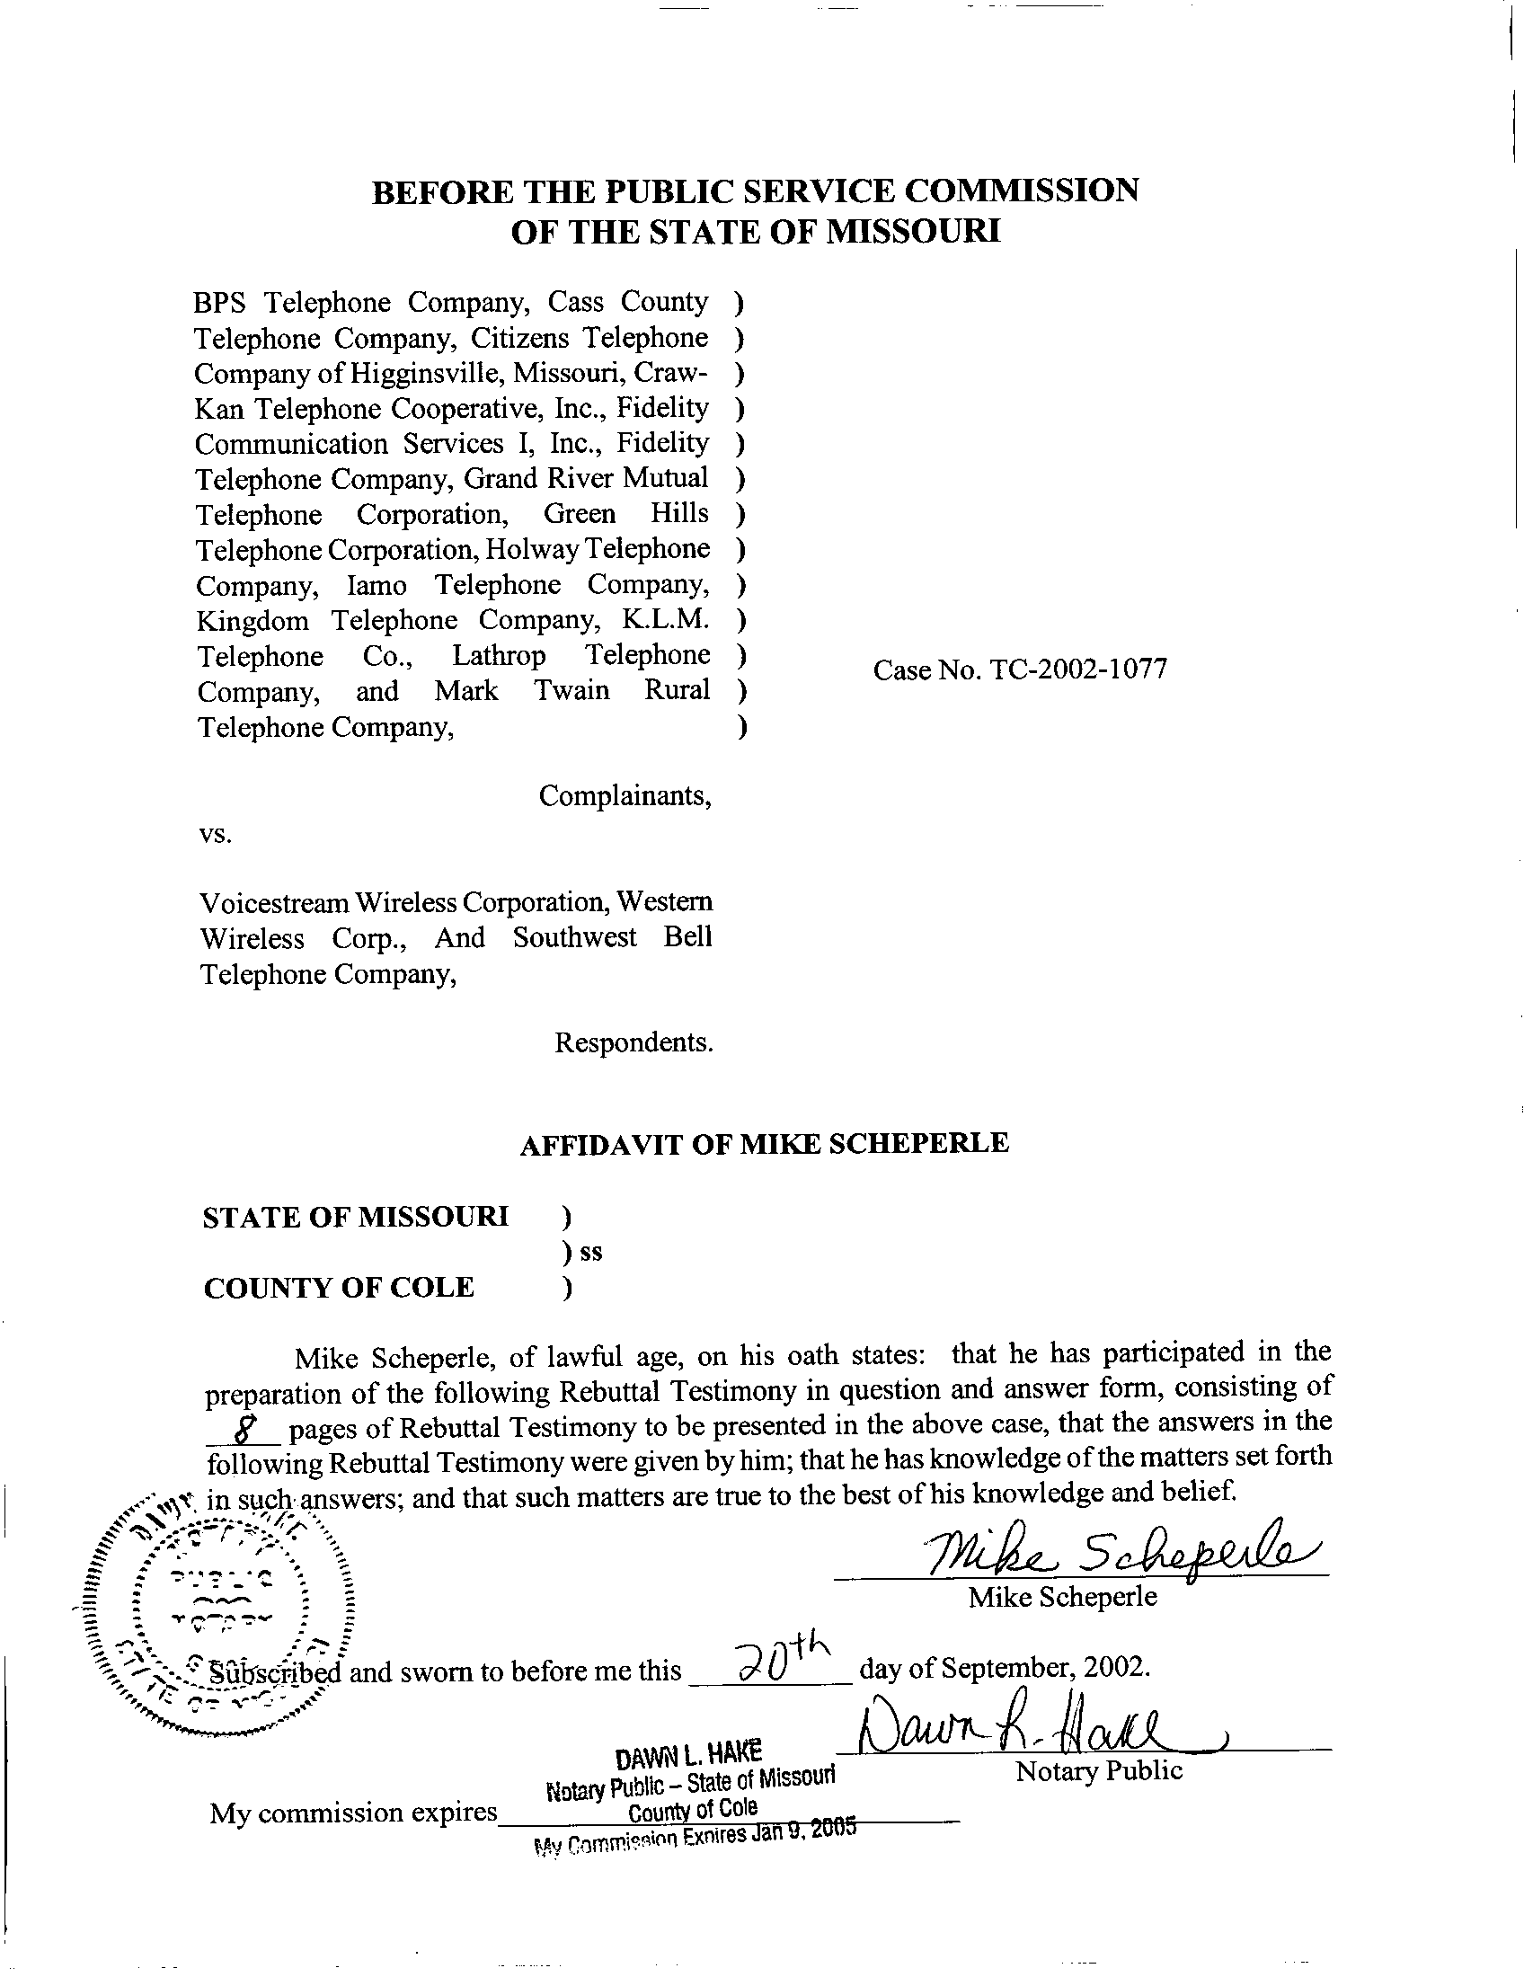

TABLE OF CONTENTS

Background and Education 1
Purpose of Testimony 2
Complaints 2
Summary 8

REBUTTAL TESTIMONY
OF
MICHAEL S. SCHEPERLE
CASE NO. TC-2002-1077

Background and Education
- Please state your name and business address.
A. My name is Michael S. Scheperle. My business address is Post Office Box 360, Governor Office Building, Suite 500, 200 Madison Street, Jefferson City, Missouri 65102-0360.
Q. By whom are you employed and what is your title?
A. I am employed by the Missouri Public Service Commission (“Commission”) as a Regulatory Economist II in the Telecommunications Department of the Utility Operations Division (“Staff”).
Q. Please describe your current responsibilities as a Regulatory Economist II.
A. I am responsible for reviewing and writing recommendations for controversial or contested tariff and case filings, and analyzing various rate components for Incumbent Local Exchange Carriers (“ILECs”). I am also responsible for reviewing, analyzing, and making recommendations on cost studies in the telecommunications industry in Missouri. I have previously filed testimony before the Commission in Case Nos. TT-2000-527/513, TT-2001-139, TT-2001-298, TO-2001-440, TO-2001-455, TO-98-329 and TC-2002-57.
Q. Please describe your educational background and employment history.
A. I hold a Bachelor of Science degree in Mathematics from Lincoln University in Jefferson City, Missouri. I was employed by Missouri Power and Light Company from 1973 to 1983 as Supervisor of Rates, Regulations and Budgeting. My duties included filing rate cases for electric and natural gas operations before the Commission. From 1983 to April 2000, I was employed by United Water Missouri as Commercial Manager supervising the customer service department, which included customer service representatives and service department employees.

Purpose of Testimony
Q. What is the purpose of your testimony?
A. The purpose of my Rebuttal Testimony is to respond to the Direct Testimonies of the witnesses comprising the fourteen companies (collectively, Complainants, Schedule 1) in this case. The Complainants, in their Direct Testimonies, allege that VoiceStream Wireless Corporation (VoiceStream) and Western Wireless Corporation (Western) (collectively, Respondents) are not compensating the Complainants for terminating wireless-originated traffic on their networks.

Complaints
Q. In your own words, what is the main issue in this case?
A. I think the main issue is to address what steps should be taken if a wireless carrier fails to compensate a local exchange company for terminating a wireless to landline call. For instance, Complainants claim they are allowed to assess late payment charges as well as seek recovery of reasonable attorney fees in pursuing any unpaid amounts. If a wireless carrier continues to refuse payment then the Complainants allege Southwestern Bell Telephone Company (SWBT) is liable for any unpaid amounts.
Q. Are the Complainants entitled to compensation for terminating the wireless traffic on their respective networks?
A. Absolutely. The Complainants, which build, operate and maintain the local network, have invested capital in creating the local network and incur costs in its operation and maintenance. Secondly, the Complainants each have a respective wireless termination service tariff on file and approved by this Commission (See Schedule 1 for tariff number and effective date), which applies in the absence of an agreement negotiated or arbitrated pursuant to the Telecommunication Act of 1996 (Act). Currently, no agreements exist between VoiceStream and the Complainants or Western and the Complainants.
Q. Are VoiceStream and Western delinquent in compensating the Complainants for terminating wireless to landline traffic?
A. Yes. The Complainants have produced evidence (Schedule 1 to the respective Direct Testimony) in which the Complainants are invoicing the Respondents based on a monthly Cellular Transiting Usage Summary Report (CTUSR) supplied by SWBT which identifies, by carrier, the Commercial Mobile Radio Service (CMRS) providers who have transited wireless-originated traffic over SWBT’s facilities for termination to the Complainants’ exchanges.
Q. Should the Complainants’ respective wireless termination tariffs apply to this traffic?
A. Yes. Each respective Complainant has established a Missouri Commission approved wireless termination service tariff (See Schedule 1 for tariff number and effective date) which contains rates, terms and conditions for the termination of intraMTA wireless-originated traffic delivered to the company via the transit services offered by SWBT. These tariffs apply in the absence of an agreement negotiated pursuant to the Act.
Q. Do the Complainants’ wireless termination tariffs provide any guidance on what action, if any, should be taken if a wireless carrier is delinquent in compensating the terminating local exchange company?
A. Yes. Specifically, Section E. 5. of each Complainant’s wireless termination tariff states:
The CMRS provider shall pay the Telephone Company for all charges in accordance with the rates set forth in this tariff. Such payments are to be received within thirty (30) days from the effective date of the billing statement. The CMRS provider shall pay a late charge on any undisputed charges, which are not paid within the thirty (30) day period. The rate of the late charge shall be the lesser of 1.5% per month or the maximum amount allowed by law. The CMRS provider shall pay the Telephone Company the reasonable amount of the Telephone Company’s expenses related to collection of overdue bills, such amounts to include reasonable attorney fees.

From Staff’s perspective, the Complainants’ wireless termination tariffs allow for a late charge and reasonable attorney fees related to collection of overdue bills. Therefore, Staff supports the request that the Commission find that the Complainant’s wireless termination tariff provisions apply to the minutes allowing late charges and reasonable attorney fees from VoiceStream and Western.
Q. Do the Complainants’ wireless termination tariffs indicate a wireless carrier’s traffic might be blocked if the wireless carrier remains delinquent?
A. Yes. The respective wireless termination tariffs state at Section G:
G. Refusal and Discontinuance of Service
1. If the CMRS provider fails to comply with any of the terms and conditions of this tariff, including any payments to be made by it on the dates and times herein specified, the Telephone Company, may on thirty (30) day’s written notice by Certified U.S. Mail to the CMRS provider, refuse additional applications…, or may discontinue the provision of the services to the non-complying CMRS provider at any time thereafter. In the case of such discontinuance, all applicable charges, including termination charges, shall become due …

3. If the Telephone Company is unable to effectuate discontinuance of service at its own office it may request the assistance of other ILECs with whom the Telephone Company’s network is connected… This tariff specifically gives authority to such other ILEC’s to respond and honor a request to effect discontinuance of service from the CMRS provider to the Telephone Company without further regulatory authorization.

Q. Has the Commission previously addressed the issue of blocking traffic?
A. Yes. The Commission’s Report and Order for Case No. TT-2001-139, (in the matter of Mark Twain Rural Telephone Company’s proposed tariff to introduce its wireless termination service, issued February 8, 2001, on pages 42 through 44) discusses traffic blocking. The Commission recognized that an intervening LEC, generally SWBT, must assist the small Incumbent Local Exchange Carrier (ILEC) in blocking the traffic of a defaulting CMRS carrier if the small ILEC is unable to discontinue service at its own office. The Commission also stated “…the requesting small LEC must pay SWBT the cost of blocking the traffic…”
Q. Has the Commission previously addressed the issue of SWBT being held secondarily liable for any unpaid amounts by a CMRS provider?
A. Yes. The Commission appears to have previously declared SWBT will be secondarily liable to the Complainants. In the Report and Order issued for Case No. TT-97-524, the Commission stated, “…Similarly, if SWBT knows it will be secondarily liable to the third-party LECs, it will have an incentive to enforce the provisions of its tariff and its interconnection agreements, which require wireless carriers to enter into agreements with third-party LECs.” This Commission statement suggests SWBT will be liable if a wireless provider fails to adequately compensate a third-party LEC for terminating wireless originated traffic. Despite this Commission statement, other considerations might suggest different measures should be taken.
Q. Please further explain the more recent Commission orders that suggest blocking the traffic might be a more appropriate method of handling delinquent carrier traffic.
A. As I previously pointed out, the Commission’s Report and Order in Case No. TT-97-524 was issued on December 23, 1997. This decision apparently provides the basis for the Complainants to claim SWBT should be liable for unpaid charges billed by third-party LECs to wireless providers. Since the date of this Report and Order, I am unaware that any company has ever attempted to actually hold SWBT liable for such charges. Since the issuance of the Report and Order in Case No. TT-97-524, the Commission has entertained various complaints regarding the inability of third party LECs to be compensated for terminating wireless originated traffic. None of the Orders in these complaints have attempted to hold SWBT liable for this traffic.
Since the issuance of the Report and Order in Case No. TT-97-524, the Commission has approved the wireless termination tariffs of the third party LECs, including the Complainants to this case. There is nothing in the Complainant’s wireless termination tariffs that suggest SWBT should be liable. However, the Commission’s Report and Order for Case No. TT-2001-139 discussed the issue of traffic blocking. From my perspective, if the Commission expects SWBT to be held liable for any delinquent charges billed to a wireless carrier, then it is unclear to me what incentive, if any, a third party LEC has in getting the traffic blocked.
Q. What considerations might suggest that it would be more appropriate to block the traffic instead of holding SWBT secondarily liable?
A. One consideration is that more recent Commission orders suggest blocking the traffic is the appropriate manner to deal with such situations. Another consideration is that wireless termination tariffs do not contemplate SWBT’s liability. A third consideration is the unclear logistics of making SWBT liable for this traffic:
- Would SWBT be liable for late payment charges and attorney fees?
- When should the terminating LEC be required to notify SWBT about such liability?
- Could a terminating LEC simply stock-pile such delinquents?
Q. Please further explain why certain logistics need to be addressed if SWBT is to be held liable for wireless originated traffic that is transited by SWBT.
A. Questions surrounding the timeliness of notifying SWBT of any liability and what, if any, additional charges would apply need to be answered if the Commission expects to hold SWBT liable for such traffic. For instance, a consideration is whether third party LECs have an obligation to notify SWBT in a timely manner about a wireless carrier’s delinquency. In my opinion, a third party LEC should have an obligation to notify SWBT at the earliest opportunity. Another question is whether SWBT should be liable for late payment fees and reasonable attorney fees contemplated by the Complainants’ tariffs.

Summary
Q. Please summarize your Rebuttal Testimony.
- Staff asserts the Complainants are entitled to compensation for terminating the wireless traffic from VoiceStream and Western.
- Staff asserts the Complainants’ respective wireless termination tariffs apply to this traffic.
- Staff supports the Complainants request that the wireless termination tariff provisions apply, allowing late charges and reasonable attorney fees from VoiceStream and Western.
- Staff does not agree that SWBT is secondarily liable for any unpaid amounts by VoiceStream and Western.
- Staff suggests it is appropriate for traffic to be blocked in the event of a delinquency.
Q. Does this conclude your Rebuttal Testimony?
A. Yes, it does.

