Exhibit No.:
Issues: Large Customer Annualization
Witness: Anne E. Ross
Sponsoring Party: MoPSC Staff
Type of Exhibit: Direct Testimony
Case No.: GR-2004-0209
Date Testimony Prepared: April 15, 2004

MISSOURI PUBLIC SERVICE COMMISSION

UTILITY SERVICES DIVISION

DIRECT TESTIMONY

OF

ANNE E. ROSS

MISSOURI GAS ENERGY

CASE NO. GR-2004-0209

Jefferson City, Missouri
April 2004
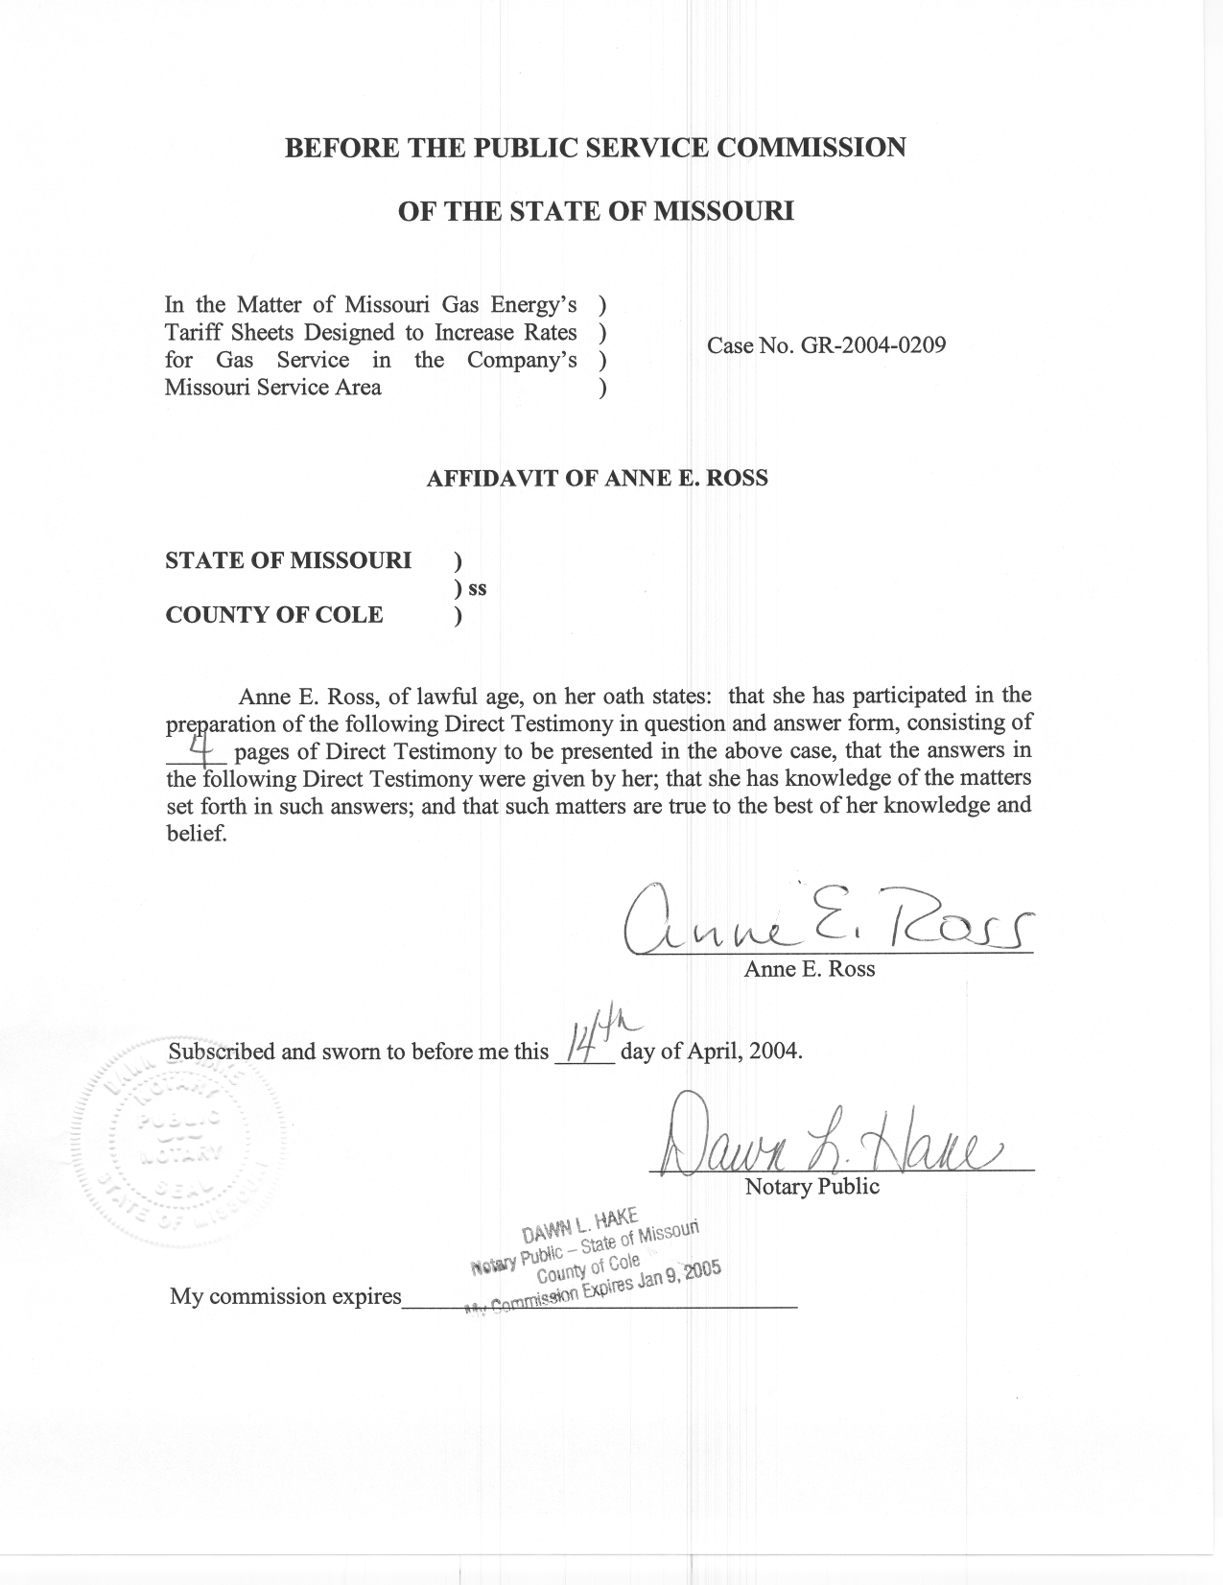
TABLE OF CONTENTS

ADJUSTMENTS TO LARGE VOLUME CUSTOMERS 2

DIRECT TESTIMONY
OF
ANNE E. ROSS
MISSOURI GAS ENERGY
CASE NO. GR-2004-0209
Q. Please state your name and business address.
A. Anne E. Ross, P.O. Box 360, Jefferson City, Missouri 65102.
Q. By whom are you employed and in what capacity?
A. I am a Regulatory Economist with the Missouri Public Service Commission (Commission).
Q. Please describe your educational background.
A. I graduated from the University of Missouri – Columbia in 1986 with an undergraduate degree in Business Administration. I graduated from the University of Missouri – Columbia, with a Masters of Business Administration in 1989.
Q. Please describe your work experience.
A. I have been employed with the Commission as a Regulatory Economist since 1989. I have also been an adjunct professor at Columbia College since 1989.
Q. What has been the nature of your duties while in the employ of the Commission?
A. The general nature of my duties at the Commission have included Class Cost of Service, Rate Design, Large Customer Analysis, and the design of programs for lower income natural gas customers.
Q. Have you previously filed testimony before this Commission?

A. Yes. Attachment 1 is a list of the gas cases in which I have filed testimony.
Q. What is the purpose of your direct testimony?
A. The purpose of my direct testimony is to describe the revenue adjustments that the Staff is proposing for the Company's Large Volume Service customers.

ADJUSTMENTS TO LARGE VOLUME CUSTOMERS
Q. What types of modifications are made to Large Volume Service (LVS) customers’ test year usage?
A. Typical adjustments include adjustments for customers coming on or going off the system during the test year; for accounts that take service on more than one tariff during the year; and weather normalization to adjust for abnormal weather during the test year.
Q. What is done if a customer comes on the system during the test year?
A. In this instance, billing units and revenues are increased to reflect a full 12 months of usage.
Q. Why?
A. To adjust the test year so that it reflects the addition of that customer on a going-forward basis.
Q. What is done if a customer goes off the system during the test year?
A. In that case, the customer’s billing units, and the associated revenue, is decreased, since the customer is no longer on the system, and will not provide any revenue for the Company.
Q. What type of adjustment is made if a customer takes service under two or more rate classes during the test year?
A. This is called rate-switching. In this case, the customer’s usage and revenue is removed from the original class, and added to that of the new class, as it is assumed that, in a normal year, the customer will take service under only one tariff or rate class.
Q. Why would customers switch from one rate to another?
A. The nature of a customer’s operations may change, and taking service under a different tariff is now more appropriate, or is even required by the Company’s tariff, or the customer may find it to be economical to switch to another customer class.
Q. Are you sponsoring Staff adjustments to reflect the revenue effect of LVS customers coming on/going off the MGE system and rate-switching?
A. Yes. Adjustment S-7.4 to the Company’s revenue requirement reflects the revenue effect to the LVS class revenues resulting from customers switching to and from the Company’s LVS tariff. Adjustment S-2.17 adjusts the Small General Service and Large General Service class revenues for the effects of customer rate-switching between these classes and the Large Volume class.
Q. Are the customers in the Large Volume Service tariff class weather-sensitive?
A. Yes. Schedule 2 shows the aggregate usage of these customers plotted against heating degree days, for the Kansas City, Joplin and St. Joseph areas. As can be seen from the graphs, these customers’ usage shows a linear response to weather, with usage increasing as the outside temperature decreases.
Q. Are you making weather adjustments for the Large Volume Service customers?
A. Yes. Adjustment S-7.5 reflects the weather adjustment to the Company’s revenue requirement for the Large Volume Service customers.
Q. How was this adjustment determined?
A. Using individual customer records supplied by the Company, I accounted for the effect of customer rate-switching on volumes and customer numbers. I also removed the records of any customers who were not in the LVS customer class as of December 31, 2003. Finally, I removed one large customer from the St. Joseph records, as it appeared to be a customer that peaks in the summer. The remaining records were used to calculate a weather-normalization adjustment to the LVS class revenues.
Q. Does this conclude your direct testimony?
A. Yes.

