BEFORE THE PUBLIC SERVICE COMMISSION
OF THE STATE OF MISSOURI

In the Matter of the Future Supply, )
Delivery and Pricing of the Electric )
Service Provided by Kansas City ) Case No. EW-2004-0596
Power & Light Company )

APPLICATION OF THE MISSOURI INDUSTRIAL ENERGY CONSUMERS
TO INTERVENE OUT OF TIME

Comes now Alcoa, Anheuser-Busch, Boeing, DaimlerChrysler, Ford, General Motors, Hussmann, Monsanto, Pfizer, Precoat Metals, Procter & Gamble, Nestlé Purina and Solutia (“Missouri Industrial Energy Consumers” or “MIEC”), and pursuant to 4 CSR 240-2.075, files its Application to Intervene Out of Time. For its Application, the MIEC states as follows:
- The MIEC is a group of large industrial energy consumers.
- The Commission’s decision in this case regarding Kansas City Power & Light Company’s (“KCPL’s ”) Application will affect the interest of MIEC members served by KCPL. The Commission’s decision in this case will also establish policy and precedent that will affect MIEC members served by other utilities regulated by the Commission.
- As large industrial customers of KCPL and other utilities regulated by the Commission, the MIEC’s interest in this case is different than that of the general public.
- The MIEC is unsure of the position that it will take in this case, but reserves the right to take positions on the issues as this case proceeds.
- The MIEC’s intervention will serve the public interest by assisting the record for the Commission’s decision in this case.
- Good cause exists to grant this Application, even though the intervention date of June 1 established by the Commission’s May 25 Order in this case has passed. Counsel for the MIEC was unable to review KCPL’s filing and consult with its members to obtain authority to participate within the intervention period. This case is at an early stage, and granting this Application will not prejudice any party.
WHEREFORE, the MIEC respectfully requests that it be permitted to intervene out of time, and that it be made a party to this case for all purposes.

Respectfully submitted,

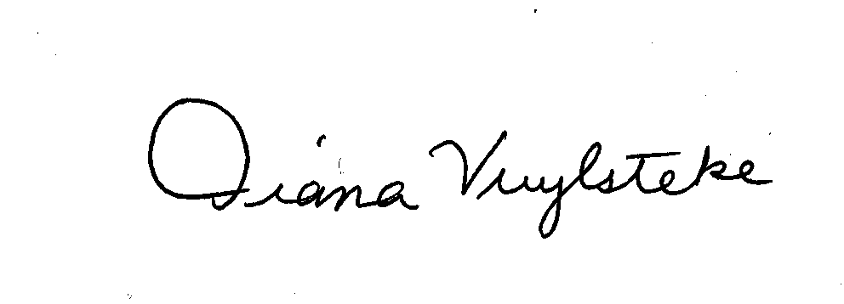
BRYAN CAVE, LLP

By:______________________
Diana M. Vuylsteke, # 42419
211 N. Broadway, Suite 3600
St. Louis, Missouri 63102
Telephone: (314) 259-2543
Facsimile: (314) 259-2020
E-mail: dmvuylsteke@bryancave.com

Attorney for The Missouri Industrial Energy Consumers

CERTIFICATE OF SERVICE

I do hereby certify that a true and correct copy of the foregoing document has been hand-delivered, transmitted by e-mail or mailed, First Class, postage prepaid, this 9th day of June, 2004, to:

Dana K Joyce  P.O. Box 360  200 Madison Street, Suite 800  Jefferson City, MO 65102 | John B Coffman  P.O. Box 2230  200 Madison Street, Suite 640  Jefferson City, MO 65102 | Legal Department  Kansas City Power & Light Company  1201 Walnut  Kansas City, MO 64106
Dean L Cooper  Aquila, Inc.  312 East Capitol  P.O. Box 456  Jefferson City, MO 65102 | Shelley A Woods  Missouri Department of Natural Resources  P.O. Box 33525  Jefferson City, MO 65102 | Mark W Comley  City of Kansas City, Missouri  601 Monroe Street, Suite 301  P.O. Box 537  Jefferson City, MO 65102-0537
Dean L Cooper
The Empire District Electric Company (duplicate)
312 East Capitol
P.O. Box 456
Jefferson City, MO 65102

______________________________________________

